Microsoft SQL Server DBA/Azure SQL DBA

Database Developer:

Responsible for writing database queries like SQL queries, joins, unions, stored procedures, triggers

Database Administrator:

Database administrator receptibility is to setup, monitor, manage and maintains the database environments

* Installation and configuration of SQL server
* Patching (applying service packs and CUs)
* Connectivity of SQL server
* Start/stop/restart the SQL server
* Security – creation of users and managing the permissions
* Creation of databases
* Development fundamentals
* Backup and Recovery
* High availability and DR solution
  + Log shipping
  + Database mirroring
  + Replication
  + Failover cluster
  + Always On
* Performance monitoring ang tuning
* Migrations and upgrades
  + In place upgrades
  + Side by side migrations
* Monitoring and alerting

Information –

Details about a particular person or a particular object is called information

|  |  |  |  |  |  |  |  |  |
| --- | --- | --- | --- | --- | --- | --- | --- | --- |
| **SNO** | **ID** | **Name** | **Phone** | **Email** | **eduction** |  |  |  |
| 1 | 1001 | Kareem | 99999 | [kareem@gmail.com](mailto:kareem@gmail.com) | B.Tech | Information | | |
| 2 | 1002 | latha | 8888 | [latha@gmail.com](mailto:latha@gmail.com) | MCA | Information | | |

What is Data

* Storing collection of information
* Data is raw collection of information
* Set of information
* Data is a not meaningful form
* Collection of related information in a systematic manner
* Data is unprocessed information
* Collection of rows and columns
* Collection of specific information
* Information in a form that can be processed by a computer
* Retrieving the information when we need
* Data is collection of information and systematic record
* Collection of information
* Data is a raw collection of information
* Statistics collected together for reference
* Create and maintain the information for reference
* Collection of information
* Collection of files and results
* Raw collection facts about people, things and objects ..etc
* Data means correct plan for the status
* Data is collection of related information

Examples of Data:

* Customers details in a bank
* Students in information in school/college
* Patients/doctors information a hospital
* eCommerce products information
* employee details in any organization
* Information about companies
* AaDar and PAN information

Database – is a storage media where we store our data

DBMS – Database Management System

* + ~~HDBMS – Hierarchical database management system~~
  + ~~NDBMS – Network Database management system~~
  + RDBMS – Relational Database management system
    - SQL Server – Microsoft, Licensed
    - Oracle - Oracle corporation, Licensed
    - MySQL – Oracle, open source
    - PostgreSQL – Open source
    - DB2 – IBM, Licensed
    - Sybase – SAP, Licensed
    - MS Access – Microsoft, open source
    - MariaDB – open source
    - SQLite - SQLite
    - Greenplum - Greenplum
    - Progress – progress
    - Informix - IBM

Cloud based RDBMS services:

Microsoft Azure

* Azure SQL
  + SQL server
  + MySQL
  + MariaDB
  + PostgreSQL

AWS:

* AWS RDS (relational database service):
  + SQL server
  + Oracle
  + MySQL
  + PostgreSQL
  + Aroura

Google Cloud Platform

* Cloud SQL
  + SQL server
  + MySQL
  + PostgreSQL
  + Oracle

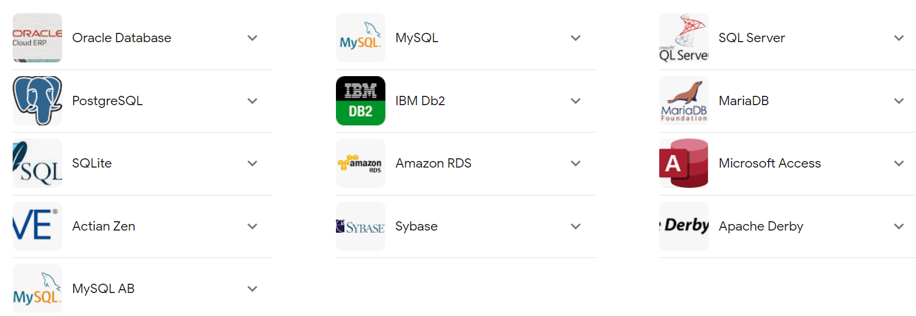

<https://www.c-sharpcorner.com/article/what-are-the-most-popular-relational-databases/>

What is SQL Server: SQL server is relational database management system from Microsoft which we can use to store, retrieve and manipulate the data

History of the SQL Server: SQL Server is not originally developed Microsoft and it was originally developed by Sybase corporation

* SQL server 1.0 first begun in 1989 to run only OS/2 by Sybase, Ashton-Tate, and Microsoft.
* SQL Server 4.2 for NT is released in 1993, marking the entry onto Windows NT.
* SQL Server 6.0 is released in 1995, marking the end of collaboration with Sybase; Sybase would continue developing their own variant of SQL Server, Sybase Adaptive Server Enterprise, independently of Microsoft.
* SQL Server 2005, released in 2005, finishes the complete revision of the old Sybase code into Microsoft code.

SQL Server Versions:

SQL server 1.0🡪OS/2

SQL server 2.0

SQL server 3.0

SQL server 4.0

SQL server 4.2🡪compatible with Windows NT

SQL server 5.0

Microsoft SQL server 6.0🡪First SQL server by Microsoft

Microsoft SQL server 6.5

Microsoft SQL server 7.0

Microsoft SQL server 2000 🡪changed versioning format

Microsoft SQL server 2005🡪totally migrated to MS code base

Microsoft SQL server 2008

Microsoft SQL server 2008 R2

Microsoft SQL server 2012

Microsoft SQL server 2014

Microsoft SQL server 2016🡪Compatible with Linux

Microsoft SQL server 2017

Microsoft SQL server 2019

Microsoft SQL server 2022 🡪latest version of SQL server

<https://sqlserverbuilds.blogspot.com/>

## Quick summary:

|  |  |  |  |  |  |
| --- | --- | --- | --- | --- | --- |
| **Release** | **RTM (no SP)** | **Latest CU** | | | |
| [↓](https://sqlserverbuilds.blogspot.com/#sql2022x) [**SQL Server 2022**](https://sqlserverbuilds.blogspot.com/#sql2022x)  SQL Server latest version  SQL Server 16 codename Dallas Release date: 2022-11-16 Support end date: 2028-01-11 Ext. end date: 2033-01-11 | [**16.0.1000.6**](https://www.microsoft.com/en-us/sql-server/sql-server-2022) | [**CU7**](https://learn.microsoft.com/en-us/troubleshoot/sql/releases/sqlserver-2022/cumulativeupdate7) (16.0.4065.3, August 2023) | | | |
| [↓](https://sqlserverbuilds.blogspot.com/#sql2019x) [**SQL Server 2019**](https://sqlserverbuilds.blogspot.com/#sql2019x)  SQL Server 15 codename  Seattle Release date: 2019-11-04 Support end date: 2025-01-07 Ext. end date: 2030-01-08 | [**15.0.2000.5**](https://www.microsoft.com/en-us/sql-server/sql-server-2019) | [**CU22**](https://learn.microsoft.com/en-us/troubleshoot/sql/releases/sqlserver-2019/cumulativeupdate22) (15.0.4322.2, August 2023) | | | |
| [↓](https://sqlserverbuilds.blogspot.com/#sql2017x) [**SQL Server 2017**](https://sqlserverbuilds.blogspot.com/#sql2017x)  SQL Server 14 codename vNext Release date: 2017-10-02 Support end date: 2022-10-11 Ext. end date: 2027-10-12 | [**14.0.1000.169**](https://www.microsoft.com/en-us/sql-server/sql-server-2017) | [**CU31**](https://support.microsoft.com/en-us/help/5016884) (14.0.3456.2, September 2022) | | | |
| Starting from SQL Server 2017 Service Packs will no longer be released | | | | | |
|  | | **SP1** | **SP2** | **SP3** | **SP4** |
| [↓](https://sqlserverbuilds.blogspot.com/#sql2016x) [**SQL Server 2016**](https://sqlserverbuilds.blogspot.com/#sql2016x)  SQL Server 13 Release date: 2016-06-01 Support end date: 2021-07-13 Ext. end date: 2026-07-14 | [**13.0.1601.5**](https://www.microsoft.com/en-us/sql-server/sql-server-2016)  + [CU9](https://support.microsoft.com/en-us/help/4037357) | [**13.0.4001.0**](https://support.microsoft.com/en-us/help/3182545) or 13.1.4001.0  + [CU15](https://support.microsoft.com/en-us/help/4495257) | [**13.0.5026.0**](https://support.microsoft.com/en-us/help/4052908) or 13.2.5026.0  + [CU17](https://support.microsoft.com/en-us/help/5001092) | [**13.0.6300.2**](https://support.microsoft.com/en-us/help/5003279) or 13.3.6300.2 |  |
| [↓](https://sqlserverbuilds.blogspot.com/#sql2014x) [**SQL Server 2014**](https://sqlserverbuilds.blogspot.com/#sql2014x)  SQL Server 12 Release date: 2014-04-01 Support end date: 2019-07-09 Ext. end date: 2024-07-09 | 12.0.2000.8  + [CU14](https://support.microsoft.com/en-us/help/3158271) | [**12.0.4100.1**](https://www.microsoft.com/en-us/download/details.aspx?id=46694) or 12.1.4100.1  + [CU13](https://support.microsoft.com/en-us/help/4019099) | [**12.0.5000.0**](https://www.microsoft.com/en-us/download/details.aspx?id=53168) or 12.2.5000.0  + [CU18](https://support.microsoft.com/en-us/help/4500180) | [**12.0.6024.0**](https://support.microsoft.com/en-us/help/4022619) or 12.3.6024.0  + [CU4](https://support.microsoft.com/en-us/help/4500181) |  |
| Obsolete versions – out of support | | | | | |
| [↓](https://sqlserverbuilds.blogspot.com/#sql2012x) [**SQL Server 2012**](https://sqlserverbuilds.blogspot.com/#sql2012x)  SQL Server 11 codename Denali Release date: 2012-03-06 Support end date: 2017-07-11 Ext. end date: 2022-07-12 | 11.0.2100.60  + [CU11](https://support.microsoft.com/en-us/help/2908007) | [**11.0.3000.0**](http://www.microsoft.com/en-us/download/details.aspx?id=35575) or 11.1.3000.0  + [CU16](https://support.microsoft.com/en-us/help/3052476) | [**11.0.5058.0**](http://www.microsoft.com/en-us/download/details.aspx?id=43340) or 11.2.5058.0  + [CU16](https://support.microsoft.com/en-us/help/3205054) | [**11.0.6020.0**](https://www.microsoft.com/en-us/download/details.aspx?id=49996) or 11.3.6020.0  + [CU10](https://support.microsoft.com/en-us/help/4025925) | [**11.0.7001.0**](https://www.microsoft.com/en-us/download/details.aspx?id=56040) or 11.4.7001.0 |
| [↓](https://sqlserverbuilds.blogspot.com/#sql2008r2x) [**SQL Server 2008 R2**](https://sqlserverbuilds.blogspot.com/#sql2008r2x)  SQL Server 10.5 codename Kilimanjaro Release date: 2010-04-21 Support end date: 2014-07-08 Ext. end date: 2019-07-09 | 10.50.1600.1 | [**10.50.2500.0**](http://www.microsoft.com/en-us/download/details.aspx?id=26727) or 10.51.2500.0 | [**10.50.4000.0**](http://www.microsoft.com/en-us/download/details.aspx?id=30437) or 10.52.4000.0 | [**10.50.6000.34**](http://www.microsoft.com/en-us/download/details.aspx?id=44271) or 10.53.6000.34 |  |
| [↓](https://sqlserverbuilds.blogspot.com/#sql2008x) [**SQL Server 2008**](https://sqlserverbuilds.blogspot.com/#sql2008x)  SQL Server 10 codename Katmai Release date: 2008-08-07 Support end date: 2014-07-08 Ext. end date: 2019-07-09 | 10.0.1600.22 | [**10.0.2531.0**](http://www.microsoft.com/downloads/details.aspx?familyid=66AB3DBB-BF3E-4F46-9559-CCC6A4F9DC19) or 10.1.2531.0 | [**10.0.4000.0**](http://www.microsoft.com/downloads/en/details.aspx?FamilyID=8FBFC1DE-D25E-4790-88B5-7DDA1F1D4E17) or 10.2.4000.0 | [**10.0.5500.0**](http://www.microsoft.com/download/en/details.aspx?id=27594) or 10.3.5500.0 | [**10.0.6000.29**](http://www.microsoft.com/en-us/download/details.aspx?id=44278) or 10.4.6000.29 |
| [↓](https://sqlserverbuilds.blogspot.com/#sql2005) [**SQL Server 2005**](https://sqlserverbuilds.blogspot.com/#sql2005)  SQL Server 9 codename Yukon Release date: 2005-11-07 Support end date: 2011-04-12 Ext. end date: 2016-04-12 | 9.0.1399.06 | [**9.0.2047**](http://www.microsoft.com/downloads/details.aspx?FamilyID=CB6C71EA-D649-47FF-9176-E7CAC58FD4BC) | [**9.0.3042**](http://www.microsoft.com/downloads/details.aspx?FamilyId=d07219b2-1e23-49c8-8f0c-63fa18f26d3a) | [**9.0.4035**](https://support.microsoft.com/en-us/help/955706) | [**9.0.5000**](https://support.microsoft.com/en-us/help/2463332) |
| [↓](https://sqlserverbuilds.blogspot.com/#sql2000) [**SQL Server 2000**](https://sqlserverbuilds.blogspot.com/#sql2000)  SQL Server 8 codename Shiloh Release date: 2000-11-30 Support end date: 2008-04-08 Ext. end date: 2013-04-09 | 8.0.194 | [**8.0.384**](http://www.microsoft.com/downloads/details.aspx?FamilyID=DFF43C50-51DF-4FE0-9717-DE41FB48556E) | [**8.0.532**](http://www.microsoft.com/downloads/details.aspx?FamilyID=75672496-af8e-40dc-853e-ad2c9fe96882) | [**8.0.760**](http://www.microsoft.com/downloads/details.aspx?familyid=90DCD52C-0488-4E46-AFBF-ACACE5369FA3) | [**8.0.2039**](http://www.microsoft.com/downloads/details.aspx?FamilyId=8E2DFC8D-C20E-4446-99A9-B7F0213F8BC5) |
| [→](https://sqlserverbuilds.blogspot.com/2007/01/sql-server-7.html) [**SQL Server 7.0**](https://sqlserverbuilds.blogspot.com/2007/01/sql-server-7.html)  SQL Server 7 codename Sphinx Release date: 1998-11-27 Support end date: 2005-12-31 Ext. end date: 2011-01-11 | 7.0.623 | [**7.0.699**](http://www.microsoft.com/downloads/details.aspx?familyid=3884A944-3363-43CD-99E9-031A93C04413) | [**7.0.842**](http://www.microsoft.com/downloads/details.aspx?FamilyID=C4C935C7-4429-4172-9D54-C8A60927F372) | [**7.0.961**](http://www.microsoft.com/downloads/details.aspx?FamilyID=9c71f91c-a88f-4d31-9e8b-9fd63fbdbdcf) | [**7.0.1063**](https://www.microsoft.com/en-us/download/details.aspx?id=7959) |
| [→](https://sqlserverbuilds.blogspot.com/2006/05/sql-server-6-5.html) [**SQL Server 6.5**](https://sqlserverbuilds.blogspot.com/2006/05/sql-server-6-5.html)  SQL Server 6.50 codename Hydra Release date: 1996-06-30 Support end date: 2002-01-01 | 6.50.201 | 6.50.213 | 6.50.240 | 6.50.258 | SP4 6.50.281 SP5 6.50.416 |
| [→](https://sqlserverbuilds.blogspot.com/2006/01/sql-server-6.html) [**SQL Server 6.0**](https://sqlserverbuilds.blogspot.com/2006/01/sql-server-6.html)  SQL Server 6 codename SQL95 Release date: 1995-06-13 Support end date: 1999-03-31 | 6.00.121 | 6.00.124 | 6.00.139 | 6.00.151 |  |

**Legend**:

|  |  |
| --- | --- |
| CTP | *Community Technology Preview* (beta release) |
| RC | *Release Candidate* |
| RTM | *Released To Manufacturing*; It is the original, released build version of the product, i.e. what you get on the DVD or when you download the ISO file from MSDN. |
| CU | *Cumulative Update*; Cumulative updates contain the bug fixes and enhancements–up to that point in time–that have been added since the previous Service Pack release and will be contained in the next service pack release. Installation of the Cumulative Update is similar to the installation of a Service Pack. Cumulative Updates are not fully regression tested. * Since January 27, 2016: Microsoft recommends ongoing, proactive installation of SQL Server CUs as they become available. SQL Server CUs are certified to the same levels as Service Packs, and should be installed with the same level of confidence. |
| SP | *Service Pack*; much larger collection of hotfixes that have been fully regression tested. In some cases delivers product enhancements. All SQLServer service packs are cumulative, meaning that each new service pack contains all the fixes that are included with previous service packs and any new fixes. * Service Packs are discontinued starting from SQL Server 2017. Only Cumulative Updates (CUs) will be provided. |
| GDR | *General Distribution Release*; GDR fixes should not contain any of the CU updates. |
| QFE | *Quick Fix Engineering*; QFE updates include CU fixes. |
| CVE | *Common Vulnerabilities and Exposures*; publicly known information-security vulnerabilities. |
| OD | *On-Demand* hotfix. An OD is released per customer request for specific problem scenarios to that customer. OD hotfixes may or may not be released to the general public. |
| COD | *Critical On-Demand* hotfix. A COD hotfix is defined as critical because security is impacted a severe stability or functionality is detected. |

SQL Server Editions:

* Enterprise Edition
  + It is the top edition in the SQL server contains all the features and support the maximum capacity
  + CPU – OS MAX
  + RAM – OS MAX
  + Database Size – 524 PB
  + This is a recommended edition for all the production applications
* Standard Edition
  + The standard edition will not have some of the enterprise features like Always ON availability, Table portioning, online index rebuilds etc.
  + CPU – 24 Vcores
  + RAM – 128 GB
  + Database Size – 524 PB
* Developer Edition
  + It is a free edition, with all the enterprise features and enterprise edition capabilities. But it is licensed to use only for non-production systems like dev, sit, UAT ..etc
  + CPU – OS MAX
  + RAM – OS MAX
  + Database Size – 524 PB
* Express Edition
  + It is also free edition and this is very basic edition suitable for small desktop application where the data volume is very minimal
  + CPU – 4 vcore
  + RAM – 1.5 GB
  + Database Size – 10 GB

Edition comparisons:

<https://learn.microsoft.com/en-us/sql/sql-server/editions-and-components-of-sql-server-2019?view=sql-server-ver16>

**Scale limits**

| **Feature** | **Enterprise** | **Standard** | **Web** | **Express** | **Express** |
| --- | --- | --- | --- | --- | --- |
| Maximum compute capacity – CPU | OS MAX | 24 cores | 16 cores | 4 cores | 4 cores |
| Maximum memory – RAM | OS MAX | 128 GB | 64 GB | 1410 MB | 1410 MB |
| Maximum relational database size | 524 PB | 524 PB | 524 PB | 10 GB | 1. GB |

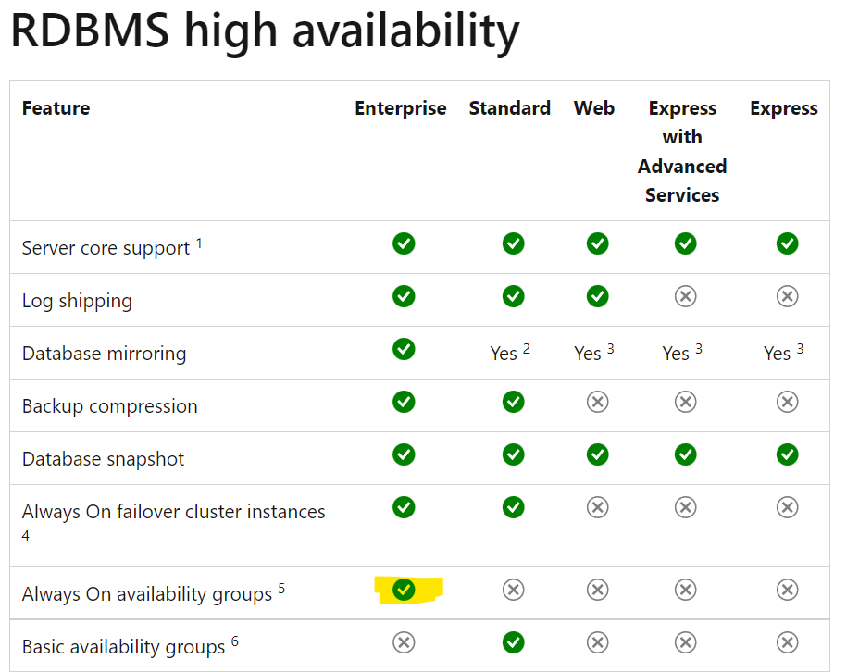

Pricing or licensing of SQL Server:

|  |  |  |  |
| --- | --- | --- | --- |
| **Editions** | **Price** | **Licensing model** | **Channel availability** |
| **Enterprise** | [USD 13,748](https://www.microsoft.com/en-in/sql-server/sql-server-2019-pricing#OneGDCWeb-ContentPlacementWithRichBlock-pp5ed24) | 2 core pack | Volume licensing, hosting |
| **Standard – per core** | [USD 3,586](https://www.microsoft.com/en-in/sql-server/sql-server-2019-pricing#OneGDCWeb-ContentPlacementWithRichBlock-pp5ed24) | 2 core pack | Volume licensing, hosting |
| **Standard – server** | [USD 899](https://www.microsoft.com/en-in/sql-server/sql-server-2019-pricing#OneGDCWeb-ContentPlacementWithRichBlock-pp5ed24) | [Server[2]](https://www.microsoft.com/en-in/sql-server/sql-server-2019-pricing#OneGDCWeb-ContentPlacementWithRichBlock-pp5ed24) | Volume licensing, hosting |
| **Standard - CAL** | $209 | CAL | Volume licensing, hosting |
| **Developer** | Free | Per user | [Free download](https://go.microsoft.com/fwlink/?linkid=866662) |
| **Express** | Free | Not applicable | [Free download](https://go.microsoft.com/fwlink/?linkid=866658) |

SQL server downloads:

<https://www.microsoft.com/en-us/sql-server/sql-server-downloads>

SQL Server 2022 -- > Evaluation edition

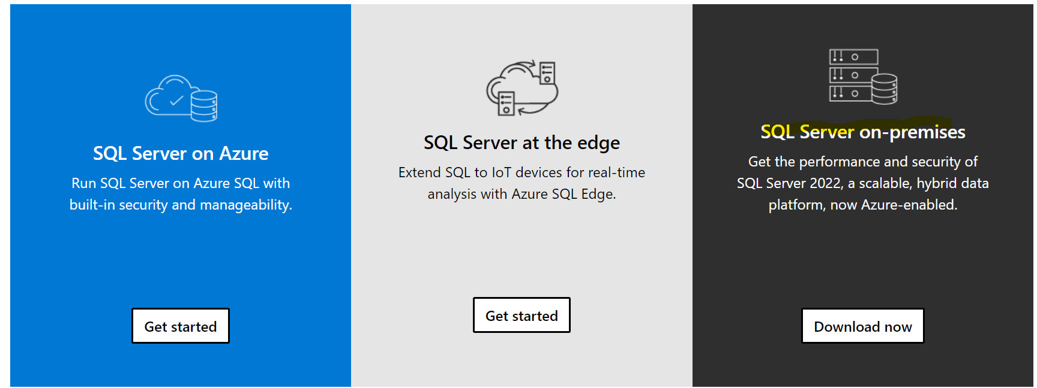

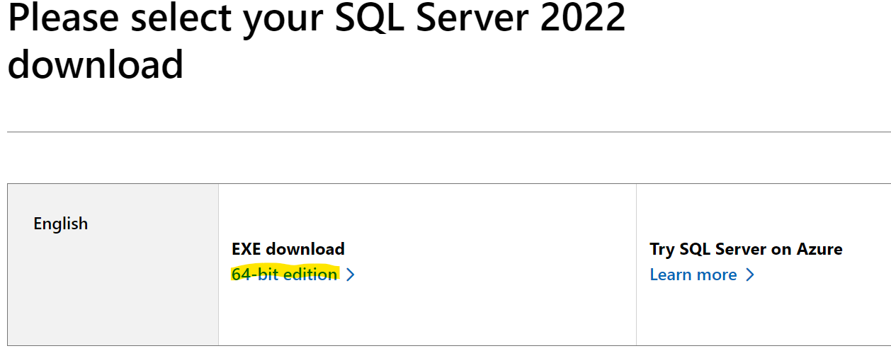

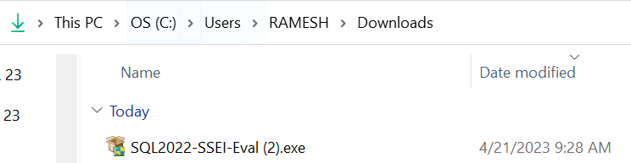

Run SQL2022-SSEI-Eval.exe 🡪to start SQL server 2022 evaluation edition

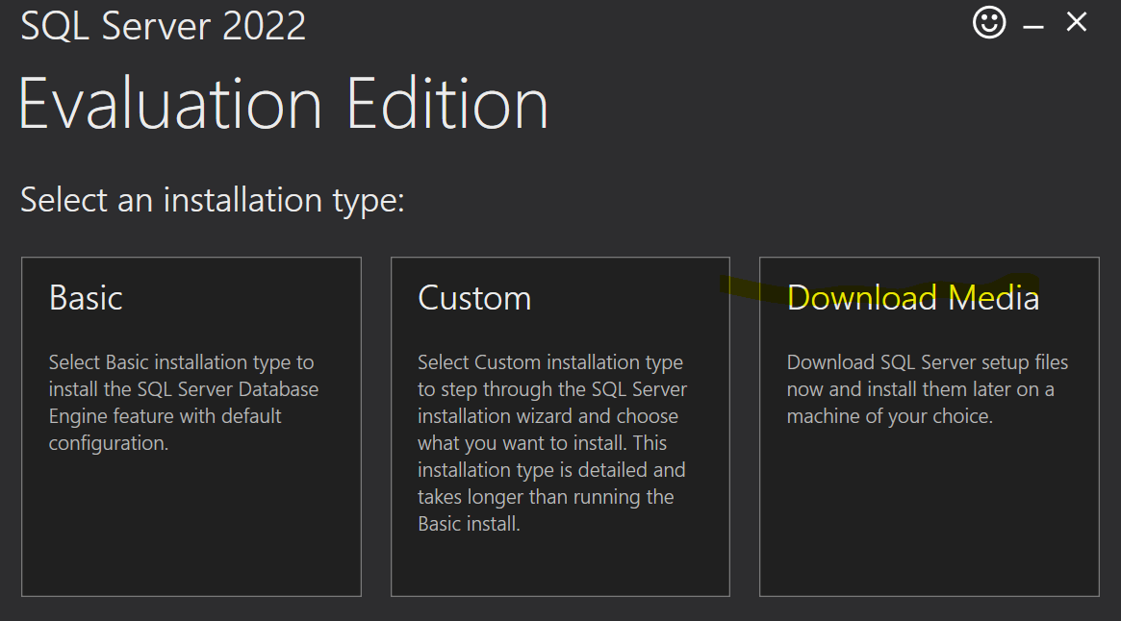

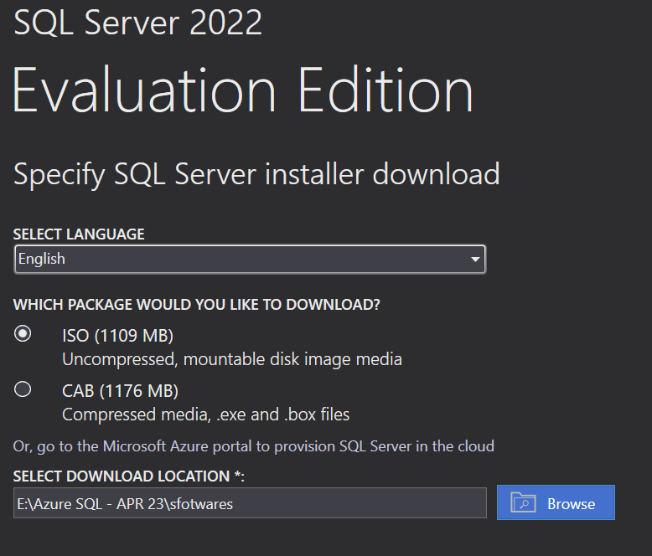

Developer and Express edition:

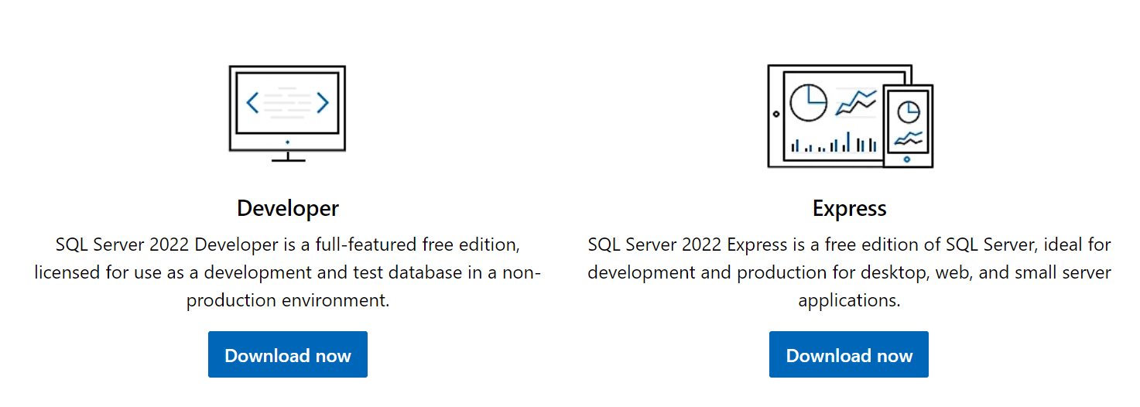

<https://www.sqlserverversions.com/2019/02/sql-server-editions.html>

|  |  |
| --- | --- |
| Free editions | |
| **Express** | Express edition is a **free** lightweight/lite edition of SQL Server with some limitations, that can be used in **production** environment. Main limitations: • Limited to lesser of **1 physical CPU** or **4 cores**. • No single database (.MDF file) can be over **10 GB**.[**Download SQL2022 Express Edition**](https://go.microsoft.com/fwlink/p/?linkid=2216019)[**Download SQL2019 Express Edition**](https://go.microsoft.com/fwlink/?linkid=866658)[**Download SQL2017 Express Edition**](https://go.microsoft.com/fwlink/?linkid=853017)[**Download SQL2016 Express Edition**](https://www.microsoft.com/en-us/download/details.aspx?id=103447) |
| **Developer** | Developer edition is a fully-functional *Enterprise Edition* of SQL Server, licensed for use as a **development** and **test** database in a **non-production** environment.[**Download SQL2022 Developer Edition**](https://go.microsoft.com/fwlink/p/?linkid=2215158)[**Download SQL2019 Developer Edition**](https://go.microsoft.com/fwlink/?linkid=866662)[**Download SQL2017 Developer Edition**](https://go.microsoft.com/fwlink/?linkid=853016) |
| **Evaluation** | Evaluation edition is a fully-functional **trial** *Enterprise Edition* of SQL Server but is limited to **180 days**, after which the tools will continue to run, but the server services will stop.[**Download SQL2022 Evaluation Edition**](https://www.microsoft.com/en-us/evalcenter/evaluate-sql-server-2022)[**Download SQL2019 Evaluation Edition**](https://www.microsoft.com/en-us/evalcenter/evaluate-sql-server-2019)[**Download SQL2017 Evaluation Edition**](https://www.microsoft.com/en-us/evalcenter/evaluate-sql-server-2017-rtm)[**Download SQL2016 Evaluation Edition**](https://www.microsoft.com/en-us/evalcenter/evaluate-sql-server-2016) |

SQL Server Pricing:

SQL server Download:

Installation SQL Server 2019 (Basis version):

Download SSMS:

Connect SQL server:

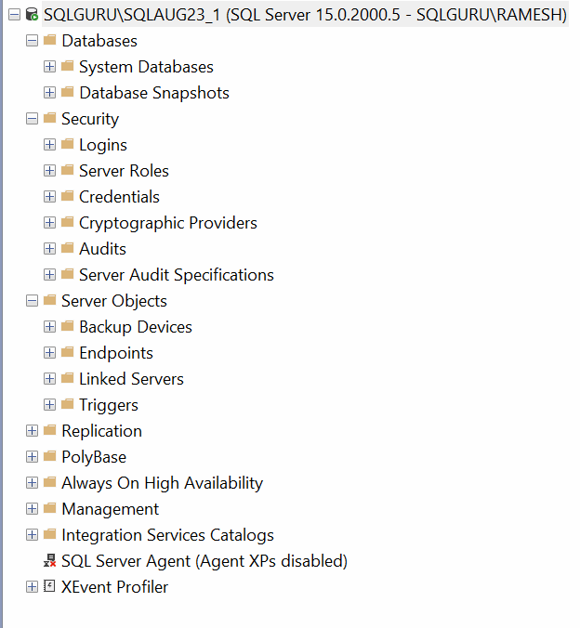

System Fundamentals:

How to find a machine name:

Option #1: right click this PC🡪properties🡪device name

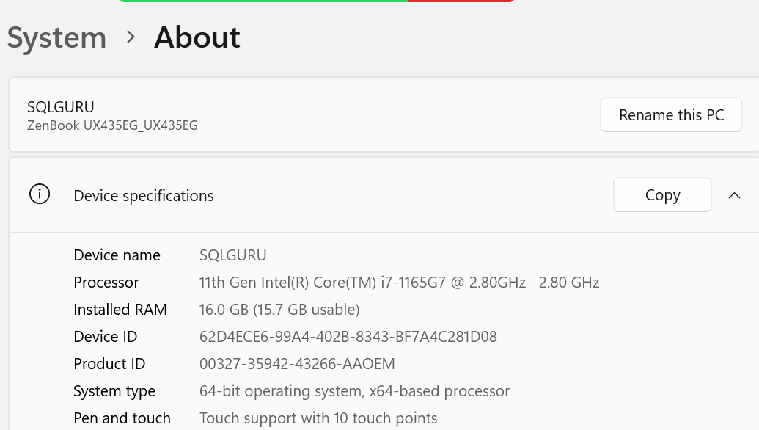

Option#2: cmd🡪hostname

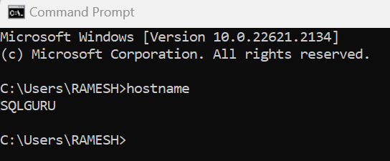

Option#3: PowerShell🡪hostname

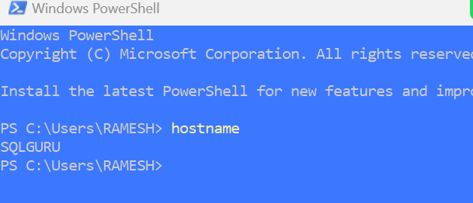

Option #4: run🡪msinfo32

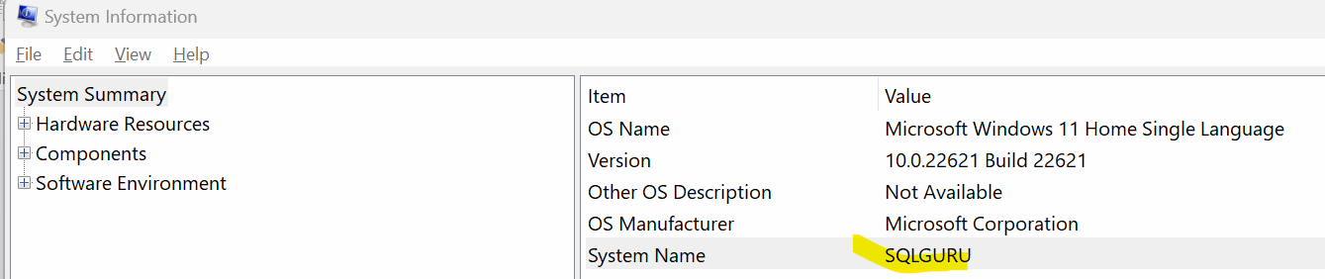

How to find IP address:

Option #1: Settings🡪network & Internet settings🡪go to properties

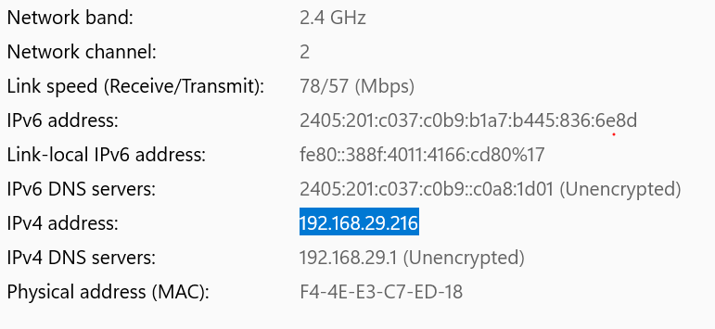

Option #2: Command Prompt

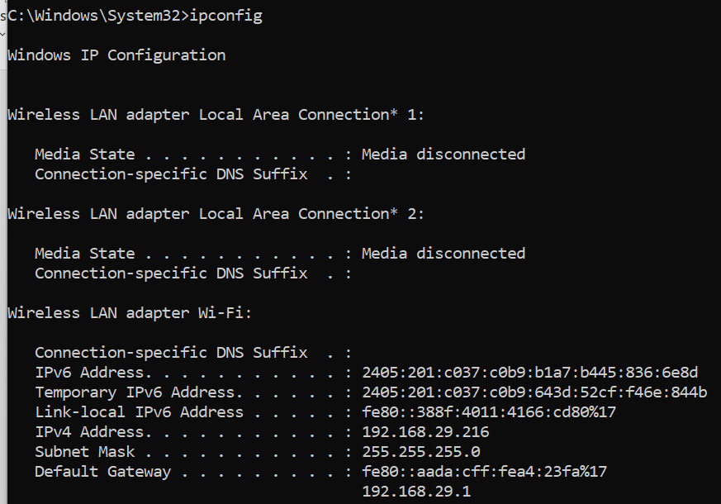

Option #3: PowerShell

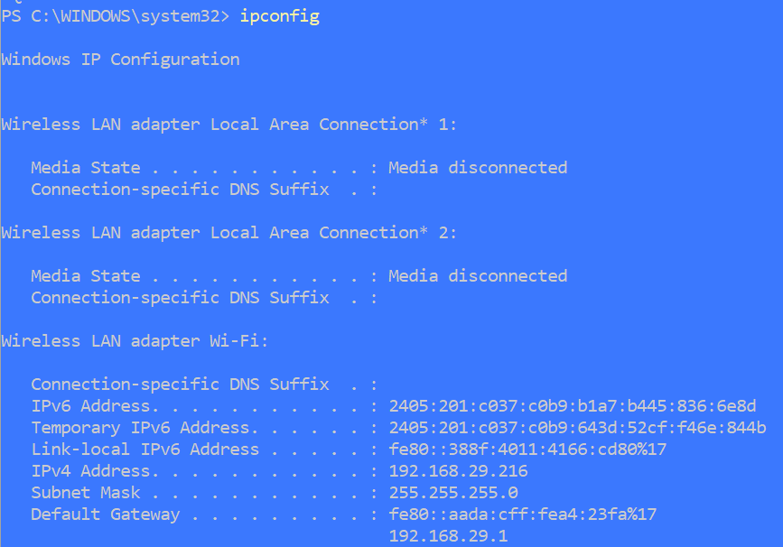

System information: run🡪msinfo32

Operating system, CPU, Memory Details:

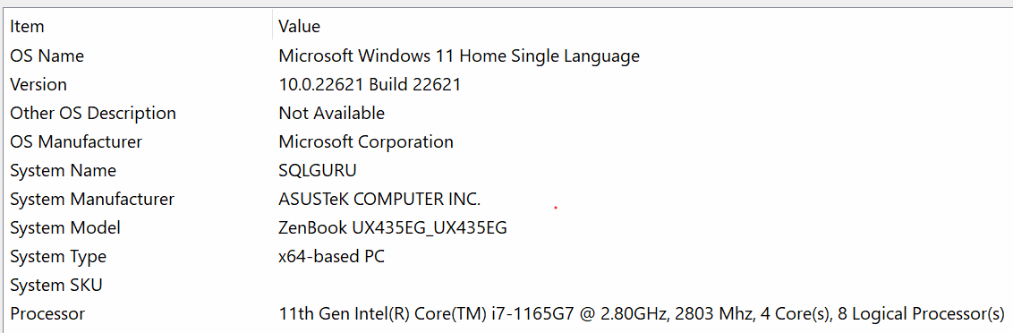

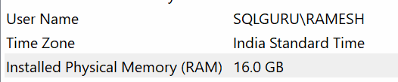

Hard Disk information:

Run🡪 diskmgmt.msc

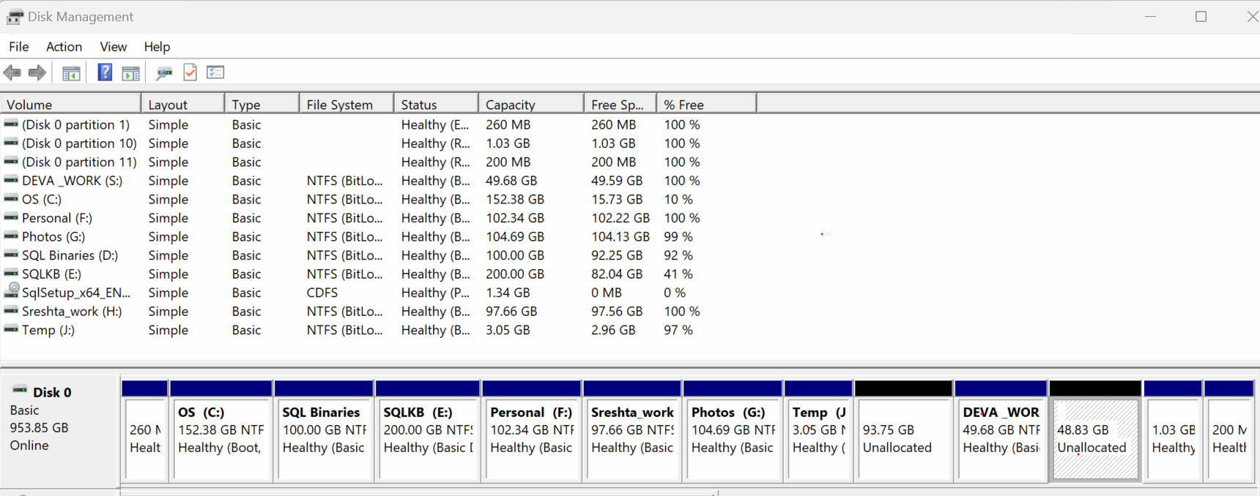

Computer Management:

Task Scheduler -> it is used to create and schedule a task to run automatically

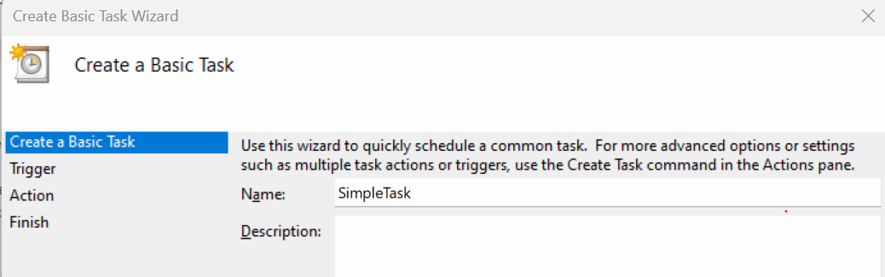

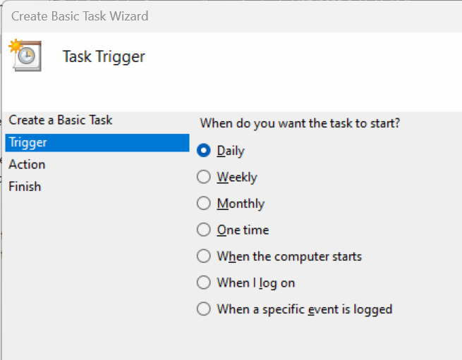

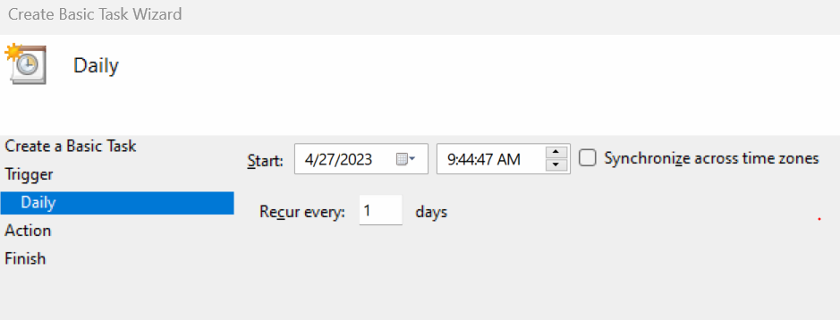

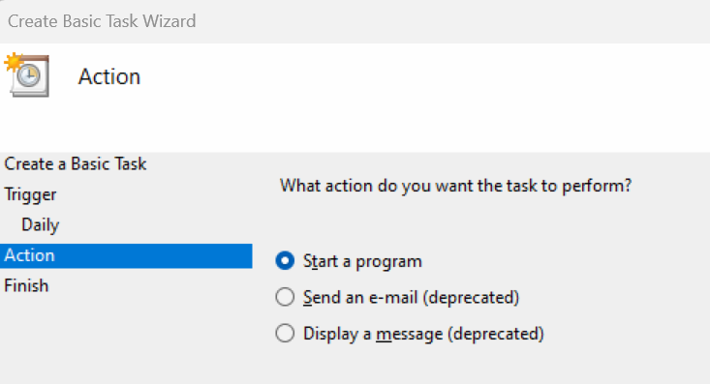

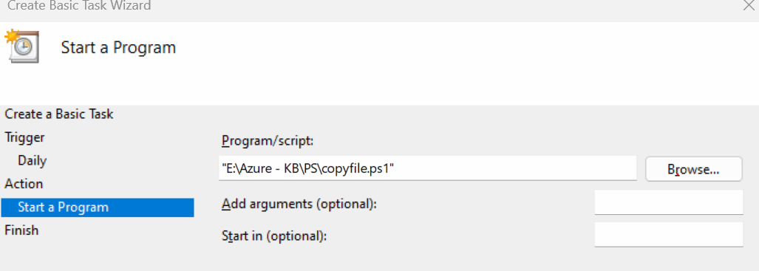

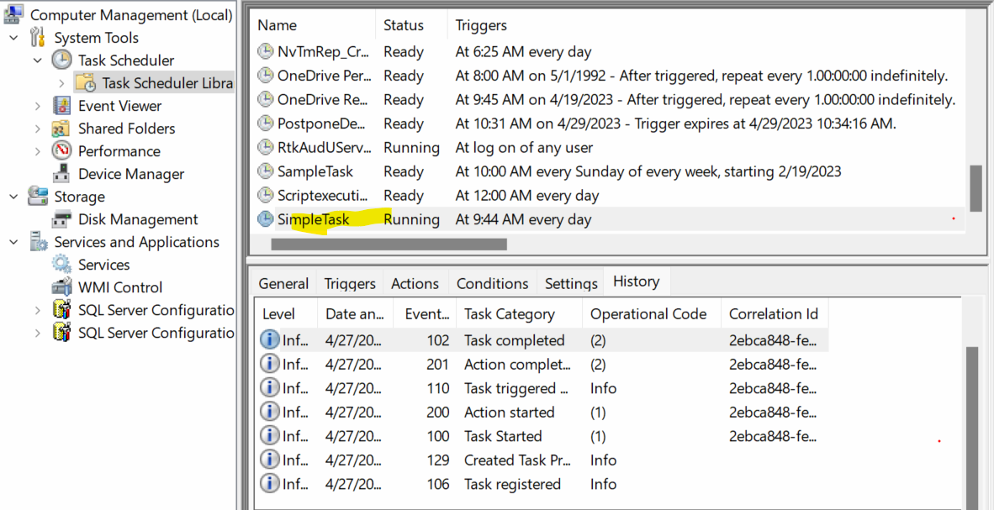

Event Viewer:

Tracks all the event occurring in the system which we can use for troubleshooting any issues. It tracks all the errors, warnings, informational messages, security error, system errors, setup logs ..etc

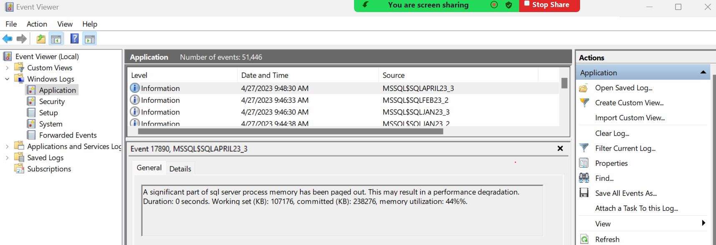

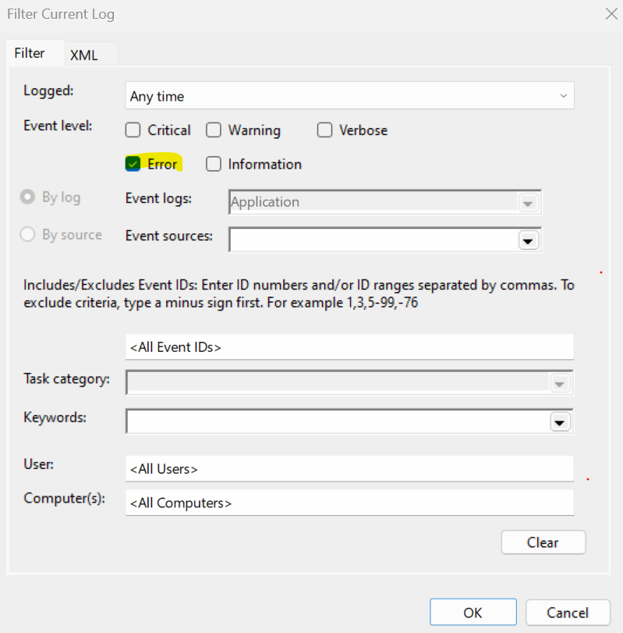

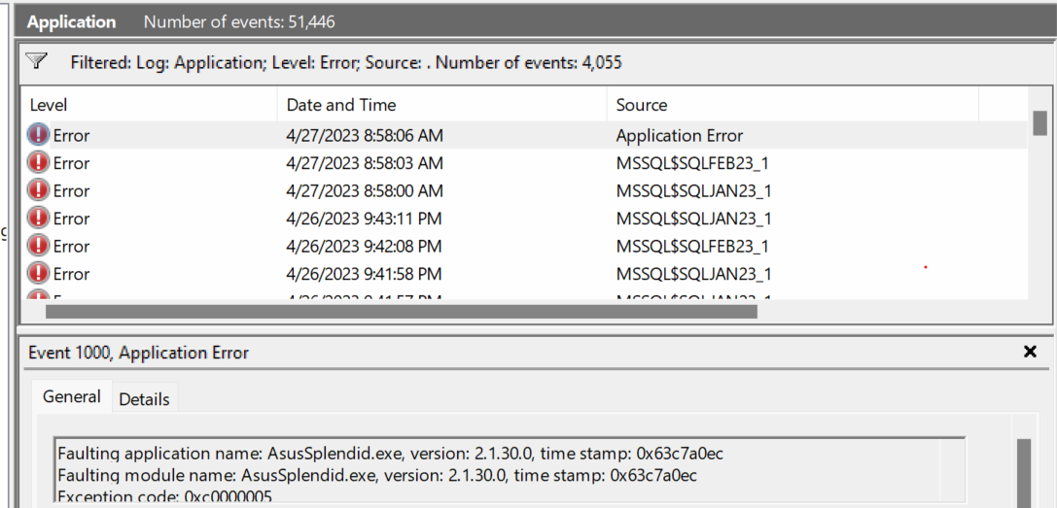

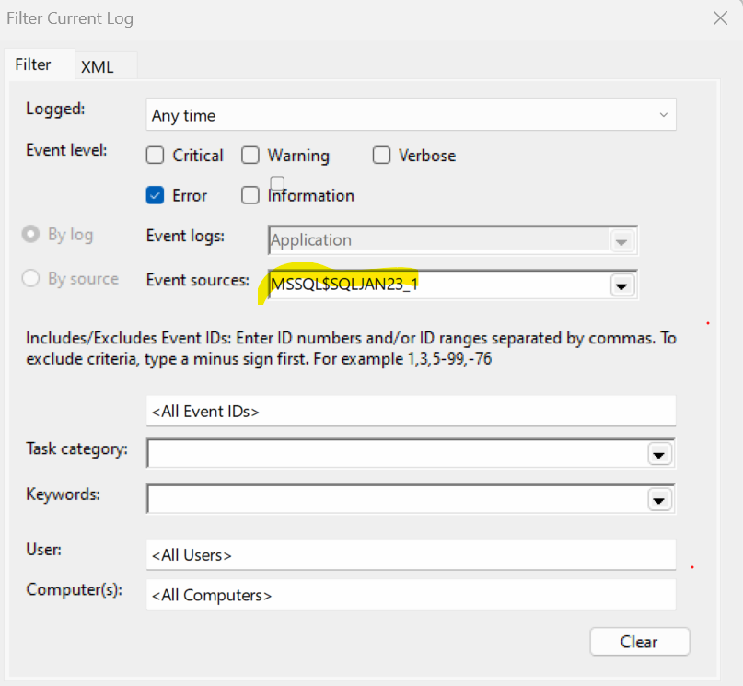

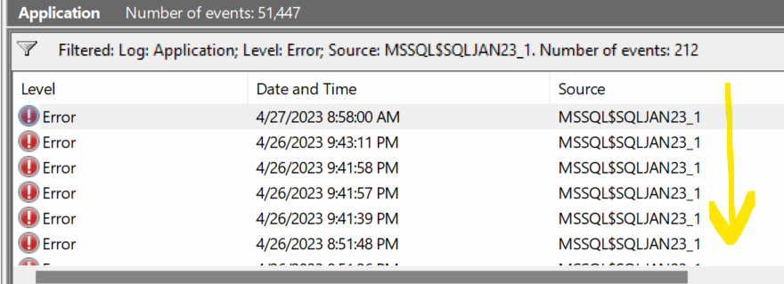

Performance Monitor (PerfMon):we can monitor performance metrics of system like CPU, Memory, Disk performance etc

Run🡪PerfMon

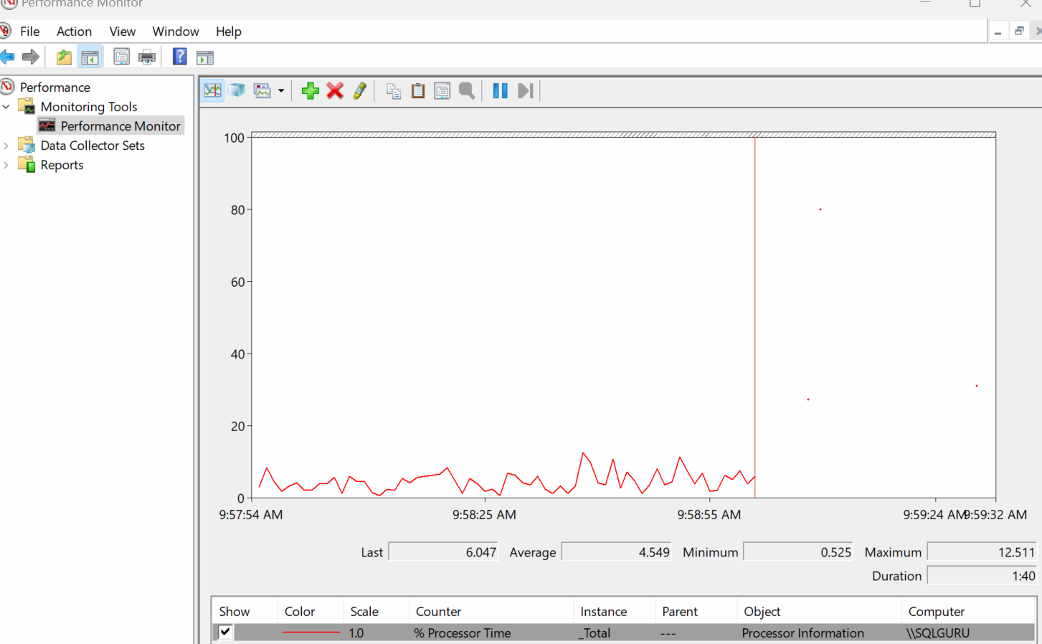

Services.msc

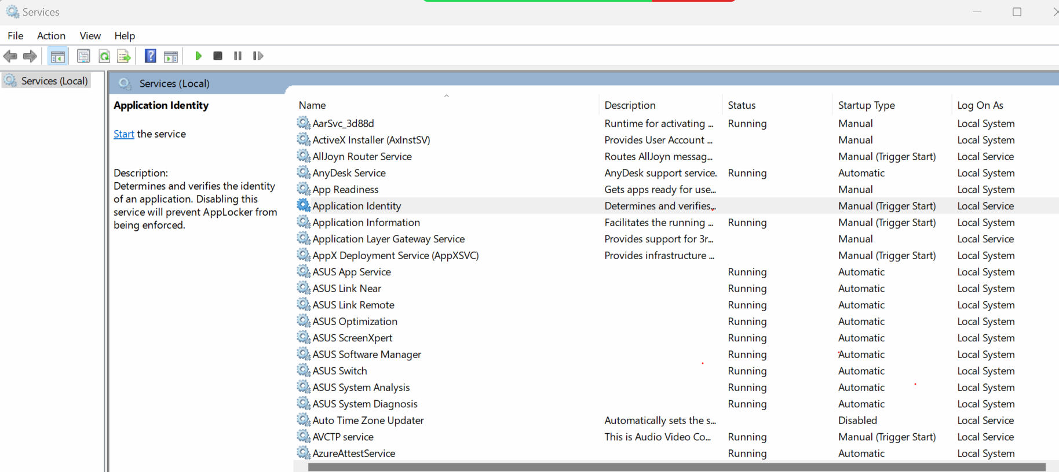

SQL Server 2019 Developer edition installation (detailed):

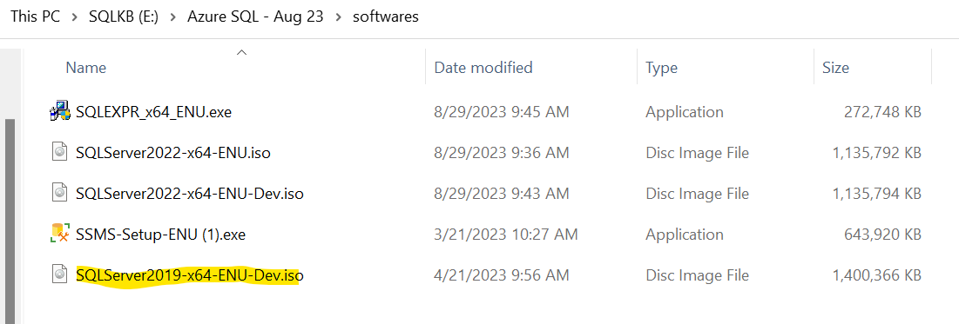

Right click on ‘SQLServer2019-x64-ENU-Dev.iso’ 🡪Mount

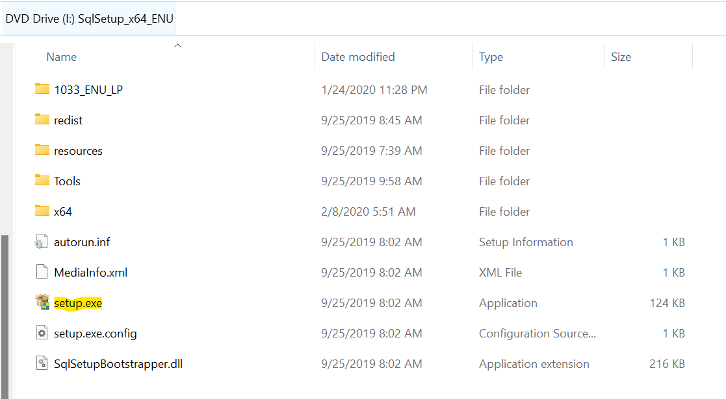

Right click on setup.exe🡪run as administrator

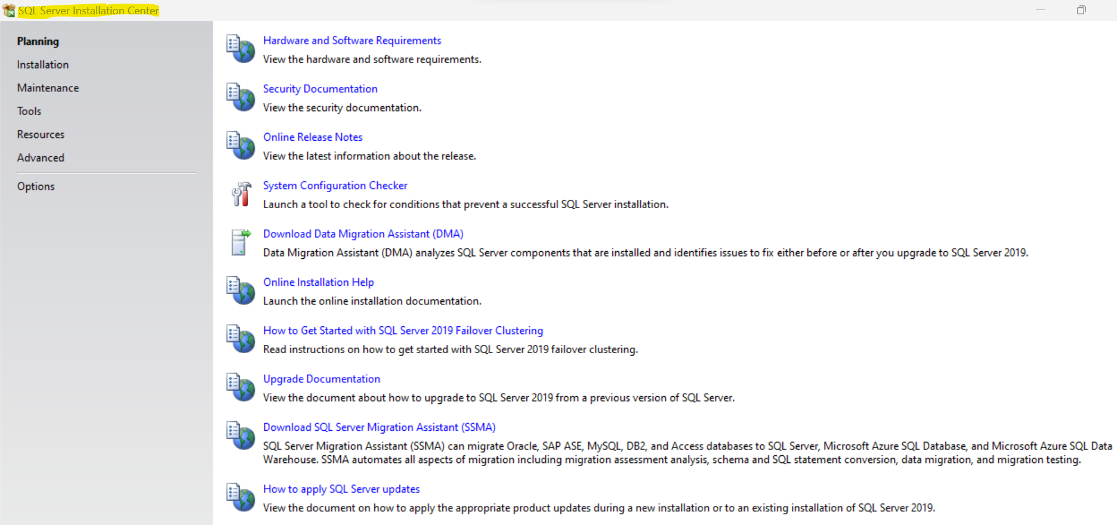

Planning:

Hardware and Software Requirements:

Hardware:

* RAM
  + Express edition – Minimum 512 MB, Recommended 1 GB
  + For all other editions – Minimum 1 GB, Recommended 4 GB
* Processor
  + Minimum 1.4 GHZ, Recommended 2 GHz



* Hard disk
  + SQL Server requires a minimum of 6-8 GB of available hard drive space.

| **Feature** | **Disk space requirement** |
| --- | --- |
| Database Engine and data files, Replication, Full-Text Search, and Data Quality Services | 1,480 MB |
| Database Engine (as above) with R Services (In-Database) | 2,744 MB |
| Database Engine (as above) with PolyBase Query Service for External Data | 4,194 MB |
| Analysis Services and data files | 698 MB |
| Reporting Services | 967 MB |
| Microsoft R Server (Standalone) | 280 MB |
| Reporting Services - SharePoint | 1,203 MB |
| Reporting Services Add-in for SharePoint Products | 325 MB |
| Data Quality Client | 121 MB |
| Client Tools Connectivity | 328 MB |
| Integration Services | 306 MB |
| Client Components (other than SQL Server Books Online components and Integration Services tools) | 445 MB |
| Master Data Services | 280 MB |
| SQL Server Books Online Components to view and manage help content1 | 27 MB |
| All features | 8,030 MB |
|  |  |

1 The disk space requirement for downloaded Books Online content is 200 MB.

Software:

Operating system:

* Windows 10 operating system or greater
* Windows Server 2016 or greater

.NET Framework

* Minimum operating systems include minimum .NET framework (3.4 or higher)

SQL Server Setup installs the following software components required by the product:

* SQL Server Native Client
* SQL Server Setup support files
* SQL server cannot be installed on Domain Controller machine

Configuration Checker:

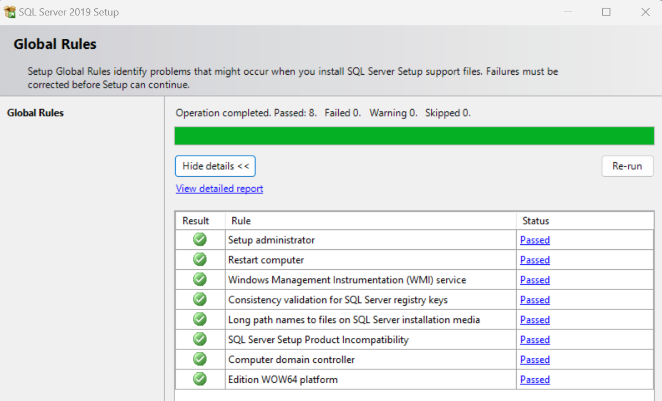

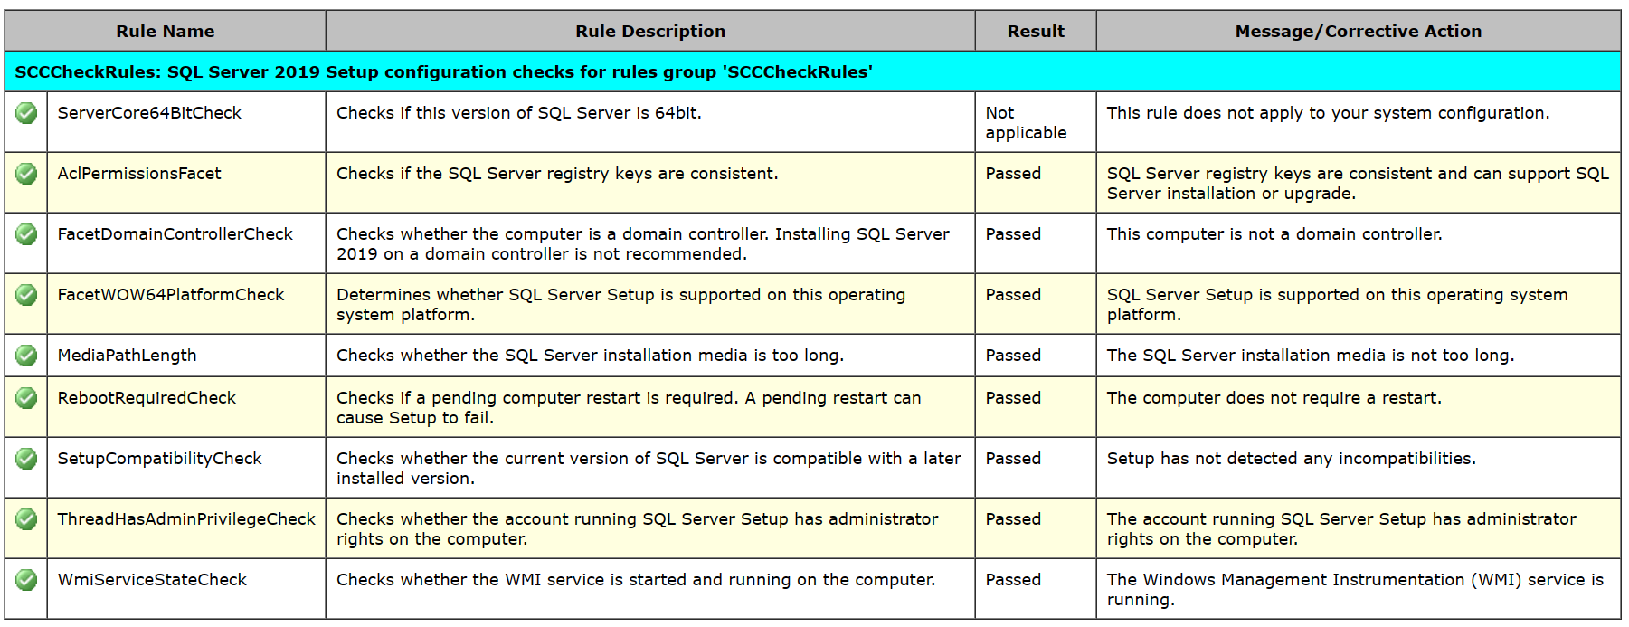

Installation:

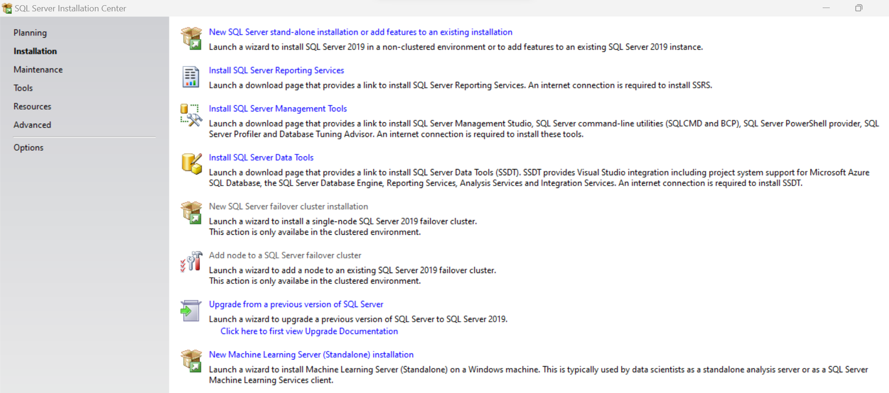

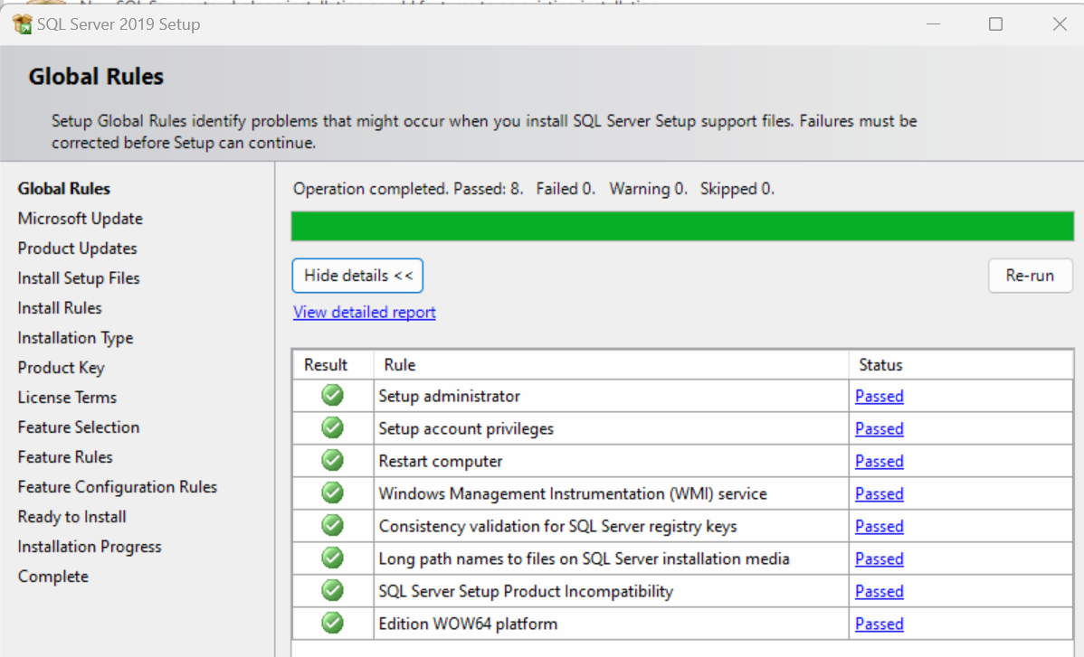

Ignore warning and skipped

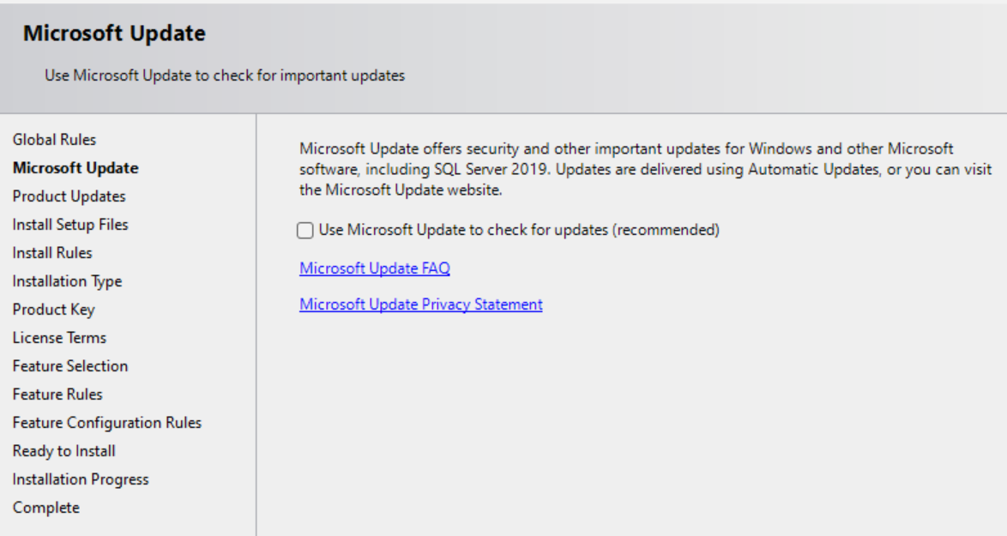

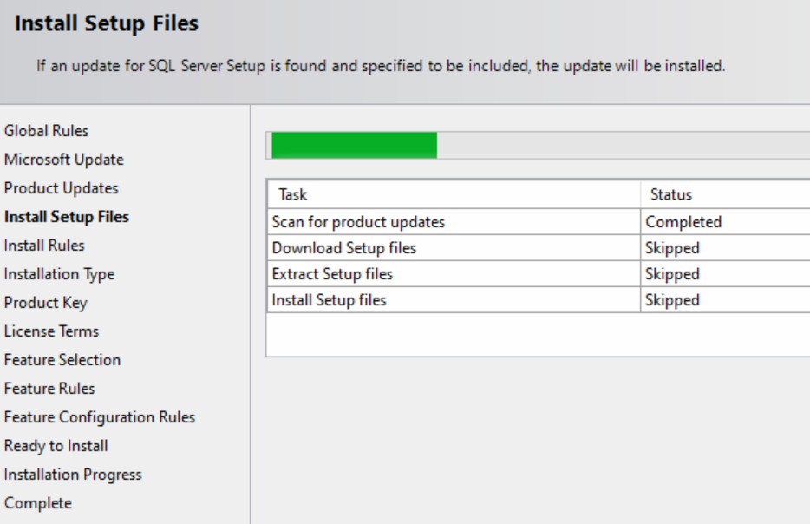

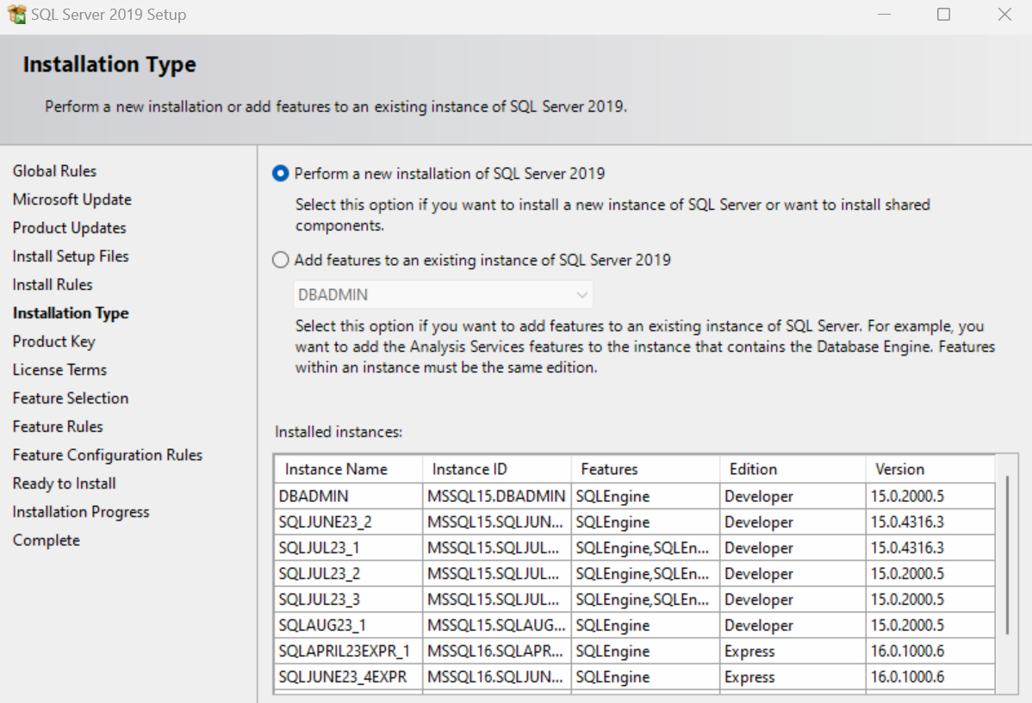

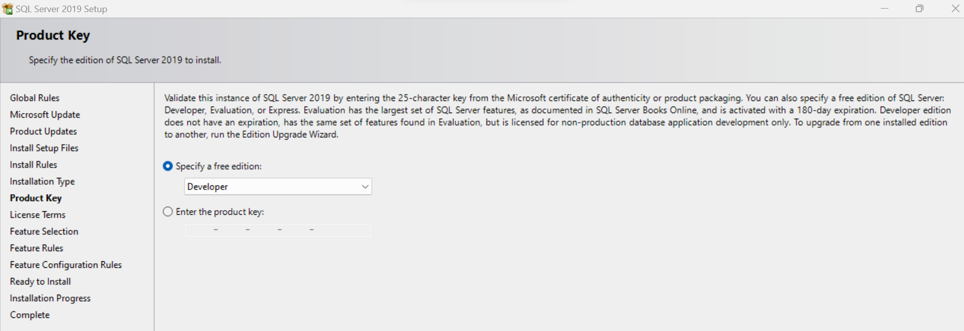

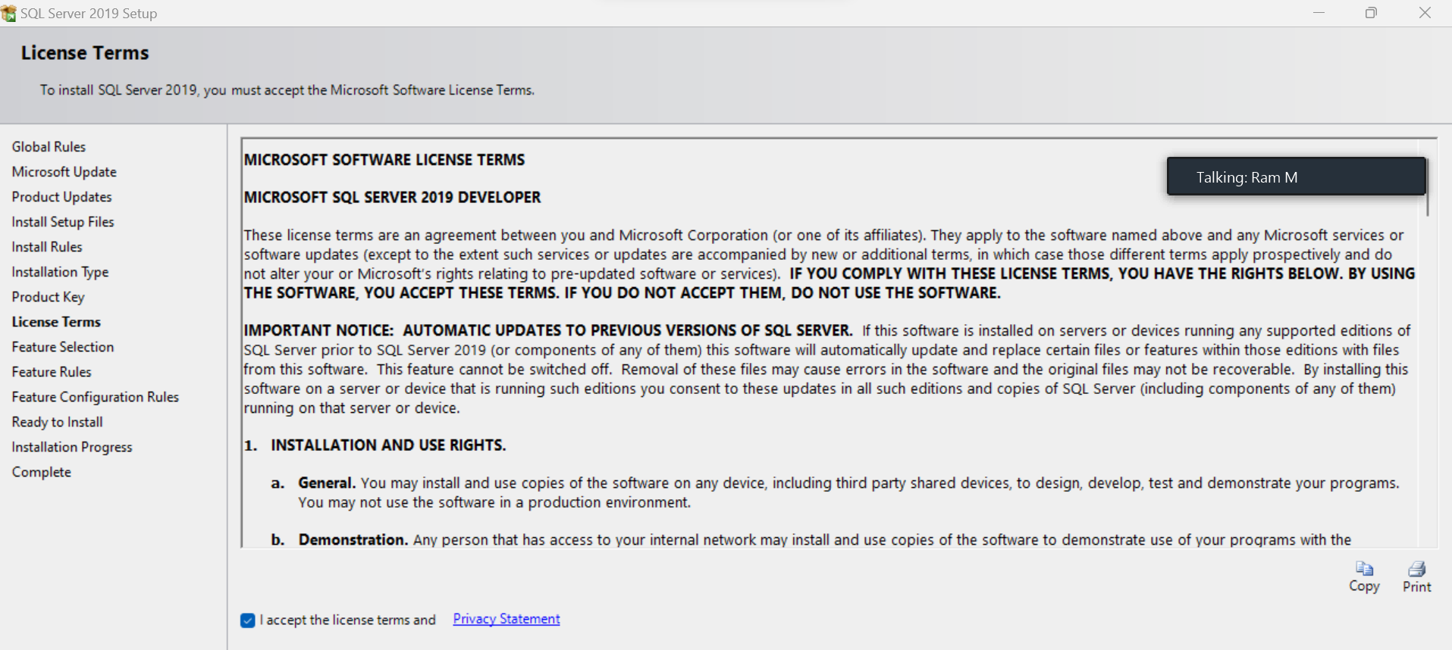

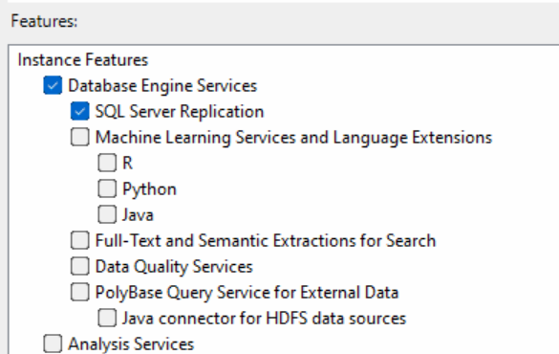

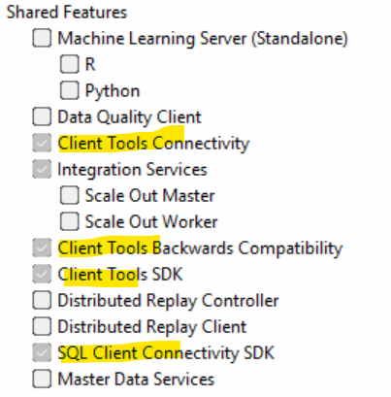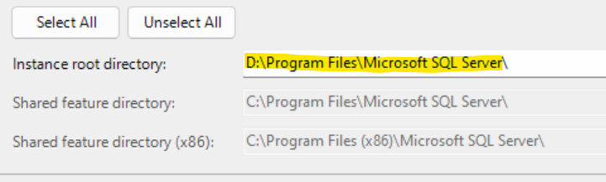

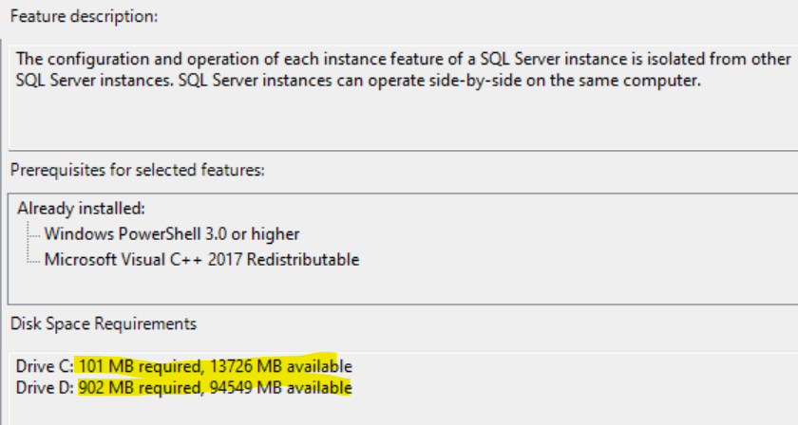

What is instance?

Instance is nothing but a SQL server, in one machine we can install multiple instances. For every SQL server, we need to assign a unique name.

Types of Instances

1. Default Instance – if we choose instance type as default, it will automatically takes windows machine name as SQL instance name. But, when we are installing default instance, it will appear the service as ‘MSSQLSERVER’ . In one machine we can install only one default instance
2. Named Instance – if we choose instance type as named, we can assign what ever the name required as per the business naming standards. In one machine, we can install 49 named instances.

Together, we can install 50 instances in one machine.

Do we need to install default instance mandatorily before installing Named instance?

No, we can directly name instance as well

Can we install Default instance after the named instance installed?

Yes, there is no dependency

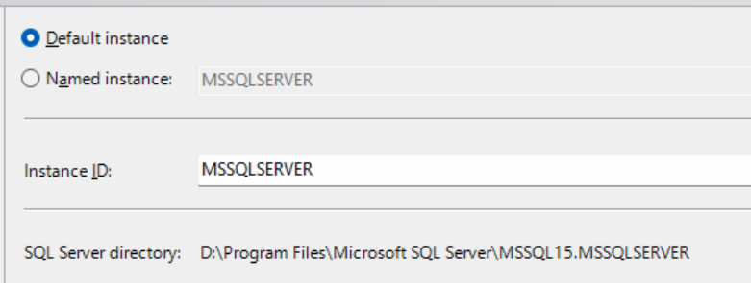

Or

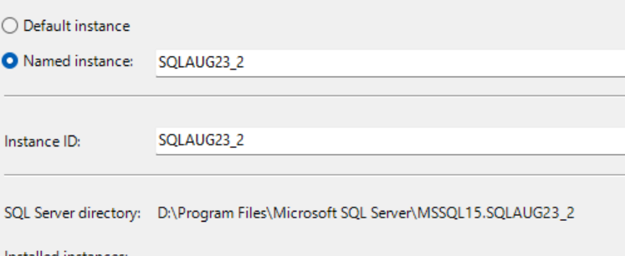

Service Account configuration:

Local user account – it is not a best practice to use local user account to run the SQL server services. The reason is password may get expires periodically for local user accounts, SQL server will not work once the password is expires

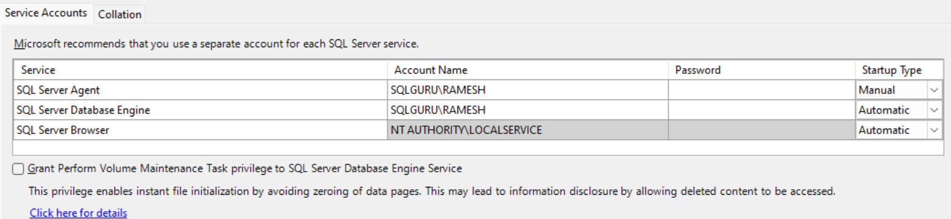

Local system Account: it does not requires a password, because it is inbuilt account and it will have full permissions

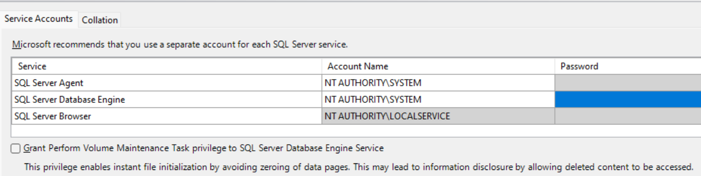

Local service Account:

it does not require a password, because it is inbuilt account and it will have full permissions

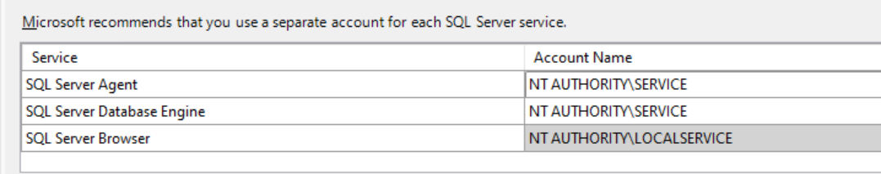

Domain service account:

Domain services are the best service accounts to use for our SQL server services. Before installing the SQL server, we need to raise request with Windows/AD team to create corresponding service accounts

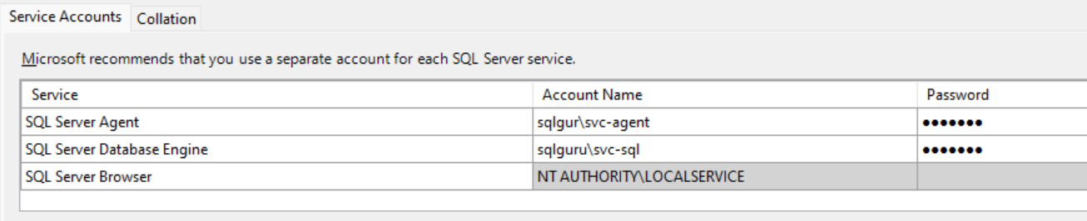

* Password should never expire
* User cannot change the password

Startup Type:

* Automatic – when ever we reboot the server (windows server), it will automatically bring SQL server online.

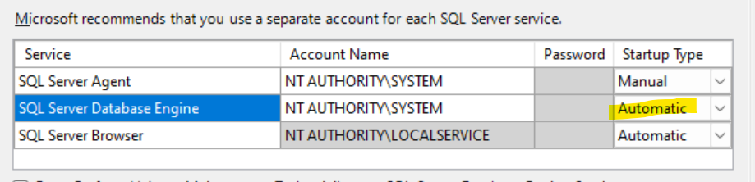

The agent service is dependent on the SQL server, if we set Agent startup type as ‘Automatic’. When ever we restart the SQL server service, the agent also comes online automatically.

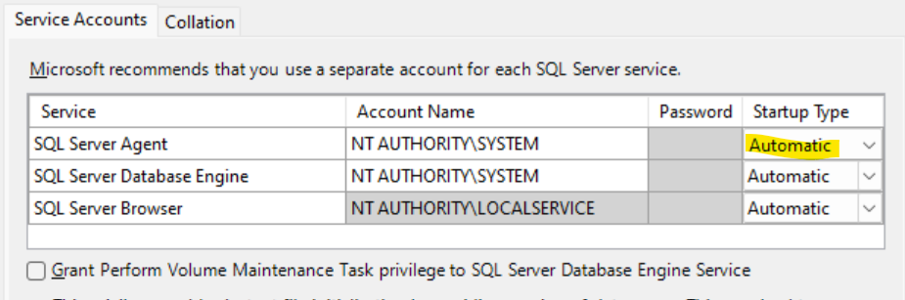

* Manual - whenever we reboot the server (windows server), it will not automatically bring SQL server online. We need to bring the SQL server service online manually.  
  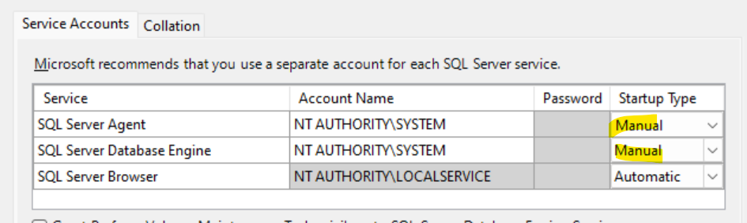
* The agent service is dependent on the SQL server, if we set Agent startup type as ‘Manual. Whenever we restart the SQL server service, the agent does not comes online automatically. We need to start it manually.



* Disabled – This will disable the SQL server services and service will not run

Authentication Modes:

1. Windows Authentication – we can grant SQL server access only to the windows users
2. Mixed authentication
   1. Windows
   2. SQL server alternation – We can create SQL server accounts for non-windows users

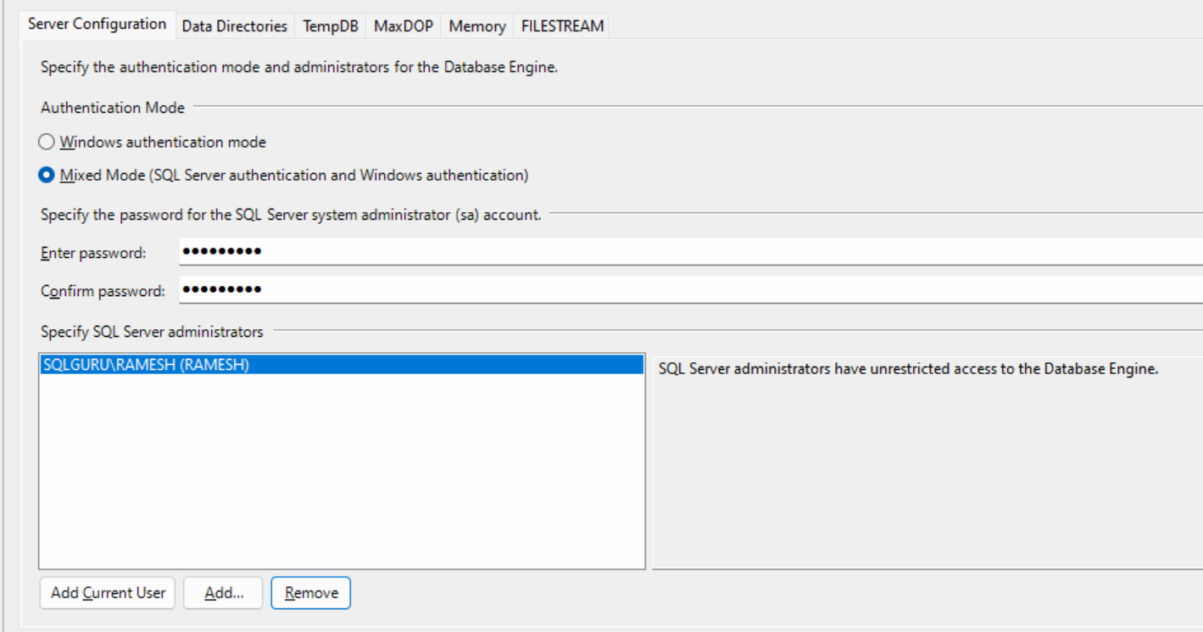

Data Directories:

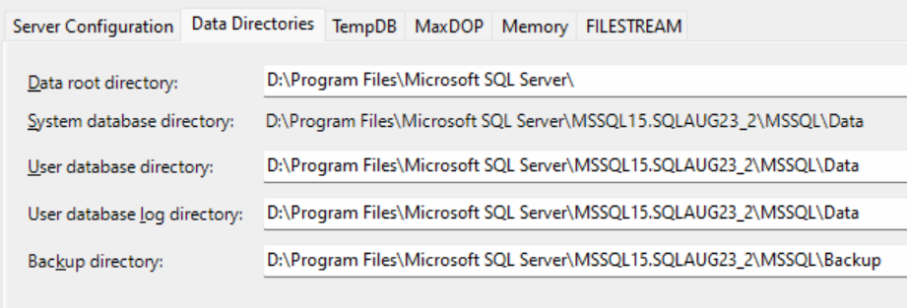

Tempdb Configuration:

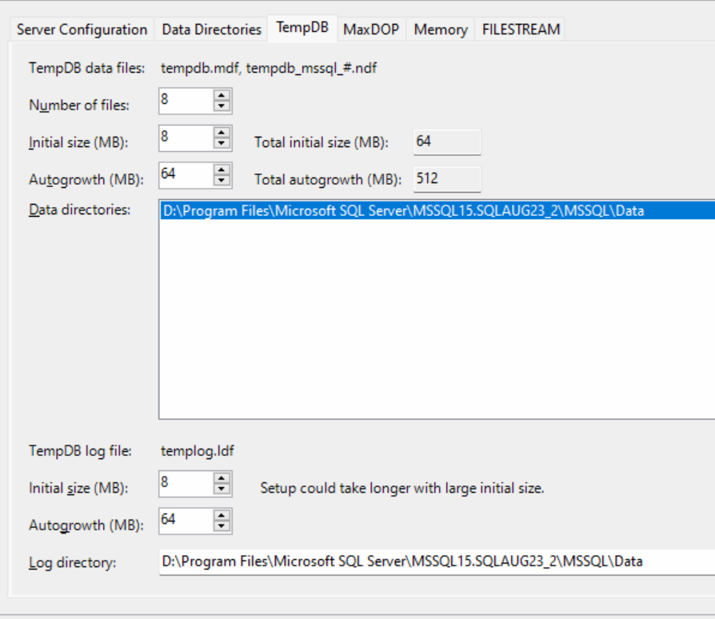

MAXDOP – Maximum degree of Parnellism

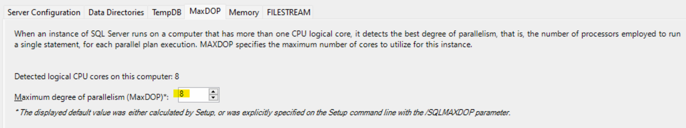

Memory Setting: (80:20)

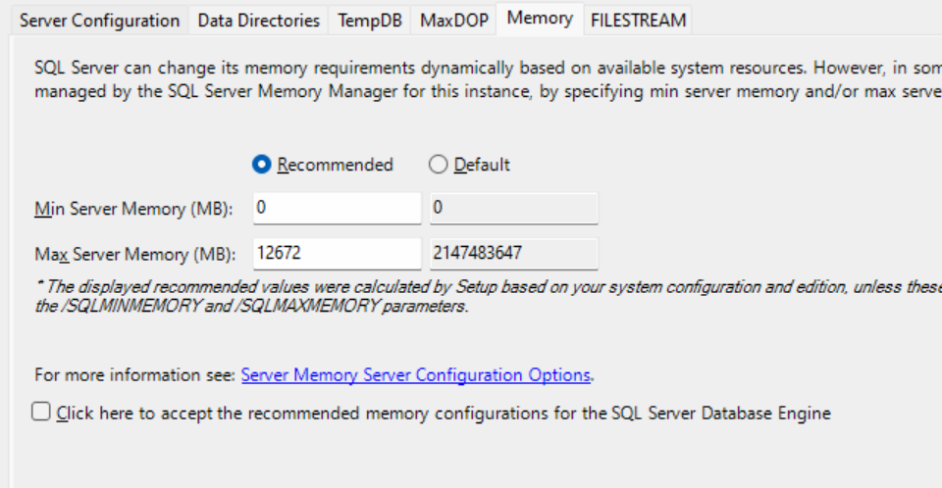

Summary:

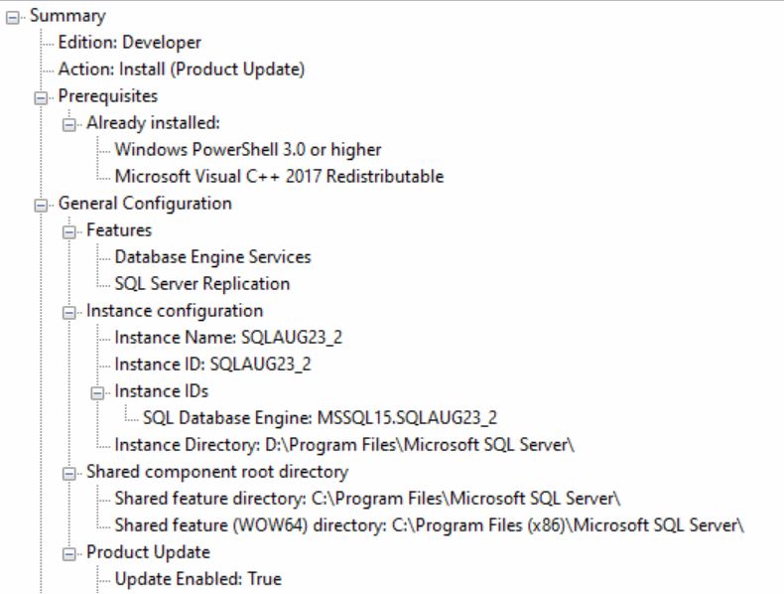

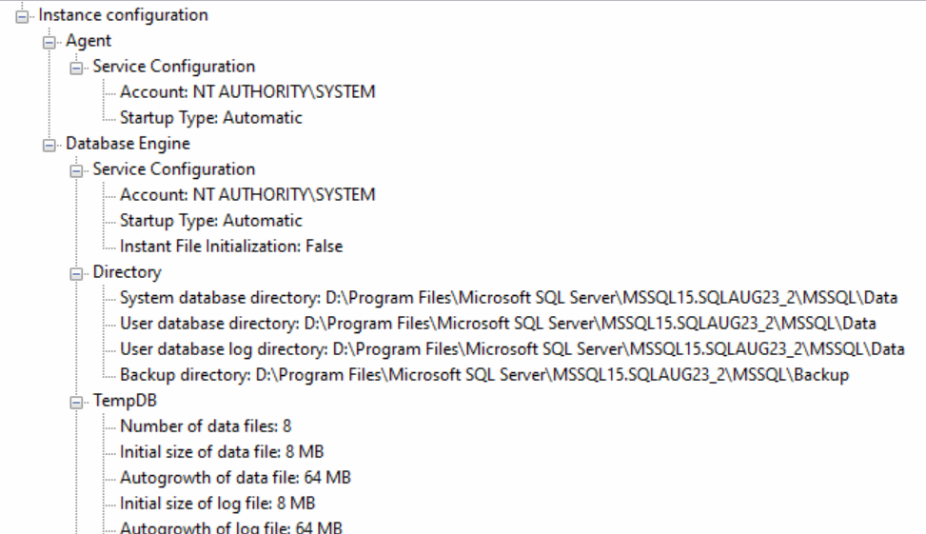

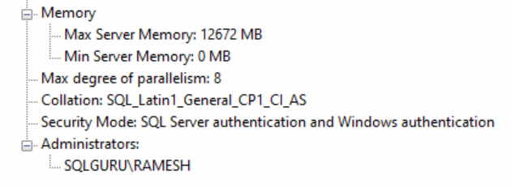

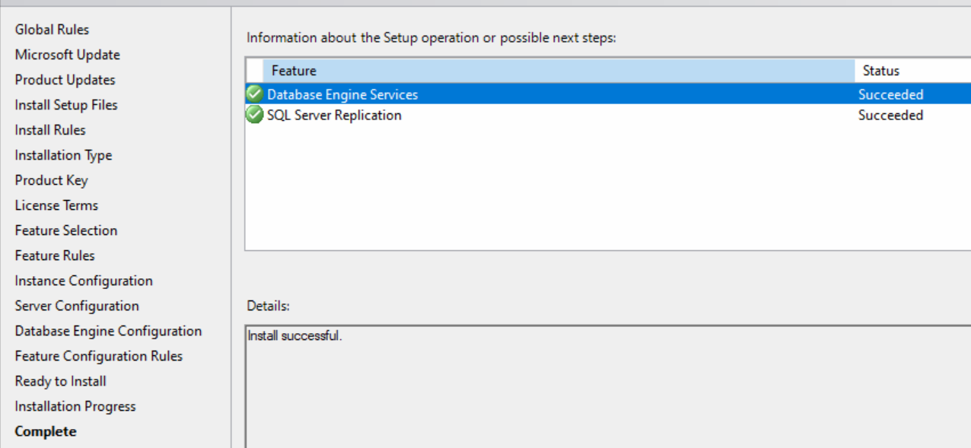

How to troubleshoot installation related failures?

We can refer summary log file to troubleshoot the installation related failures

What is location of summary log file ?

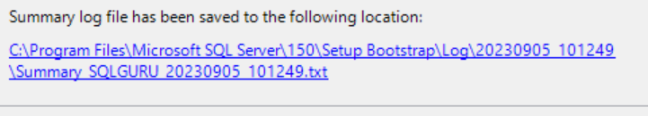

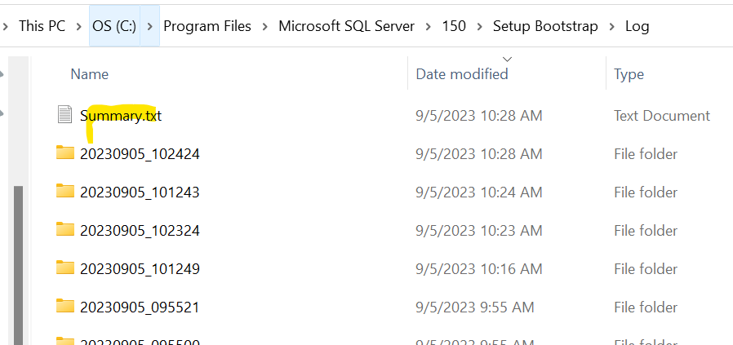

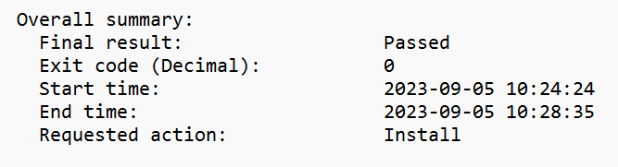

SQL Server Connectivity:

SSMS (SQL Server Management studio) – is the tool which we can use to connect SQL server and also to perform any activity like create database, create tables, inserting data, updating data, deleting data, take backup , restore backup, creating users, providing permissions etc.

Download SSMS-

<https://learn.microsoft.com/en-us/sql/ssms/download-sql-server-management-studio-ssms?view=sql-server-ver16>

run🡪ssms

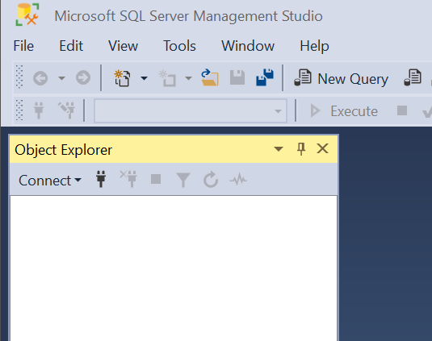

Default instance:

Option #1 – Server name🡪machine Name

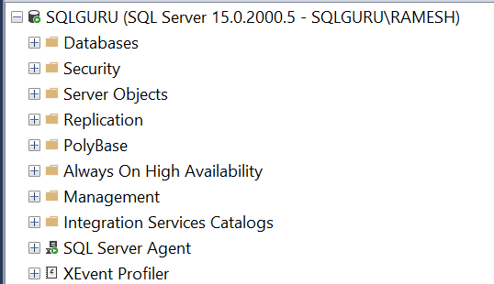

Option #2 – Server name🡪. (dot)

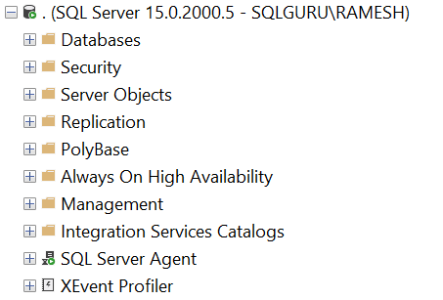

Option #3 – Server name🡪(local)

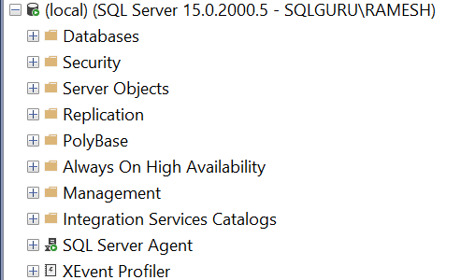

Option #4 – connecting Default instance in SQL server authentication using SA

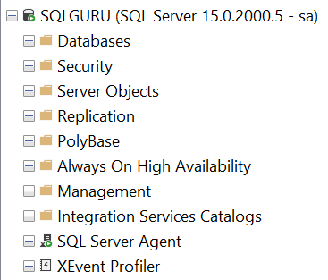

Named instance:

Option #1 – Server name🡪machine Name\instance name

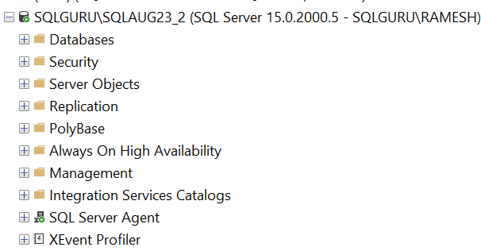

Option #2 – Server name🡪. (dot)\ instance name

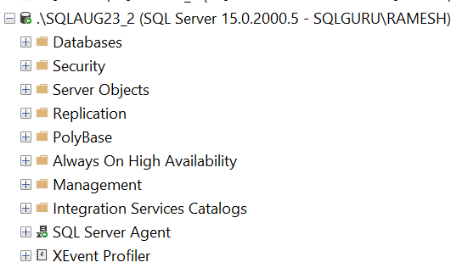

Option #3 – Server name🡪(local)\ instance name

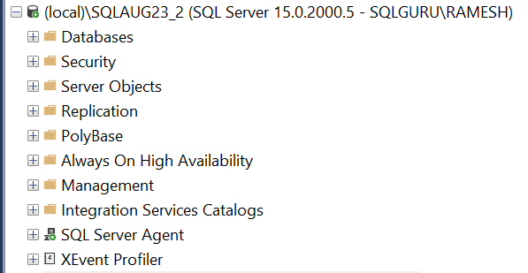

Option #4 – connecting named instance in SQL server authentication

using SA

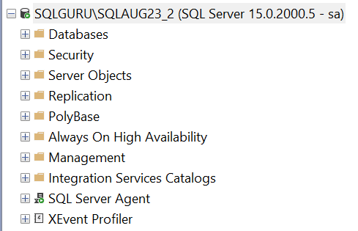

SQL Server Configuration Manager (SSCM):

Configuration Manager is the SQL server native tool where we can find all the SQL server related service along with service name, status, description, startup type etc. We can perform the following tasks using configuration manager

* We can use configuration Manager to start, stop, restart SQL server service
* We can change the service accounts and startup types using configuration manager
* We can verify and also change the SQL server port from the configuration manager
* We can also force to use encryption
* We can enable/disable the protocols

How to open the configuration Manager:

Run🡪sqlservermanager16.msc 🡪this will open SQL server 2022 configuration manager

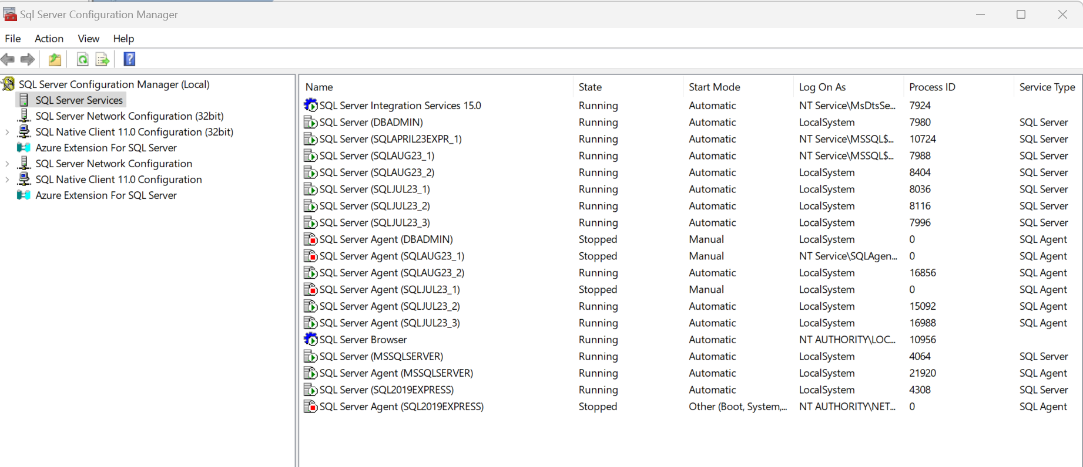

Run🡪sqlservermanager15.msc🡪this will open SQL server 2019 configuration manager

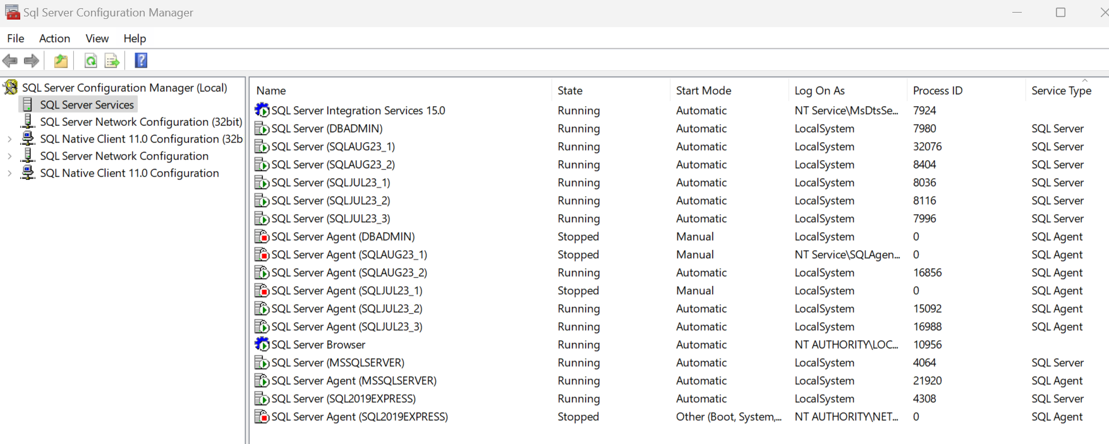

Run🡪sqlservermanager14.msc🡪 this will open SQL server 2017 configuration manager

Run🡪sqlservermanager13.msc🡪 this will open SQL server 2016 configuration manager

Run🡪sqlservermanager12.msc🡪 this will open SQL server 2014 configuration manager

Run🡪sqlservermanager11.msc🡪 this will open SQL server 2012 configuration manager

Run🡪sqlservermanager10.msc🡪 this will open SQL server 2008/R2 configuration manager

Start, STOP, Restart SQL server:

Option #1 – configuration Manager

Run🡪sqlservermanager16.msc🡪SQL server services🡪right click on SQL service🡪start/stop/restart

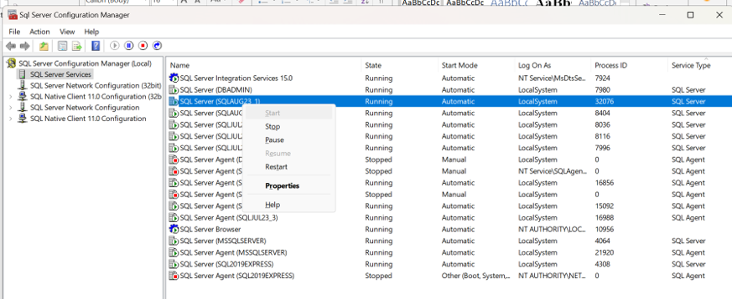

Option #2 – Services

Run🡪services.msc🡪right click SQL server service🡪start/stop/restart

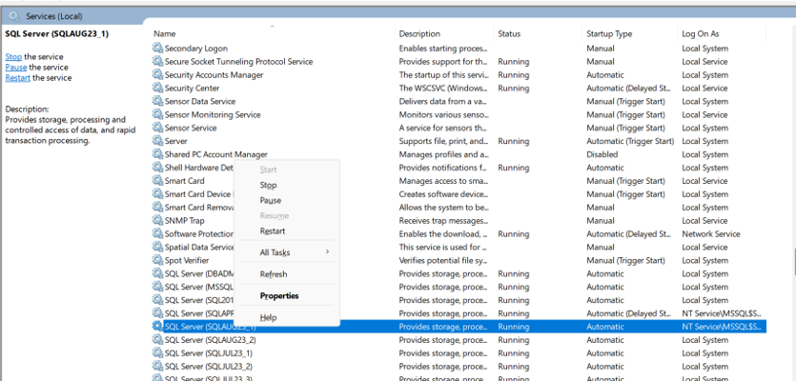

Option #3 – Command Prompt

Cmd🡪run as administrator

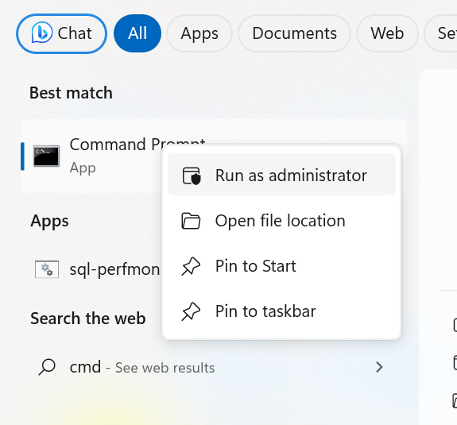

Default instance:

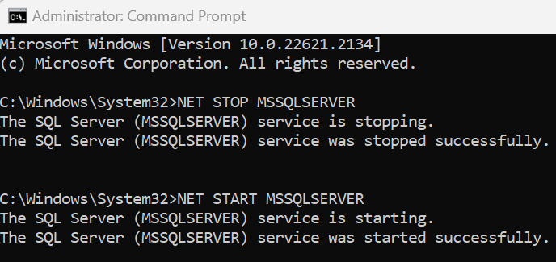

Default Agent:

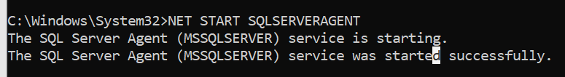

Named Instance:

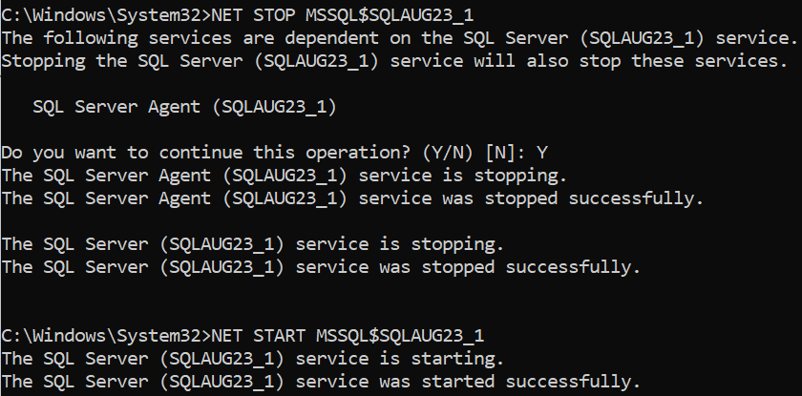

Agent:

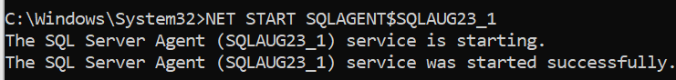

Option #4 – PowerShell

PowerShell🡪run as Administrator

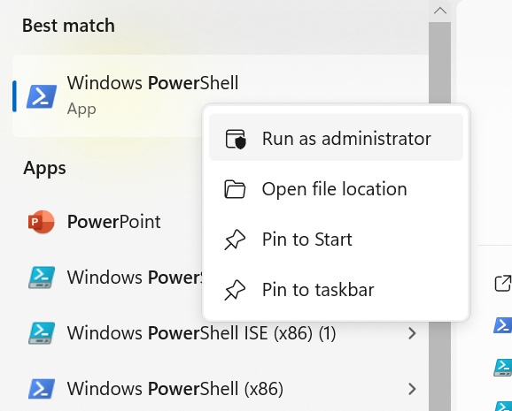

Default instance and agent:

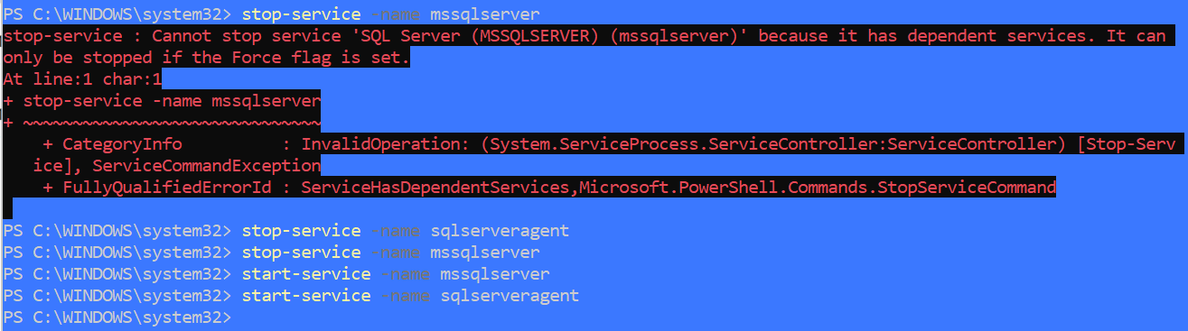

Named instance and agent:

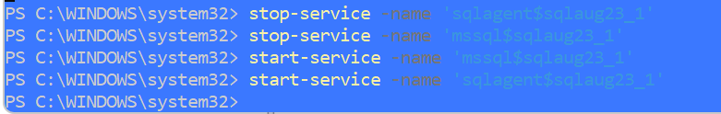

Option #5 – SSMS

SSMS🡪right click on the instance name🡪start/stop/restart

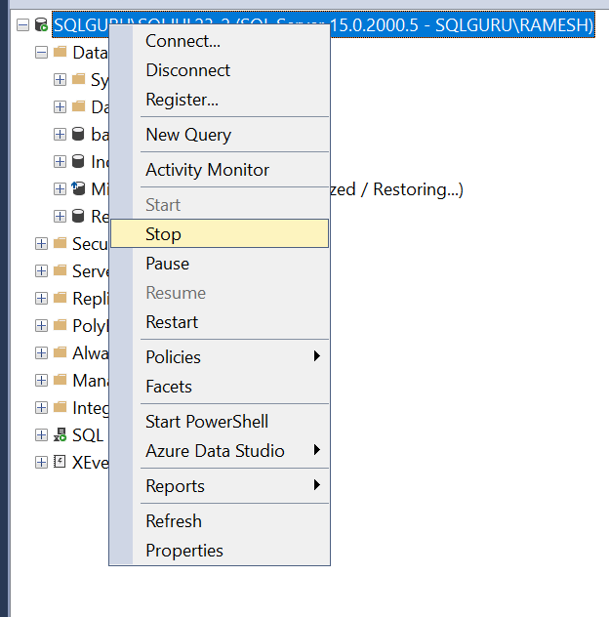

How to change the authentication modes:

Option #1 – SSMS🡪right click on the Instance Name🡪properties🡪Security🡪Server Authentication🡪change the authentication🡪Restart SQL server service

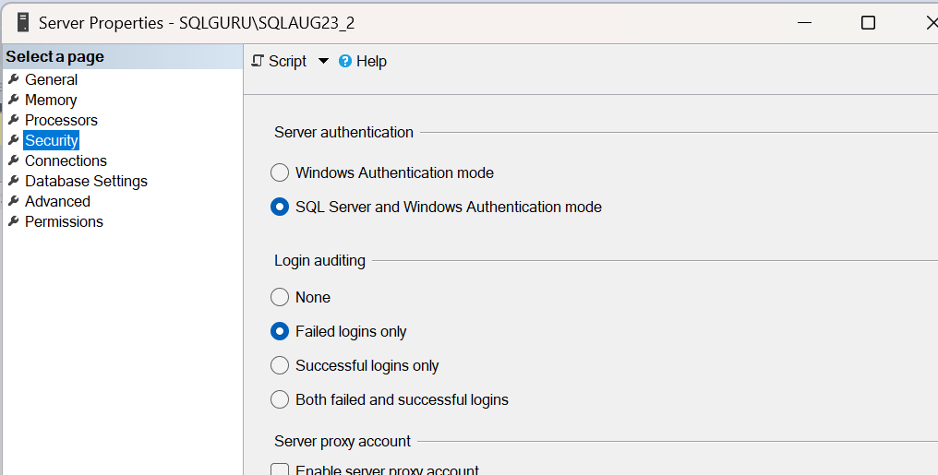

Now it is in mixed authentication, so it will allow to connect both with windows accounts and SQL server accounts

Let’s change it windows authentication

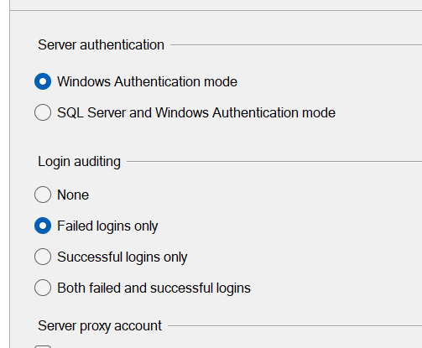

After Restart, SQL server authentication will not work

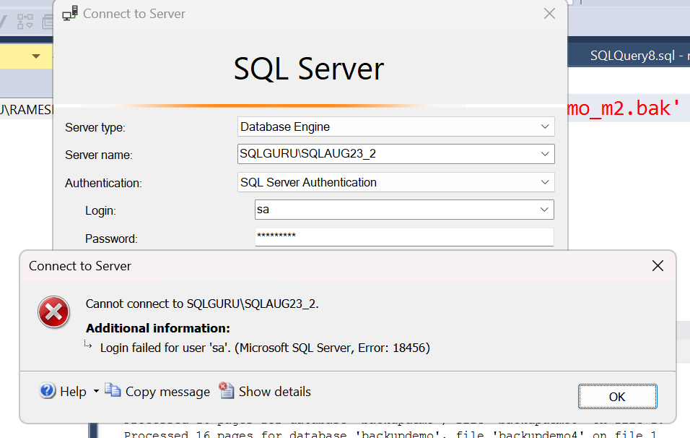

Now change it back to mixed authentication and restart the SQL server service

Option #2: Run🡪regedit

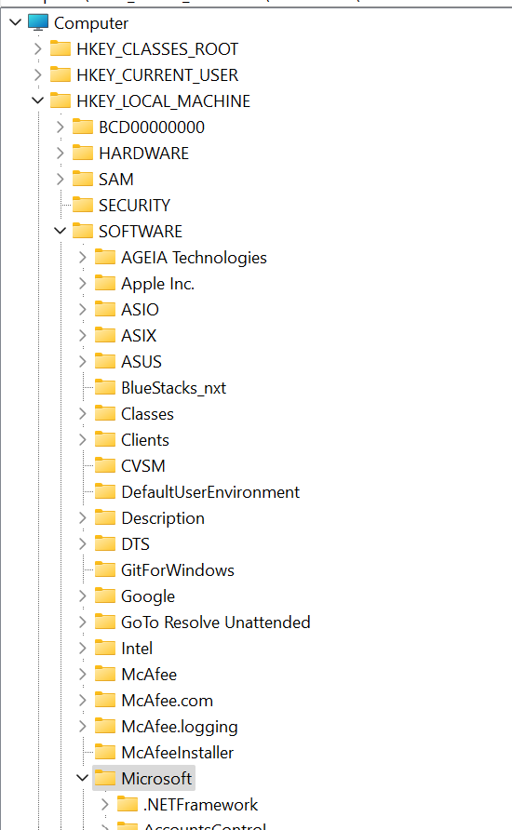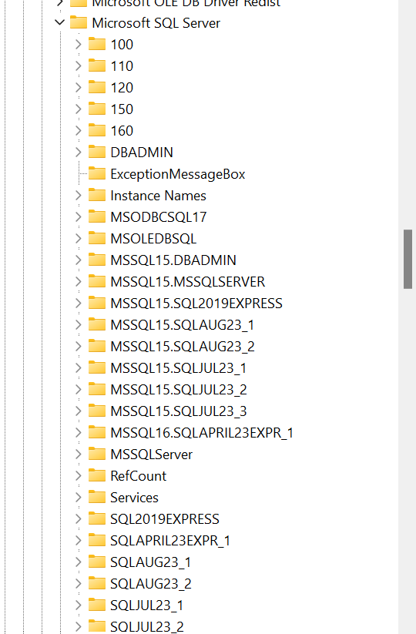

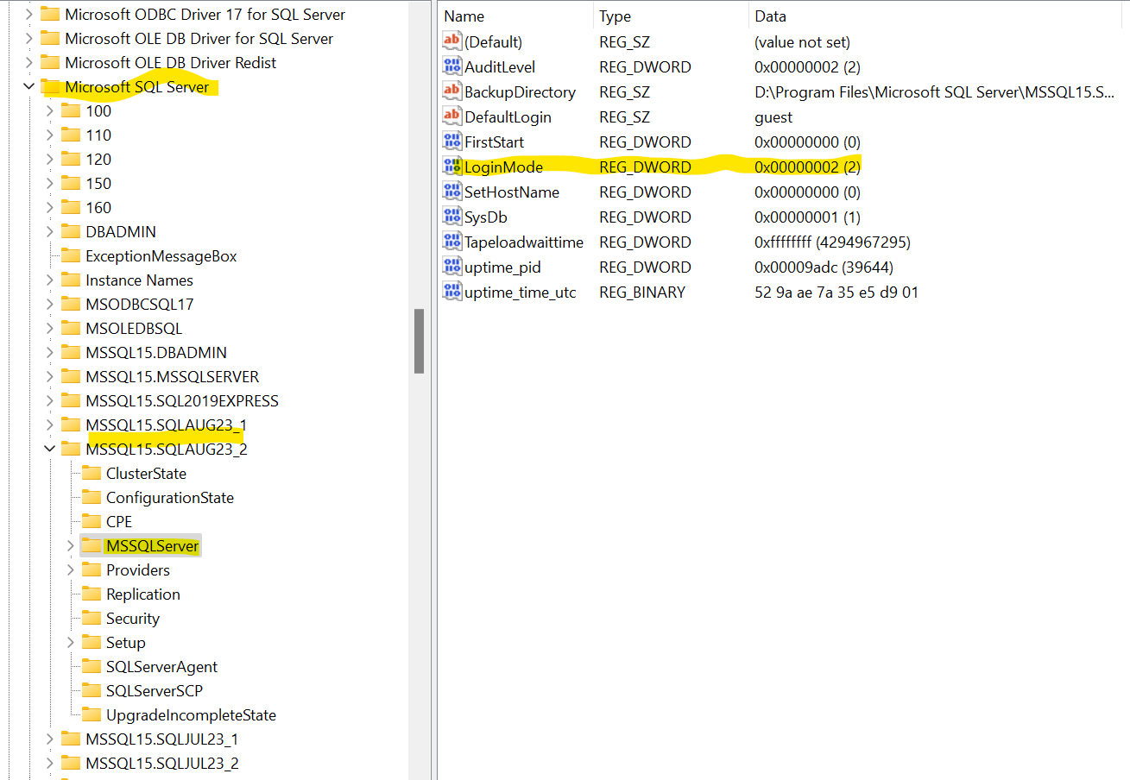

If the

login mode is 1 – windows authentication

login mode is 2 – Mixed authentication

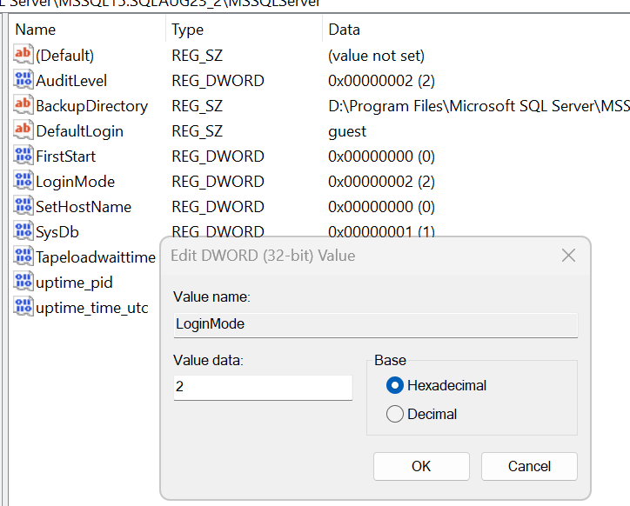

Change the login mode to 1🡪restart the SQL server

Resetting SA password:

When we install the SQL server in mixed authentication mode, by default one SQL account will be created with name ‘sa’ and we set the password for SA at the time of installation. Let if we forgot that password, we can change the password

SSMS🡪expand the instance 🡪Security🡪logins🡪SA🡪properties🡪change password

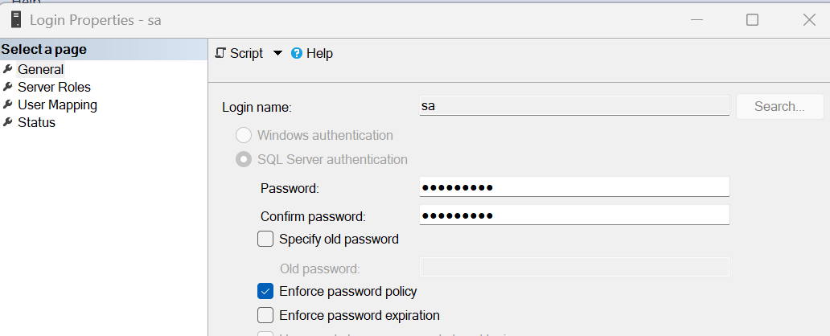

How to find SQL server name and Version details:

use master

go

select @@SERVERNAME as sql_instance

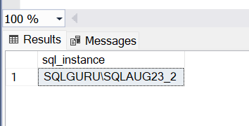

select @@VERSION as sql_version



Installation of CU22 for SQL server 2019:

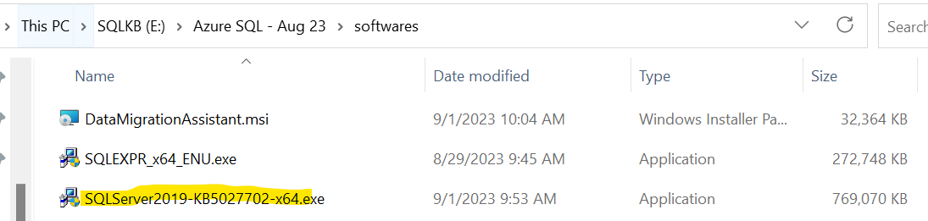

Right click🡪Run as administrator

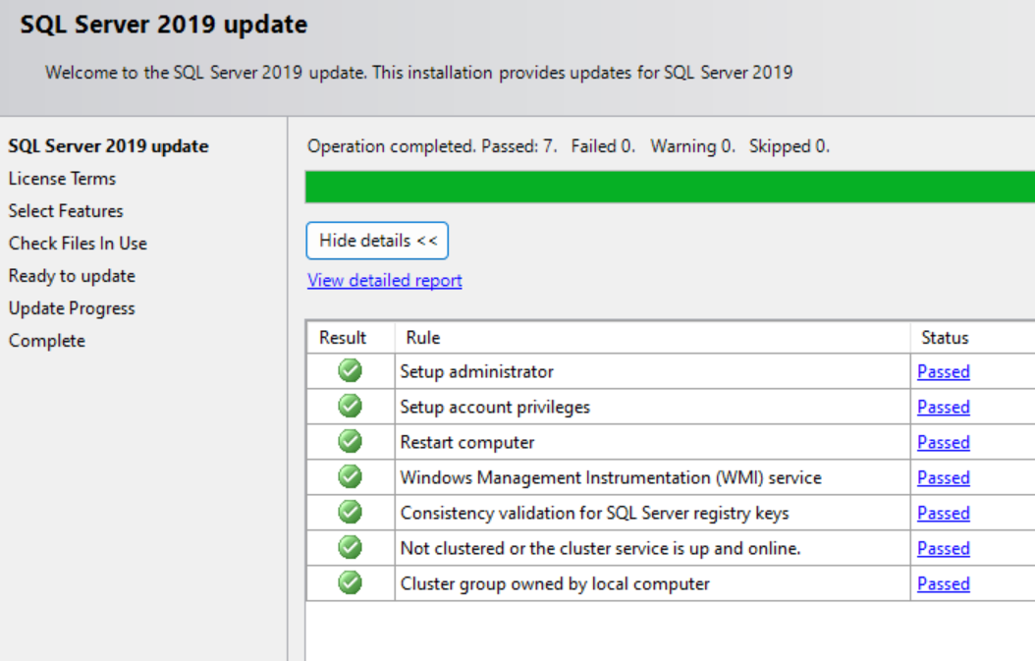

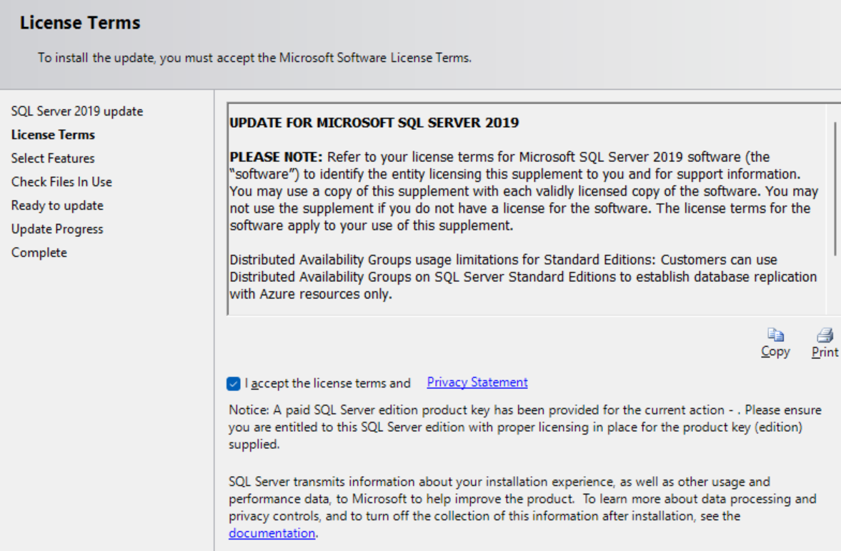

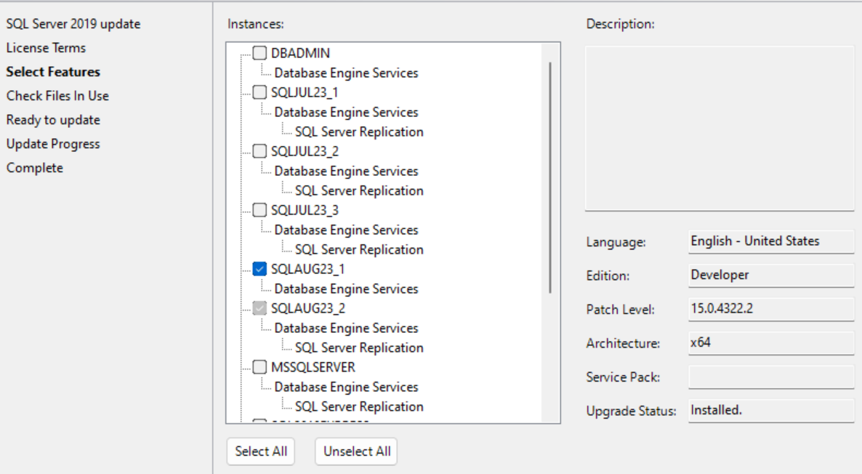

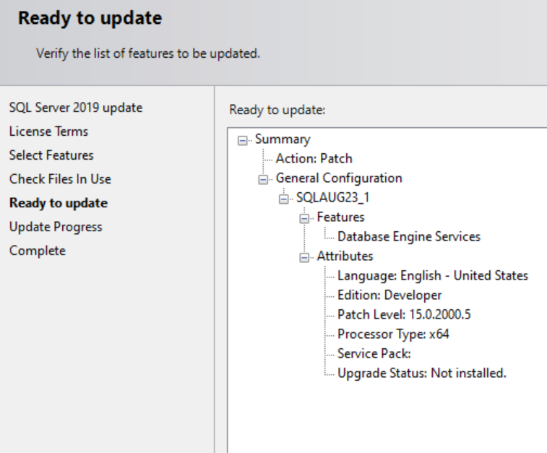

After CU22 installed for SQL server 2019:

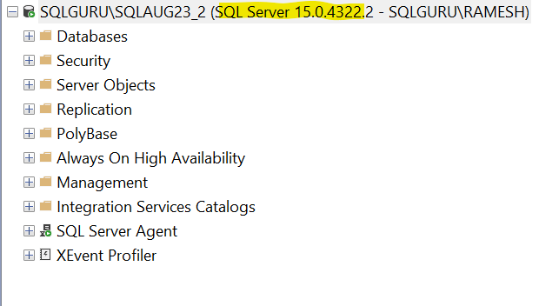

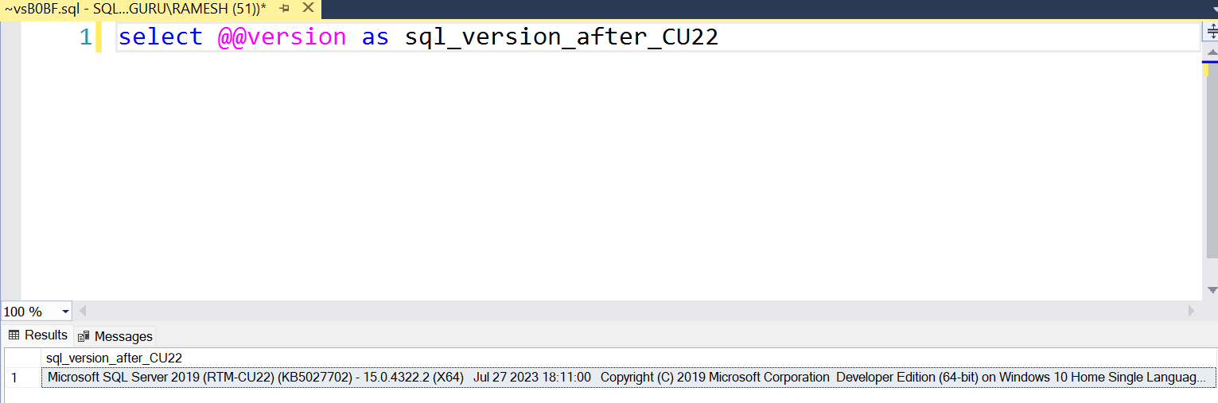

How to uninstall the SQL server:

Control panel🡪programs🡪Programs and Features🡪uninstall program

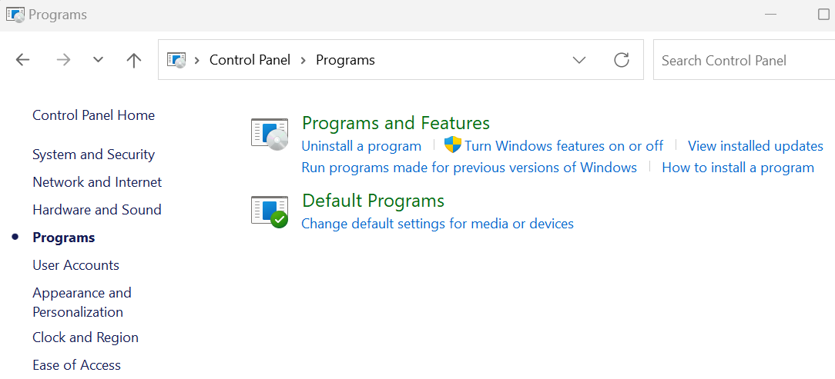

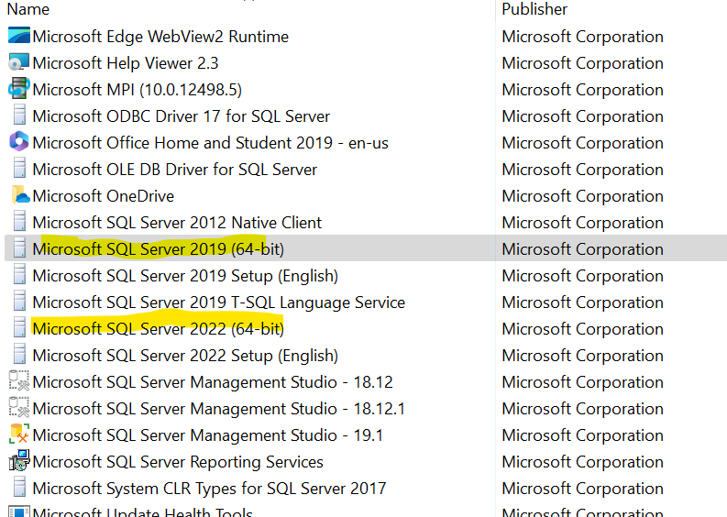

Right click🡪uninstall

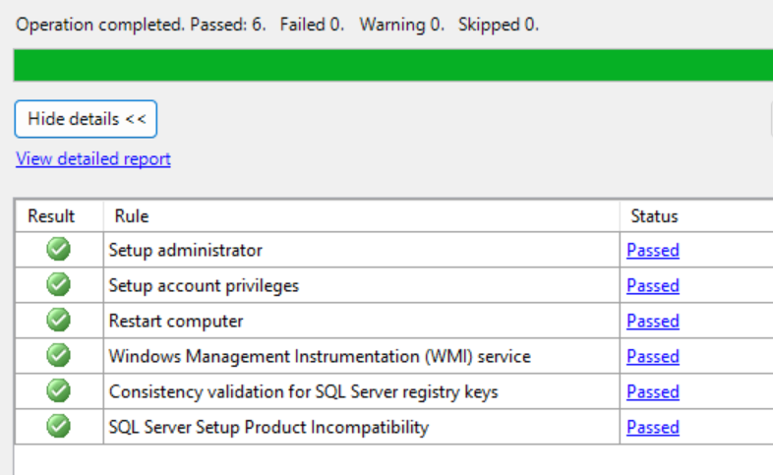

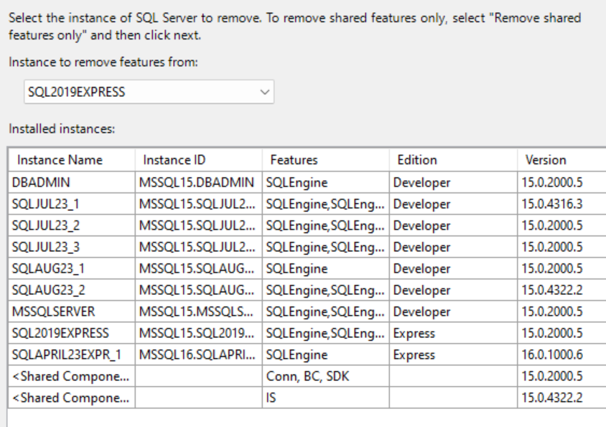

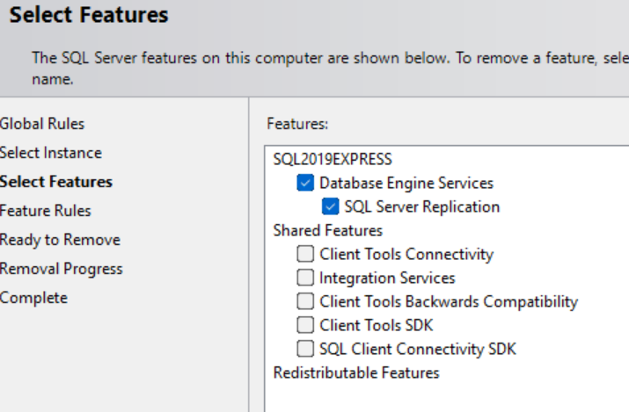

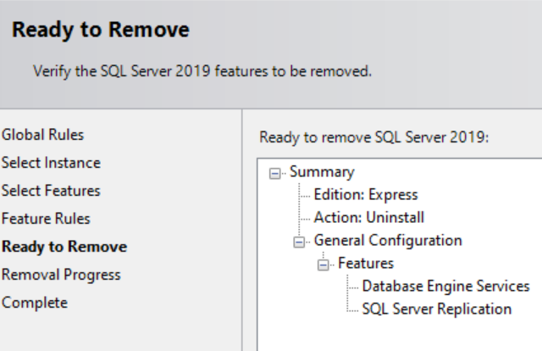

Click on Remove

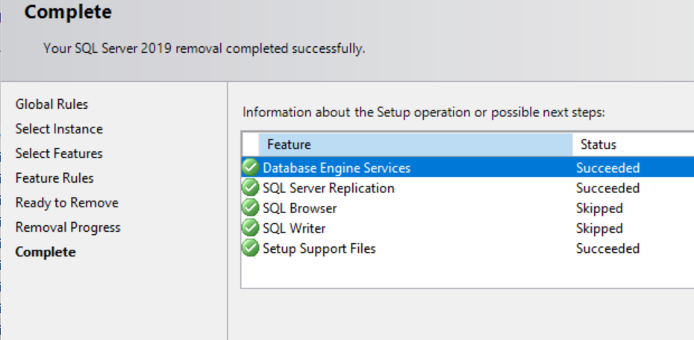

Registered Servers or CMS (Centralized Management Servers):

Registering a server in SQL Server Management Studio allows you to store the server connection information for future connections

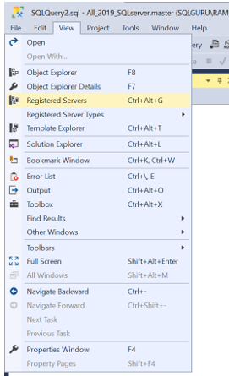

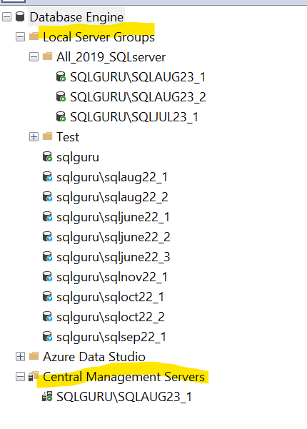

Central management servers store a list of instances of SQL Server that is organized into one or more central management server groups. Actions that are taken by using a central management server group act on all servers in the server group

Querying from Registered servers:

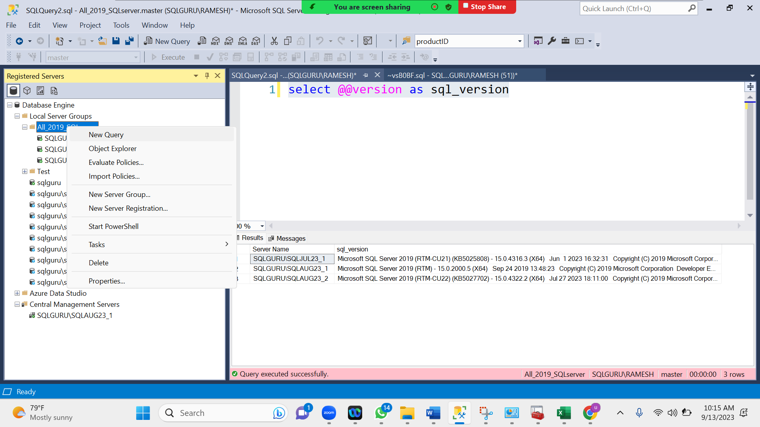

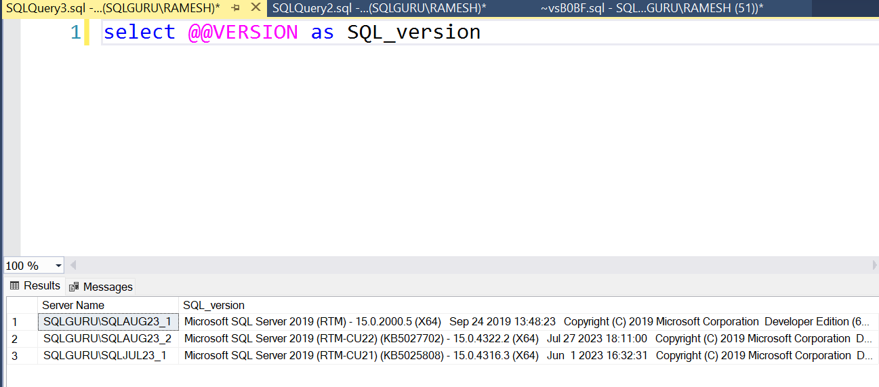

Activity Monitor: is SQL server native inbuilt monitoring solution where we can monitor CPU utilization, Waiting tasks, Database IO, processes (user sessions) details, expensive queries, Resource waits

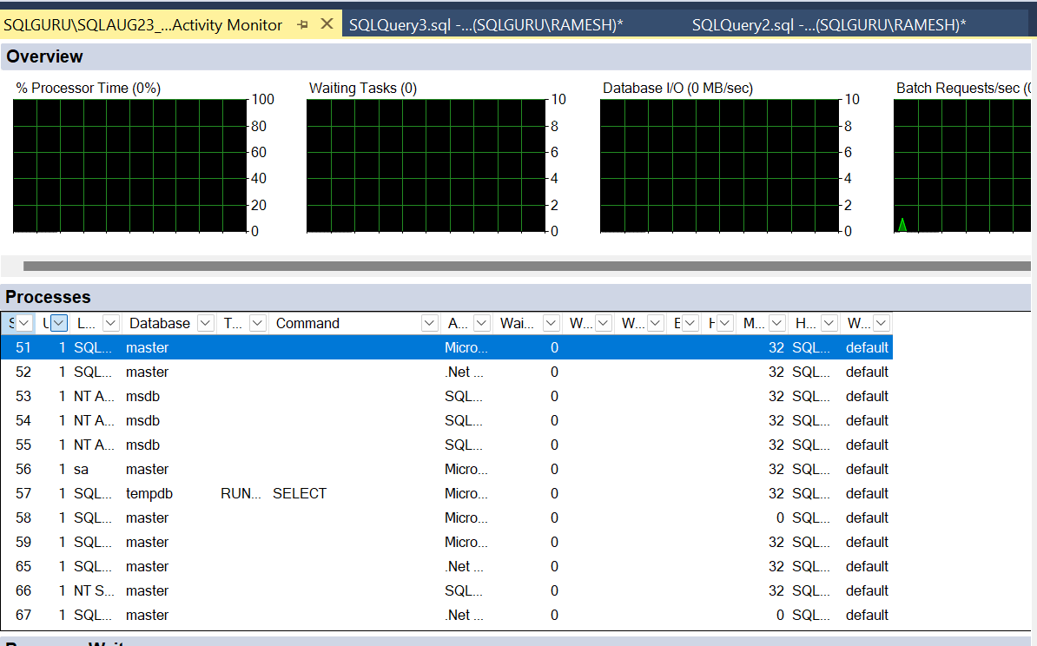

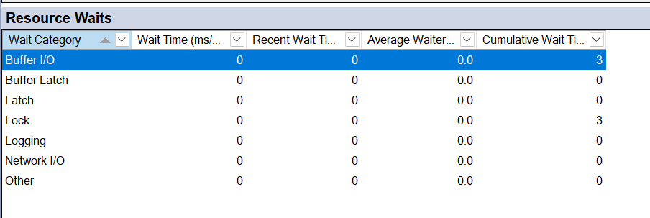

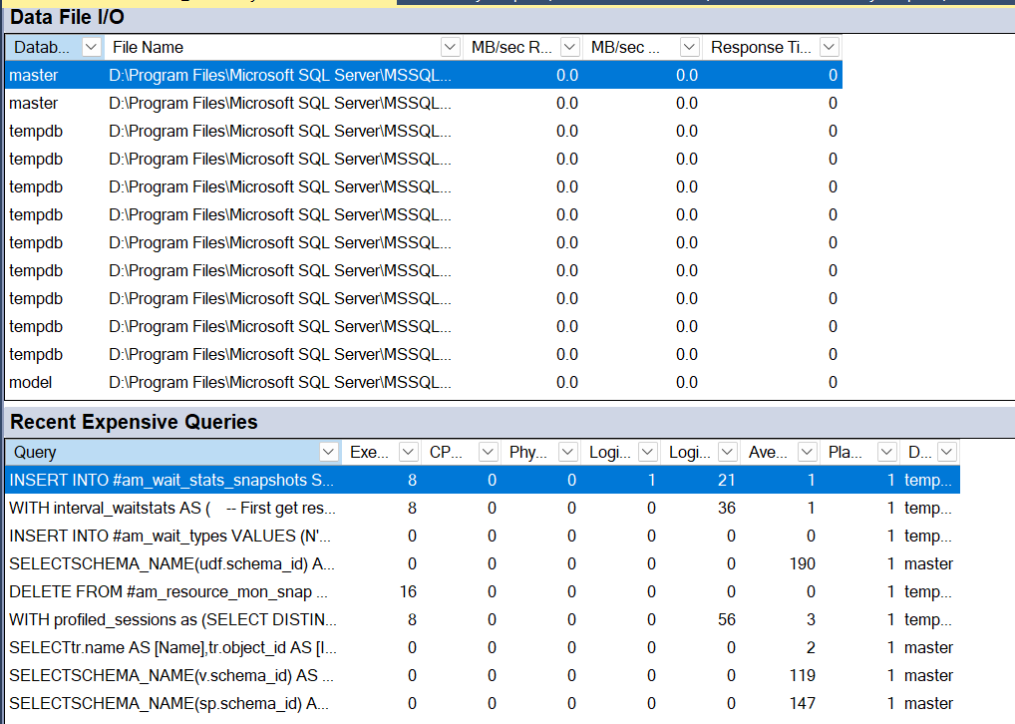

SQL Server Development basics:

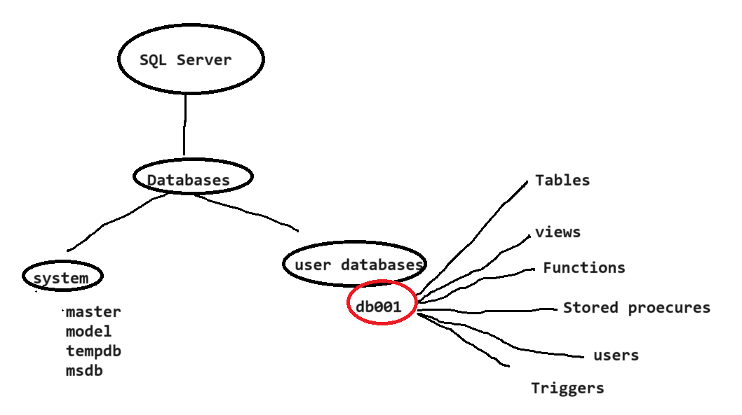

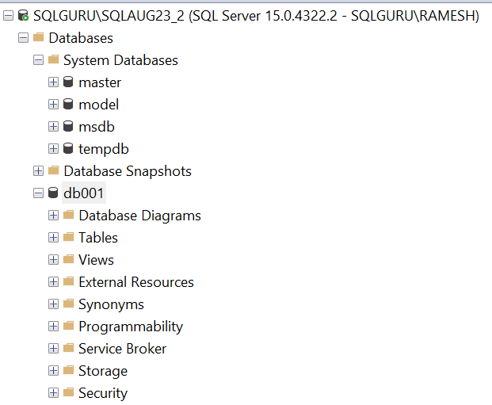

Database – is an object in side the SQL server where we can store our data. In one SQL server we can have multiple databases

There are two types of databases

1. System databases – which will be created by the installation and maintains all the SQL server system level information
   1. Master
   2. Model
   3. MSDB
   4. Tempdb
2. User Databases – which we need to create as per the business requirements to store application data

Table 🡪 is an object inside the database contains rows and columns where we can store the data

|  |  |  |  |
| --- | --- | --- | --- |
| **EMP** | | | |
| **ID** | **Name** | **Sal** | **Location** |
|  |  |  |  |
|  |  |  |  |
|  |  |  |  |

Data Types -are used to define what type of data a column in a table should accept

|  |  |  |  |
| --- | --- | --- | --- |
| **EMP** | | | |
| **ID int** | **Name varchar(50)** | **Sal int** | **Location varchar(50)** |
|  |  |  |  |
|  |  |  |  |

Data Types – Defines what type of data a column should accept in a table

Each column in a database table is required to have a name and a data type.

An SQL developer must decide what type of data that will be stored inside each column when creating a table. The data type is a guideline for SQL to understand what type of data is expected inside of each column, and it also identifies how SQL will interact with the stored data.

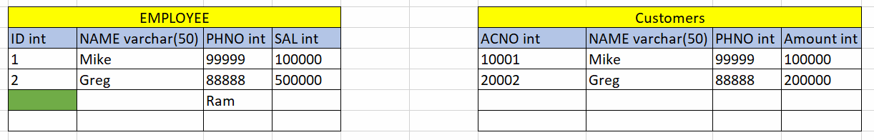

**Types of Data types:**

Numerical Data Types:

|  |  |  |
| --- | --- | --- |
| **Data type** | **Description** | **Storage** |
| Bit | Integer that can be 0, 1, or NULL |  |
| Tinyint | Allows whole numbers from 0 to 255 | 1 byte |
| Smallint | Allows whole numbers between -32,768 and 32,767 | 2 bytes |
| Int | Allows whole numbers between -2,147,483,648 and 2,147,483,647 | 4 bytes |
| Bigint | Allows whole numbers between -9,223,372,036,854,775,808 and 9,223,372,036,854,775,807 | 8 bytes |
| numeric(p,s) | Fixed precision and scale numbers. | 5-17 bytes |
| Smallmoney | Monetary data from -214,748.3648 to 214,748.3647 | 4 bytes |
| Money | Monetary data from -922,337,203,685,477.5808 to 922,337,203,685,477.5807 | 8 bytes |
| float(n) | Floating precision number data from -1.79E + 308 to 1.79E + 308. | 4 or 8 bytes |
| Real | Floating precision number data from -3.40E + 38 to 3.40E + 38 | 4 bytes |

String Data types:

|  |  |  |
| --- | --- | --- |
| **Data type** | **Description** | **Max size** |
| char(n) | Fixed width character string | 8,000 characters |
| varchar(n) | Variable width character string | 8,000 characters |
| varchar(max) | Variable width character string | 1,073,741,824 characters |
| Text | Variable width character string | 2GB of text data |
| Nchar | Fixed width Unicode string | 4,000 characters |
| Nvarchar | Variable width Unicode string | 4,000 characters |
| nvarchar(max) | Variable width Unicode string | 536,870,912 characters |
| Ntext | Variable width Unicode string | 2GB of text data |
| binary(n) | Fixed width binary string | 8,000 bytes |
| Varbinary | Variable width binary string | 8,000 bytes |
| varbinary(max) | Variable width binary string | 2GB |
| Image | Variable width binary string |  |

Date and Time Data Types:

|  |  |  |
| --- | --- | --- |
| **Data type** | **Description** | **Storage** |
| Datetime | From January 1, 1753 to December 31, 9999 with an accuracy of 3.33 milliseconds | 8 bytes |
| datetime2 | From January 1, 0001 to December 31, 9999 with an accuracy of 100 nanoseconds | 6-8 bytes |
| Smalldatetime | From January 1, 1900 to June 6, 2079 with an accuracy of 1 minute | 4 bytes |
| Date | Store a date only. From January 1, 0001 to December 31, 9999 | 3 bytes |
| Time | Store a time only to an accuracy of 100 nanoseconds | 3-5 bytes |
| Datetimeoffset | The same as datetime2 with the addition of a time zone offset | 8-10 bytes |
| Timestamp | Stores a unique number that gets updated every time a row gets created or modified. The timestamp value is based upon an internal clock and does not correspond to real time. Each table may have only one timestamp variable |  |

Special Data types:

|  |  |
| --- | --- |
| **Data type** | **Description** |
| sql_variant | Stores up to 8,000 bytes of data of various data types, except text, ntext, and timestamp |
| Uniqueidentifier | Stores a globally unique identifier (GUID) |
| Xml | Stores XML formatted data. Maximum 2GB |
| Cursor | Stores a reference to a cursor used for database operations |
| Table | Stores a result-set for later processing |

Constraints:

Constraints are nothing but rules/conditions/restrictions we can apply on the columns in a table

1. Primary key
   1. It will not accept duplicate values
   2. It will not accept null value
   3. In one table, we can create only one primary key
   4. If we create a primary key on a column, by default a clustered index will be created on that column

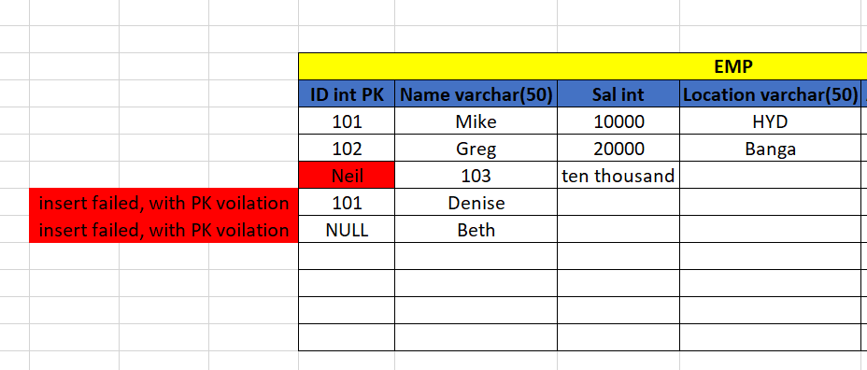

1. Not null
   1. It will not accept null values

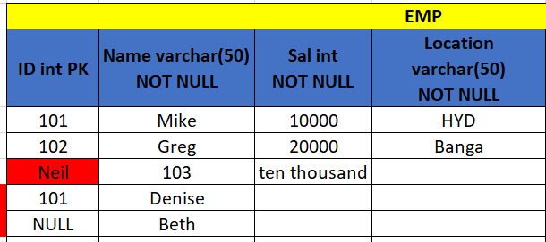

1. Unique
   1. It will not allow duplicates, but it will allow one null value

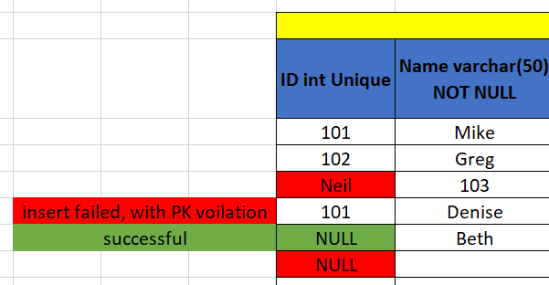

1. Check
   1. It accepts the values in a particular range

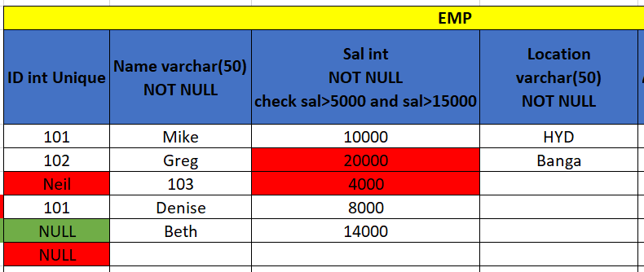

1. Default
   1. We can assign a default value to the column while creating the table and it will populate same value for all the records automatically

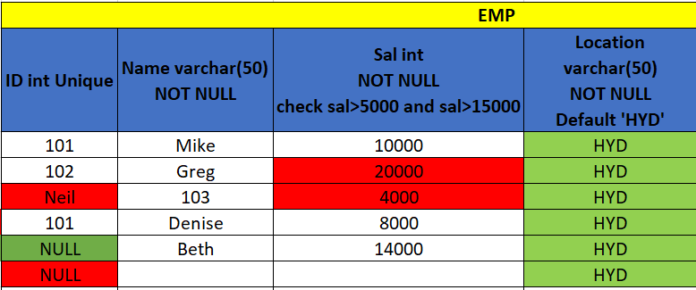

1. Identity
   1. If we have any integer columns with fixed auto incremental values, then we can define that column as identity

Ex – SNO int identity (1,1)

|  |  |  |  |  |
| --- | --- | --- | --- | --- |
| **EMP** | | | | |
| **SNO INT   Identity (1,1)** | **ID int PK** | **Name varchar(50) NOT NULL** | **Sal int NOT NULL check sal>5000 and sal>15000** | **Location varchar(50) NOT NULL Default 'HYD'** |
| 1 | 101 | Mike | 10000 | HYD |
| 2 | 102 | Greg | 20000 | HYD |
| 3 | Neil | 103 | 4000 | HYD |
| 4 | 101 | Denise | 8000 | HYD |
| 5 | NULL | Beth | 14000 | HYD |
| 6 | NULL |  |  | HYD |

1. Foreign key Constraint
   1. If we want define a particular column a foreign key that must be a primary key in some other table
   2. The FOREIGN KEY constraint is used to prevent actions that would destroy links between tables.
   3. A FOREIGN KEY is a field (or collection of fields) in one table, that refers to the [PRIMARY KEY](https://www.w3schools.com/sql/sql_primarykey.asp) in another table.
   4. The table with the foreign key is called the child table, and the table with the primary key is called the referenced or parent table

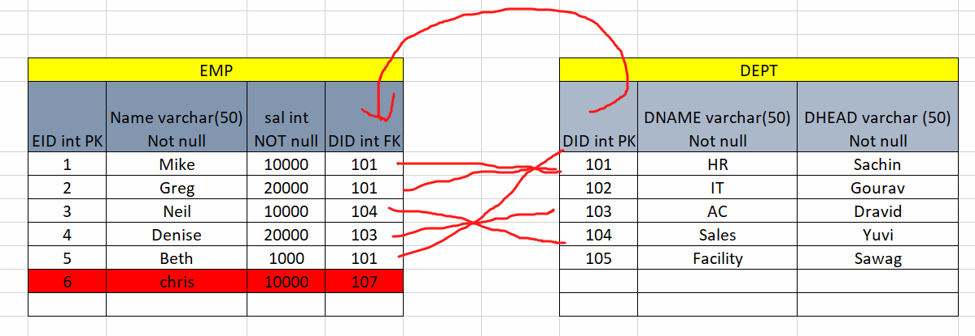

SQL Languages:

* + DDL – Data definition language
    - Create
    - Alter
    - Drop
    - Truncate
  + DML – Data Manipulation language
    - Insert
    - Delete
    - Update
    - Merge
  + TCL – Transaction control language
    - Commit
    - Rollback
    - Save point
  + DCL – Data Control language
    - Grant
    - With Grant
    - Revoke
  + DQL – Data Query Language
    - Select

Practical’s:

--DDL Commands at Database level

--CREATE

create database [dev-basics1]

USE [master]

GO

/****** Object: Database [DevBasics] Script Date: 9/16/2023 10:51:17 AM ******/

CREATE DATABASE [DevBasics2]

ON PRIMARY

( NAME = N'DevBasics2', FILENAME = N'D:\Program Files\Microsoft SQL Server\MSSQL15.SQLAUG23_2\MSSQL\DATA\DevBasics2.mdf')

LOG ON

( NAME = N'DevBasics2_log', FILENAME = N'D:\Program Files\Microsoft SQL Server\MSSQL15.SQLAUG23_2\MSSQL\DATA\DevBasics2_log.ldf')

GO

--ALTER (add file to the database)

ALTER DATABASE [DevBasics]

ADD FILE

(NAME='DevBasics1',FILENAME='D:\Program Files\Microsoft SQL Server\MSSQL15.SQLAUG23_2\MSSQL\DATA\DevBasics1.ndf')

USE [master]

GO

ALTER DATABASE [DevBasics]

ADD FILE

(NAME = N'DevBasics2', FILENAME = N'D:\Program Files\Microsoft SQL Server\MSSQL15.SQLAUG23_2\MSSQL\DATA\DevBasics2.ndf' , SIZE = 8192KB , FILEGROWTH = 65536KB ) TO FILEGROUP [PRIMARY]

GO

--Remove the file

alter database [DevBasics] remove file DevBasics2

select * from sys.databases

ALTER DATABASE [DevBasics] SET ANSI_NULL_DEFAULT OFF

ALTER DATABASE [DevBasics] SET ANSI_NULLS OFF

ALTER DATABASE [DevBasics] SET ANSI_PADDING OFF

ALTER DATABASE [DevBasics] SET ANSI_WARNINGS OFF

ALTER DATABASE [DevBasics] SET ARITHABORT OFF

ALTER DATABASE [DevBasics] SET AUTO_CLOSE OFF

ALTER DATABASE [DevBasics] SET AUTO_SHRINK OFF

ALTER DATABASE [DevBasics] SET AUTO_UPDATE_STATISTICS ON

ALTER DATABASE [DevBasics] SET CURSOR_CLOSE_ON_COMMIT OFF

ALTER DATABASE [DevBasics] SET CURSOR_DEFAULT GLOBAL

ALTER DATABASE [DevBasics] SET CONCAT_NULL_YIELDS_NULL OFF

ALTER DATABASE [DevBasics] SET NUMERIC_ROUNDABORT OFF

ALTER DATABASE [DevBasics] SET QUOTED_IDENTIFIER OFF

ALTER DATABASE [DevBasics] SET RECURSIVE_TRIGGERS OFF

ALTER DATABASE [DevBasics] SET DISABLE_BROKER

ALTER DATABASE [DevBasics] SET AUTO_UPDATE_STATISTICS_ASYNC OFF

ALTER DATABASE [DevBasics] SET DATE_CORRELATION_OPTIMIZATION OFF

ALTER DATABASE [DevBasics] SET TRUSTWORTHY OFF

ALTER DATABASE [DevBasics] SET ALLOW_SNAPSHOT_ISOLATION OFF

ALTER DATABASE [DevBasics] SET PARAMETERIZATION SIMPLE

ALTER DATABASE [DevBasics] SET READ_COMMITTED_SNAPSHOT OFF

ALTER DATABASE [DevBasics] SET HONOR_BROKER_PRIORITY OFF

ALTER DATABASE [DevBasics] SET RECOVERY FULL

ALTER DATABASE [DevBasics] SET RECOVERY SIMPLE

ALTER DATABASE [DevBasics] SET RECOVERY BULK_LOGGED

ALTER DATABASE [DevBasics] SET MULTI_USER

ALTER DATABASE [DevBasics] SET SINGLE_USER

ALTER DATABASE [DevBasics] SET PAGE_VERIFY CHECKSUM

ALTER DATABASE [DevBasics] SET DB_CHAINING OFF

ALTER DATABASE [DevBasics] SET FILESTREAM( NON_TRANSACTED_ACCESS = OFF )

ALTER DATABASE [DevBasics] SET TARGET_RECOVERY_TIME = 60 SECONDS

ALTER DATABASE [DevBasics] SET DELAYED_DURABILITY = DISABLED

ALTER DATABASE [DevBasics] SET ACCELERATED_DATABASE_RECOVERY = OFF

ALTER DATABASE [DevBasics] SET QUERY_STORE = OFF

ALTER DATABASE [DevBasics] SET QUERY_STORE = ON

ALTER DATABASE [DevBasics] SET READ_WRITE

ALTER DATABASE [DevBasics] SET READ_ONLY

--DROP

DROP DATABASE [dev-basics1]

DROP DATABASE [DevBasics]

--DDL COMMANDS AT TABLE LEVEL

--Creating a table

use [DevBasics]

go

Create table employee(

id int,

name varchar(50),

sal int,

location varchar(50))

--adding column

Alter table [dbo].[employee] add dept varchar(50)

--delete a column

alter table [dbo].[employee] drop column dept

--Delete entire table

drop table [dbo].[EMP]

--DML commands

--INSERT

insert into [dbo].[employee] values

(101,'Sachin',5000,'Mum')

insert into [dbo].[employee] values

(102,'Sourav',9000,'Kol'),

(103,'Dravid',7000,'Bang'),

(104,'Yuvi',1000,'Jaipur'),

(105,'Dhoni',8000,'Jark'),

(106,'Sewag',9000,'Delhi')

insert into [dbo].[employee] values

(107,'Zaheer',8000)

--Column name or number of supplied values does not match table definition.

insert into [dbo].[employee]

(id,name,sal)

values

(107,'Zaheer',8000)

--Insert the data from one table to another table

--if the target table exist

insert into [dbo].[employee1]

select * from [dbo].[employee]

--Insert the data from one table to another table

--if the target table does not exist

-- taking backup of the table

select * into employe2 from [dbo].[employee]

select * into [dbo].[employee_bkp160923] from [dbo].[employee]

select * into [dbo].[employee] from [dbo].[employee_bkp160923]

--Update

update [dbo].[employee]

set location='Delhi' where id=107

update [dbo].[employee]

set location='Delhi'

update [dbo].[employee]

set location='Bang' ,sal=10000

where id=103

--Delete

delete from employee where id=107

delete from employee

--Truncate

Truncate table employee

--DROP

DROP table [dbo].[employee]

select * from employee

Difference between Delete, Truncate and DROP:

|  |  |  |
| --- | --- | --- |
| DELETE | TRUNCATE | DROP |
| DML operation | DDL operation | DDL operation |
| It deletes the data but the table remain table | It deletes the data but the table remain table | It deletes the data along with table |
| We can delete the conditionally what ever the records we want to delete | There is no way delete selective data, it wipes out all the data | Data and table |
| Logged operation | Non logged operation | Logged operation |

Constraints:

create table employye(

SNO int identity(1,1),

ID int primary key,

Name varchar(50) not null,

organization varchar(50) not null,

sal int not null check (sal>5000 and sal<15000),

location varchar(50) not null default 'HYD')

insert into employye

(ID,name,organization,sal)

values

(101,'Sachin','IBM',6000)

insert into employye

(ID,name,organization,sal, location)

values

(102,'Sourav','Oracle',9000,'Bang')

insert into employye

(ID,name,organization,sal)

values

(102,'Yuvi','TCS',9000)

insert into employye

(ID,name,organization,sal)

values

(NULL,'Yuvi','TCS',9000)

insert into employye

(name,organization,sal)

values

('Yuvi','TCS',9000)

insert into employye

(ID,organization,sal)

values

(103,'TCS',9000)

insert into employye

(ID,name,organization,sal)

values

(104,'Sewag','IBM',4500)

insert into employye

(ID,name,organization,sal)

values

(104,'Sewag','IBM',16000)

select * from employye

drop table employye

--Unique

create table employye(

SNO int identity(1,1),

ID int unique,

Name varchar(50) not null,

organization varchar(50) not null,

sal int not null check (sal>5000 and sal<15000),

location varchar(50) not null default 'HYD')

insert into employye

(id, name,organization,sal)

values

(101,'sachin','IBM',6000)

insert into employye

(name,organization,sal)

values

('Greg','TCS',9000)

insert into employye

(name,organization,sal)

values

('Pete','IBM',8000)

select * from employye

Foreign Key:

create table persons(

personid int primary key,

Name varchar(50) not null,

phone int not null,

address varchar(50) not null)

insert into persons values

(101, 'Sachin',999999,'Mum'),

(102, 'Sourav',999999,'Kol'),

(103, 'Sewag',999999,'Delhi'),

(104, 'Yuvi',999999,'Jaipur'),

(105, 'Mahi',999999,'JArkhand')

create table Orders(

OrderID int primary key,

Orderqty int not null,

OrderDt datetime not null,

personid int FOREIGN KEY REFERENCES Persons(PersonID)

)

insert into orders values

(10001,5,getdate(),101),

(10002,99,getdate(),104),

(10003,9,getdate(),102),

(10004,15,getdate(),102),

(10005,11,getdate(),102),

(10006,100,getdate(),101)

insert into orders values

(10007,5,getdate(),109)

select * from Orders

Sample Databases:

<https://learn.microsoft.com/en-us/sql/samples/adventureworks-install-configure?view=sql-server-ver16&tabs=ssms>

SQL Tutorials:

<https://www.w3schools.com/sql/default.asp>

SQL: SQL is a standard language for accessing and manipulating databases.

What is SQL?

* SQL stands for Structured Query Language
* SQL lets you access and manipulate databases
* SQL became a standard of the American National Standards Institute (ANSI) in 1986, and of the International Organization for Standardization (ISO) in 1987

What Can SQL do?

* SQL can execute queries against a database
* SQL can retrieve data from a database
* SQL can insert records in a database
* SQL can update records in a database
* SQL can delete records from a database
* SQL can create new databases
* SQL can create new tables in a database
* SQL can create stored procedures in a database
* SQL can create views in a database
* SQL can set permissions on tables, procedures, and views

SELECT:

--retrive all the columns and all the rows

select * from [Sales].[SalesOrderDetail]

--column level filter

select SalesOrderID,OrderQty from [Sales].[SalesOrderDetail]

--row level filters

select * from [Sales].[SalesOrderDetail]

where SalesOrderID=43659

--IN and NOT IN

select * from [Sales].[SalesOrderDetail]

where SalesOrderID IN (43659,43660,43661)

select * from [Sales].[SalesOrderDetail]

where SalesOrderID NOT IN (43659,43660,43661)

--Between

select * from [Sales].[SalesOrderDetail]

where OrderQty between 5 and 10

--NOT

select * from [Sales].[SalesOrderDetail]

where SalesOrderID<>43659

--AND

select * from [Sales].[SalesOrderDetail]

where SalesOrderID=43659 AND OrderQty>2

--OR

select * from [Sales].[SalesOrderDetail]

where SalesOrderID=43659 OR OrderQty>2

--Distinct

select distinct SalesOrderID from [Sales].[SalesOrderDetail]

--Sorting the results (ORder by)

select * from [Sales].[SalesOrderDetail]

order by OrderQty desc

select * from [Sales].[SalesOrderDetail]

order by OrderQty asc

--TOP, max, min, sum, avg, count

select top 10 SalesOrderID,* from [Sales].[SalesOrderDetail]

select max(OrderQty) as maxordqty from [Sales].[SalesOrderDetail]

select min(OrderQty) as minordqty from [Sales].[SalesOrderDetail]

select sum(OrderQty) as totordqty from [Sales].[SalesOrderDetail]

select avg(OrderQty) as avgordqty from [Sales].[SalesOrderDetail]

select count(*) as totrecords from [Sales].[SalesOrderDetail]

--Group by

select SalesOrderID,sum(OrderQty) from [Sales].[SalesOrderDetail]

group by SalesOrderID

--HAving

select SalesOrderID,sum(OrderQty) from [Sales].[SalesOrderDetail]

group by SalesOrderID

having sum(OrderQty) >50

--Like

select * from [Sales].[Currency]

select * from [Sales].[Currency] where name like 'E%'

select * from [Sales].[Currency] where name like '%E'

select * from [Sales].[Currency] where name like '%E%'

select * from [Sales].[Currency] where name like '__E%'

select * from [Sales].[Currency] where name like 's%a'

Databases:

* User databases – which we create to store the business data/user’s data. In one SQL server, we can create multiple user databases

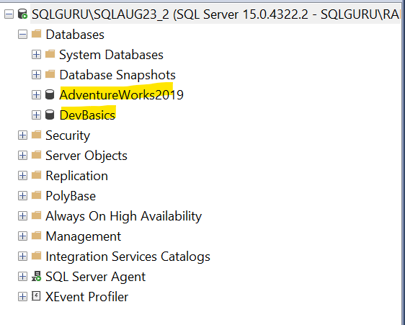

* System Databases – are gets created as part of the installation and maintains all the system level information’s
  + **Master**
  + **Model**
  + **MSDB**
  + **Tempdb**
  + Resource🡪read only Hidden databases
  + Distribution 🡪This will be created when we configure replication
  + Report Server 🡪will be created when we configure SSRS
  + Report Server Tempdb🡪 will be created when we configure SSRS

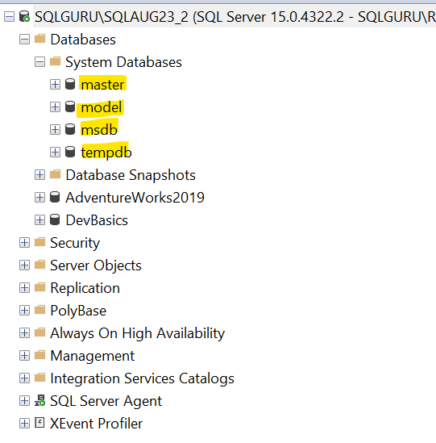

Master – it is master of all the databases in a SQL server and it maintains system level information’s such as logins, linked servers, registered servers, end points, open sessions, information about other databases and database files information

Login – is server level security principal which allows us to connect the SQL server

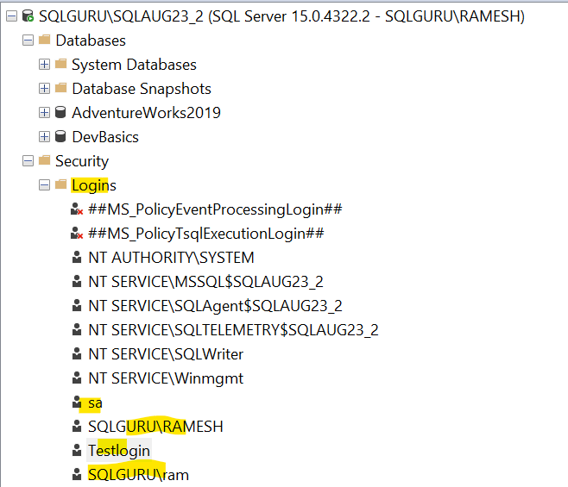

select name,createdate from [sys].[syslogins]

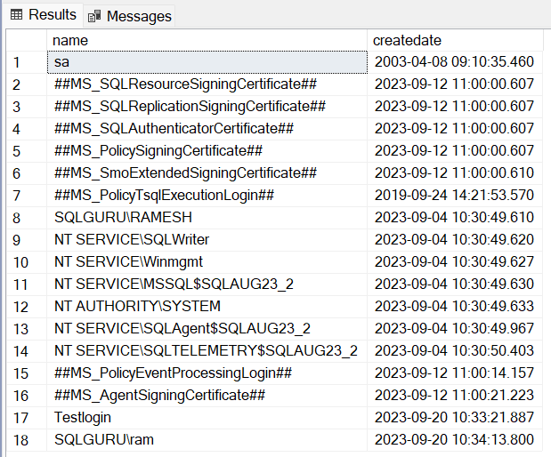

**Linked servers:**

Linked servers are used to access the data from one SQL server to another SQL server

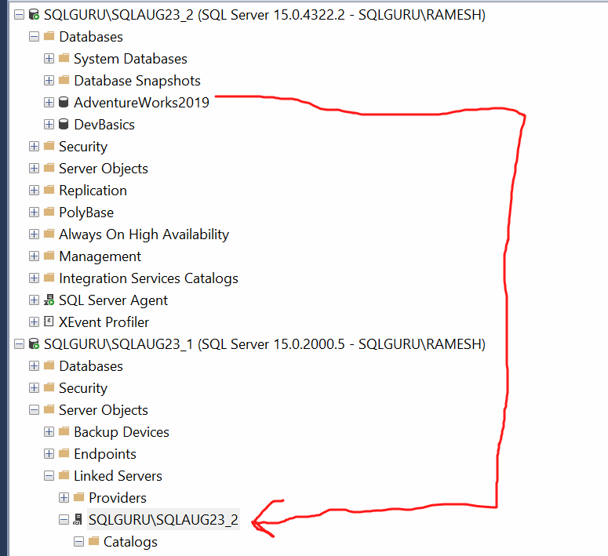 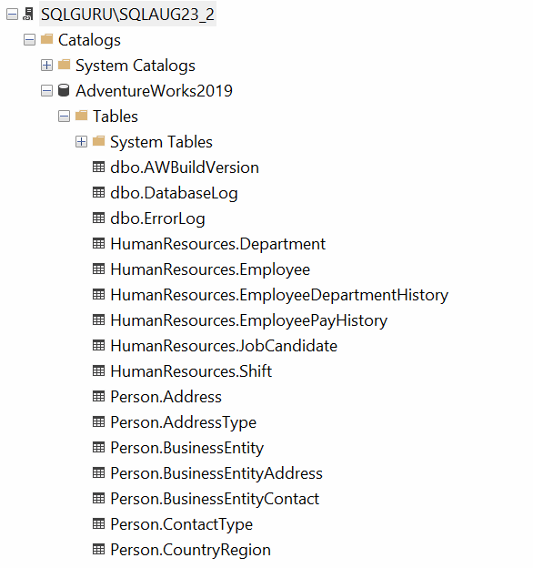

select * from [sys].[sysservers]

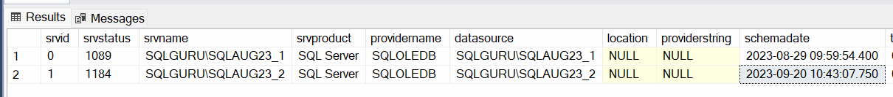

End points – are used for the network communication in the Database mirroring and Always On

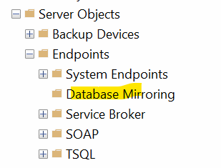

select * from [sys]. [endpoints]

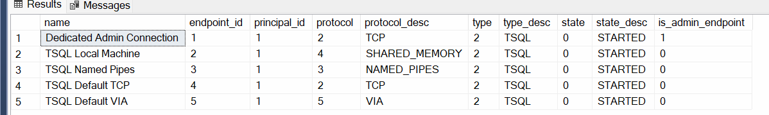

Information about all the databases:

select * from [sys].[databases]

select

name,

database_id,

create_date,

compatibility_level,

collation_name ,

recovery_model,

state_desc

from [sys].[databases]

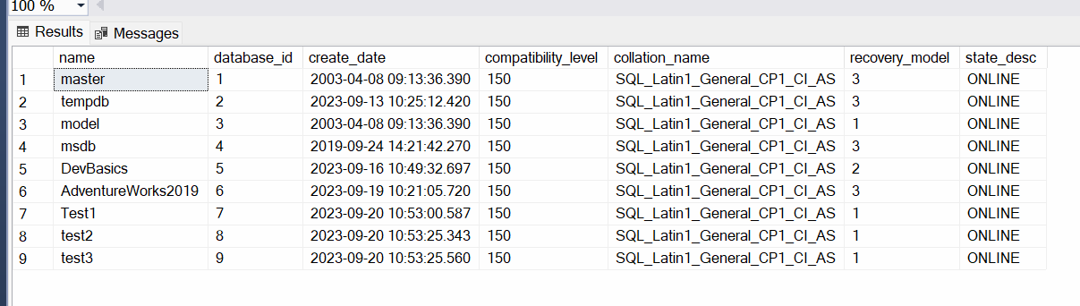

Database files information:

select * from sys.master_files

select

database_id,

name as log_filename,

type_desc,

physical_name

from sys.master_files

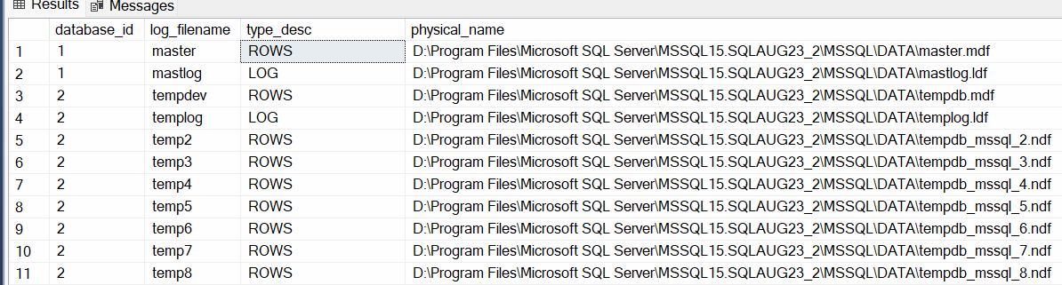

Query the database names along with file locations:

--Joins, if we want to pull the data from two or more tables.

--then we can write joins

--To write join, both the tables must have atleast one common column

select * from sys.databases

select * from sys.master_files

select

sd.name as dbname,

sd.database_id,

smf.state_desc,

smf.name as logical_filename,

smf.type_desc,

smf.physical_name

from sys.databases sd

join sys.master_files smf

on sd.database_id=smf.database_id

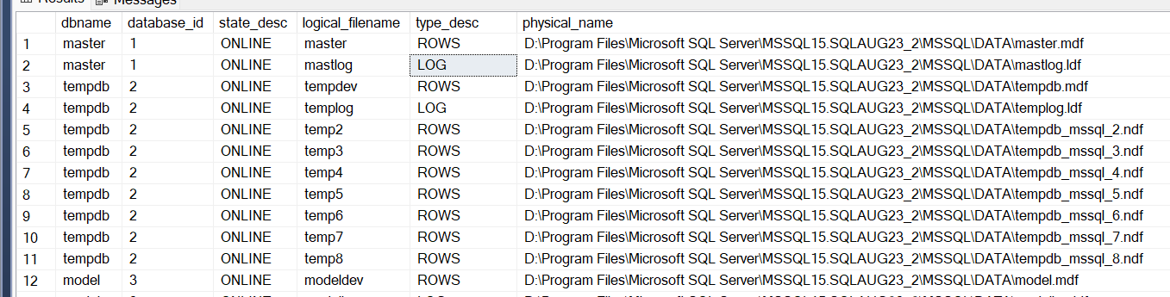

Retrieve only System databases information:

select

sd.name as dbname,

sd.database_id,

smf.state_desc,

smf.name as logical_filename,

smf.type_desc,

smf.physical_name

from sys.databases sd

join sys.master_files smf

on sd.database_id=smf.database_id

where sd.database_id <5

Retrieve only User databases information:

select

sd.name as dbname,

sd.database_id,

smf.state_desc,

smf.name as logical_filename,

smf.type_desc,

smf.physical_name

from sys.databases sd

join sys.master_files smf

on sd.database_id=smf.database_id

where sd.database_id >4

Only Data files:

select

sd.name as dbname,

sd.database_id,

smf.state_desc,

smf.name as logical_filename,

smf.type_desc,

smf.physical_name

from sys.databases sd

join sys.master_files smf

on sd.database_id=smf.database_id

where smf.type_desc='ROWS'

**With out master database, SQL server will not work***

Model – is a template SQL Server. Whenever we create a new database or tempdb. this will inherit all the properties from model database and assigns to the new user database.

Case1 – Whenever we create a new database, by default it should get created with simple recovery model

Sol – Change the recovery model of model database to simple. from there whatever the new databases we create will be created with simple recovery model

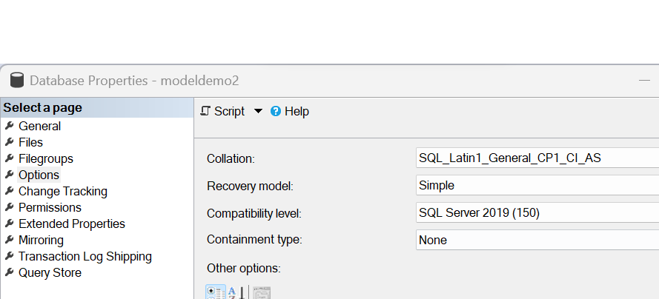

Case2 – Whenever we create a new user database, by default it should get 10 tables in the database

Sol: Create all the default 10 tables in the model database, whenever we create new database, that will get these 10 tables by default.

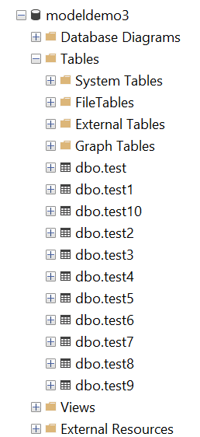

Case 3: Whenever we create new user database, it should a stored procedures created by default

Sol -> create SP in the model database, so that when ever we create new database. It will get the SP created by default

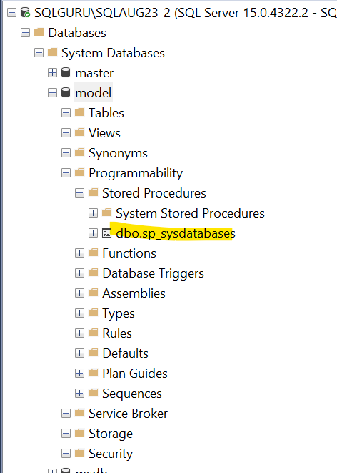

**With out model database, SQL server will work or not?

No, SQL server will not start. When ever we restart the SQL server, it will create new tempdb. For that it requires a template from model. If the model is not available. template will not be generated. so Tempdb will not create. With out that SQL server will not start

MSDB – is for SQL server agent service

SQL server Agent – is service which gets installed for every database engine. For every SQL server that we install a corresponding agent service will be created which we can use to atomate the activities in SQL server by creating jobs and assigning schedules to run the job automatically

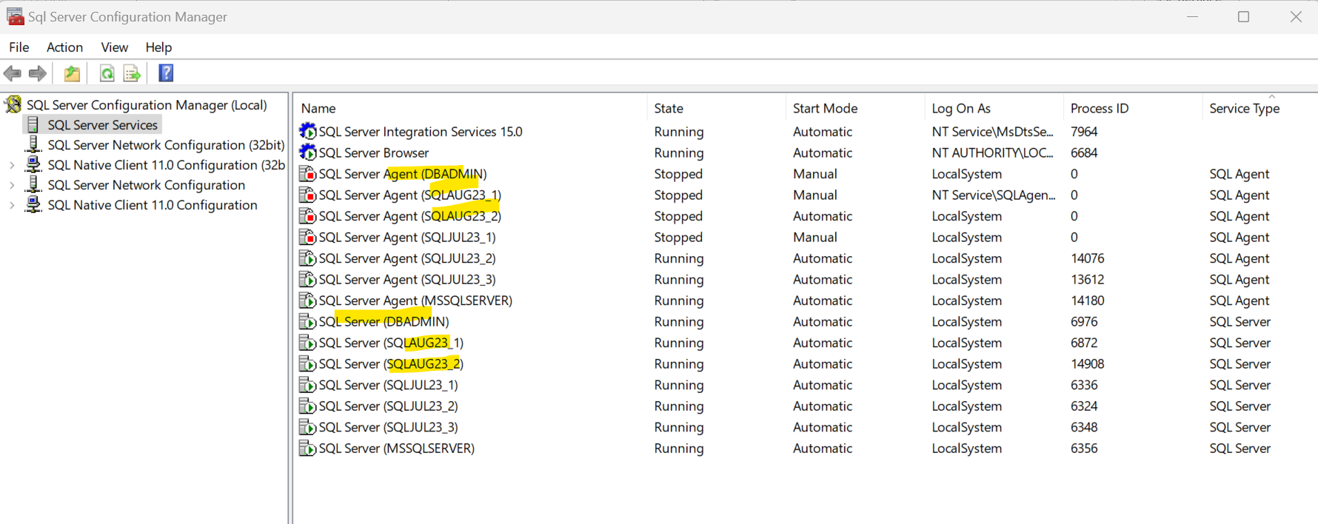

--all the daily sales detail will be inserted

create table daily_sales

(sales_order_id int, order_qty int, order_date datetime)

insert into daily_sales values

(101,9,getdate()),

(102,9,getdate()),

(103,9,getdate()),

(104,9,getdate()),

(105,9,getdate())

--every day 12:00 am.. it have dump all the data from

--daily sales to sales history and remove the data from

--daily sales

create table sales_History

(sales_order_id int, order_qty int, order_date datetime)

--insert the into sales history from daily sales

insert into sales_History

select * from daily_sales

--clean up the data from dail_sales

truncate table daily_sales

MSDB – is for SQL Server agent purpose. It maintains all the agent related information such as jobs, steps, schedules, alerts, operators, notification and also maintains backup and restore history and maintain log shipping details

Jobs-

select * from sysjobs

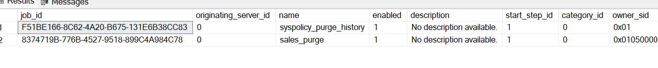

Steps-

select * from sysjobsteps

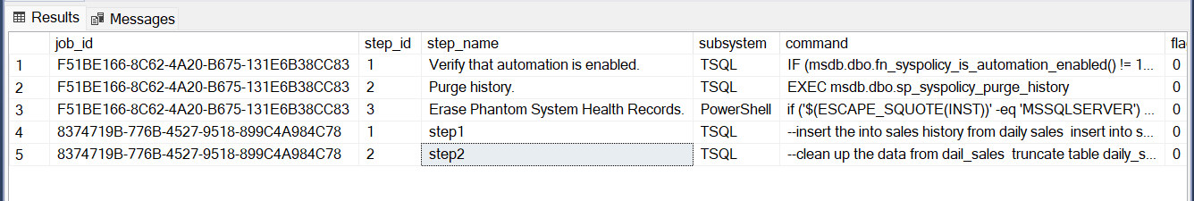

Schedules-

select * from sysjobschedules

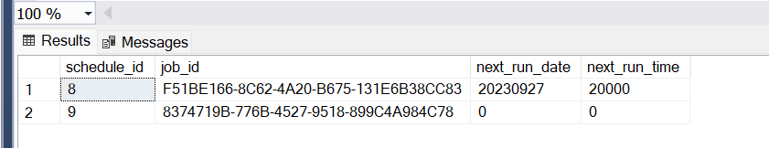

Write a join to retrieve job, step and schedules:

select

sj.name,

jst.step_name,

jst.command,

js.next_run_date,

js.next_run_time

from sysjobs sj

join sysjobsteps jst

on sj.job_id=jst.job_id

join sysjobschedules js

on sj.job_id=js.job_id

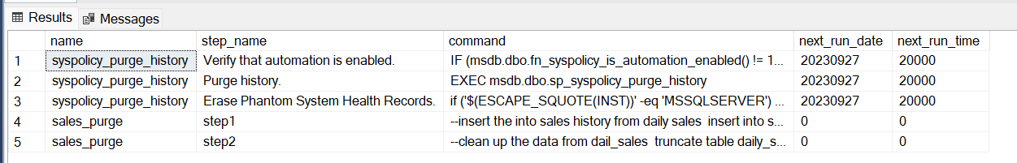

**With out MSDB database, SQL server will work or not ***

Yes, SQL server will work absolutely fine. But Agent service will not work

Tempdb – it is temporary SQL server which maintains all the intermittent results of transaction temporarily in temporary tables.

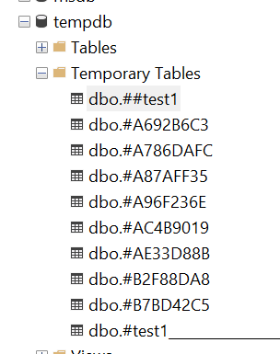

Local Temporary Tables 🡪span is limited to the session where it is created

create table #test1(id int)

insert into #test1 values (1)

select * from #test1

Global Temporary Tables🡪it can be accessible from other session as well

create table ##test1(id int)

insert into ##test1 values (1)

select * from ##test1

***Whenever we restart the SQL server, it will create a new Tempdb

**With out Tempdb, SQL server will work or not ***

Yes, it will work with out any issues. As SQL server creates new Tempdb when we restart the SQL server.

How to find the database locations:

Option #1 – right click on the database name🡪properties-->files

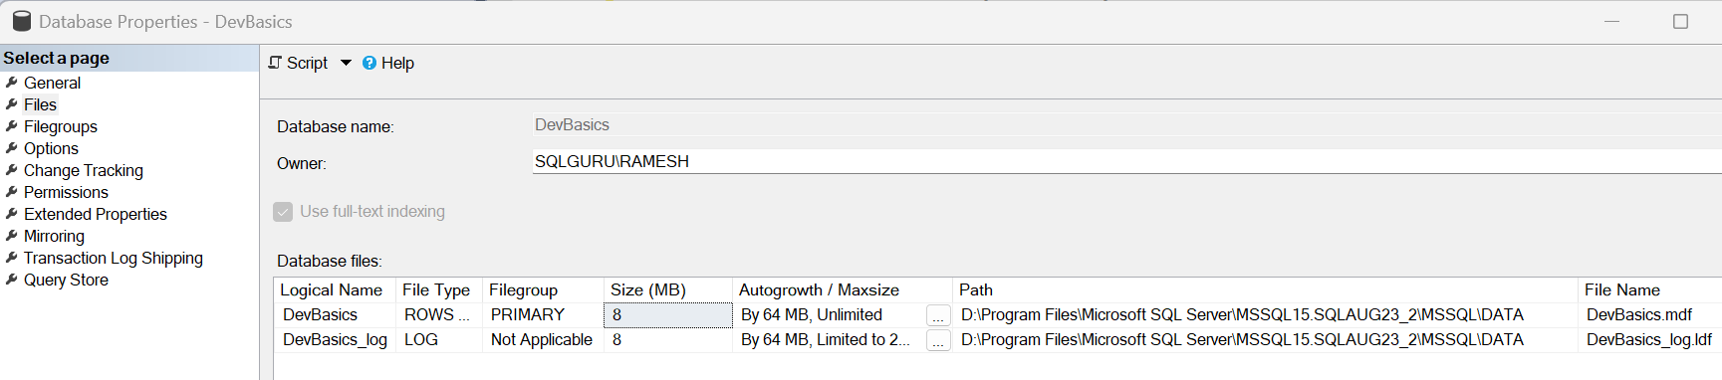

Option #2 –

use [DevBasics]

go

sp_helpfile



Option #3

select name,type_desc,physical_name from sys.master_files

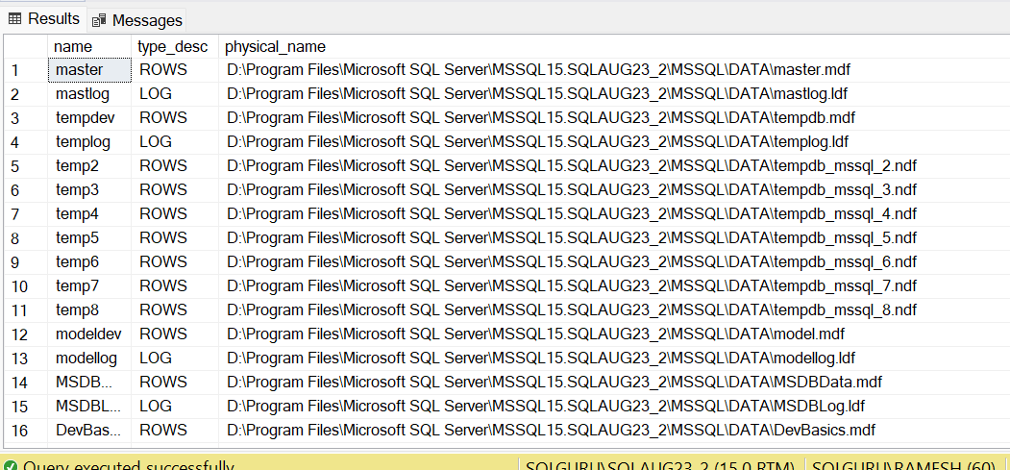

select * from sys.sysaltfiles

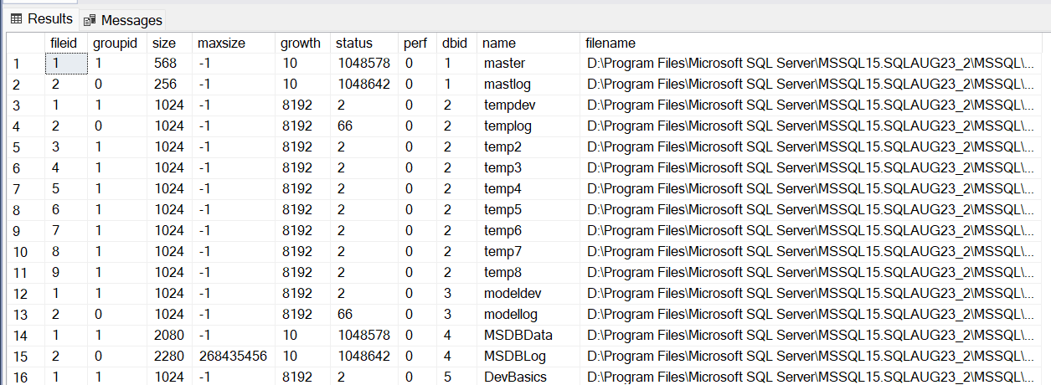

Query the database names along with file locations:

--Joins, if we want to pull the data from two or more tables.

--then we can write joins

--To write join, both the tables must have atleast one common column

select * from sys.databases

select * from sys.master_files

select

sd.name as dbname,

sd.database_id,

smf.state_desc,

smf.name as logical_filename,

smf.type_desc,

smf.physical_name

from sys.databases sd

join sys.master_files smf

on sd.database_id=smf.database_id



Option #4 – Start up parameters (This is only for master database)

Run🡪sqlservermanager16.msc🡪SQL server services🡪right click on the services🡪properties🡪startup parameters

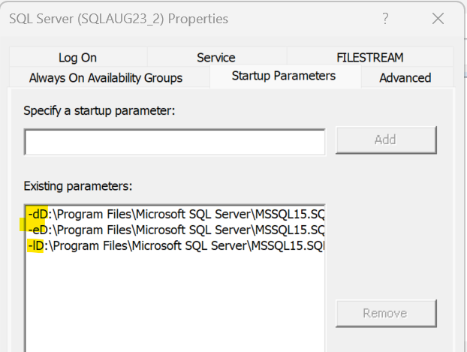

-d: gives the master database data file (mdf) location

-dD:\Program Files\Microsoft SQL Server\MSSQL15.SQLAUG23_2\MSSQL\DATA\master.mdf

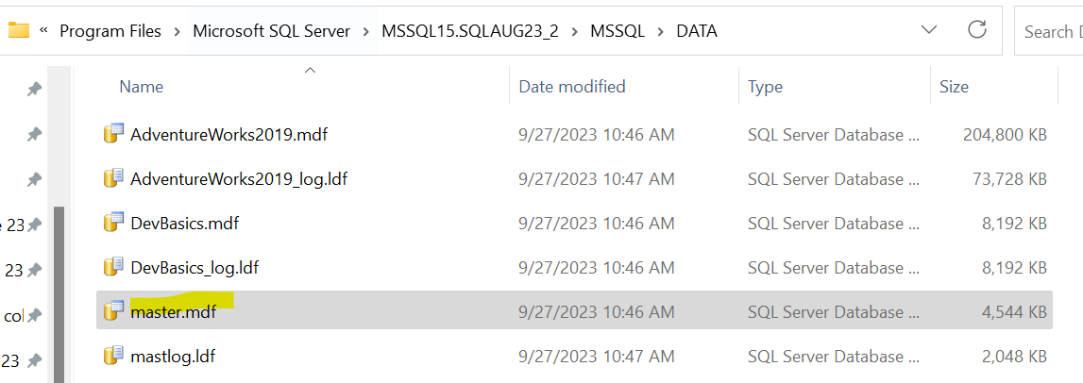

-e: gives us the error log location

-l: gives us master database log file (ldf) location

-lD:\Program Files\Microsoft SQL Server\MSSQL15.SQLAUG23_2\MSSQL\DATA\mastlog.ldf

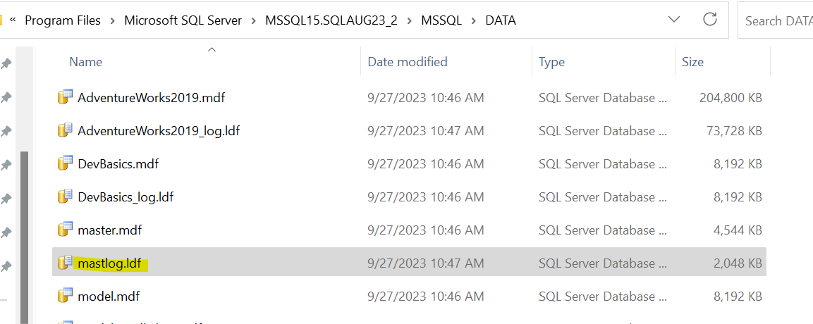

SQL server restart process:

When ever we restart the SQL server, SQL server starts bringing all the databases online one by one.. To bring these databases online, SQL server must know the location of all these databases. First SQL server brings the master database online, once master is online.. SQL server reads the databases and file locations from master database and it will go the location verify the path and file names are correct then it will bring that particular database online

Ex- AdventureWorks2019

select

sd.name as dbname,

sd.database_id,

smf.state_desc,

smf.name as logical_filename,

smf.type_desc,

smf.physical_name

from sys.databases sd

join sys.master_files smf

on sd.database_id=smf.database_id

where sd.name='AdventureWorks2019'



For Data file🡪

SQL server control goes to 🡪 D:\Program Files\Microsoft SQL Server\MSSQL15.SQLAUG23_2\MSSQL\DATA\ and verifies the file exist with the name 🡪AdventureWorks2019.mdf

For log file🡪

SQL server control goes to 🡪 D:\Program Files\Microsoft SQL Server\MSSQL15.SQLAUG23_2\MSSQL\DATA\ and verifies the file exist with the name 🡪 AdventureWorks2019_log.ldf

For both data file and log file, if the path is correct and files exist then it will bring the database ‘AdventureWorks2019’ online.

If the path is incorrect or file does not exist, Then the database gets into recovery pending state

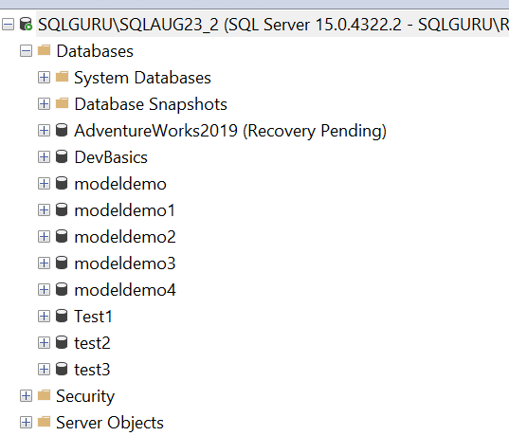

The process will be followed for all the databases in a SQL server.

As we discussed, First SQL server brings the master database online. To bring master database online, SQL server should know the location of master database. For that SQL server reads the startup parameters.

SQL server reads the -d value in the startup parameters 🡪goes to -d location and verifies the path is and file exists.

-dE:\SQLLAB\MSSQL15.SQLJUL23_2\MSSQL\Data\master.mdf

Control goes to 🡪E:\SQLLAB\MSSQL15.SQLJUL23_2\MSSQL\Data

Verifies file 🡪master.mdf

SQL server reads the -l value in the startup parameters 🡪goes to -l location and verifies the path is and file exists.



-lE:\SQLLAB\MSSQL15.SQLJUL23_2\MSSQL\DATA\mastlog.ldf

Control goes to 🡪E:\SQLLAB\MSSQL15.SQLJUL23_2\MSSQL\Data

Verifies file 🡪 mastlog.ldf

Both the path and files are exists, then it will bring the master database online



Error log: it is log file in SQL server which basically captures all the events occurring in the SQL Server like errors, warnings, informational messages, critical error ..etc. We need to start with verifying error log for trouble any SQL server related issue.

How to verify error log:

Option #1: -e: in the start up parameters gives the location of error log

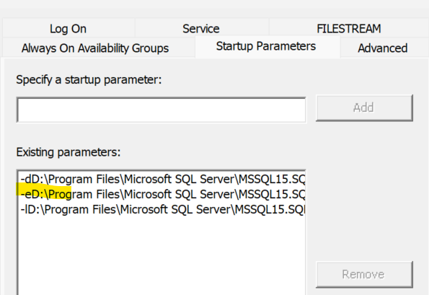

-eD:\Program Files\Microsoft SQL Server\MSSQL15.SQLAUG23_2\MSSQL\Log\ERRORLOG

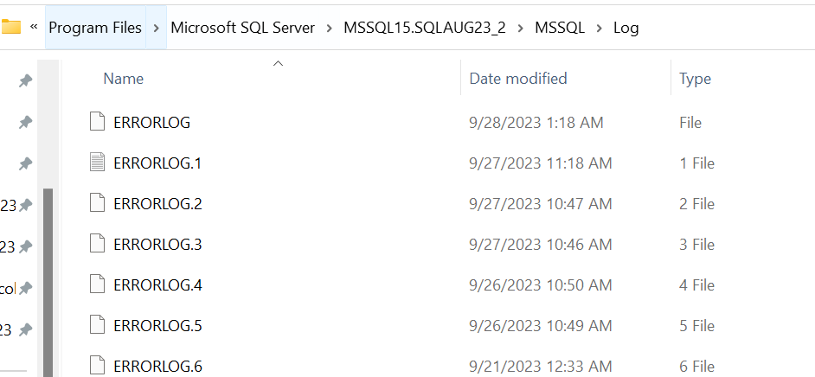

What exactly the error log contains:

SQL server versions, edition, patch level, build number and OS details:

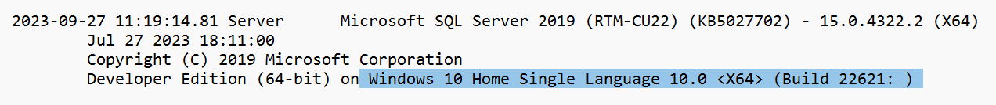

Time Zone, Hardware and Authentication details:

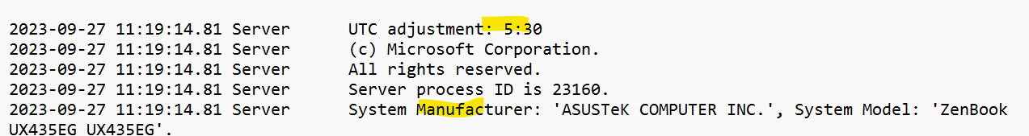



Reading the startup parameters:

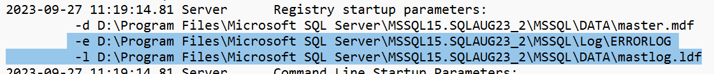

Brings the master database online:



Brings all the user databases online:

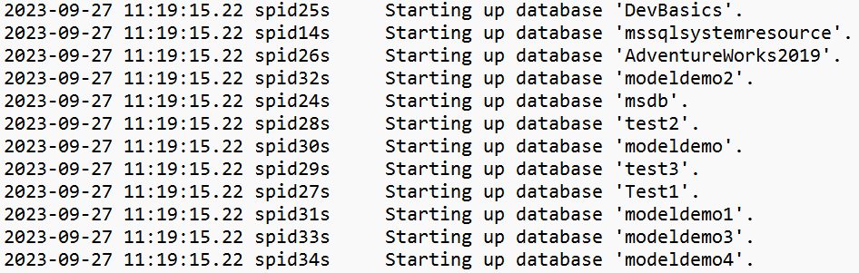



Clears the Tempdb and then it will create a new tempdb:





CPU and Memory:





Port information:



Option #2: SSMS GUI

Connect to SQL server🡪Management🡪SQL server logs

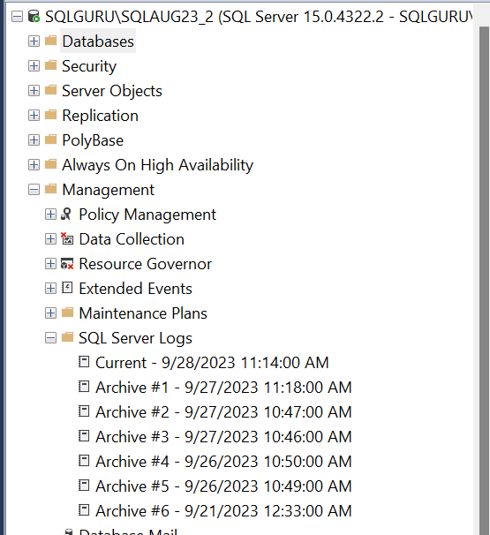

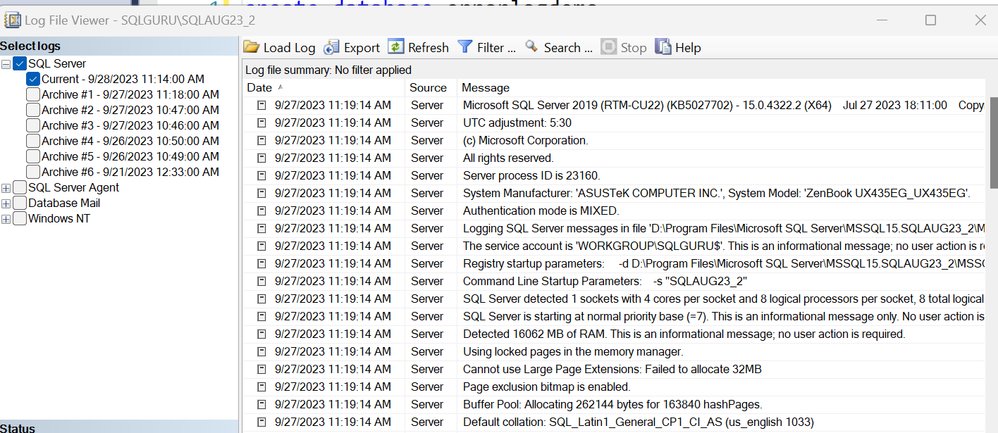

What is the default error log count?

6 (1 Current, 6 Archives)

Whenever we restart the SQL server, the current becomes archive #1 and it created new current file and when the current file reaches to threshold, then it will create a new error log file

Can we change the default error log count ?

Yes (6-99)

How to change it ?

Right click SQL server logs🡪configure

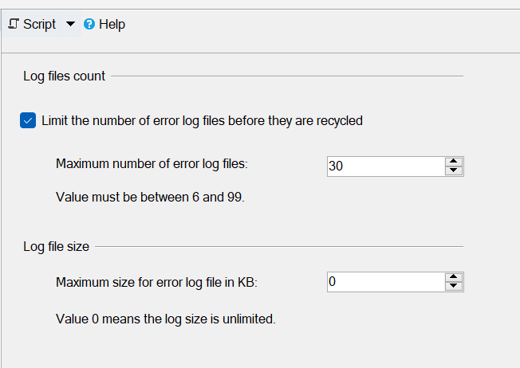

Recycle error log:

sp_cycle_errorlog

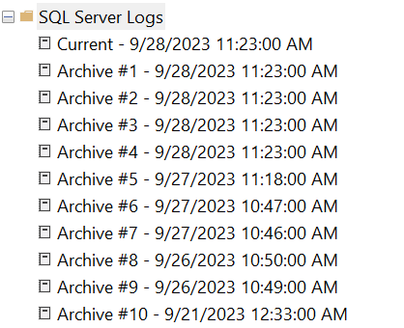

Option #3:

sp_readerrorlog --reads the current error log file

sp_readerrorlog 0,1 --read the current error log

--1 st paramter -->file number

--2 nd paramter -->file type

--1: SQL server log

--2: SQL server agent log

--3 rd paramter: search string #1

--4 th paramter: search string #2

sp_readerrorlog 8,1 --Archive #8 of SQL server log

sp_readerrorlog 1,1 --Archive #1 of SQL server log

sp_readerrorlog 0,2 -- Curent agent error log

sp_readerrorlog 4,2 -- Archive #4 of agent log

sp_readerrorlog 0,1,'error','log' -- Curent SQL server error log

Moving system Database:

When we install the SQL server with all the default options, the SQL Server will be installed in C – Drive and all the system databases will be created in C -drive. It is not a recommended by Microsoft to keep the databases in C-drive. As part of our assessment, when ever we find any of the database files are created in C -drive, we need to move the databases to different drive.

--Moving system databases

--Model

--step1: identify the current location of model database

use model

go

sp_helpfile

--Step2: modify the system catalogue with new path for model

use master

go

alter database model modify file

(name='modeldev',filename='E:\SQLLab\backups\SQLAUG22_1_sysdbs\model.mdf')

alter database model modify file

(name='modellog',filename='E:\SQLLab\backups\SQLAUG22_1_sysdbs\modellog.ldf')

--step3: stop the sql server

--Step4: copy the files from old to new location

--step5: start the SQL server

--Step6: verify the new path

use model

go

sp_helpfile

--Moving system databases

--MSDB

--step1: identify the current location of MSDB database

use msdb

go

sp_helpfile

--Step2: modify the system catalogue with new path for msdb

use master

go

alter database msdb modify file

(name='MSDBData',filename='E:\SQLLab\backups\SQLAUG22_1_sysdbs\MSDBData.mdf')

alter database msdb modify file

(name='MSDBLog',filename='E:\SQLLab\backups\SQLAUG22_1_sysdbs\MSDBLog.ldf')

--step3: stop the sql server

--Step4: copy the files from old to new location

--step5: start the SQL server

--Step6: verify the new path

use msdb

go

sp_helpfile

--Moving system databases

--MSDB

--step1: identify the current location of MSDB database

use tempdb

go

sp_helpfile

--Step2: modify the system catalogue with new path for tempdb

use master

go

alter database tempdb modify file

(name='tempdev',filename='E:\SQLLab\backups\SQLAUG22_1_sysdbs\tempdb.mdf')

alter database tempdb modify file

(name='temp2',filename='E:\SQLLab\backups\SQLAUG22_1_sysdbs\tempdb_mssql_2.ndf')

alter database tempdb modify file

(name='temp3',filename='E:\SQLLab\backups\SQLAUG22_1_sysdbs\tempdb_mssql_3.ndf')

alter database tempdb modify file

(name='temp4',filename='E:\SQLLab\backups\SQLAUG22_1_sysdbs\tempdb_mssql_4.ndf')

alter database tempdb modify file

(name='temp5',filename='E:\SQLLab\backups\SQLAUG22_1_sysdbs\tempdb_mssql_5.ndf')

alter database tempdb modify file

(name='temp6',filename='E:\SQLLab\backups\SQLAUG22_1_sysdbs\tempdb_mssql_6.ndf')

alter database tempdb modify file

(name='temp7',filename='E:\SQLLab\backups\SQLAUG22_1_sysdbs\tempdb_mssql_7.ndf')

alter database tempdb modify file

(name='temp8',filename='E:\SQLLab\backups\SQLAUG22_1_sysdbs\tempdb_mssql_8.ndf')

alter database tempdb modify file

(name='templog',filename='E:\SQLLab\backups\SQLAUG22_1_sysdbs\templog.ldf')

--step3: restart the SQL server

--Step6: verify the new path

use tempdb

go

sp_helpfile

--Moving system databases

--Master

--step1: identify the current location of master database

use master

go

sp_helpfile

--Step2: update the startup parameters with the new path

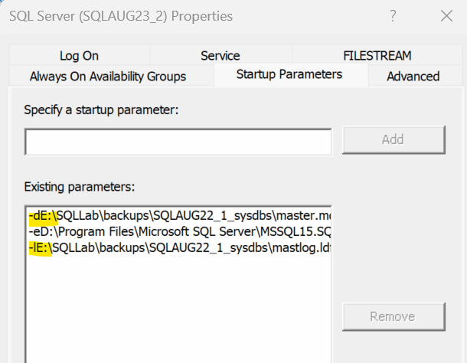

--step3: stop the sql server

--Step4: copy the files from old to new location

--step5: start the SQL server

--Step6: verify the new path

use master

go

sp_helpfile

Moving User Databases:

Option #1: with Alter Statement

--Moving user databases

--Model

--Step1: identify the current location model database

use AdventureWorks2019

go

sp_helpfile

go

--Step2: modify the AdventureWorks2019 database locatin in the system catalogue

alter database [AdventureWorks2019] modify file

(name='AdventureWorks2019',filename='E:\SQLLab\sysdbs\Oct23_1\AdventureWorks2019.mdf')

alter database [AdventureWorks2019] modify file

(name='AdventureWorks2019_log',filename='E:\SQLLab\sysdbs\Oct23_1\AdventureWorks2019_log.ldf')

--step3: offline the AdventureWorks2019 database

use master

go

alter database [AdventureWorks2019] set offline

go

--Step4: copy the files from old to new locations

--Step5: bring the database online

use master

go

alter database [AdventureWorks2019] set online

go

--step6: verify the new path

use [AdventureWorks2019]

go

sp_helpfile

Option #2: Detach and attach

Detach:

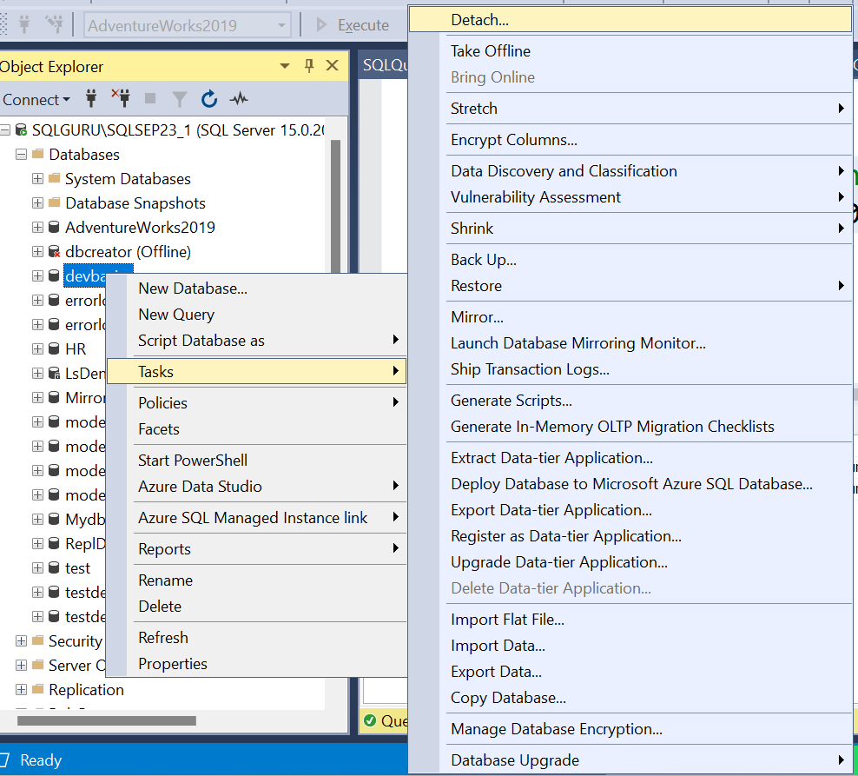

Once the detach is done, copy the files from old to new location

Attach:

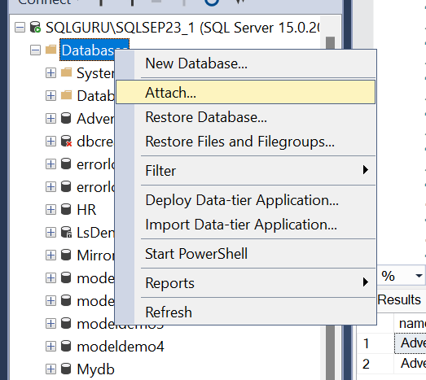

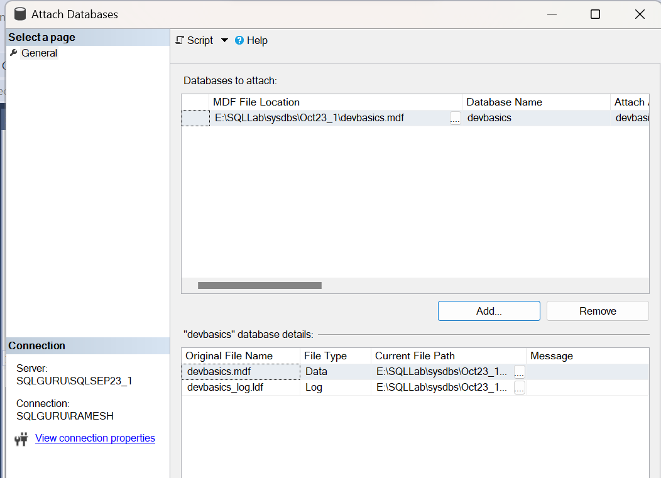

use [devbasics]

go

sp_helpfile

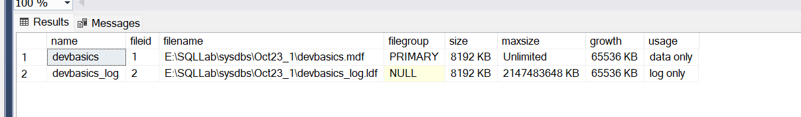

Using T-SQL:

--Detach the database

USE master;

GO

EXEC sp_detach_db @dbname = N'HR';

GO

--Copy the files from old to new location

--Attahc the database

USE master;

GO

CREATE DATABASE HR

ON (FILENAME = 'E:\SQLLab\sysdbs\Oct23_1\HR.mdf'),

(FILENAME = 'E:\SQLLab\sysdbs\Oct23_1\HR_Log.ldf')

FOR ATTACH;

GO

--verify the new path

use HR

GO

sp_helpfile

go

SQL server Architectures:

1. Database Architecture
   1. Data file Architecture
   2. Log file architecture
2. Page Architecture
3. SQL server physical architecture

Database Architecture:

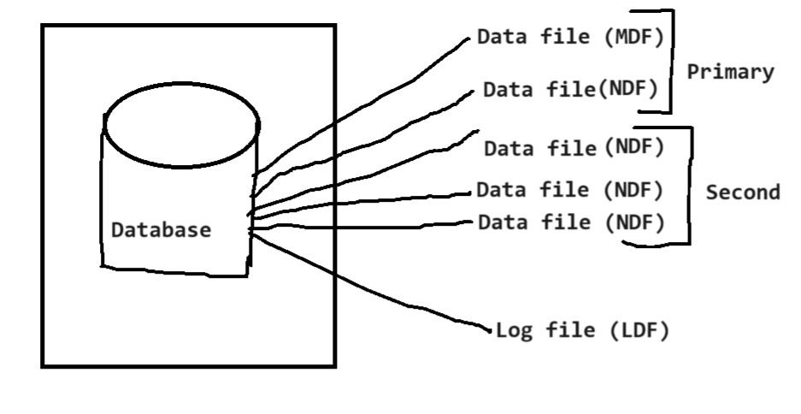

The database gets created with minimum two files

1. Data file (mdf – master data file) 🡪 contains the data
2. Log file (ldf – log data file)🡪contains the transactions

Additionally, we can create multiple data file a database called as secondary data file and gets created with extension of **NDF**

**Data file architecture:**

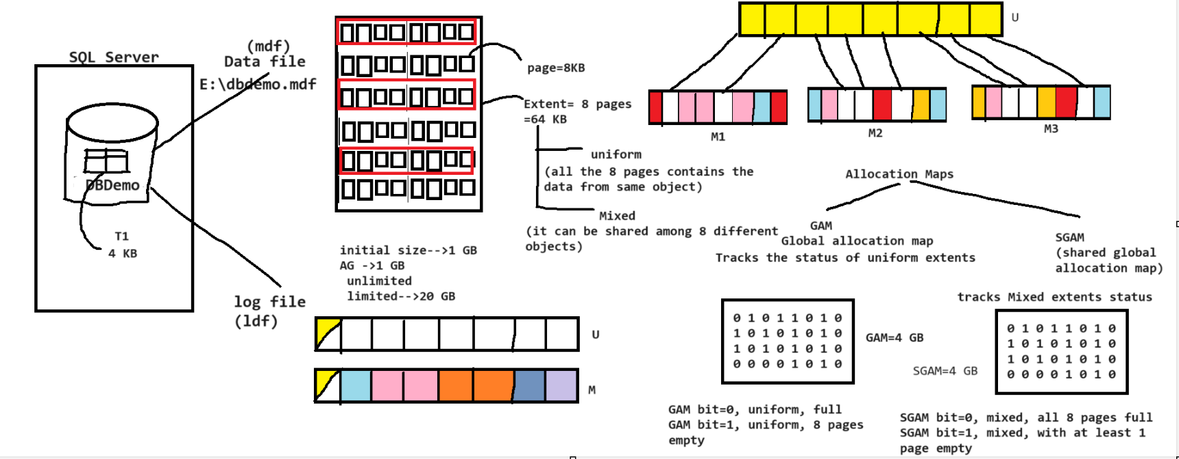

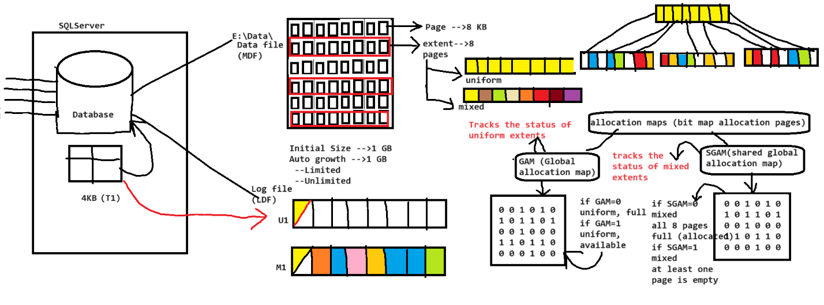

Page Architecture:

Page – a smallest data unit in the data file where SQL server stores actual data and its size is 8 KB

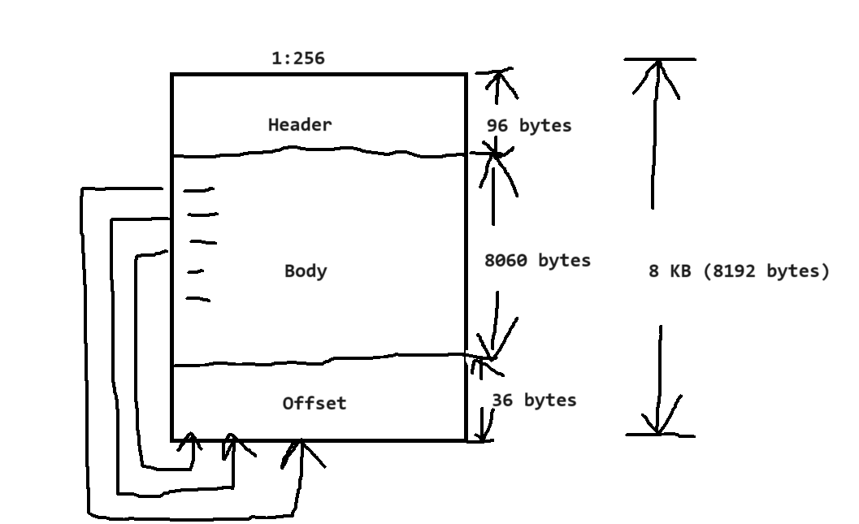

The fundamental unit of data storage in SQL Server is the page. The disk space allocated to a data file (.mdf or .ndf) in a database is logically divided into pages numbered contiguously from 0 to n. Disk I/O operations are performed at the page level. That is, SQL Server reads or writes whole data pages.

Extents are a collection of eight physically contiguous pages and are used to efficiently manage the pages.

The following table shows the page types used in the data files of a SQL Server database.

| **Page type** | **Contents** |
| --- | --- |
| Data | Data rows with all data, except **text**, **ntext**, **image**, **nvarchar(max)**, **varchar(max)**, **varbinary(max)**, and **xml** data, when text in row is set to ON. |
| Index | Index entries. |
| Text/image | Large object data types: **text**, **ntext**, **image**, **nvarchar(max)**, **varchar(max)**, **varbinary(max)**, and **xml** data.  Variable length columns when the data row exceeds 8 KB: **varchar**, **nvarchar**, **varbinary**, and **sql_variant**. |
| Global Allocation Map (GAM)  Shared Global Allocation Map (SGAM) | Information about whether extents are allocated. |
| Page Free Space (PFS) | Information about page allocation and free space available on pages. |
| Index Allocation Map (IAM) | Information about extents used by a table or index per allocation unit. |
| Bulk Changed Map (BCM) | Information about extents modified by bulk operations since the last BACKUP LOG statement per allocation unit. |
| Differential Changed Map (DCM) | Information about extents that have changed since the last BACKUP DATABASE statement per allocation unit. |

### Extents

Extents are the basic unit in which space is managed. An extent is eight physically contiguous pages, or 64 KB. This means that SQL Server databases have 16 extents per megabyte.

SQL Server has two types of extents:

* **Uniform** extents are owned by a single object; all eight pages in the extent can only be used by the owning object.
* **Mixed** extents are shared by up to eight objects. Each of the eight pages in the extent can be owned by a different object.

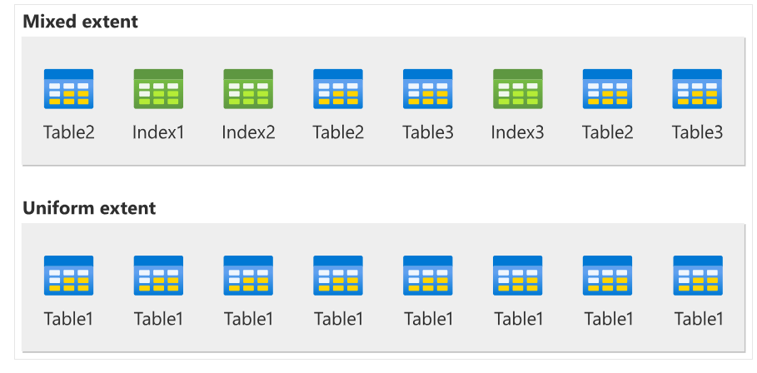

Log file Architecture:

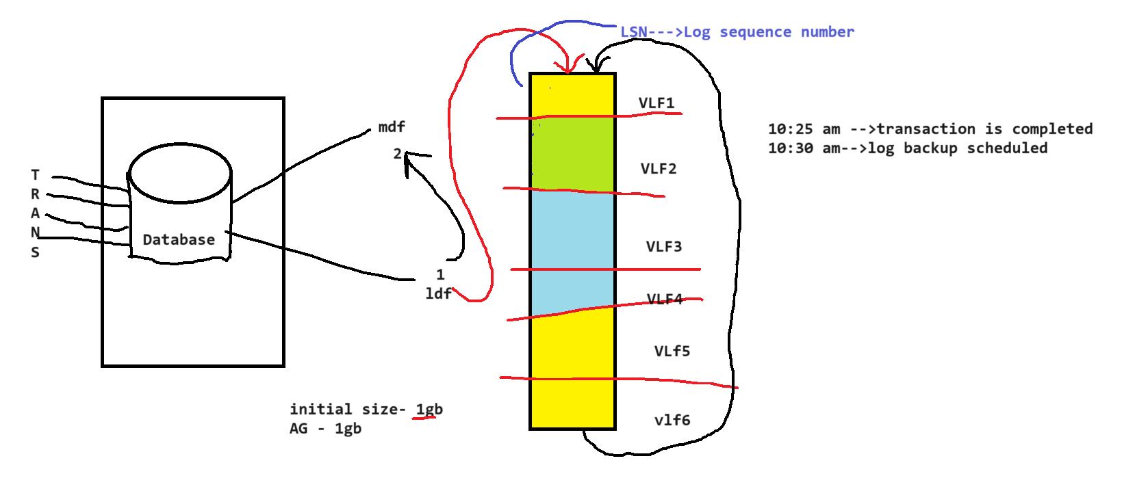

Each Transaction log record that is written to the SQL Server transaction log file can be identified by its **Log Sequence Number** (LSN)

Reading the transaction log:

SELECT [Current LSN],[Operation] ,[Transaction ID],[Previous LSN] ,[AllocUnitName],[Previous Page LSN],

[Page ID],[XACT ID],[Begin Time],[End Time]

FROM sys.fn_dblog (NULL, NULL)

SQL server Architecture: 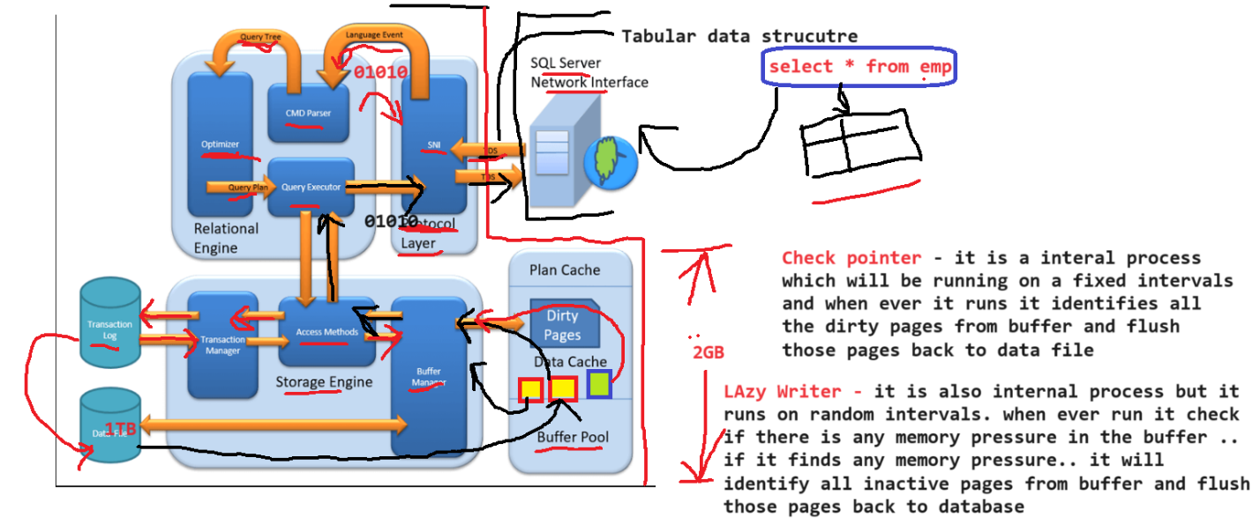

MS SQL Server is a client-server architecture. MS SQL Server process starts with the client application sending a request. The SQL Server accepts, processes and replies to the request with processed data. Let’s discuss in detail the entire architecture shown below:

As the below Diagram depicts there are three major components in SQL Server Architecture:

* Protocol Layer
* Relational Engine
* Storage Engine

## Protocol Layer – SNI

MS SQL SERVER PROTOCOL LAYER supports 3 Type of Client Server Architecture. We will start with “**Three** **Type** **of** **Client Server Architecture”** which MS SQL Server supports.

### Shared Memory

Let’s reconsider an early morning Conversation scenario.

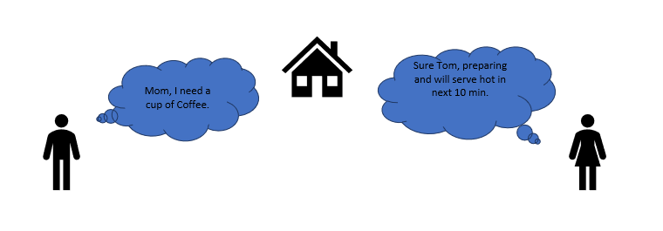

MOM and TOM – Here Tom and his Mom, were at the same logical place, i.e. at their home. Tom was able to ask for Coffee and Mom was able it serve it hot.

EXPLORE MORE

**MS SQL SERVER –** Here **MS SQL** server provides **SHARED MEMORY PROTOCOL**. Here **CLIENT** and **MS SQL** server run on the same machine. Both can communicate via Shared Memory protocol.

**Analogy:** Lets map entities in the above two scenarios. We can easily map Tom to Client, Mom to SQL server, Home to Machine, and Verbal Communication to Shared Memory Protocol.

**From the desk of configuration and installation:**

For Connection to Local DB – In SQL Management Studio, “Server Name” Option could be

“.”

“localhost”

“127.0.0.1”

“Machine\Instance”

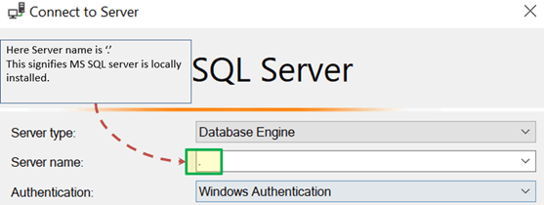

### TCP/IP

Now consider in the evening, Tom is in the party mood. He wants a Coffee ordered from a well-known Coffee Shop. The Coffee shop is located 10 km away from his home.

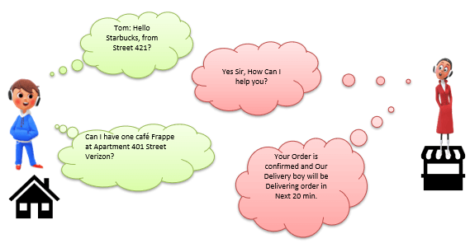

Here Tom and Starbuck are in different physical location. Tom at home and Starbucks at the busy marketplace. They’re communicating via Cellular network. Similarly, MS SQL SERVER provides the capability to interact via TCP/IP protocol, where CLIENT and MS SQL Server are remote to each other and installed on a separate machine.

**Analogy:** Lets map entities in the above two scenarios. We can easily map Tom to Client, Starbuck to SQL server, the Home/Market place to Remote location and finally Cellular network to TCP/IP protocol.

**Notes from the desk of Configuration/installation:**

* In SQL Management Studio – For Connection via TCP\IP, “Server Name” Option has to be “Machine\Instance of the server.”
* SQL server uses port 1433 in TCP/IP.

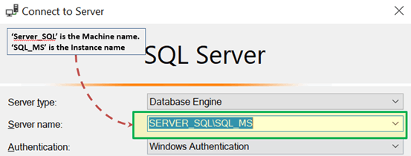

### Named Pipes

Now finally at night, Tom wanted to have a light green tea which her neighbor, Sierra prepare very well.

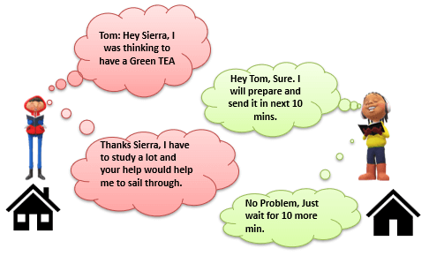

Here **Tom** and his **Neighbor**, Sierra, are in same **physical** **location, being each other’s neighbor.**They’re communicating via**Intra network.**Similarly, **MS SQL SERVER** provides the capability to interact via the **Named Pipe** protocol. Here the CLIENT and **MS SQL SERVER** are in connection via **LAN**.

**Analogy:** Lets map entities in the above two scenarios. We can easily map Tom to Client, Sierra to SQL server, Neighbor to LAN and finally Intra network to Named Pipe Protocol.

**Notes from the desk of Configuration/installation:**

* **For Connection via Named Pipe.** This option is disabled by default and needs to be enabled by the SQL Configuration Manager.

### What is TDS?

Now that we know that there are three types of Client-Server Architecture, lets us have a glance at TDS:

* TDS stands for Tabular Data Stream.
* All 3 protocols use TDS packets. TDS is encapsulated in Network packets. This enables data transfer from the client machine to the server machine.
* TDS was first developed by Sybase and is now Owned by Microsoft

## Relational Engine

The Relational Engine is also known as the Query Processor. It has the SQL Server components that determine what exactly a query needs to do and how it can be done best. It is responsible for the execution of user queries by requesting data from the storage engine and processing the results that are returned.

As depicted in the Architectural Diagram there are **3 major components** of the Relational Engine. Let’s study the components in detail:

### CMD Parser

Data once received from Protocol Layer is then passed to Relational Engine. **“CMD Parser”**is the first component of Relational Engine to receive the Query data. The principal job of CMD Parser is to check the query for **Syntactic and Semantic error.** Finally, it **generates a Query Tree**. Let’s discuss in detail.

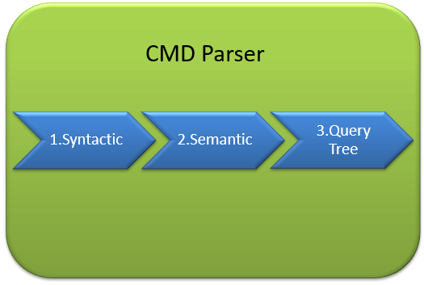

**Syntactic check:**

* Like every other Programming language, MS SQL also has the predefined set of Keywords. Also, SQL Server has its own grammar which SQL server understands.
* SELECT, INSERT, UPDATE, and many others belong to MS SQL predefined Keyword lists.
* CMD Parser does syntactic check. If users’ input does not follow these language syntax or grammar rules, it **returns an error.**

**Example:** Let’s say a Russian went to a Japanese restaurant. He orders fast food in the Russian language. Unfortunately, the waiter only understands Japanese. What would be the most obvious result?

The Answer is – the waiter is unable to process the order further.

There should not be any deviation in Grammar or language which SQL server accepts. If there are, SQL server cannot process it and hence will return an error message.

We will learn about MS SQL query more in upcoming tutorials. Yet, consider below most basic Query Syntax as

SELECT * from <TABLE_NAME>;

Now, to get the perception of what syntactic does, say if the user runs the basic query as below:

SELECR * from <TABLE_NAME>

Note that instead of ‘SELECT’ user typed “SELECR.”

**Result:**THE CMD Parser will parse this statement and will throw the error message. As “SELECR” does not follow the predefined keyword name and grammar. Here CMD Parser was expecting “SELECT.”

**Semantic check:**

* This is performed by **Normalizer**.
* In its simplest form, it checks whether Column name, Table name being queried exist in Schema. And if it exists, bind it to Query. This is also known as **Binding**.
* Complexity increases when user queries contain VIEW. Normalizer performs the replacement with the internally stored view definition and much more.

Let’s understand this with help of below example –

SELECT * from USER_ID

**Result:**THE CMD Parser will parse this statement for Semantic check. The parser will throw an error message as Normalizer will not find the requested table (USER_ID) as it does not exist.

**Create Query Tree:**

* This step generates different execution tree in which query can be run.
* Note that, all the different trees have the same desired output.

### Optimizer

The work of the optimizer is to create an execution plan for the user’s query. This is the plan that will determine how the user query will be executed.

Note that not all queries are optimized. Optimization is done for DML (Data Modification Language) commands like SELECT, INSERT, DELETE, and UPDATE. Such queries are first marked then send to the optimizer. DDL commands like CREATE and ALTER are not optimized, but they are instead compiled into an internal form. The query cost is calculated based on factors like CPU usage, Memory usage, and Input/ Output needs.

Optimizer’s role is to find the **cheapest, not the best, cost-effective execution plan.**

Before we Jump into more technical detail of Optimizer consider below real-life example:

**Example:**

Let’s say, you want to open an online Bank account. You already know about one Bank which takes a maximum of 2 Days to open an account. But, you also have a list of 20 other banks, which may or may not take less than 2 days. You can start engaging with these banks to determine which banks take less than 2 days. Now, you may not find a bank which takes less than 2 Days, and there is additional time lost due to the search activity itself. It would have been better to open an account with the first bank itself.

**Conclusion:**It’s is more important to select wisely. To be precise, choose which **option is best, not the cheapest.**

Similarly, MS **SQL Optimizer works on inbuilt exhaustive/heuristic algorithms. The goal is to minimize query run time.**All the Optimizer algorithms are **propriety of Microsoft and a secret.**Although**,** below are the high-level steps performed by MS SQL Optimizer. Searches of Optimization follows three phases as shown in the below diagram:

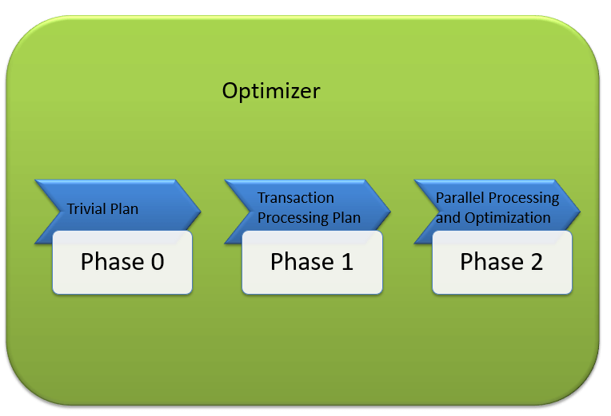

#### Phase 0: Search for Trivial Plan:

* This is also known as **Pre-optimization stage**.
* For some cases, there could be only one practical, workable plan, known as a trivial plan. There is no need for creating an optimized plan. The reason is, searching more would result in finding the same run time execution plan. That too with the extra cost of Searching for optimized Plan which was not required at all.
* If no Trivial plan found, then 1st Phase starts.

#### Phase 1: Search for Transaction processing plans

* This includes the search for **Simple and Complex Plan**.
* Simple Plan Search: Past Data of column and Index involved in Query, will be used for Statistical Analysis. This usually consists but not restricted to one Index Per table.
* Still, if the simple plan is not found, then more complex Plan is searched. It involves Multiple Index per table.

#### Phase 2: Parallel Processing and Optimization.

* If none of the above strategies work, Optimizer searches for Parallel Processing possibilities. This depends on the Machine’s processing capabilities and configuration.
* If that is still not possible, then the final optimization phase starts. Now, the final optimization aim is finding all other possible options for executing the query in the best way. Final optimization phase Algorithms are Microsoft Propriety.

### Query Executor

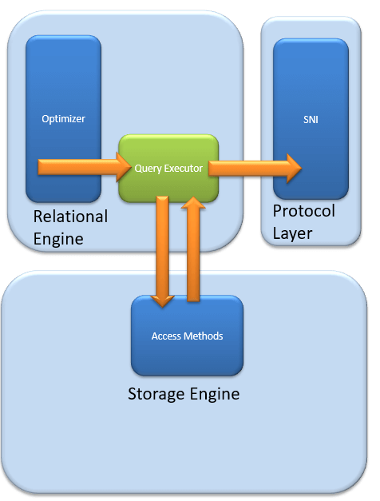

Query executer calls **Access Method.**It provides an execution plan for data fetching logic required for execution.Once data is received from Storage Engine, the result gets published to the Protocol layer. Finally, data is sent to the end user.

## Storage Engine

The work of the Storage Engine is to store data in a storage system like Disk or SAN and retrieve the data when needed. Before we deep dive into Storage engine, let’s have a look at how data is stored in **Database**and**type of files available.**

#### Data File and Extent:

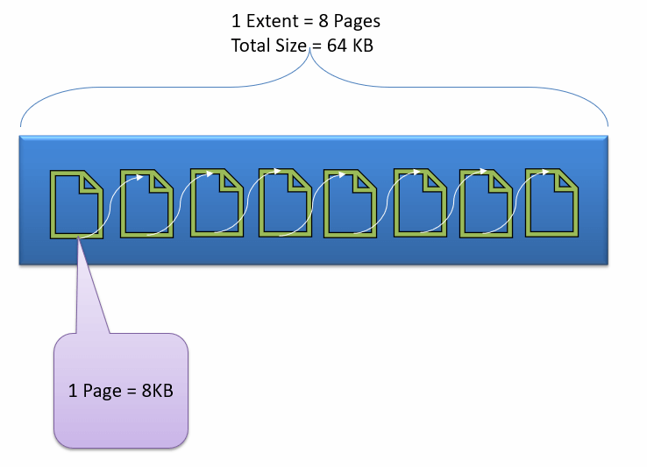

Data File, physically stores data in the form of data pages, with each data page having a size of 8KB, forming the smallest storage unit in SQL Server. These data pages are logically grouped to form extents. No object is assigned a page in SQL Server.

The maintenance of the object is done via extents. The page has a section called the Page Header with a size of 96 bytes, carrying the metadata information about the page like the Page Type, Page Number, Size of Used Space, Size of Free Space, and Pointer to the next page and previous page, etc.

### File types

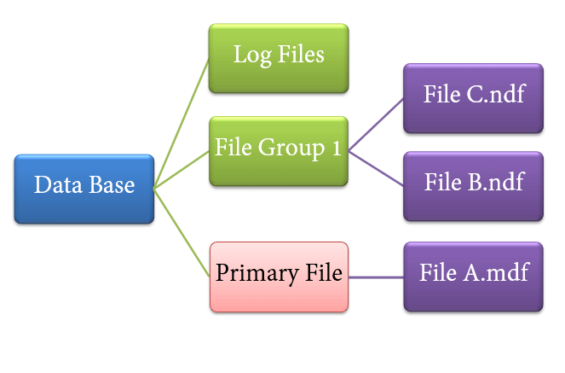

1. **Primary file**

* Every database contains one Primary file.
* This store all important data related to tables, views, Triggers, etc.
* Extension is .**mdf** usually but can be of any extension.

1. **Secondary file**

* Database may or may not contains multiple Secondary files.
* This is optional and contain user-specific data.
* Extension is .**ndf** usually but can be of any extension.

1. **Log file**

* Also known as Write ahead logs.
* Extension is .**ldf**
* Used for Transaction Management.
* This is used to recover from any unwanted instances. Perform important task of Rollback to uncommitted transactions.

Storage Engine has 3 components; let’s look into them in detail.

### Access Method

It acts as an interface between query executor and Buffer Manager/Transaction Logs.

Access Method itself does not do any execution.

The first action is to determine whether the query is:

1. Select Statement (DDL)
2. Non- Select Statement (DDL & DML)

Depending upon the result, the Access Method takes the following steps:

1. If the query is **DDL**, SELECT statement, the query is pass to the **Buffer Manager** for further processing.
2. And if query if **DDL, NON-SELECT statement**, the query is pass to Transaction Manager. This mostly includes the UPDATE statement.

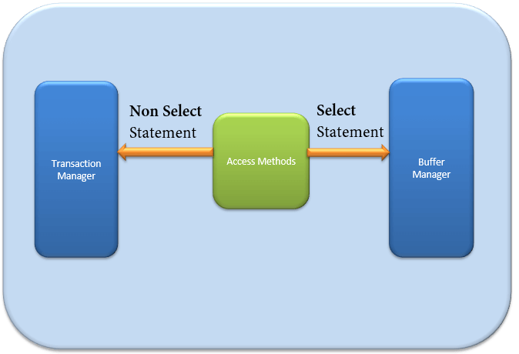

### Buffer Manager

Buffer manager manages core functions for modules below:

* Plan Cache
* Data Parsing: Buffer cache & Data storage
* Dirty Page

We will learn Plan, Buffer and Data cache in this section. We will cover Dirty pages in the Transaction section.

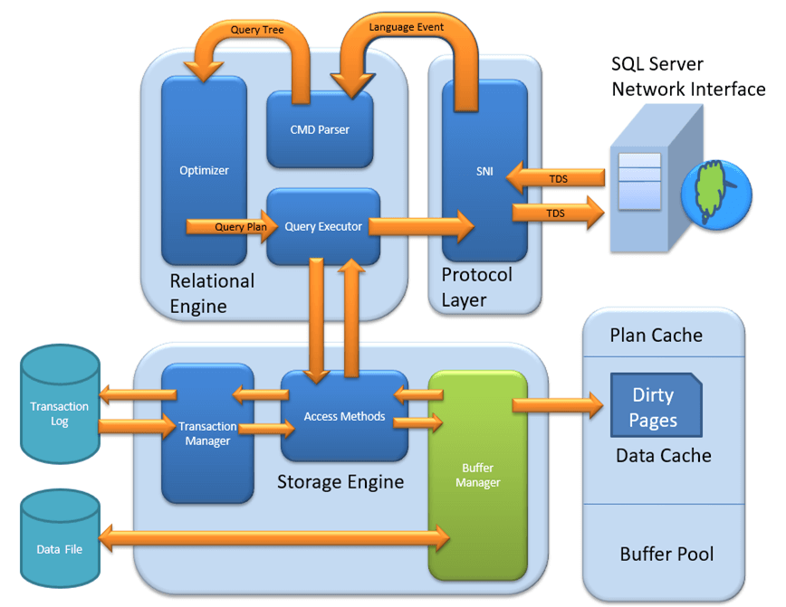

### Plan Cache

* **Existing Query plan:**The buffer manager checks if the execution plan is there in the stored Plan Cache. If Yes, then query plan cache and its associated data cache is used.
* **First time Cache plan:**Where does existing Plan cache come from?If the first-time query execution plan is being run and is complex, it makes sense to store it in in the Plane cache. This will ensure faster availability when the next time SQL server gets the same query. So, it’s nothing else but the query itself which Plan execution is being stored if it is being run for the first time.

### Data Parsing: Buffer cache & Data Storage

Buffer manager provides access to the data required. Below two approaches are possible depending upon whether data exist in the data cache or not:

#### Buffer Cache – Soft Parsing:

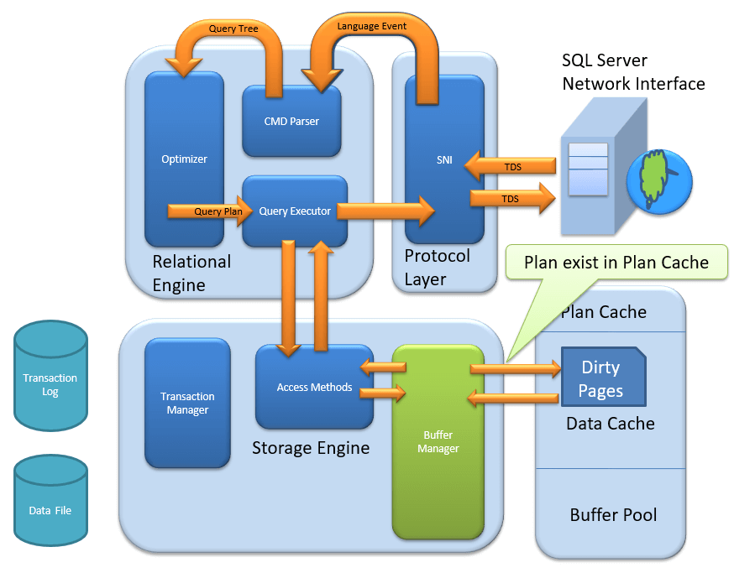

Buffer Manager looks for Data in Buffer in Data cache. If present, then this Data is used by Query Executor. This improves the performance as the number of I/O operation is reduced when fetching data from the cache as compared to fetching data from Data storage.

#### Data Storage – Hard Parsing:

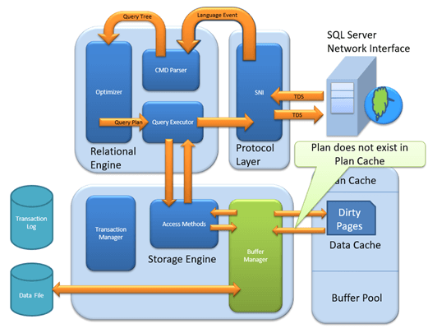

If data is not present in Buffer Manager than required Data is searched in Data Storage. If also stores data in the data cache for future use.

#### Dirty Page

It is stored as a processing logic of Transaction Manager. We will learn in detail in Transaction Manager section.

### Transaction Manager

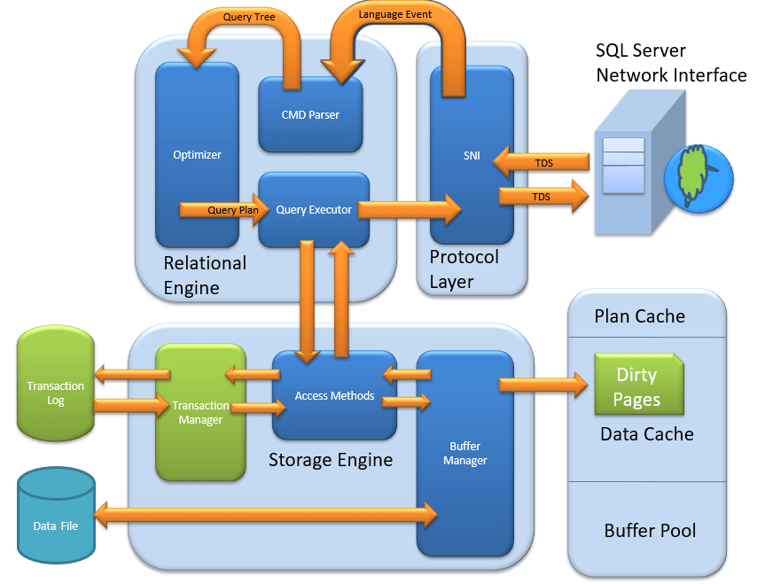

Transaction Manager is invoked when access method determines that Query is a Non-Select statement.

#### Log Manager

* Log Manager keeps a track of all updates done in the system via logs in Transaction Logs.
* Logs have **Logs Sequence Number with the Transaction ID and Data Modification Record**.
* This is used for keeping track of **Transaction Committed and Transaction Rollback**.

#### Lock Manager

* During Transaction, the associated data in Data Storage is in the Lock state. This process is handled by Lock Manager.
* This process ensures **data consistency and isolation**. Also known as ACID properties.

#### Execution Process

* Log Manager start logging and Lock Manager locks the associated data.
* Data’s copy is maintained in the Buffer cache.
* Copy of data supposed to be updated is maintained in Log buffer and all the events updates data in Data buffer.
* Pages which store the data is also known as **Dirty Pages**.
* **Checkpoint and Write-Ahead Logging:**This process run and mark all the page from Dirty Pages to Disk, but the page remains in the cache. Frequency is approximately 1 run per minute. But the page is first pushed to Data page of the log file from Buffer log. This is known as **Write Ahead Logging.**
* **Lazy Writer:**The Dirty page can remain in memory. When SQL server observes a huge load and Buffer memory is needed for a new transaction, it frees up Dirty Pages from the cache. It operates on **LRU** – Least recently used Algorithm for cleaning page from buffer pool to disk.

Backups and Recovery:

Backup – maintaining another copy of original data in different location. If something goes wrong with original database, we can recover the data from the backup.

Backup Architecture:

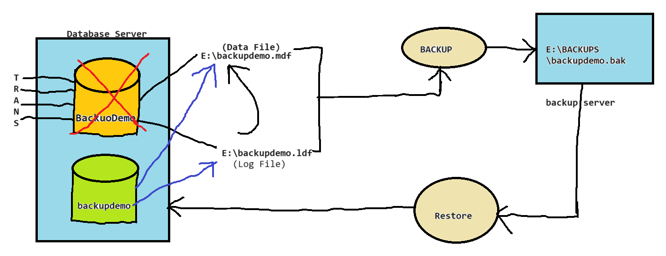

Backup Types:

* Full backup
* Differential backup
* Log backup or T-log backup
* File and File group backups
* Split backups
* Mirror backups
* Tail log backup
* Copy only backups

Full back up : it takes the backup of entire database. If I have the database size if 100 GB then if we take full backup of that database the database size will 100 Gb. The extension for full backup ‘BAK’

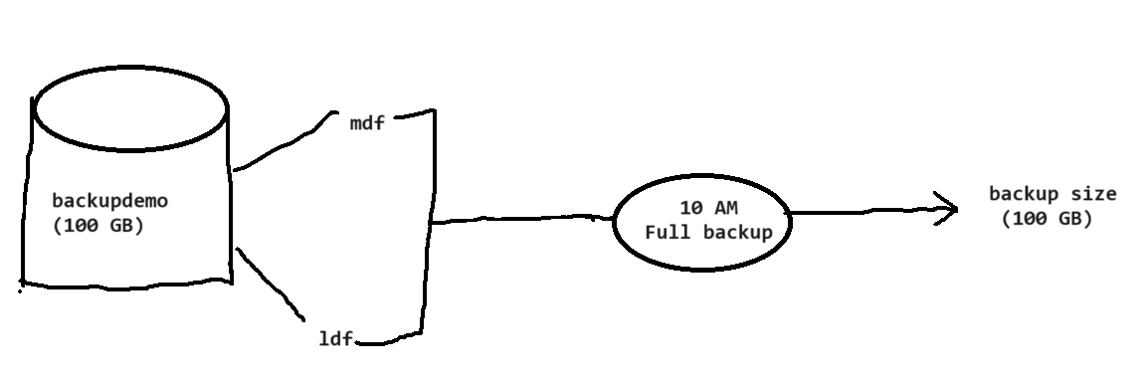

Differential Backup: it takes the backup of all the changes (pages, extents) happened to the database from last successful full backup. The extension of differential backup is ‘BAK’. If we have taken full backup of the database at 10 am and there is about 10 Gb worth of changes happened to the database from 10 am🡪4 PM. Now if we perform differential backup at 4 PM. The differential backup size will be 10 GB

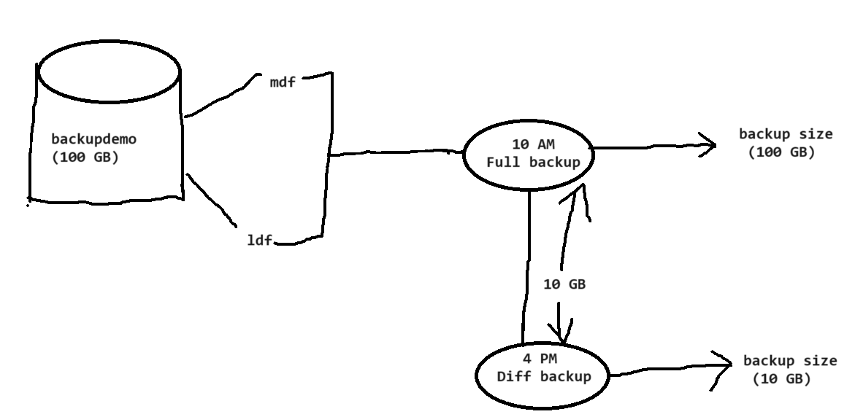

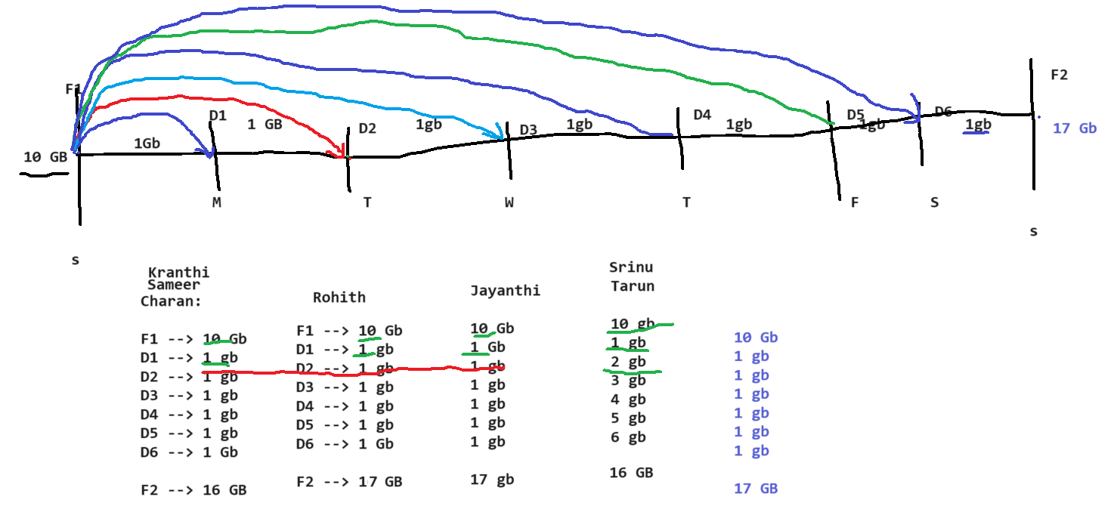

Log backup: it takes the backup of all the transactions available in the log file. Once the log backup is done, it will truncate those transactions from the log file. The extension of log backup is **‘TRN’**

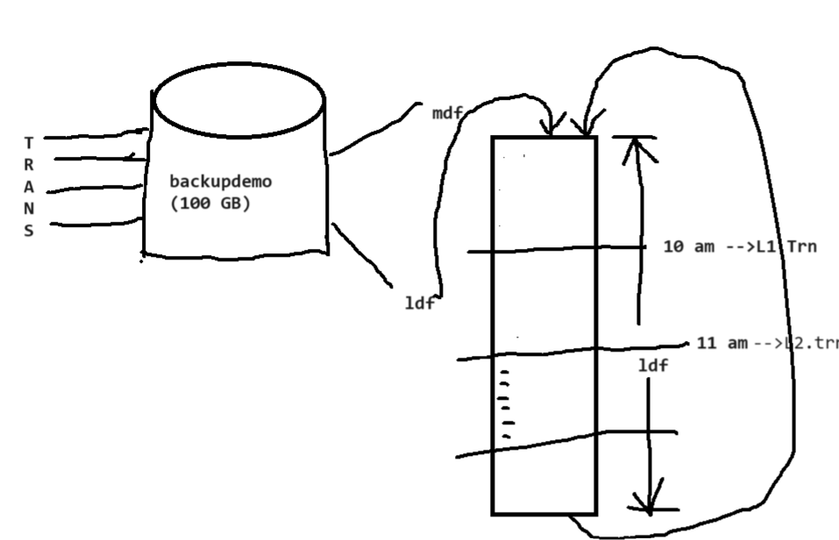

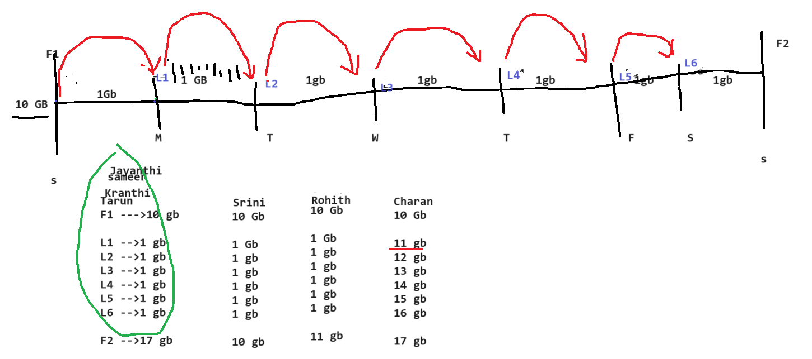

Backup Strategy –

* Weekly full backups – Sunday 12:00 am
* Daily Differential backups – every day 10 am
* Log backups for every 1 hours

The database is crashed at 4.30 PM on Thursday

Recovery process:

Step1: restore latest Sunday full backup

Step2: Restore Thursday 10 am differential backup

Step3: Restore 11 am, 12 pm, 1 pm, 2pm, 3 pm and 4 log backups sequentially one by one

Failure point 🡪 the exact time at which the database is crashed. In above example “Thursday 4.30 PM” is the failure point

PIR (Point in Time recovery) – the process of recovering the database to the exact failure point is called Point In Time recovery

Recovery Model: is database level property which decides what all are the backups can be performed for a database

Types of recovery models:

* Simple- In simple recovery model, the transaction log (ldf) gets truncated automatically in a regular interval when the check pointer occurs. So, we cannot take log backup. If we don’t have log backups, we cannot achieve point in time recovery. It is recommended only for non-production databases
* Bulk logged recovery – In bulk logged recovery model, the transactions will be minimally logged for bulk operations like bulk insert, select into, bcp, index rebuild ..etc, so it will save the transaction log space for bulk operations

Case 1 – if the database is in bulk logged recovery model and there are no bulk operations. So, it treats as full recovery model we can achieve PIR

Case 2 - if the database is in bulk logged recovery model and there are bulk operations. Then we cannot achieve PIR

* Full recovery model – In full recovery model, all the transactions will be fully logged into the transaction log file and there wont be any automatic truncation happens. So it will allows us to take transaction log backup and as we have transaction log backup we can achieve the PIR. It is recommended to use for all production databases

How to find the recovery model:

Option #1 – right click on the database🡪properties🡪options

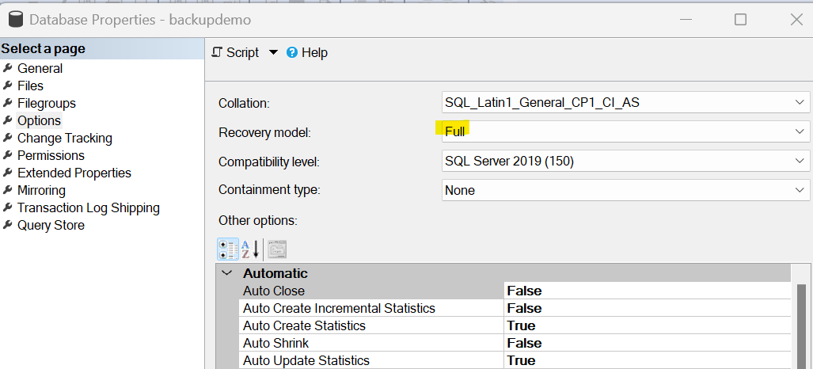

Option #2 –

select name, recovery_model_desc

from sys.databases

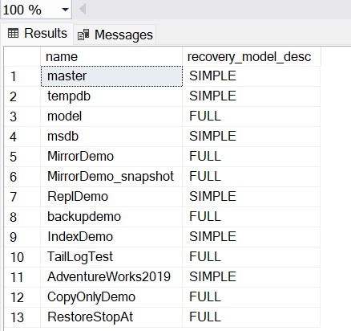

Option #3 sp_helpdb

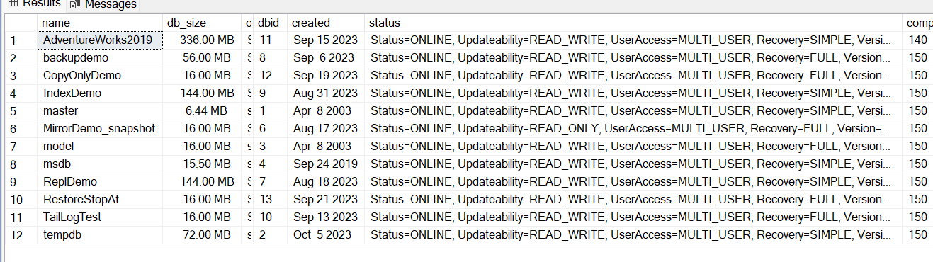

How to change the recovery model:

alter database [AdventureWorks2019] set recovery full

alter database [AdventureWorks2019] set recovery simple

alter database [AdventureWorks2019] set recovery bulk_logged

Recovery Models of System databases:

* Master 🡪Simple, yes we can change
* Model🡪Full, yes we can change
* Msdb🡪simple, we can change
* Tempdb🡪simple (We can change)

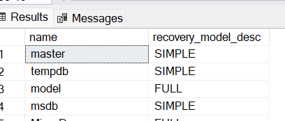

Recovery state/Restore options:

* Restore with no recovery 🡪when there are further backups to be restored then we can use with no recovery. It will restore the backup, but it will not bring the database online, it will keep in restoring state and we cannot access it

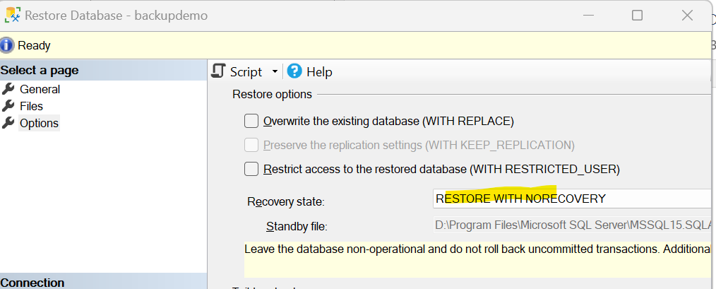

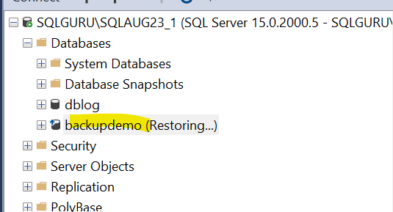

* Restore with recovery🡪 If there are no further backups and this is last backup which we need to restore then we can use With recovery. Then it restores the backups and brings the database online

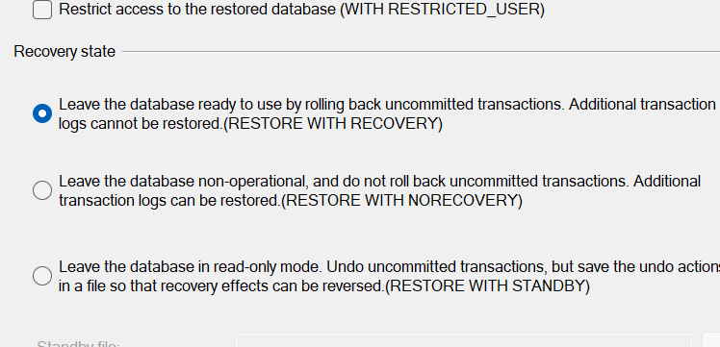

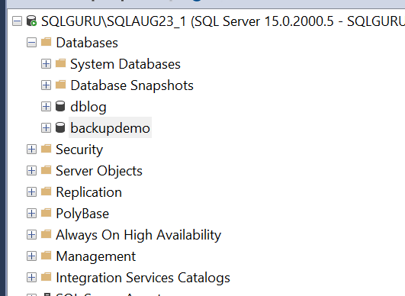

* Restore with Stand by🡪it restores the database and brings the database online in stand by readonly mode

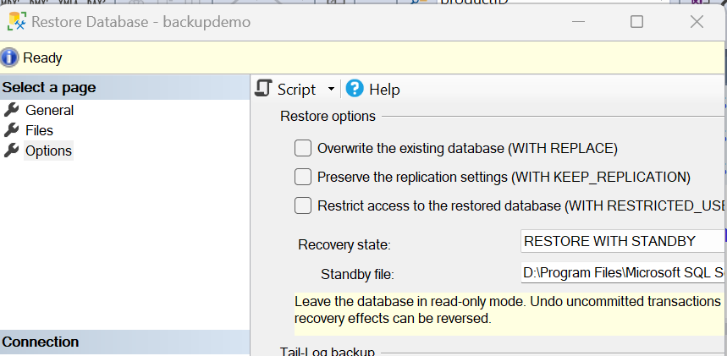

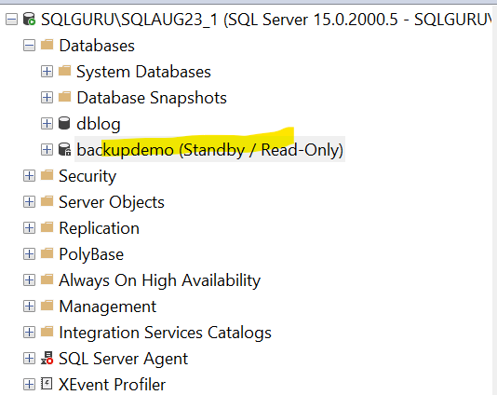

Backup Strategy –

* Weekly full backups – Sunday 12:00 am
* Daily Differential backups – every day 10 am
* Log backups for every 1 hours

The database is crashed at 4.30 PM on Thursday

Recovery process:

Step1: restore latest Sunday full backup w/n

Step2: Restore Thursday 10 am differential backup w/n

Step3: Restore 11 am, 12 pm, 1 pm, 2pm, 3 pm w/n

Step4: Restore 4 log backup w/r

How many ways we can take backups:

* 1. SSMS 🡪GUI

SSMS 🡪TSQL commands

Backups:

create database backupdemo

go

use backupdemo

go

create table employee (id int, name varchar(50))

go

insert into employee values (1, 'full backup')

go 10

--Take a full backup

backup database [backupdemo]

to disk='E:\SQLLab\backups\backupdemo.bak'

insert into employee values (2, 'Diff backup')

go 10

backup database [backupdemo]

to disk='E:\SQLLab\backups\backupdemo_diff.bak'

with differential

insert into employee values (3, 'log backup1')

go 10

backup log [backupdemo]

to disk='E:\SQLLab\backups\backupdemo1.trn'

insert into employee values (4, 'log backup2')

go 10

backup log [backupdemo]

to disk='E:\SQLLab\backups\backupdemo2.trn'

Restore Commands:

--Restore a full backup

restore database [backupdemo]

from disk='E:\SQLLab\backups\backupdemo.bak'

with norecovery

restore database [backupdemo]

from disk='E:\SQLLab\backups\backupdemo_diff.bak'

with norecovery

restore log [backupdemo]

from disk='E:\SQLLab\backups\backupdemo1.trn'

with norecovery

restore log [backupdemo]

from disk='E:\SQLLab\backups\backupdemo2.trn'

with recovery

SQL server agent service

* 1. SQL Server Maintenance plans
  2. PowerShell
  3. Third party tools
* SSMS GUI:

File and File group backup:

Instead of taking entire database backup, If we want to take a backup of particular file or file groups then we can use file and file group backups

File backup 🡪GUI:

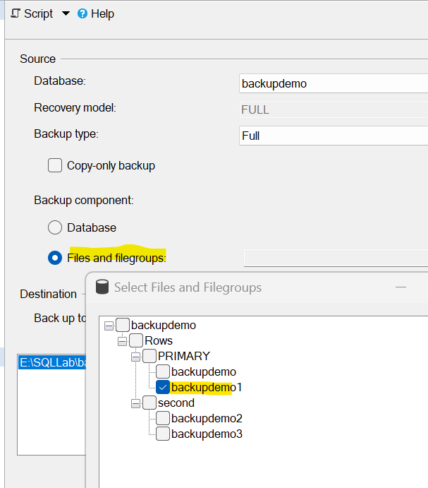

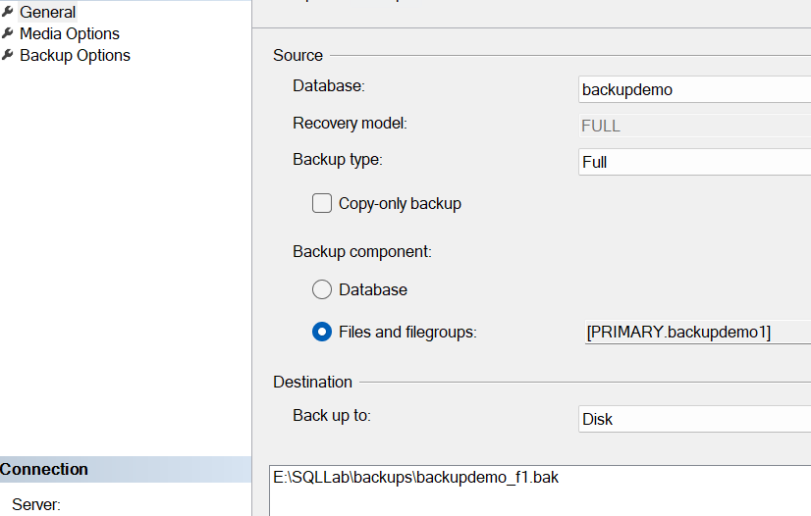

T-SQL:

backup database [backupdemo] file='backupdemo2'

to disk='E:\SQLLab\backups\backupdemo_f2.bak'

Processed 8 pages for database **'backupdemo', file 'backupdemo2'** on file 1.

Processed 1 pages for database **'backupdemo', file 'backupdemo_log'** on file 1.

BACKUP DATABASE...FILE=<name> successfully processed 9 pages in 0.005 seconds (14.062 MB/sec).

Completion time: 2023-10-09T11:07:53.6823095+05:30

File Group backup 🡪GUI:

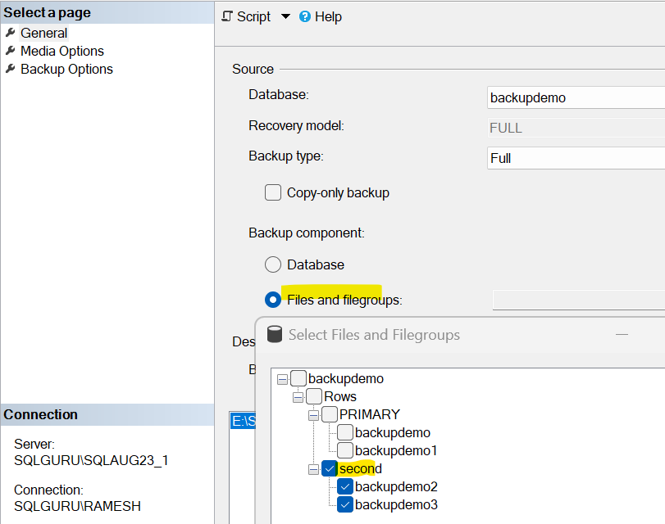

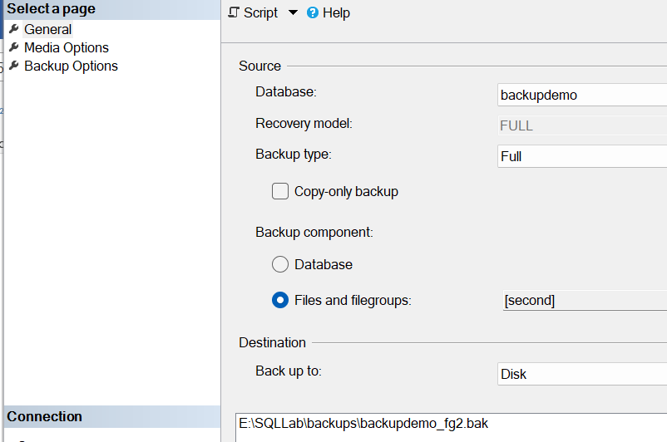

T-SQL:

backup database [backupdemo] filegroup='second'

to disk='E:\SQLLab\backups\backupdemo_fg_2.bak'

Processed 8 pages for database **'backupdemo', file 'backupdemo2**' on file 1.

Processed 8 pages for database **'backupdemo', file 'backupdemo3'** on file 1.

Processed 1 pages for database **'backupdemo', file 'backupdemo_log'** on file 1.

BACKUP DATABASE...FILE=<name> successfully processed 17 pages in 0.006 seconds (22.135 MB/sec).

Completion time: 2023-10-09T11:10:41.7577544+05:30

Split backup:

IF we don’t have enough disk space to accommodate to take backup in one particular drive, we can use split backup, Split backup divides the database backup equally into multiple destinations

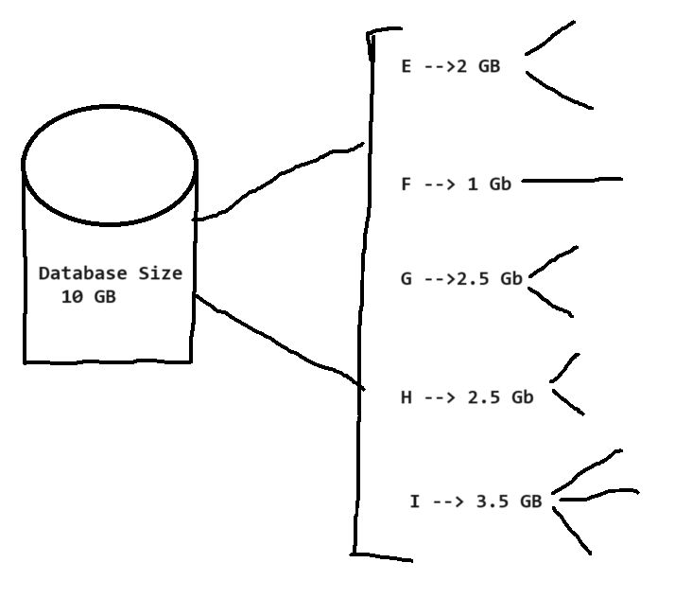

GUI 🡪

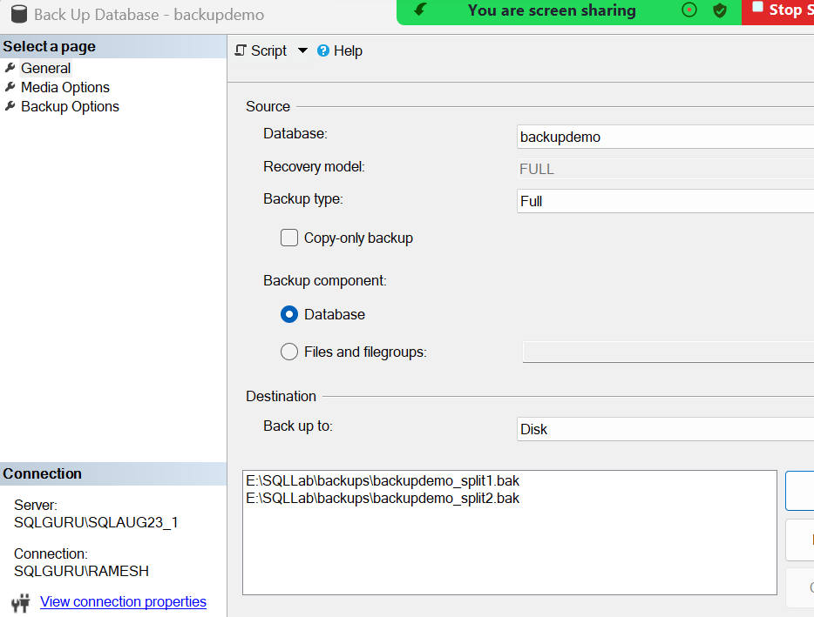

T-SQL:

backup database [backupdemo]

to

disk='E:\SQLLab\backups\backupdemo_s1.bak',

disk='E:\SQLLab\backups\backupdemo_s2.bak',

disk='E:\SQLLab\backups\backupdemo_s3.bak'

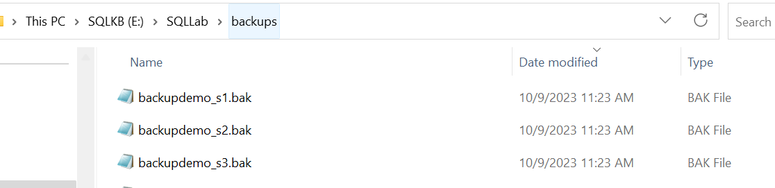

Restore:

Restore database [backupdemo]

from

disk='E:\SQLLab\backups\backupdemo_s1.bak',

disk='E:\SQLLab\backups\backupdemo_s2.bak',

disk='E:\SQLLab\backups\backupdemo_s3.bak'

with recovery, replace

Mirror Backup:

This takes multiple copies of full backup.

backup database [backupdemo]

to disk='E:\SQLLab\backups\backupdemo_M1.bak'

Mirror

to disk='E:\SQLLab\backups\backupdemo_M2.bak' with format

Backup Set🡪

If we take the backup of the database to the same location and to the same physical file multiple time, it will internal create a separate backup set to hold the backup of each execution

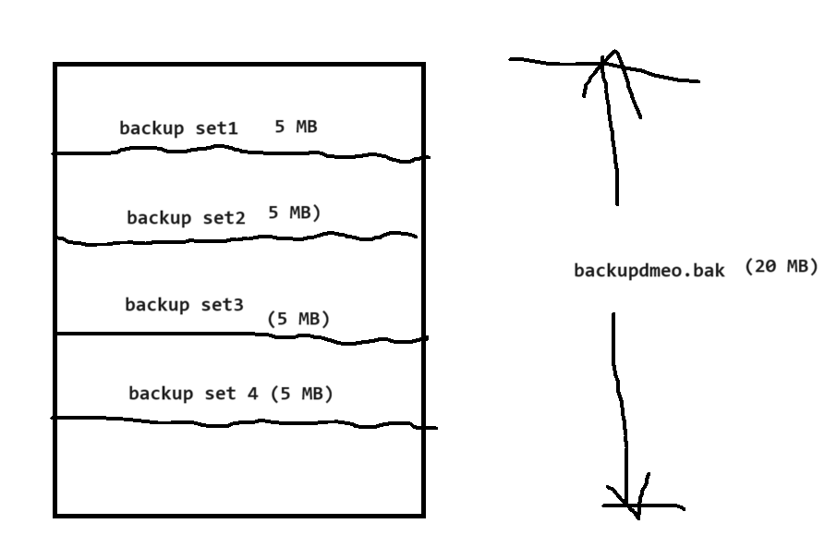

Backup options:

backup database [backupdemo]

to disk='E:\SQLLab\backups\backupdemo.bak'

with stats=2, --backups status in %

init, -->it will overrides the existing backup set

--noinit -->it will create a new backup set every time (default one)

differential, -->it takes the differential backup

format, -->it will clear if there are any disk level inconsistencies

copy_only, --> it will take copy_only backup

no_truncate --> this will take tail log backup

restore database [backupdemo]

from disk='E:\SQLLab\backups\backupdemo.bak'

with stats=2, --backups status in %

norecovery,

recovery,

standby,

replace,

Move

Restore commands:

**--Restore verifyonly** - verifies wether backup is in valid

--restorable format or not

restore verifyonly

from disk='E:\SQLLab\backups\backupdemo.bak'

The backup set on file 1 is valid.

Completion time: 2023-10-09T11:41:20.5132046+05:30

In case if there are any issues with the backup:

Msg 3242, Level 16, State 6, Line 3

The file on device 'E:\SQLLab\backups\backupdemo.bak' is not a valid Microsoft Tape Format backup set.

Msg 3013, Level 16, State 1, Line 3

VERIFY DATABASE is terminating abnormally.

**--Restore Headeronly -- this provides the metadata backup like database name,**

**--backup type, backup date, size, version, server name, sever version..etc**

**restore headeronly**

**from disk='E:\SQLLab\backups\backupdemo.bak'**





**Also this provides the backup sets information**

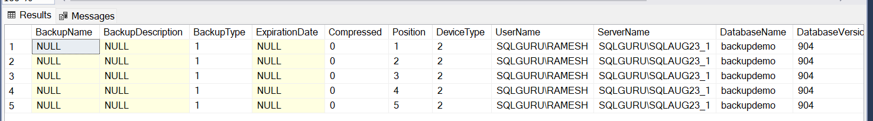

**--Restore Filelistonly,** it gives the files information of a backup

restore filelistonly

from disk='E:\SQLLab\backups\backupdemo.bak'

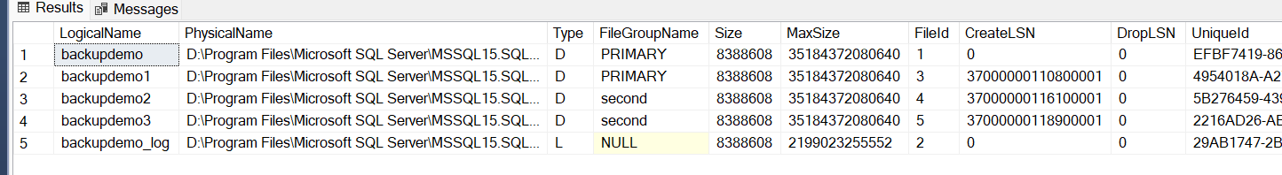

**--Restore labelonly** -- this gives us the backup media metadata information

restore labelonly

from disk='E:\SQLLab\backups\backupdemo.bak'



Q: I have database, but not able to take log backups. Why?

Please verify the recovery model of the database. If the recovery model is simple, then log backups are not allowed

I changed recovery model to full and now log backup option is visible

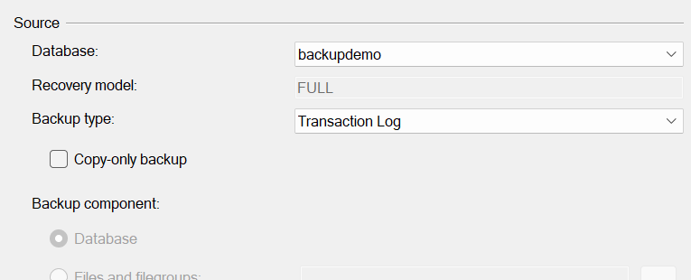 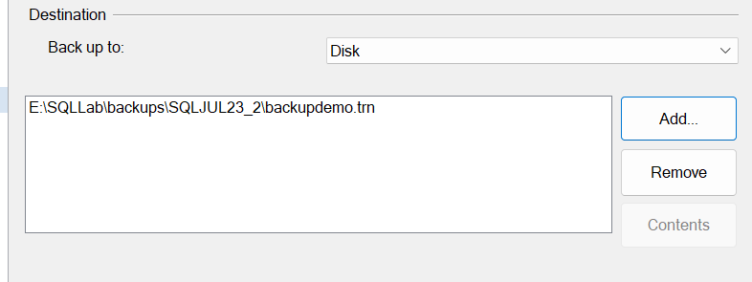

Log backup is failing

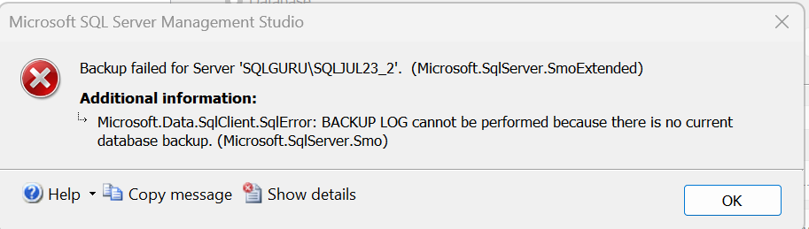

Whenever we change the recovery model, first we need to take a fresh full backup. then only log backup is possible

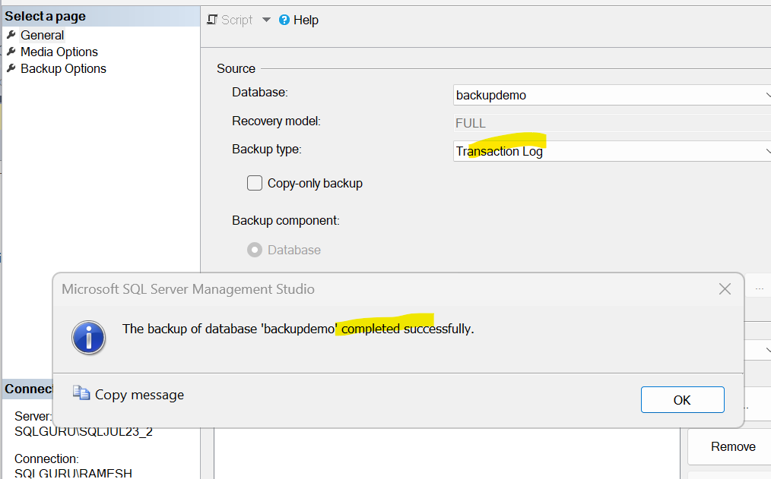

Tail log backup:

* Weekly full back up 🡪Sunday 12:00 am
* Daily differential backups 🡪10 am
* Log backups for every 1 hours

Database is crashed at 4.30 PM on Thursday

Recovery process:

Step1: restore latest Sunday full backup w/n

Step2: restore Thursday 10 am differential backup w/n

Step3: Restore 11 am to 3 PM all the log backups w/n

Step4: restore 4 PM log backup w/r

With above recovery strategy, we are able to recover the database up to 4 PM. but the database is crashed 4.30 PM. So, we have about 30 mins of transaction loss. To recover the 30 mins of transactions we can use tail log backup. Tail log backup also a log backup which takes the backup all the transactions happened from last successful log backup (4 PM) to failure point (4.30 PM).

Tail log backup is something which we perform in the event any database is crashed. We can tail log backup only when the log file is healthy.

With tail log backup in place, the process would be

Recovery process:

Step1: Take a tail log backup

Step2: restore latest Sunday full backup w/n

Step3: restore Thursday 10 am differential backup w/n

Step4: Restore 11 am to 4 PM all the log backups w/n

Step4: restore tail log backup w/r

--Tail Log back up and Restore Demonstration:

--Create a Databaser

CREATE DATABASE [TailLogTest]

--Create a Table

USE [TailLogTest]

GO

CREATE TABLE [dbo].[Emp_Details]

([ID] [int] NULL,

[Name] [varchar](50) NULL,

[Sal] [money] NULL)

ON [PRIMARY]

GO

--Insert Data into the table

INSERT INTO [TailLogTest].[dbo].[Emp_Details]

VALUES (1, 'full', 1000)

GO 10

--Issue a Full backup (Sunday 12:00 am backups)

BACKUP DATABASE TailLogTest TO

DISK = 'E:\SQLLab\backups\taillog\FULL.BAK'

GO

--Insert Data into the table again

INSERT INTO [TailLogTest].[dbo].[Emp_Details]

VALUES (2, 'Diff', 2000)

GO 10

--Issue a diff babkup (thursday 10 am diff backup)

BACKUP DATABASE TailLogTest TO

DISK = 'E:\SQLLab\backups\taillog\diff.bak'

with differential

GO

--Insert Data into the table again

INSERT INTO [TailLogTest].[dbo].[Emp_Details]

VALUES (3, 'log1', 3000)

GO 10

--Issue a log backup1 (Thursday 3 PM log backup)

BACKUP LOG TailLogTest TO

DISK = 'E:\SQLLab\backups\taillog\LOG1.TRN'

GO

--Insert Data into the table again

INSERT INTO [TailLogTest].[dbo].[Emp_Details]

VALUES (4, 'log2', 4000)

GO 10

--Issue a log backup2 (Thursday 4 PM log backups)

BACKUP LOG TailLogTest TO

DISK = 'E:\SQLLab\backups\taillog\LOG2.TRN'

GO

--Insert Data into the table again

INSERT INTO [TailLogTest].[dbo].[Emp_Details]

VALUES (5, 'tail', 5000) --Time is 4.30 PM thursday

GO 10

--Will force the database crash

use master

Go

--Set database to offline

ALTER DATABASE [TailLogTest] SET OFFLINE

GO

--get the database file locations

select * from sys.master_files

---DELETE DATA FILE (mdf)

--Set database to online

ALTER DATABASE [TailLogTest] SET ONLINE

GO

--TAKE TAIL LOG BACKUP

USE MASTER

GO

BACKUP LOG TailLogTest TO DISK

= 'E:\SQLLab\backups\taillog\TAIL.TRN'

with no_truncate

GO

--Restore all the back ups:

Restore database TailLogTest from

disk ='E:\SQLLab\backups\taillog\Full.bak'

with norecovery

Restore database TailLogTest

from disk ='E:\SQLLab\backups\taillog\diff.bak'

with norecovery

Restore database TailLogTest

from disk ='E:\SQLLab\backups\taillog\Log1.Trn'

with norecovery

Restore database TailLogTest

from disk ='E:\SQLLab\backups\taillog\Log2.Trn'

with norecovery

Restore database TailLogTest

from disk ='E:\SQLLab\backups\taillog\Tail.Trn'

with recovery

Copy Only Backup:

* Weekly full back up 🡪Sunday 12:00 am
* Daily differential backups 🡪10 am
* Log backups for every 1 hours

On Thursday, 4.30 PM 🡪We got a request from application team/development to do database refresh from production to Test server

Thursday 4.30 PM 🡪Ticket got assigned to Charan

He takes a fresh full backup from the production and restores it into the test server, responds to the requester saying refresh is completed.

Requester 🡪 thank you Charan for your quick response and everything looks good and Charan closes the ticket

On Saturday 4.30 PM🡪Database is crashed

Jayanthi (on call support) 🡪Need to recover the database

Recovery process:

Step1 🡪Restore latest Sunday full backup w/n

Step2🡪Restore Saturday 10 am differential backup w/n

This differential backup restore will fail saying the database has not been restored to the correct earlier point

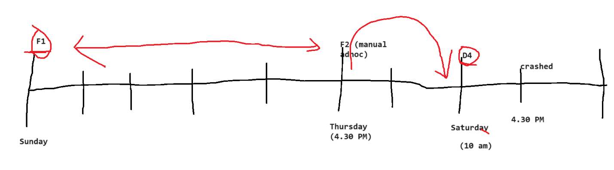

To avoid getting into such situations, we can use copy only backup for all such ad hoc manual backups. Copy only will not disturb the regular backup schedule or regular backup chain.

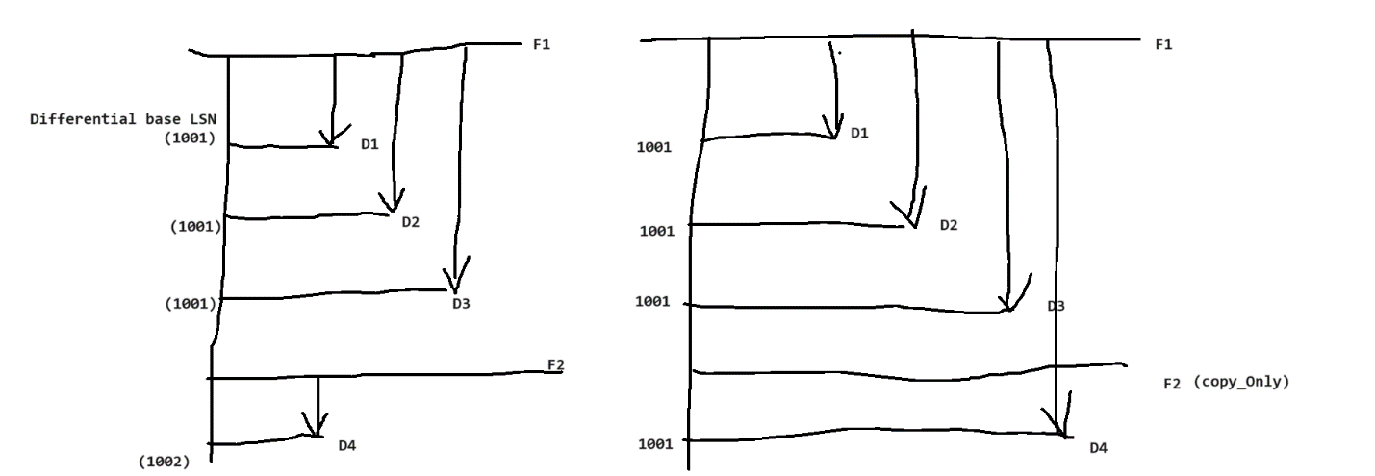

High Availability (HA) and Disaster Recovery (DR):

Making database services available for the applications all the time.

RPO 🡪Recovery Process Objective, how much amount data loss is acceptable. For most of critical systems RPO should be near zero.

Ex: RPO 🡪2 hours

The database is crashed at 4.30 PM, if we are able to recover all the data up to 2.30 PM, then we are good. If there is any data loss beyond 2 hours. that means you are able to recover the data up 1.30 PM. Then this will be considered as SLA (Service Level Agreement) miss

RPO 🡪there should not be any data loss

RTO🡪Recovery Time Objective, How much time we can take to recover the database

RTO 🡪2 hours, The database is crashed at 4.30 PM, we should be able to recover the database by 6.30 PM. If we take more than 2 hours to recover the database, then it will be considered as SLA miss

So, it is difficult to achieve such critical RPO and RTO SLAs with Backup and recovery. That’s where we go for configuring HADR solutions

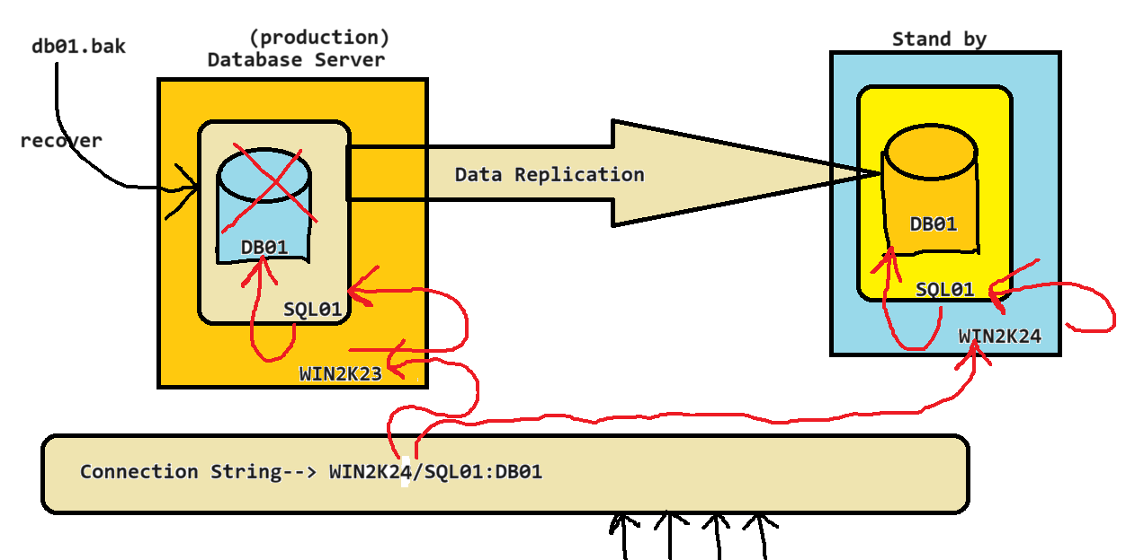

HA solutions:

* 1. Log shipping 🡪Database level
  2. Database Mirroring🡪Database Level
  3. Replication 🡪object level solution
  4. Failover clusters or Always On clusters🡪instance level or server level
  5. AlwaysOn availability group 🡪for group of databases (SQL server 2012)

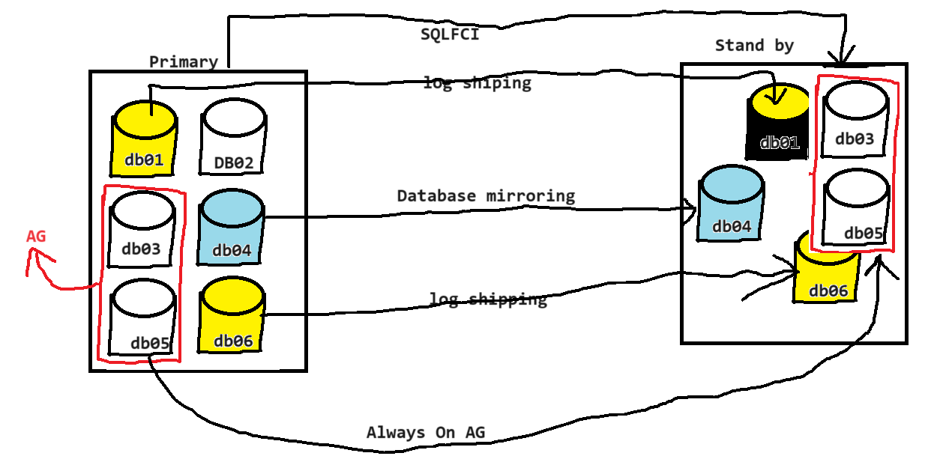

Log shipping:

Log shipping is basic database level HA solution which transfers the transaction log backups from one server another server and restore there automatically.

Pre requisites:

* 1. Minimum 2 server
     + Primary🡪source SQL server in log shipping
     + Secondary🡪Target SQL server in log shipping
  2. Database must be in either full and bulk logged recovery model (recommended is FULL)
  3. Two Network share folders, 1 in primary and another in secondary server

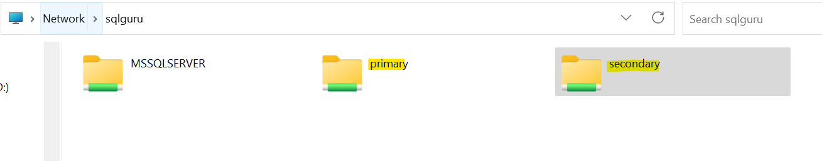

* 1. SQL Server agent service must be up and running
  2. Take a full backup of primary database and restore it into secondary w/n

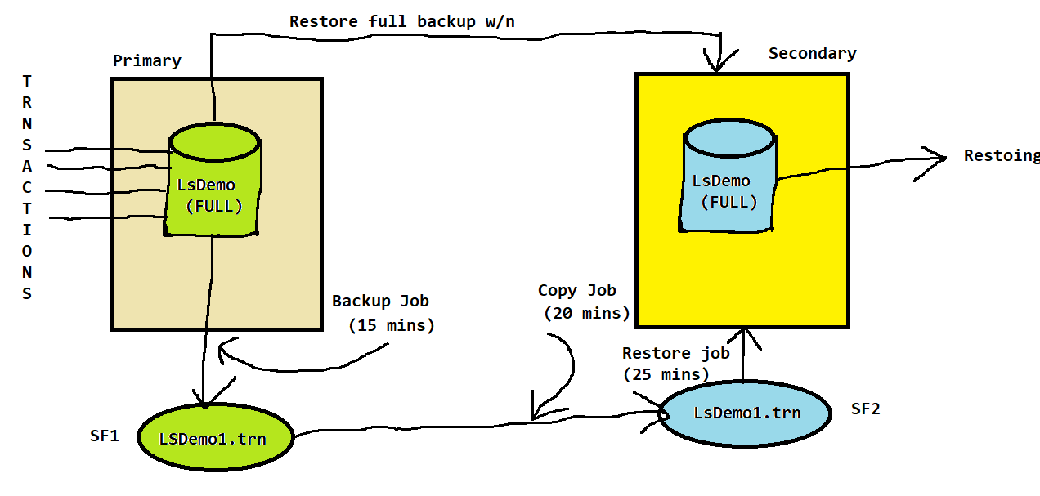

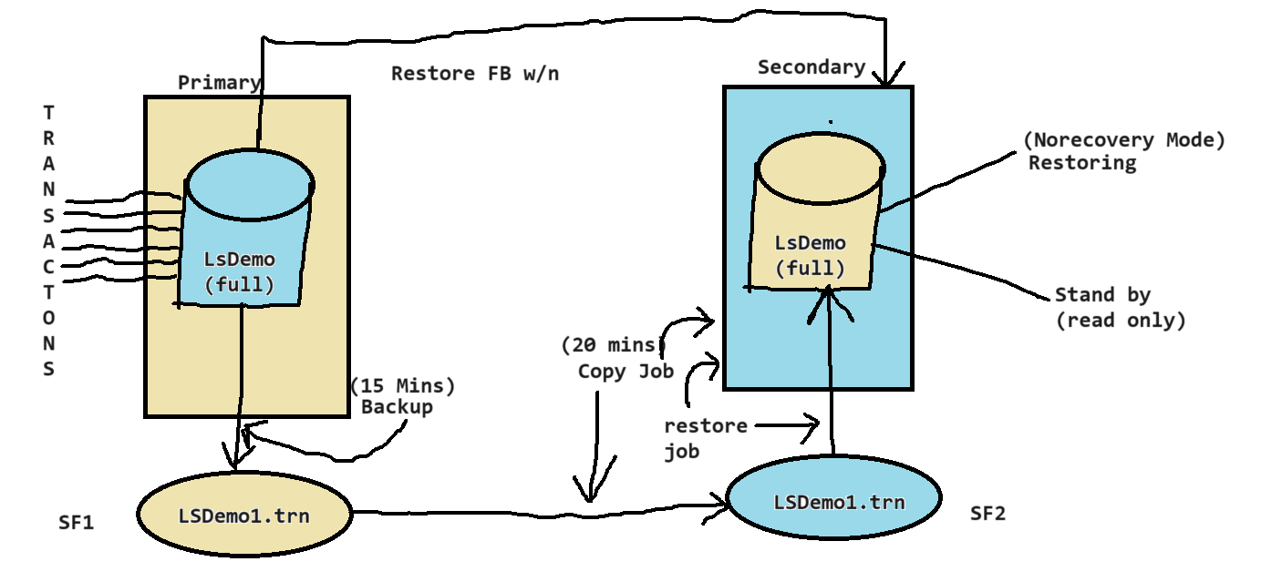

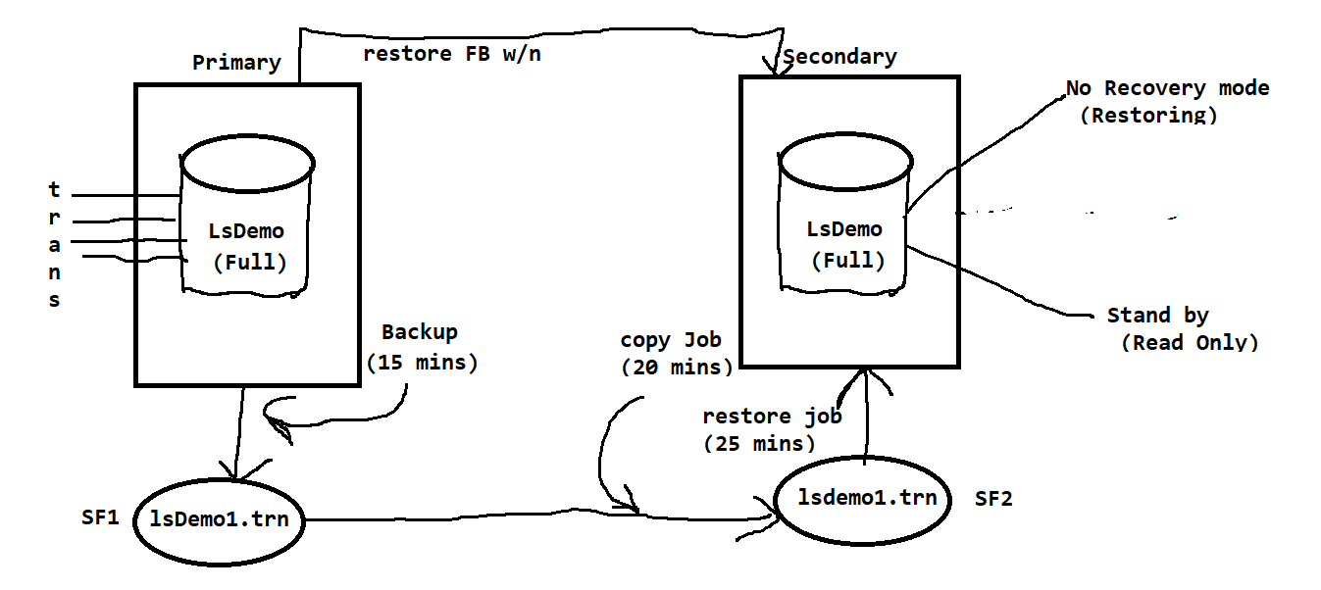

Demo:

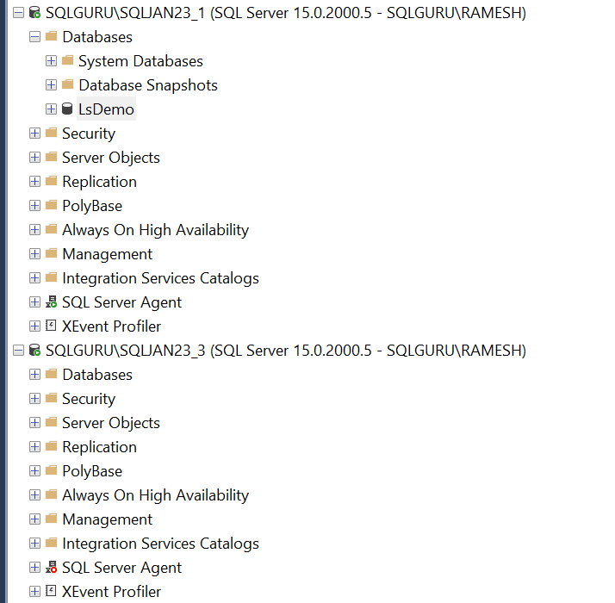

Right click on the primary database🡪Tasks🡪Ship Transactions logs

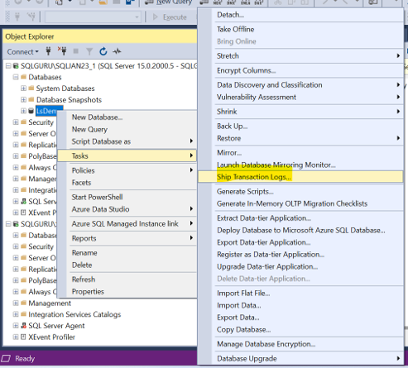

Or

Right click on the primary database🡪Properties🡪Transactions log shipping

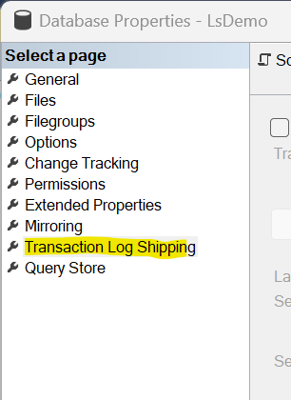

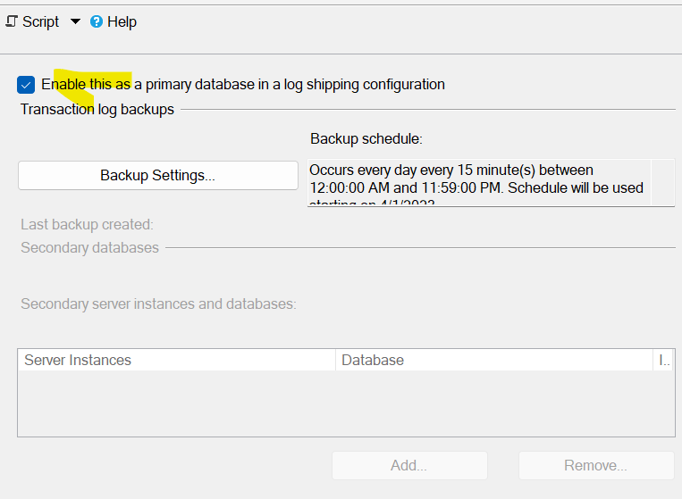

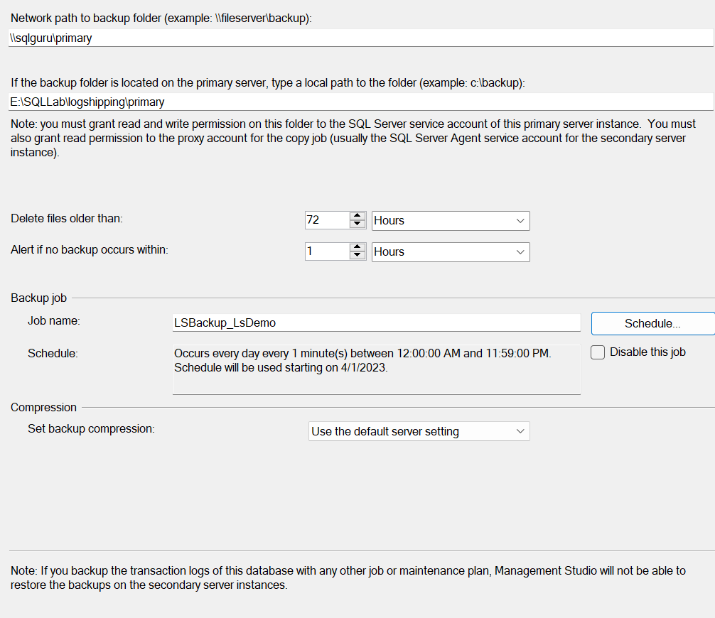

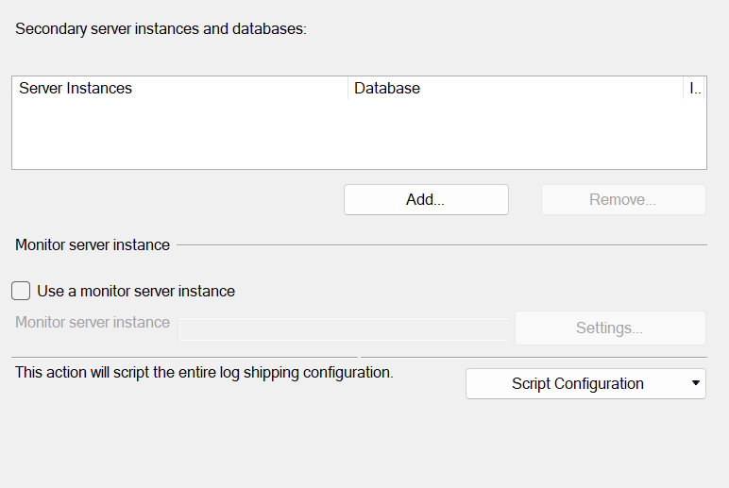

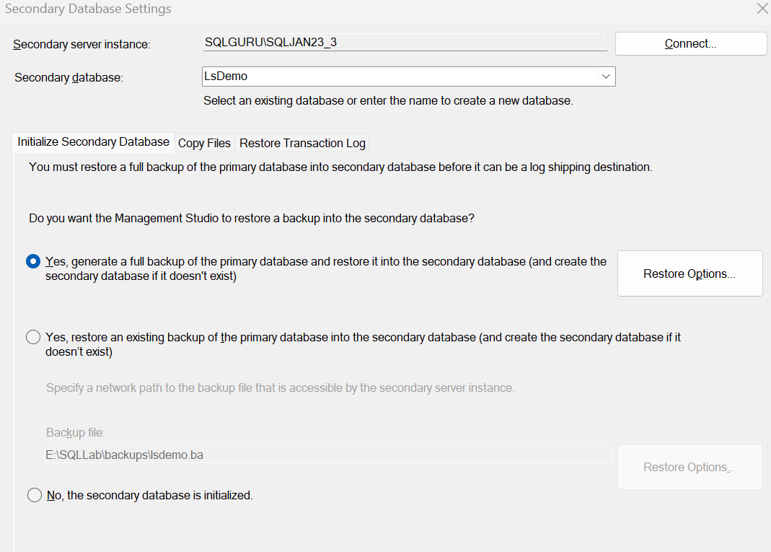

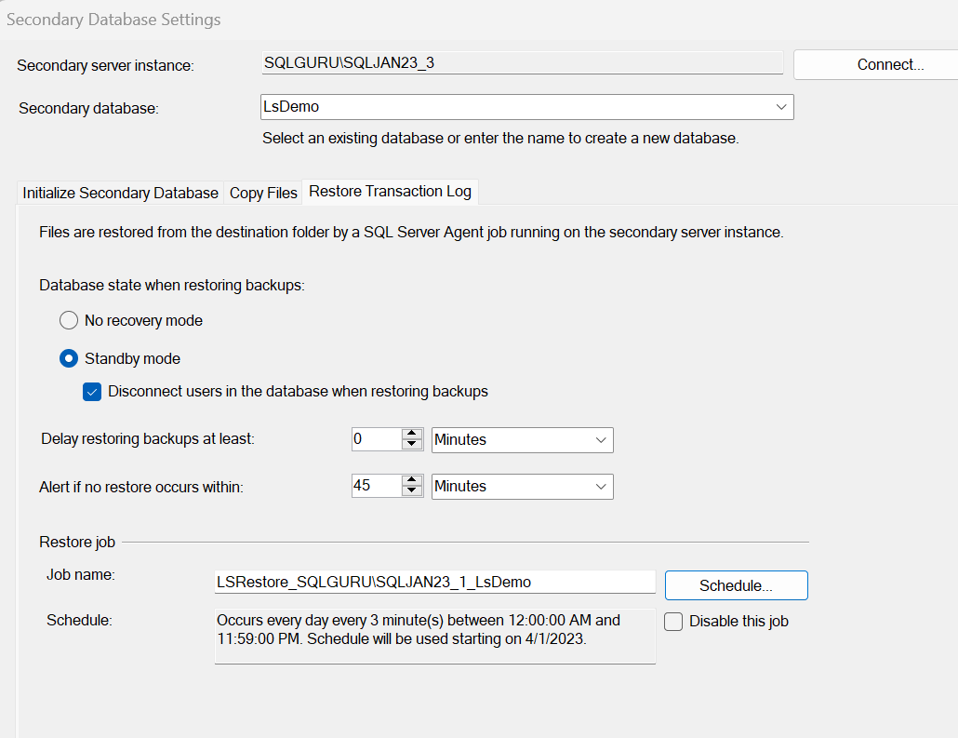

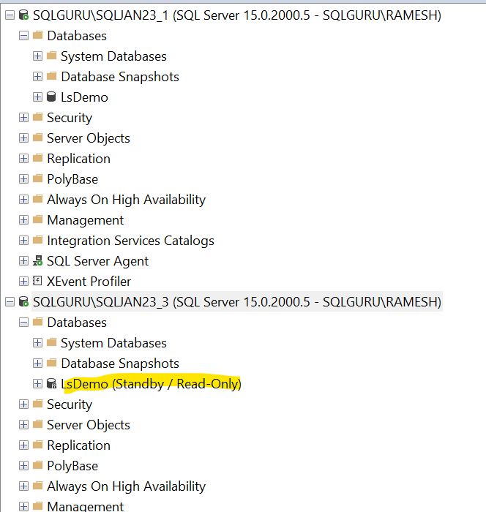

Jobs in Primary:

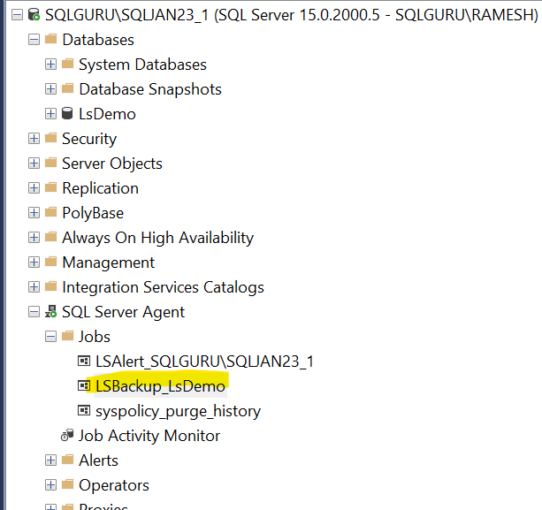

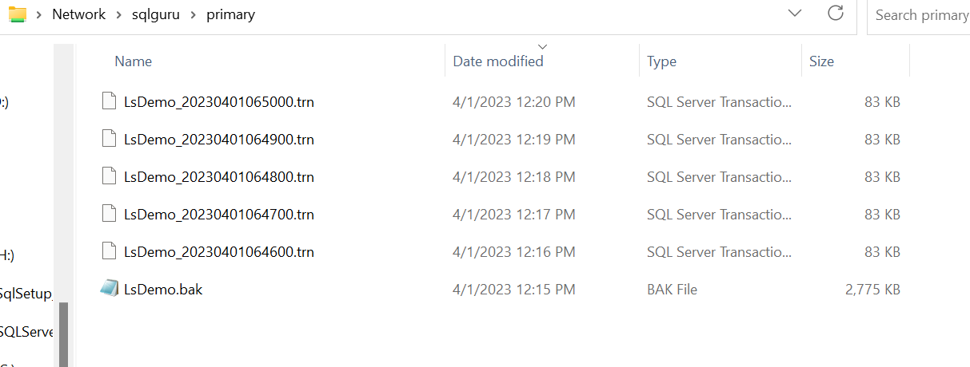

Jobs in Secondary:

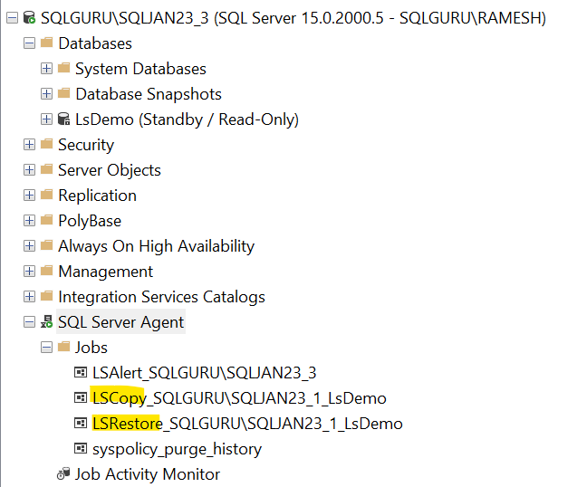

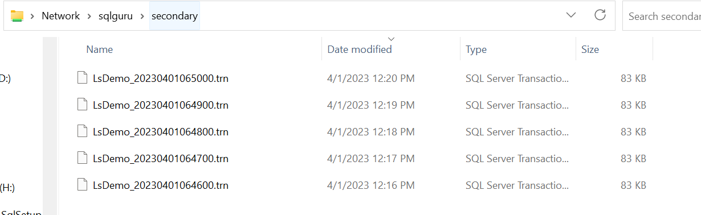

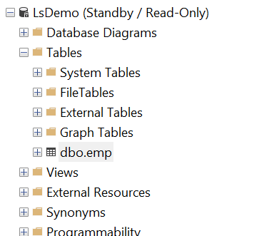

How many modes we can configure log shipping secondary Database?

We Can configure log shipping secondary database in 2 modes

1. No Recovery mode 🡪the database will be in restoring state, we cannot access it
2. Stand by 🡪the database will be read only mode; we can use it for read only reporting purpose

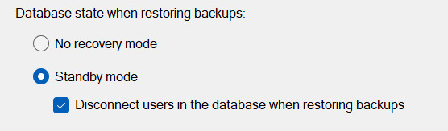

How to change the recovery mode of log shipping secondary database?

Right click the primary database🡪go to properties🡪log shipping🡪secondary instances and databases🡪click (...)

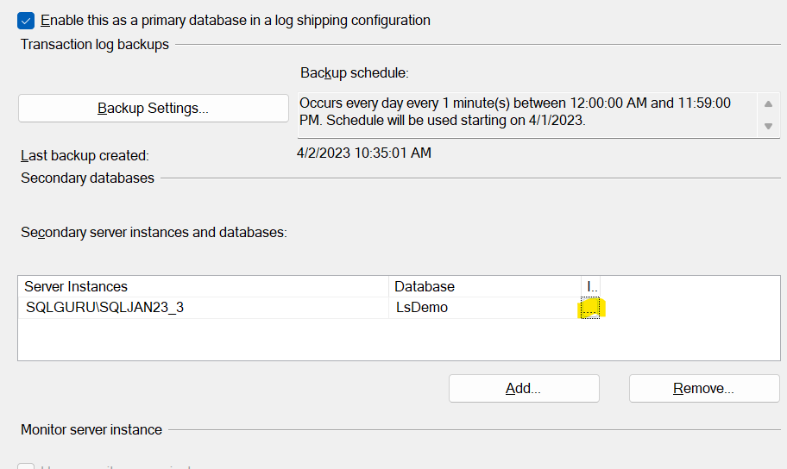

Restore Transaction log

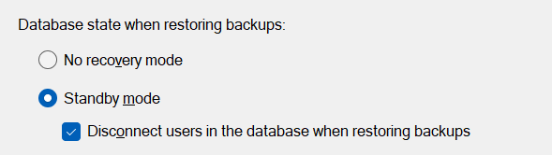

ADD file to log shipping primary database: What will happened?

alter database [LsDemo]

add file (name='lsdemo1',filename='E:\SQLLab\logshipping\lsdemo1.ndf')

After adding the secondary database file to the primary database, there are no issues for backup job and copy job. But the restore job failing?

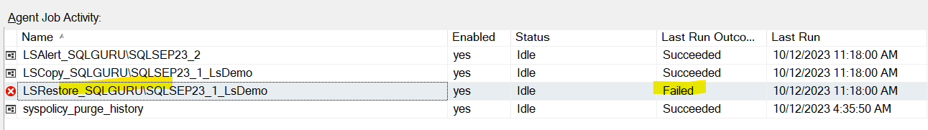

Why it is failed?

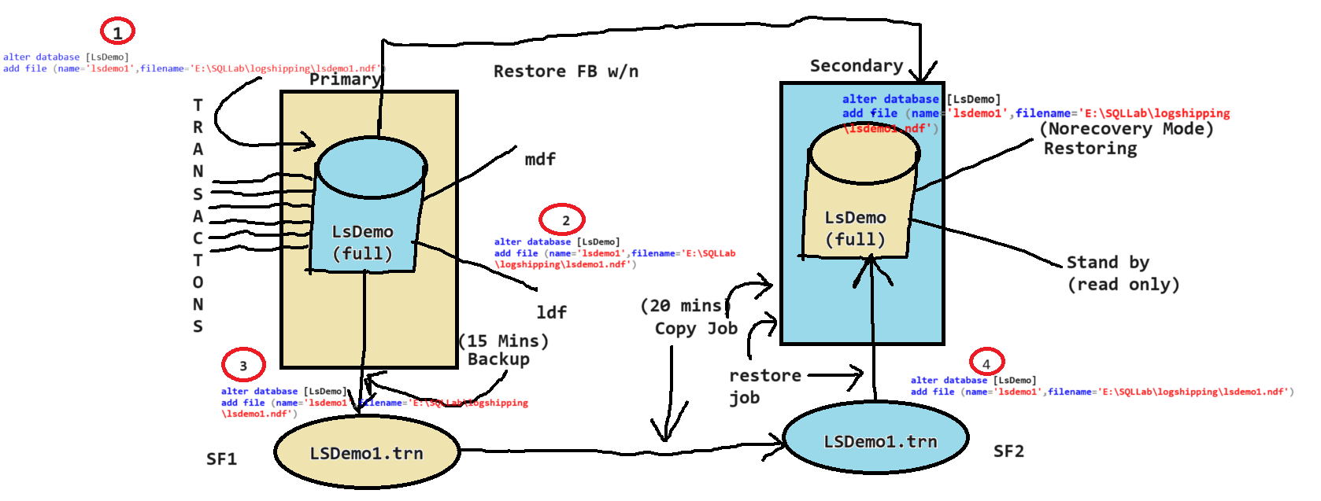

After we have added secondary file to the log shipping primary database, whatever the next log backup restores at secondary.. it will try to add a file to secondary database in the same location of primary database. As there is already a file exist with the same name in the same location. the restore will fail.

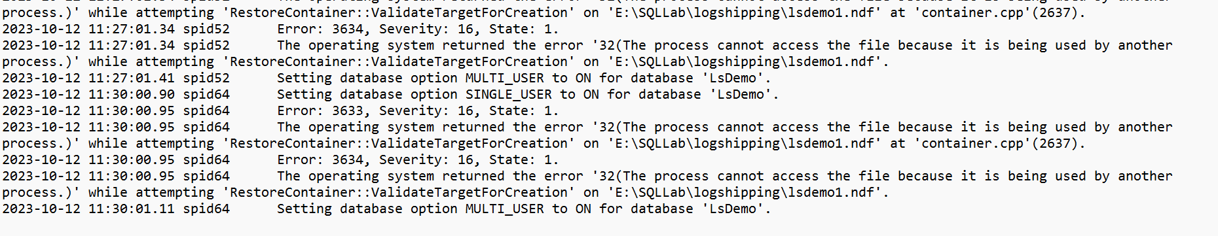

How to Fix:

First we need to identify the log backup at which the restore job started failing. For that we can refer log shipping monitoring

Log shipping Monitoring:

On Primary🡪right click on the instance name🡪reports🡪standard reports🡪log shipping status

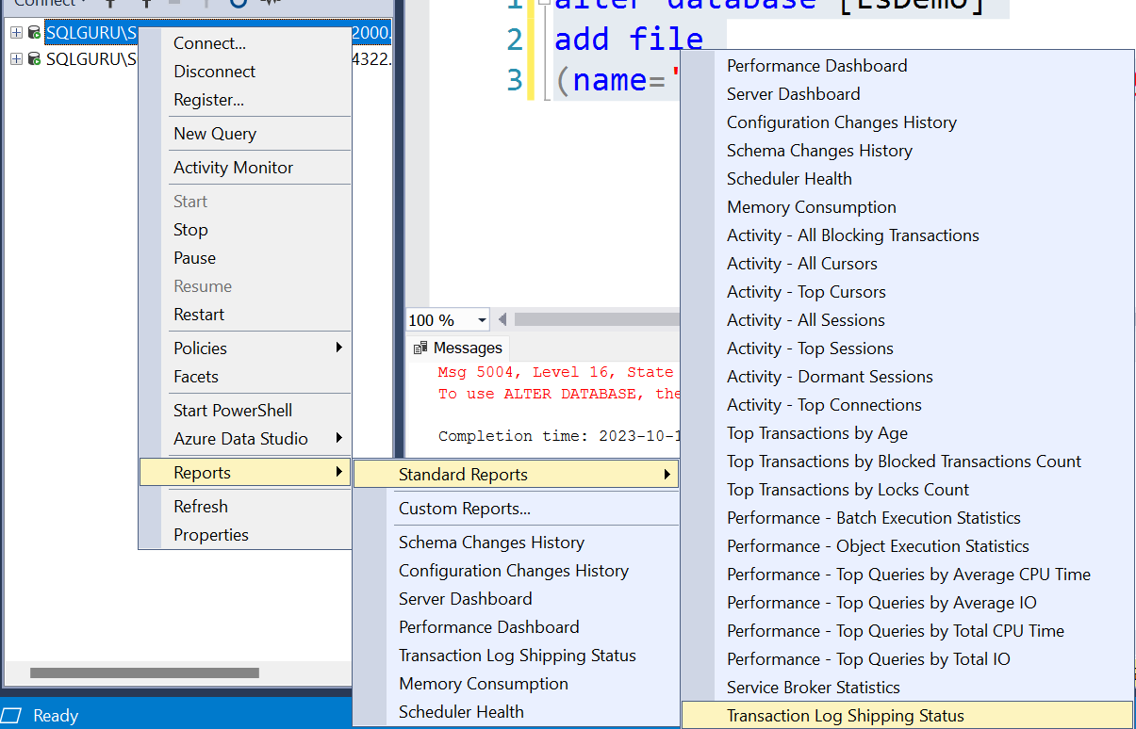

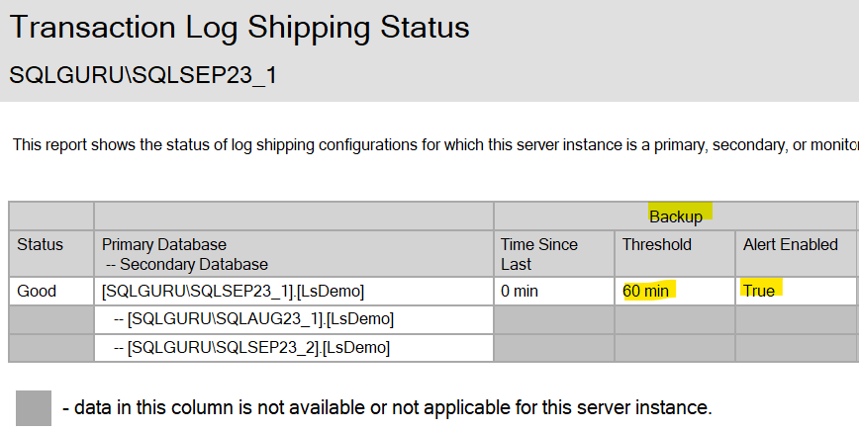

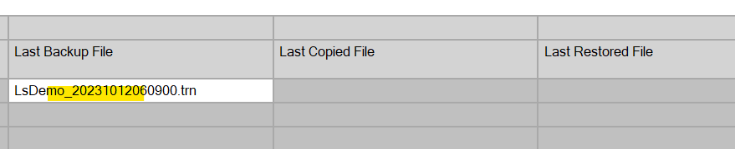

On Secondary🡪 right click on the instance name🡪reports🡪standard reports🡪log shipping status

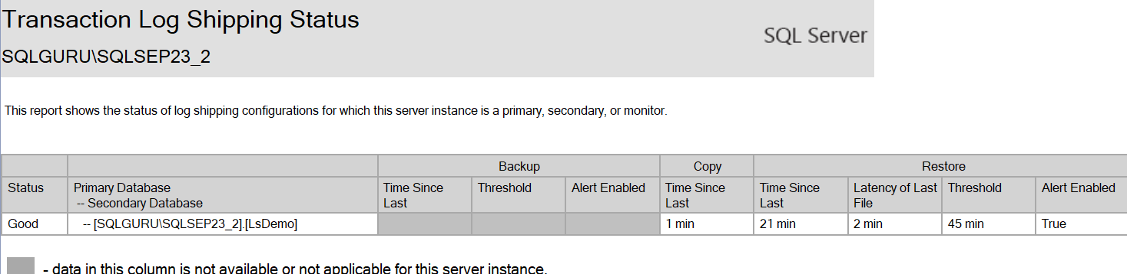

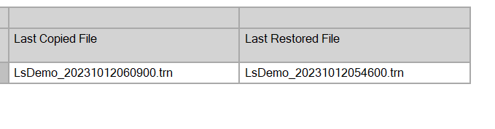

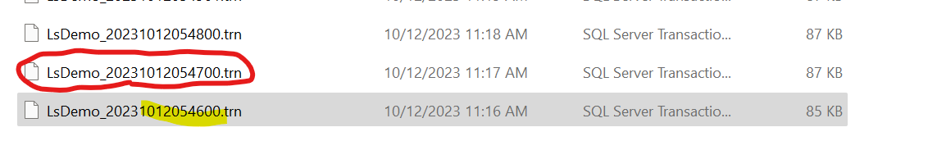

LsDemo_20231012054600.trn 🡪last log backup which got restore successfully

LsDemo_20231012054700.trn🡪is the log backup at which the restore job started failing. We can assume this is the log backup generated after we added the data file to primary database

restore filelistonly from

disk='\\sqlguru\logshipping\secondary\LsDemo_20231012054700.trn'

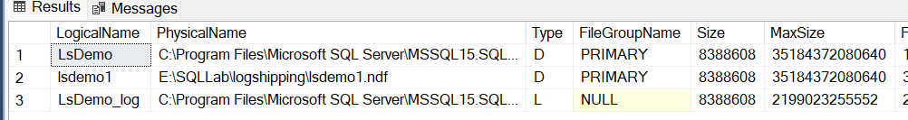

Now we need to restore this log backup manually into the secondary using with move option to different location

restore log Lsdemo from

disk='\\sqlguru\logshipping\secondary\LsDemo_20231012054700.trn'

with move

'lsdemo1' to 'E:\SQLLab\logshipping\seond\lsdemo1.ndf',

norecovery

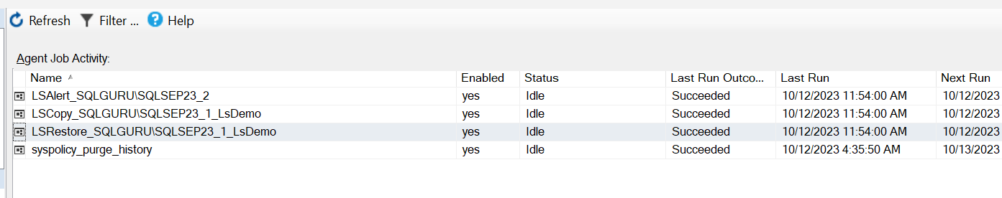

What will happened, if some of the log backups are deleted accidentally before they copy and restore to the secondary?

Log shipping will not work, Restore job fails with LSN mis match error.

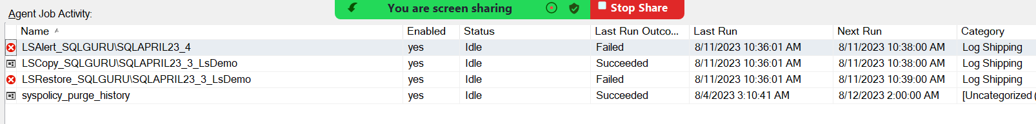To Fix :

Take a manual differential backup from primary and restore it into the secondary with nonrecovery

On Primary-

backup database [LsDemo]

to disk='E:\SQLLab\logshipping\lsdemo_diff.bak'

with differential

On Secondary:

restore database [LsDemo]

from disk='E:\SQLLab\logshipping\lsdemo_diff.bak'

with norecovery

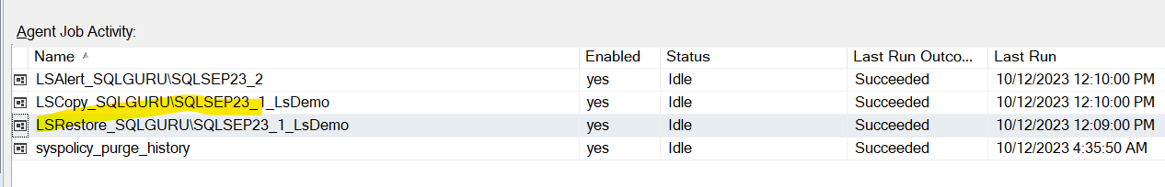

TUF (Transaction Undo file):

It is a transaction undo file which will be created when we configure log shipping secondary database in stand by mode which maintains all the uncommitted transactions from the primary database and it will be created in the same location of secondary database. It can be used to rollback the transactions on secondary in case if the transactions failed at primary

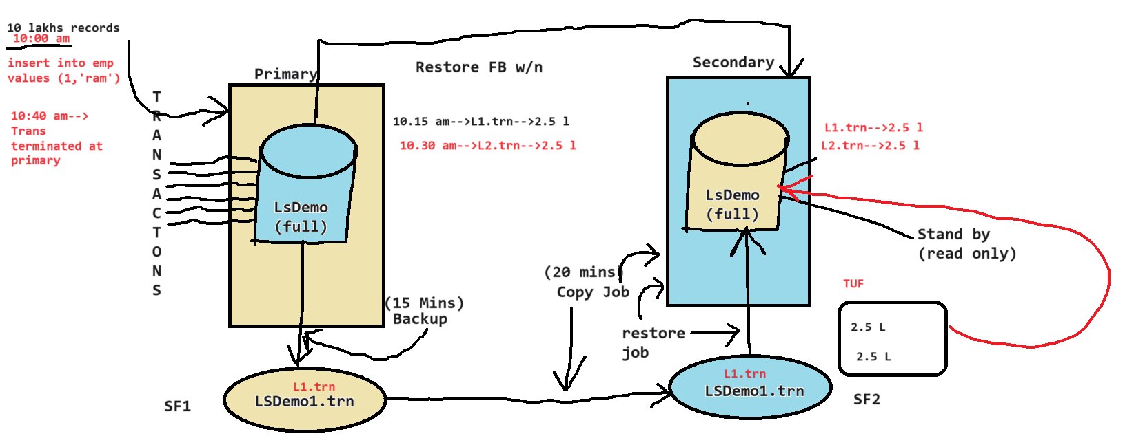

Execute on primary:

insert into lsTest values (1,'TUF')

go 10000000

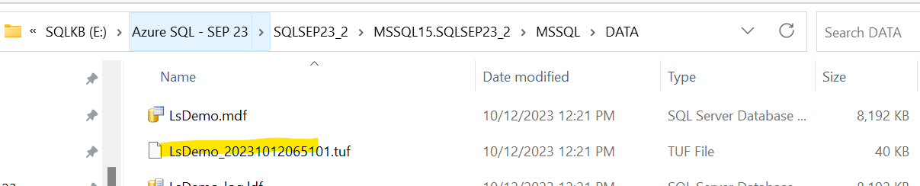

What happens of the TUF file is deleted?

Log shipping will not work, restore job fails

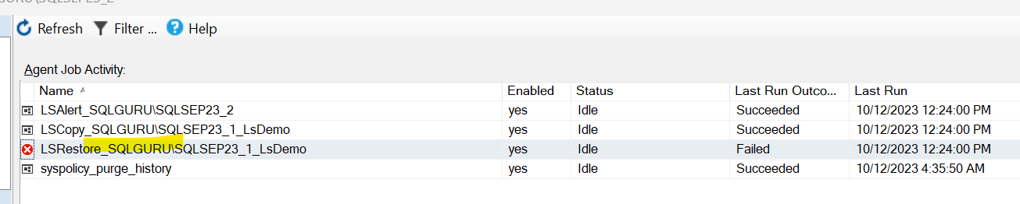

How to Fix it ?

We need to reconfigure the log shipping. Take the full backup from log shipping primary and restore it into the secondary w/n

On Primary:

backup database lsdemo to disk

='E:\SQLLab\logshipping\LsDemo_full.bak'

On Secondary:

restore database lsdemo from disk

='E:\SQLLab\logshipping\LsDemo_full.bak'

with norecovery

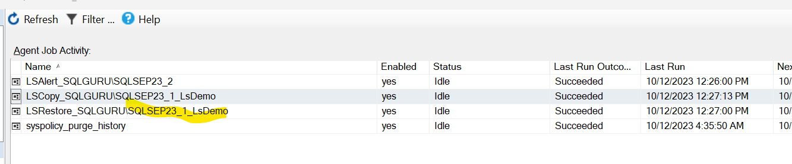

WRK File (Worker File) :

When the copy job is copying the log backup (TRN) from primary network share to the secondary network share. Until the copy the is completed, this will appear as WRK fine in the secondary directory. Restore job ignores these WRK files, other wise restore will fail for that perticual log backup.

How to apply patching on log shipping environment:

There is no required sequence to apply a service pack or hotfix for Primary, Secondary and Monitor servers in a Log Shipping environment. The following is my preferable to apply service pack or hotfix:

* 1. Apply the service pack or hotfix on the Monitor server.
  2. Apply the service pack or hotfix on the all-Secondary servers.
  3. Apply the service pack or hotfix on the Primary server.

Log shipping Fail over Process:

backup log lsdemo

to disk='E:\SQLLab\logshipping\lsdemo_tail.trn'

with norecovery

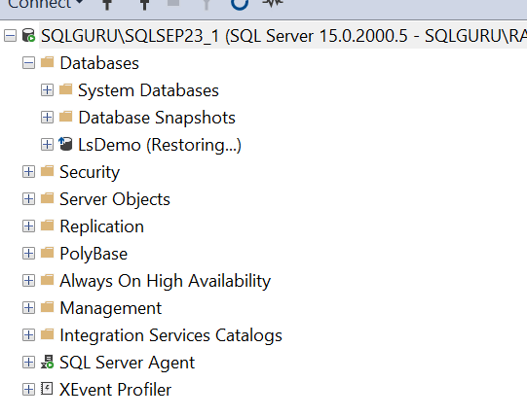

On Secondary:

restore log lsdemo

from disk='E:\SQLLab\logshipping\lsdemo_tail.trn'

with recovery

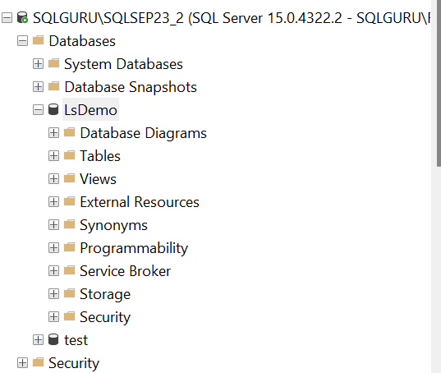

Then we can configure reverse log shipping:

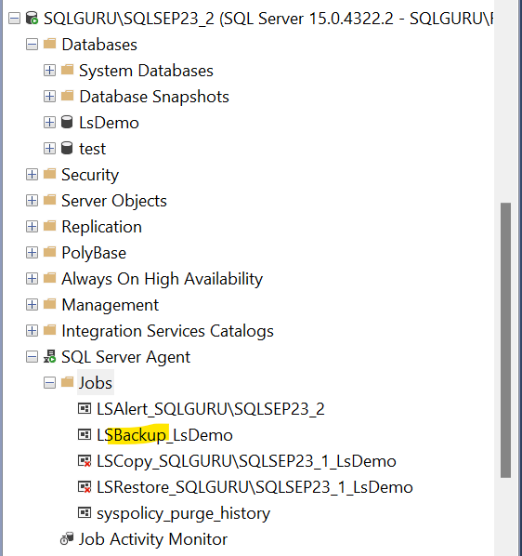

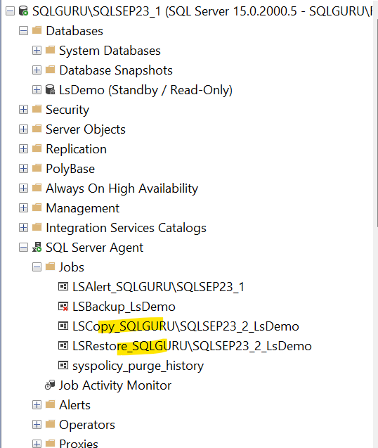

Database Mirroring:

Database mirroring also database HA level solution which transfer the transactions logs (ldf) from one server another server over the network using end point and applies the transaction on the other server

Pre-requisites to configure Mirroring:

* 1. Minimum two server
     + Principal 🡪source SQL server in Mirroring
     + Mirror 🡪Target SQL server in Mirroring
     + Witness 🡪optional server
  2. The Database Must be in full recovery model
  3. Take a full backup of principal database and restore it in mirror server w/n
  4. Take a log backup of principal database and restore it in mirror server w/n
  5. Database name must be same

Modes or Types of Mirroring:

1. Synchronous
   1. Synchronous high safety

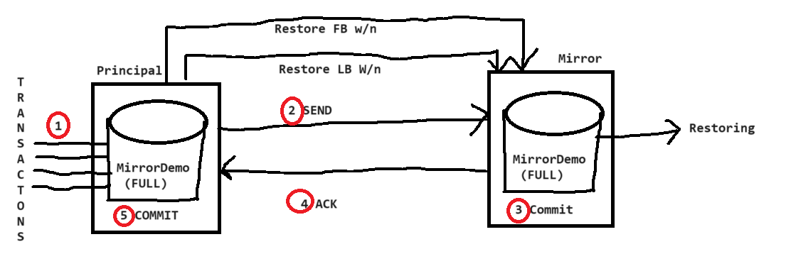

the transaction will be first committed on mirror. Based on the acknowledgement the transaction will be commuted on the principal, so the transaction always safe. we call this as high safety mode.

* 1. Synchronous high availability

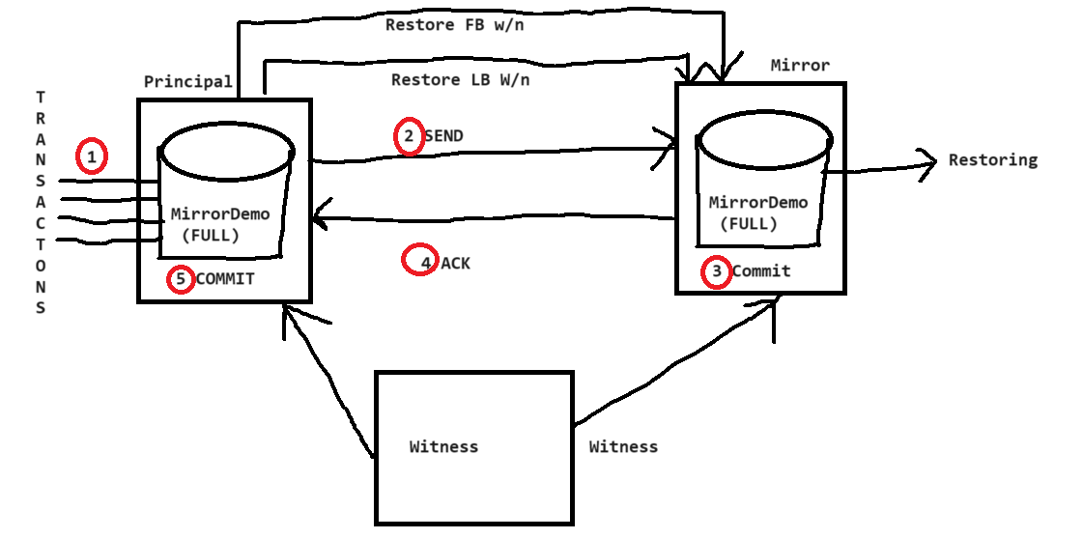

**If we add a new witness server to the high safety mode. this becomes high availability mode. Witness server monitors the status of principal. if some thing goes wrong with principal. this will automatically bring mirror online. So we call this as high availability mode.**

1. Asynchronous
   1. Asynchronous high-performance mode

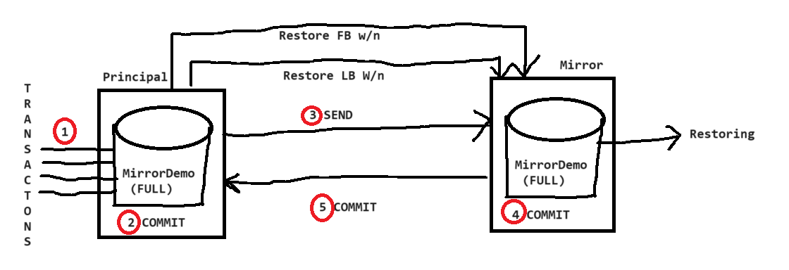

The transaction will be committed first on the principal, then it will send the transaction mirror. There can be chance that transaction may get failed at mirror, causes data mismatch. In the event of principal goes down. There will be a data loss. But it does not have to wait for the acknowledgement from the mirror, so the performance will be good. So we call it as High performance mode.

restore filelistonly from disk

='E:\SQLLab\backups\Mirroring\mirrordemo.bak'

restore database [MirrorDemo]

from disk='E:\SQLLab\backups\Mirroring\mirrordemo.bak'

with

move 'MirrorDemo' to 'E:\SQLLab\backups\Mirroring\mirrordemo.mdf',

move 'MirrorDemo_log' to 'E:\SQLLab\backups\Mirroring\MirrorDemo_log.ldf',

norecovery

restore log [MirrorDemo]

from disk='E:\SQLLab\backups\Mirroring\mirrordemo.trn'

with norecovery

Demo:

On Principal Server:

backup database [MirrorDemo]

to disk='E:\SQLLab\Mirroring\MirrorDemo.bak'

backup log [MirrorDemo]

to disk='E:\SQLLab\Mirroring\MirrorDemo.trn'

On Mirror Server:

USE [master]

RESTORE DATABASE [MirrorDemo] FROM

DISK = N'E:\SQLLab\Mirroring\MirrorDemo.bak' WITH FILE = 1,

MOVE N'MirrorDemo' TO N'E:\SQLLab\Mirroring\MirrorDemo.mdf',

MOVE N'MirrorDemo_log' TO N'E:\SQLLab\Mirroring\MirrorDemo_log.ldf',

NOUNLOAD, STATS = 5, norecovery

GO

restore log [MirrorDemo]

from disk='E:\SQLLab\Mirroring\MirrorDemo.trn'

with norecovery

GUI:

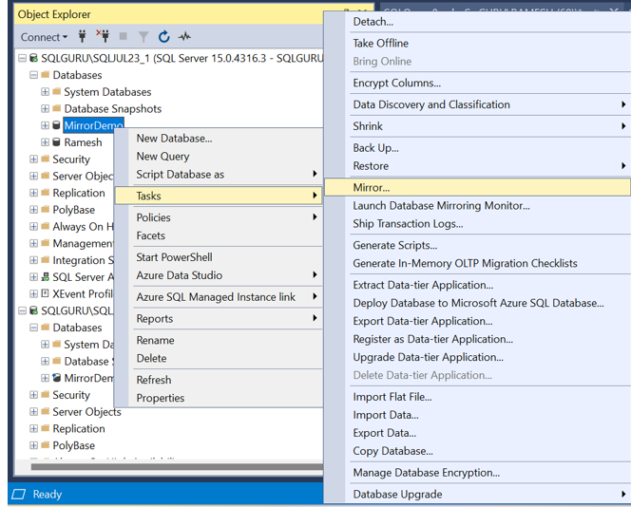

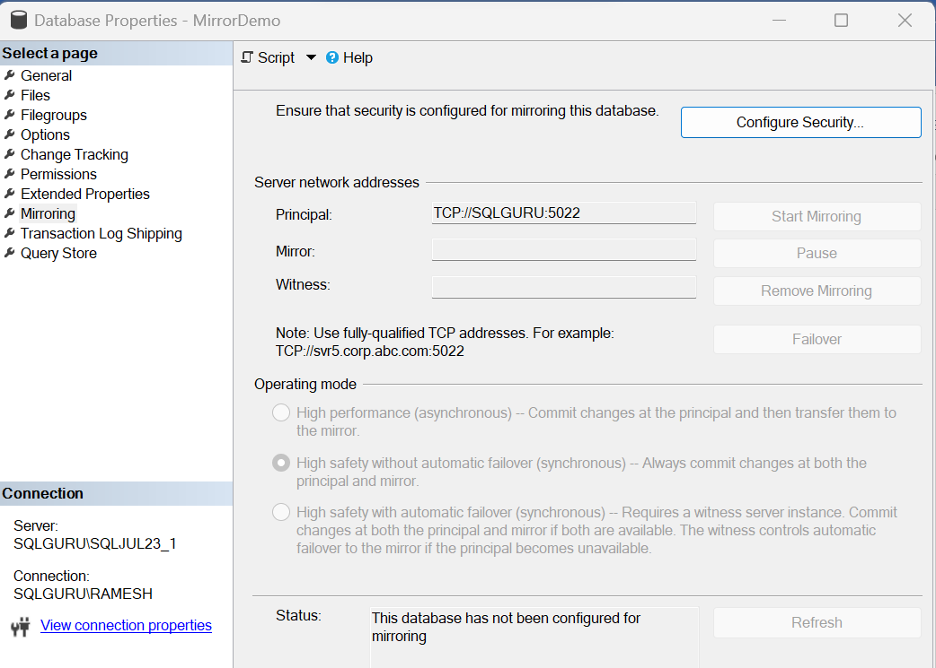

**Configure Security:**

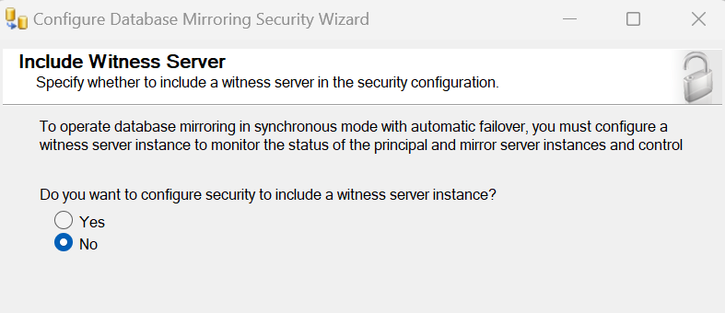

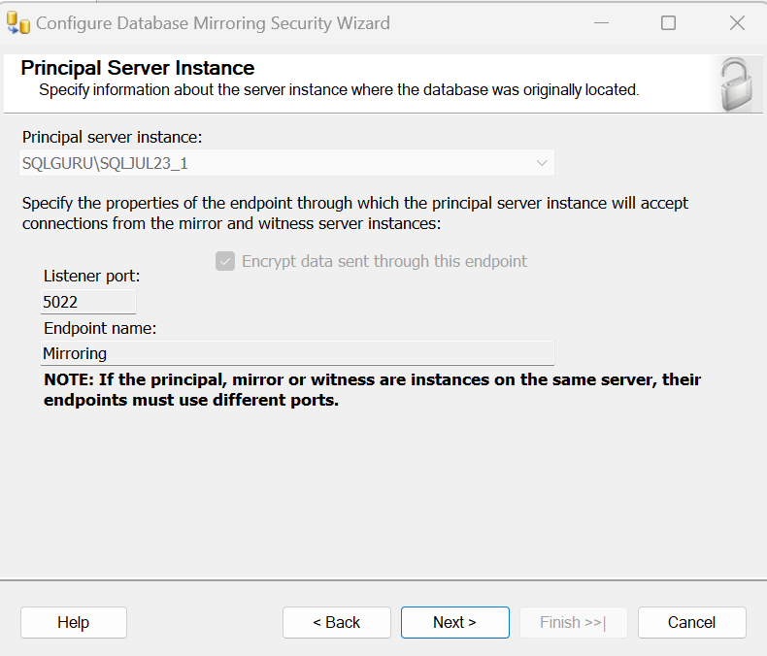

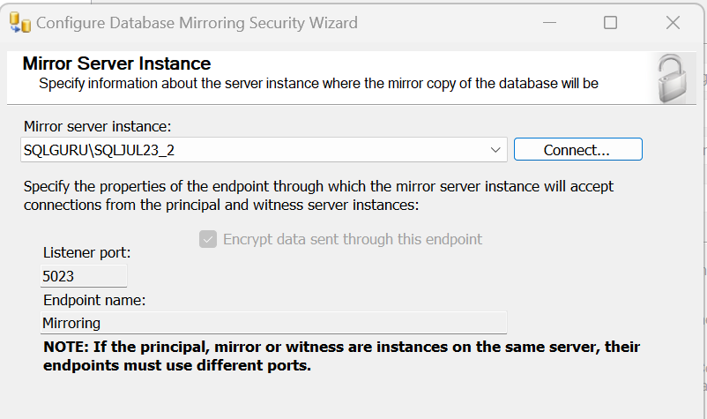

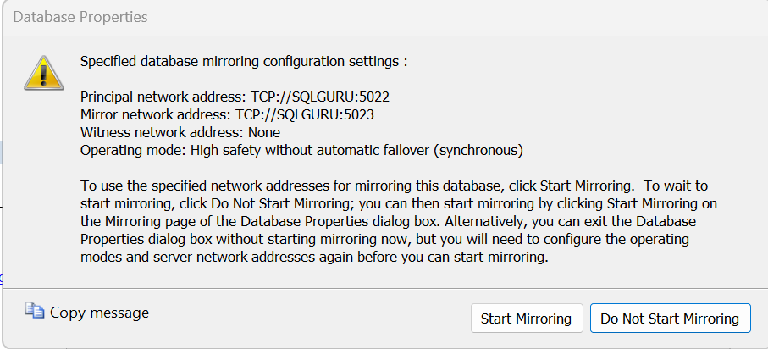

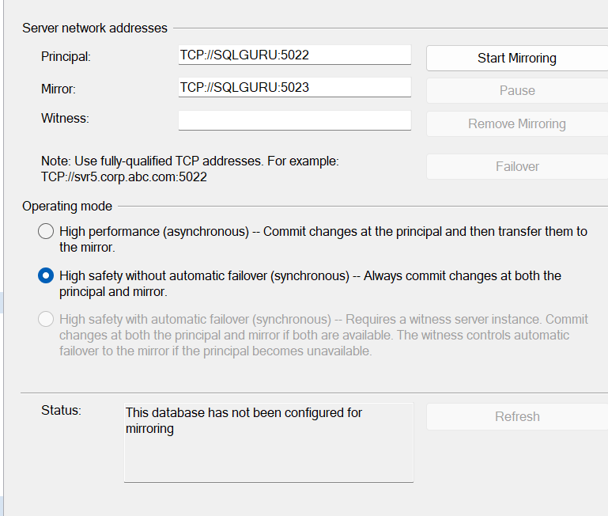

**Click on start mirroring**

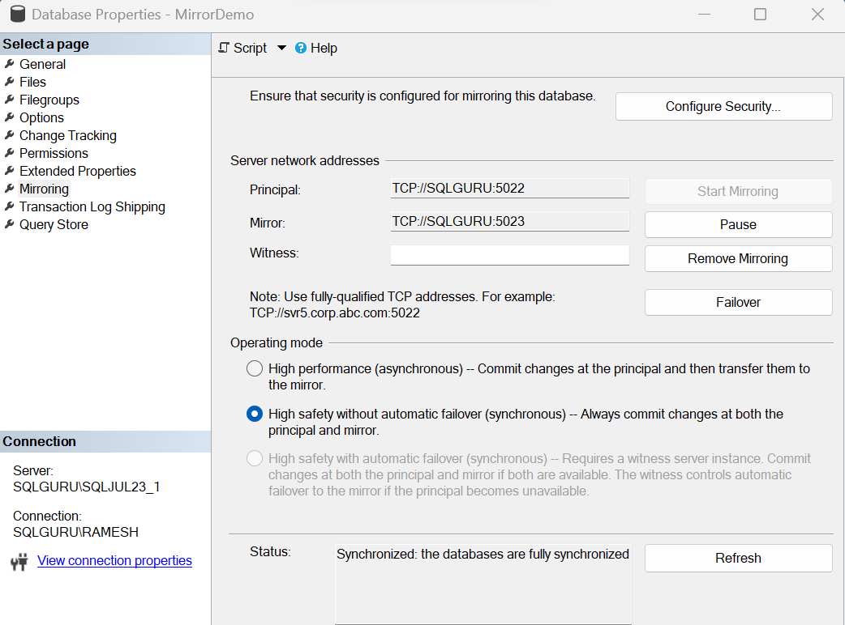

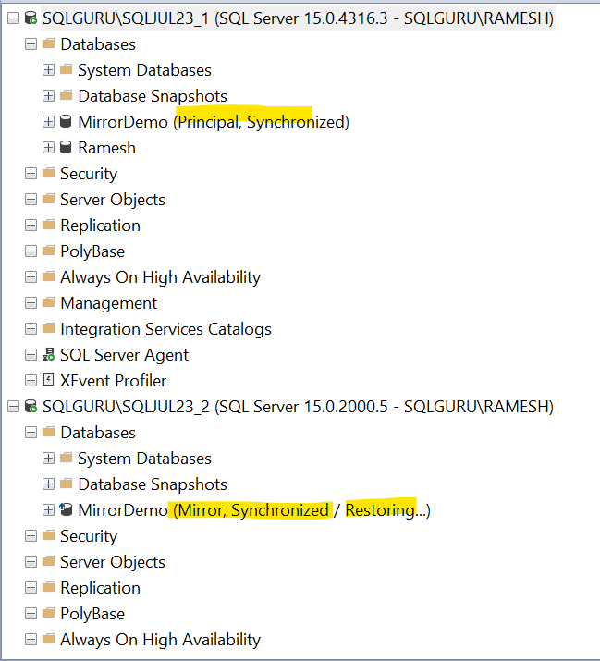

**Adding witness:**

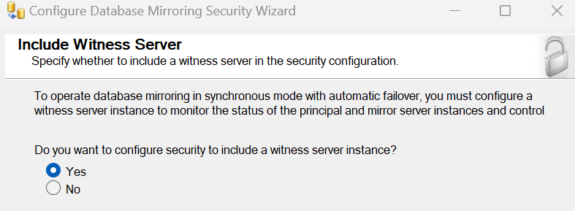

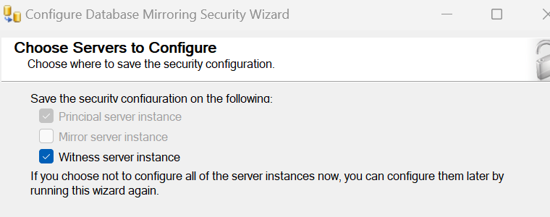

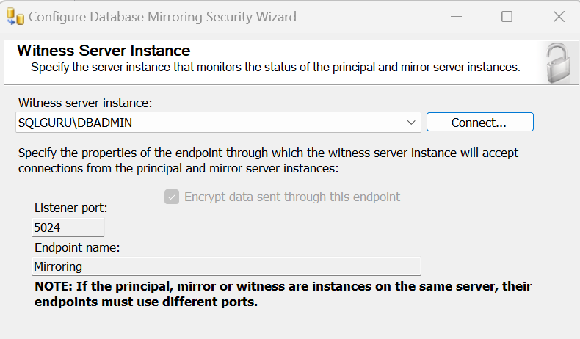

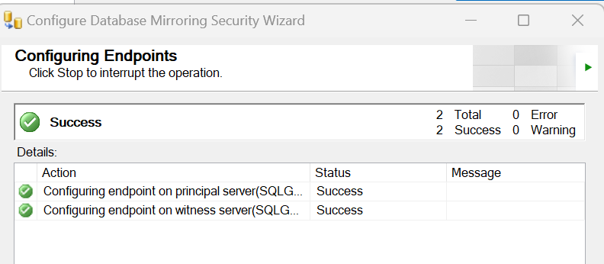

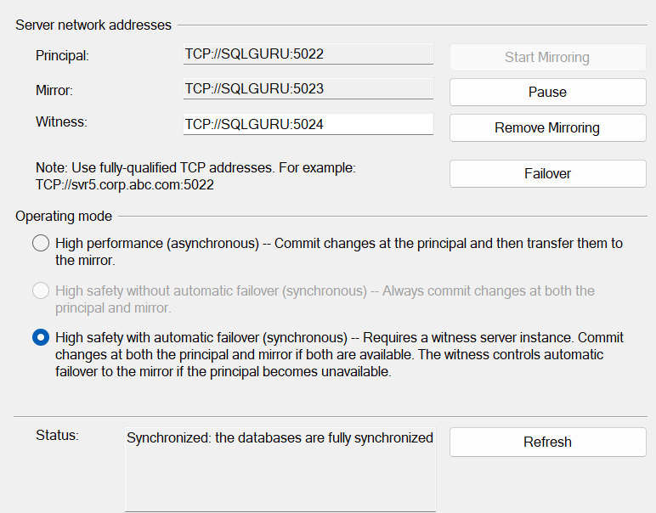

**Bring Principal SQL server down:**

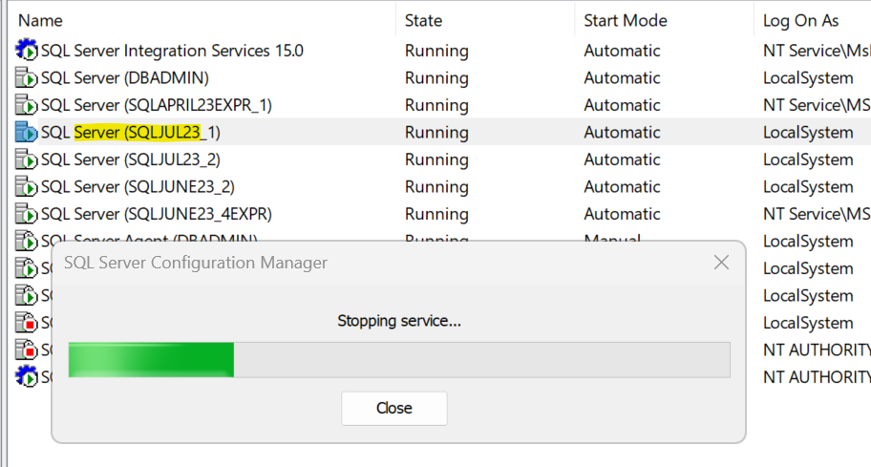

**Verify the mirror:**

**Mirror database automatically came online:**

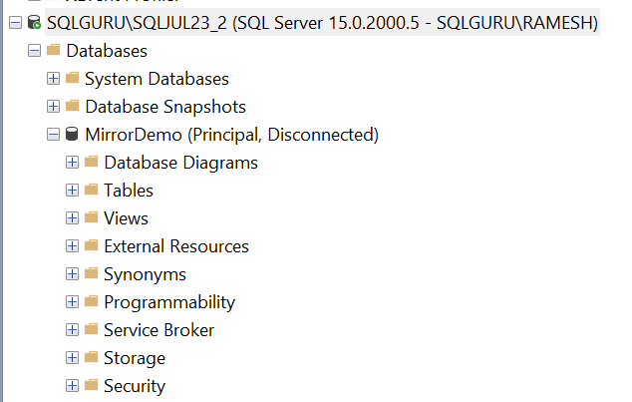

**Now if we bring original principal online, it will automatically take the mirror role**

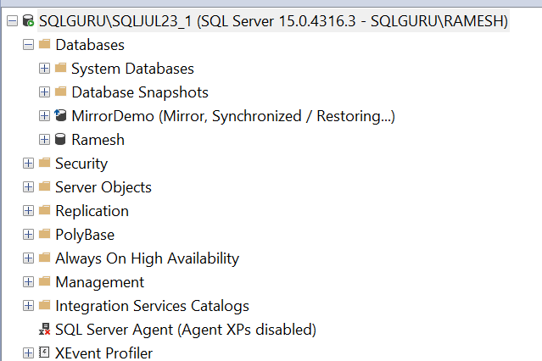

**Bring current principal down, it will trigger failback**

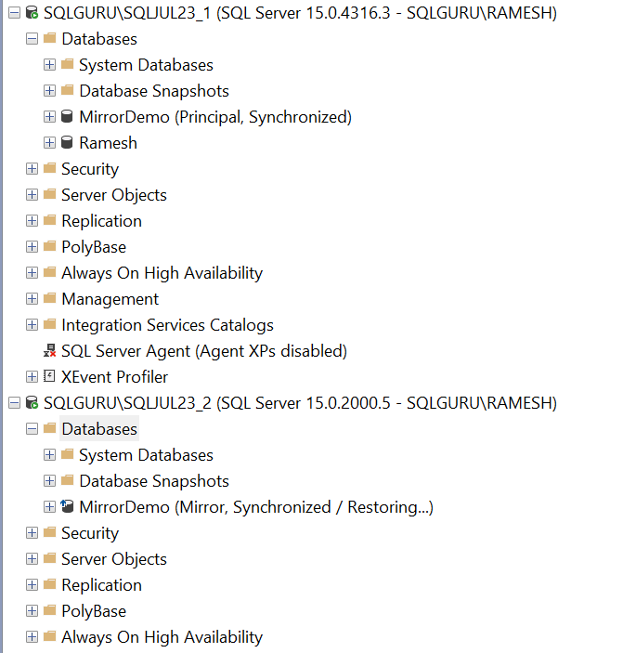

**T-SQL:**

**Configure the Mirroring:**

--On Mirror

alter database [MirrorDemo]

set partner='TCP://SQLGURU:5022'

--On Principal

alter database [MirrorDemo]

set partner='TCP://SQLGURU:5023'

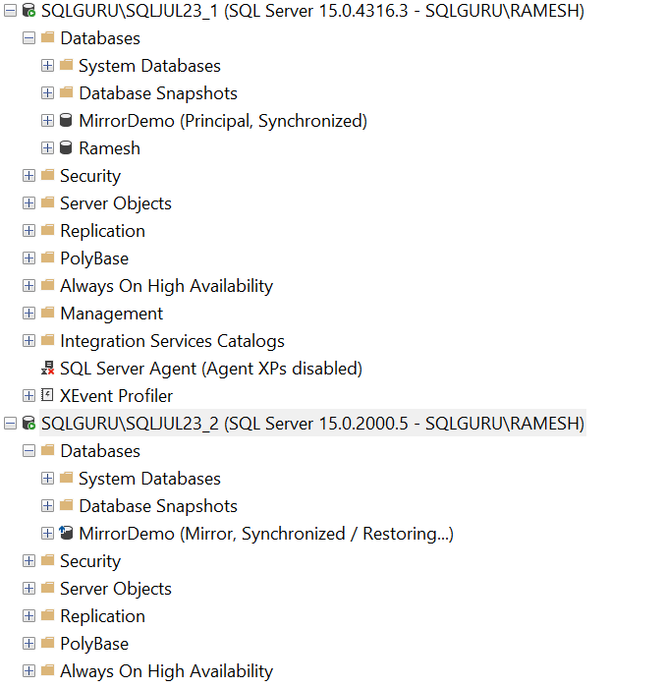

**Changing modes:**

--high safety to high performance

alter database [MirrorDemo] set partner safety off

--high performance to high safety

alter database [MirrorDemo] set partner safety full

--adding witness (high availability mode)

alter database [MirrorDemo] set witness='TCP://SQLGURU:5024'

--removing witness (high safety mode)

alter database [MirrorDemo] set witness off

--Manual failover

alter database [MirrorDemo] set partner failover

--Resume the mirrring

alter database [MirrorDemo] set partner suspend

alter database [MirrorDemo] set partner resume

**Mirroring Monitor:**

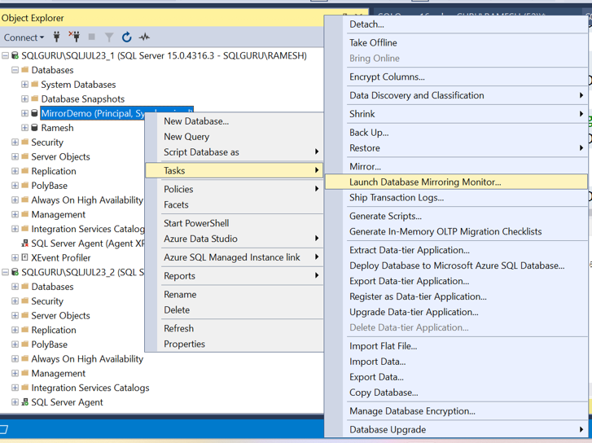

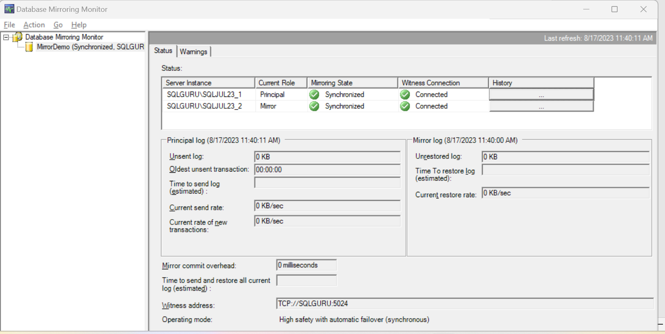

**Replication:**

Replication is process of distributing the data from one database to one or more databases and it is a object level solution

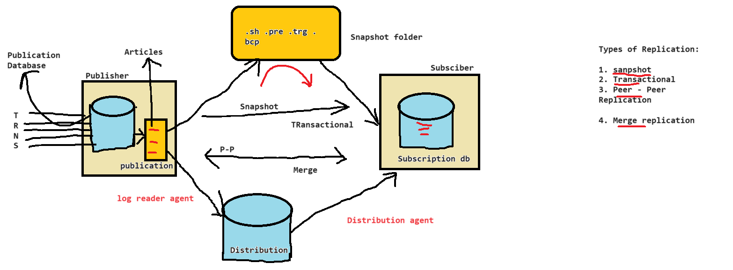

Replication Terminology:

Publisher

SQL Server Security:

SQL Server support two levels of security

* 1. Authentication 🡪to get into the SQL server
  2. Authorization 🡪 what we can access and we can perform

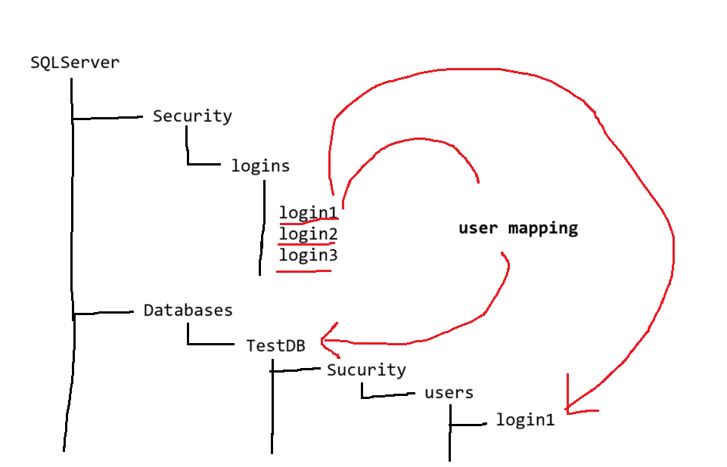

* Login – is server level principal which allows us to connect SQL server. Pre-requisite to connect a SQL server is ‘login’

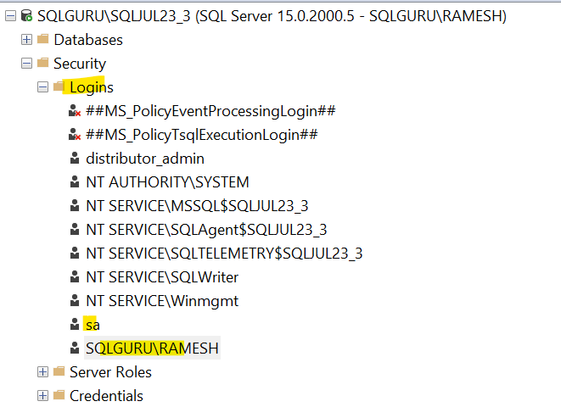

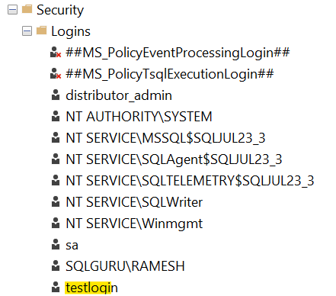

User – is database level principal which authorizes to access particular database, when we map a login to a particular database. It comes user under that database and can able access the database

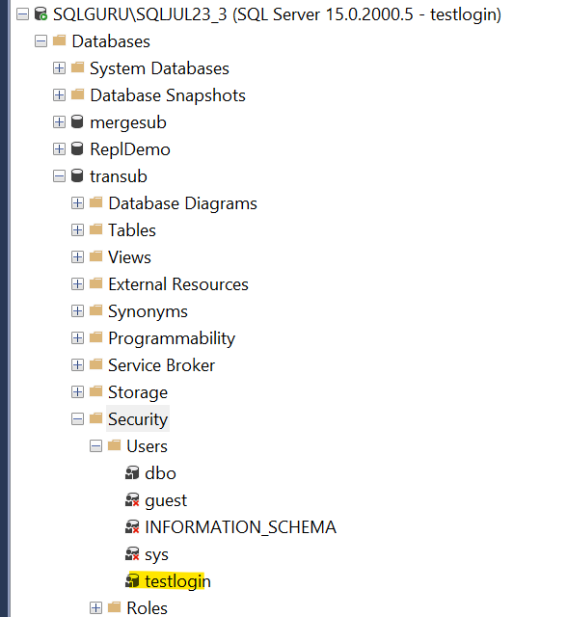

Server Level Security Roles:

When we are creating a login at server level, we can assign server level roles to the login

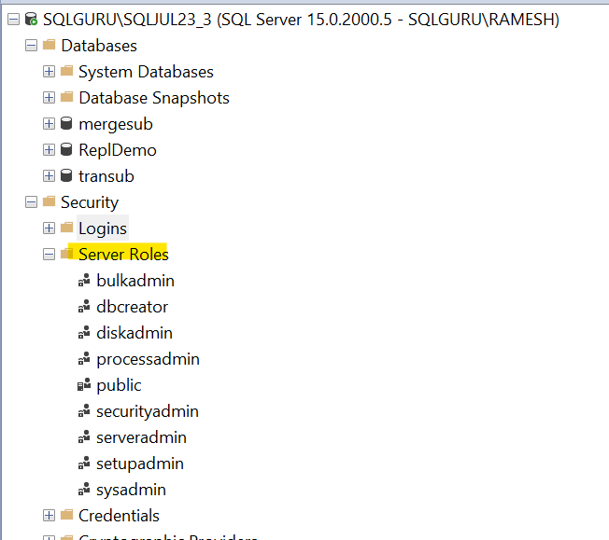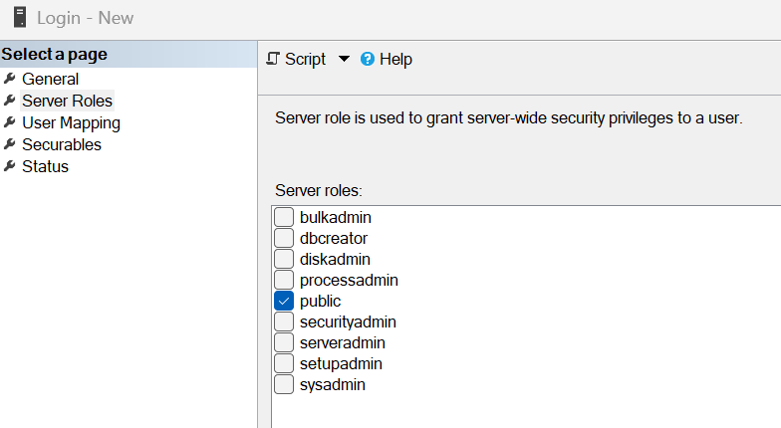

| **Fixed server-level role** | **Description** |
| --- | --- |
| **sysadmin** | Members of the **sysadmin** fixed server role can perform any activity in the server. |
| **serveradmin** | Members of the **serveradmin** fixed server role can change server-wide configuration options and shut down the server.  sp_configure  go  sp_configure 'show advanced options', 1  go  reconfigure  go  sp_configure  go  sp_configure 'max server memory (MB)',2048  go  reconfigure  go  sp_configure 'max degree of parallelism',4  go  reconfigure  go  sp_configure 'max degree of parallelism'  go |
| **securityadmin** | Members of the **securityadmin** fixed server role manage logins and their properties. They can GRANT, DENY, and REVOKE server-level permissions. They can also GRANT, DENY, and REVOKE database-level permissions if they have access to a database. Additionally, they can reset passwords for SQL Server logins.  **IMPORTANT:** The ability to grant access to the Database Engine and to configure user permissions allows the security admin to assign most server permissions. The **securityadmin** role should be treated as equivalent to the **sysadmin** role. As an alternative, starting with SQL Server 2022 (16.x), consider using the new fixed server role **##MS_LoginManager##**. |
| **processadmin** | Members of the **processadmin** fixed server role can end processes that are running in an instance of SQL Server.  **sp_who**  **sp_who2**  **kill 97** |
| **setupadmin** | Members of the **setupadmin** fixed server role can add and remove linked servers by using Transact-SQL statements. (**sysadmin** membership is needed when using Management Studio.)  USE [master]  GO  EXEC master.dbo.sp_addlinkedserver  @server = N'SQLGURU\SQLJUL23_2',  @srvproduct=N'SQL Server';  GO  EXEC master.dbo.sp_addlinkedsrvlogin  @rmtsrvname = N'SQLGURU\SQLJUL23_2',  @locallogin = NULL ,  @useself = N'True';  GO |
| **bulkadmin** | Members of the **bulkadmin** fixed server role can run the BULK INSERT statement.  The **bulkadmin** role or ADMINISTER BULK OPERATIONS  permissions isn't supported for SQL Server on Linux. Only the **sysadmin** can perform bulk inserts for SQL Server on Linux.  **BULK INSERT Employees**  **FROM 'E:\SQLLab\users.csv'**  **WITH (**  **FIELDTERMINATOR = ',',**  **ROWTERMINATOR = '\n',**  **FIRSTROW = 2**  **);** |
| **diskadmin** | The **diskadmin** fixed server role is used for managing disk files. |
| **dbcreator** | Members of the **dbcreator** fixed server role can create, alter, drop, and restore any database. |
| **public** | Every SQL Server login belongs to the **public** server role. When a server principal hasn't been granted or denied specific permissions on a securable object, the user inherits the permissions granted to **public** on that object. Only assign public permissions on any object when you want the object to be available to all users. You can't change membership in public.  **Note:** **public** is implemented differently than other roles, and permissions can be granted, denied, or revoked from the public fixed server roles. |

Database Roles: are the roles which we can assign to a user at database level

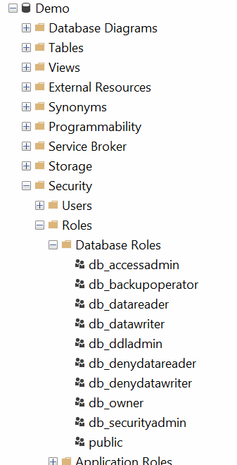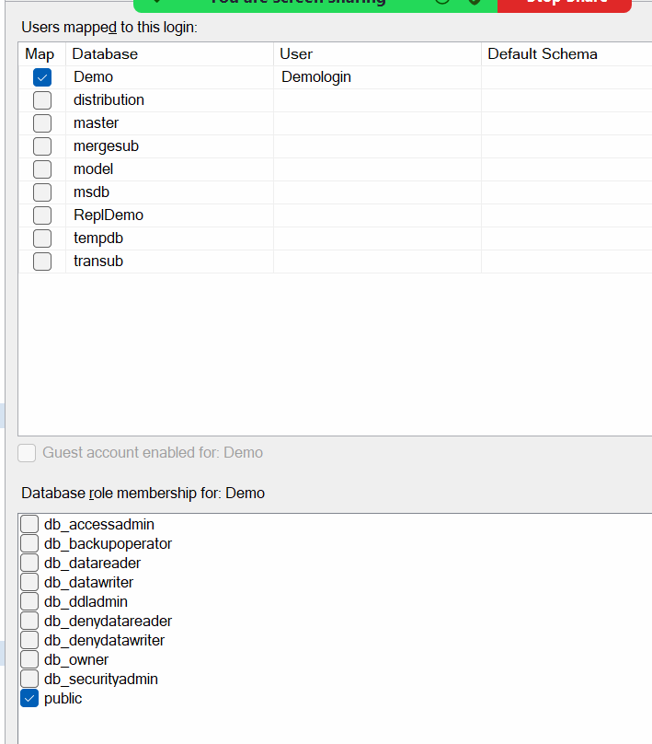

| **Fixed-Database role name** | **Description** |
| --- | --- |
| **db_owner** | Members of the **db_owner** fixed database role can perform all configuration and maintenance activities on the database, and can also drop the database in SQL Server. (In SQL Database and Azure Synapse, some maintenance activities require server-level permissions and can't be performed by **db_owners**.) |
| **db_securityadmin** | Members of the **db_securityadmin** fixed database role can modify role membership for custom roles only and manage permissions. Members of this role can potentially elevate their privileges and their actions should be monitored. |
| **db_accessadmin** | Members of the **db_accessadmin** fixed database role can add or remove access to the database for Windows logins, Windows groups, and SQL Server logins. |
| **db_backupoperator** | Members of the **db_backupoperator** fixed database role can back up the database. |
| **db_ddladmin** | Members of the **db_ddladmin** fixed database role can run any Data Definition Language (DDL) command in a database. Members of this role can potentially elevate their privileges by manipulating code that may get executed under high privileges and their actions should be monitored. |
| **db_datawriter** | Members of the **db_datawriter** fixed database role can add, delete, or change data in all user tables. In most use cases this role will be combined with **db_datareader** membership to allow reading the data that is to be modified. |
| **db_datareader** | Members of the **db_datareader** fixed database role can read all data from all user tables and views. User objects can exist in any schema except *sys* and *INFORMATION_SCHEMA*. |
| **db_denydatawriter** | Members of the **db_denydatawriter** fixed database role can't add, modify, or delete any data in the user tables within a database. |
| **db_denydatareader** | Members of the **db_denydatareader** fixed database role can't read any data from the user tables and views within a database |
|  |  |

**--SQL server accounts with T-SQL**

use master

go

create login mylogin with password='Welcome@2404'

go

ALTER SERVER ROLE [sysadmin] ADD MEMBER [mylogin]

GO

ALTER SERVER ROLE [sysadmin] drop MEMBER [mylogin]

GO

create user mylogin for login mylogin

go

use [repldemo]

go

create user mylogin for login mylogin

go

alter role db_owner add member mylogin

go

use test

go

create user mylogin for login mylogin

go

alter role db_owner add member mylogin

go

**--For windows domain accounts**

use [repldemo]

go

create user mylogin for login mylogin

go

alter role db_owner add member mylogin

go

USE [master]

GO

CREATE LOGIN [SQLGURU\ram] FROM WINDOWS WITH DEFAULT_DATABASE=[master]

GO

create user [SQLGURU\ram] for login [SQLGURU\ram]

go

use repldemo

go

create user [SQLGURU\ram] for login [SQLGURU\ram]

go

alter role db_owner add member [SQLGURU\ram]

go

use demo

go

create user [Demologin] for login [Demologin]

go

grant select on [dbo].[Employees] to [Demologin]

go

grant insert on [dbo].[test] to [Demologin]

go

revoke insert on [dbo].[test] to [Demologin]

go

grant execure on usp_database to [Demologin]

go

**-- table definition and database definition**

grant view definition to [Demologin]

**--Permissions required to run the profiler (Server level)**

use master

go

grant alter trace to [Demologin]

--custom role

use demo

go

create role custrole

go

grant select on [dbo].[Employees] to custrole

go

grant insert on [dbo].[test] to custrole

go

alter role custrole add member demologin

--create a login (in master)

create login ahalya with password='sqlserver'

go

--add server level role to a the login

alter server role sysadmin add member ahalya

go

create login charan with password ='sqlserver'

go

use master

go

create user charan for login charan

go

use [AdventureWorks2019]

go

create user charan for login charan

go

alter role db_owner add member charan

go

alter role db_datareader add member charan

go

use HR

go

create user charan for login charan

go

alter role db_owner add member charan

go

--create a login with name jayanthi and provided db owner access

--to mydb

use master

go

create login jayanthi with password='sqlserver'

go

use mydb

go

create user jayanthi for login jayanthi

go

alter role db_owner add member jayanthi

go

alter role db_owner drop member jayanthi

go

alter role db_datareader add member jayanthi

go

alter role db_datareader drop member jayanthi

go

alter role db_datawriter add member jayanthi

go

--Object level permissions

use master

go

create login simha with password='sqlserver'

go

use [AdventureWorks2019]

go

create user simha for login simha

go

--grant select only to the table [HumanResources].[Department]

grant select on [HumanResources].[Department] to simha

go

revoke select on [HumanResources].[Department] to simha

go

grant insert, update, delete on [Person].[Address]

to simha

go

grant execute on [dbo].[uspLogError] to simha

go

--custom role

create role customrole

go

grant select on [HumanResources].[Department] to customrole

go

grant insert, update, delete on [Person].[Address]

to customrole

go

grant execute on [dbo].[uspLogError] to customrole

go

use master

go

create login sindhu with password='sqlserver'

go

use [AdventureWorks2019]

go

create user sindhu for login sindhu

go

alter role customrole add member sindhu

go

Performance tuning:

Index – is a special mechanism/technology with which we can improve the data retrieval process. It is not mandatory to create a index for every column in every table. But adding right index on a right column improves the performance of data retrieval.

Index basically follows B (binary or Balance)-Tree algorithm to search for the data.

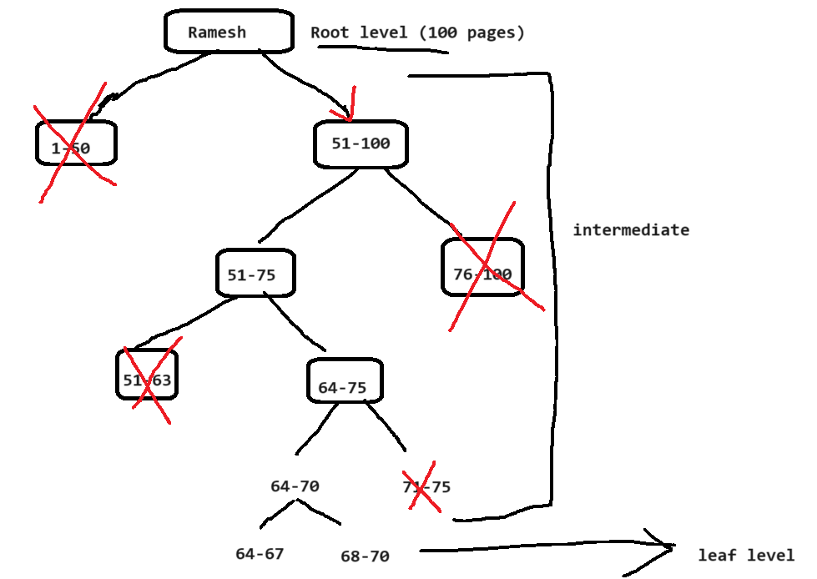

Types of Indexes:

* 1. Clustered index
  2. Non-Clustered index

Clustered index – In Clustered index, the leaf level contains the actual data pages. In one table we can create only one clustered index. If we create a primary key, by default clustered index will be created on that column. Clustered index will have the data in a particular sorted order

Non Clustered index – In the non-clustered index, the leaf level will not contains the actual data pages instead it contains the pointer to another cluster index or direct data rows and this performs the key lookup or RID lookup operations to fetch the data.

If the table contains both clustered and non-clustered index, the non-clustered index leaf level will have the pointer to another cluster index and it will perform key lookup operation.

If the table have only non-clustered index, then it will have pointer to direct data rows and it performs RID lookup operations

In one table, we can create up to 999 non clustered index.

The more index we create requires more storage and more maintenance.

Index practical:

--1.create the table

USE [Devbasics]

GO

CREATE TABLE Sales(

ID INT IDENTITY(1,1)

,ProductCode VARCHAR(20)

,Price FLOAT(53)

,DateTransaction DATETIME);

--2.inserting data (create the stored procedure)

CREATE PROCEDURE insertIntoSales

AS

SET NOCOUNT ON

BEGIN

DECLARE @PC VARCHAR(20)='A12CB'

DECLARE @Price INT = 50

DECLARE @COUNT INT = 0

WHILE @COUNT<200000

BEGIN

SET @PC=@PC+CAST(@COUNT AS VARCHAR(20))

--A12CB2

SET @Price=@Price+@COUNT

--52

INSERT INTO Sales VALUES (@PC,@Price,GETDATE())

SET @PC='A12CB'

SET @Price=50

SET @COUNT+=1

END

END

--execute the stored procedures

EXEC insertIntoSales

--CASE – 1 🡪No index

--include actual execution plan.

SET STATISTICS IO ON

SET STATISTICS TIME ON

SELECT * FROM Sales WHERE ID=189923

Operation: (table scan) table without any indexes is called heap table

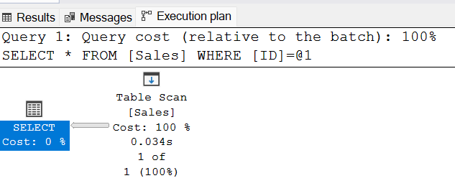

Output: 1 row returned

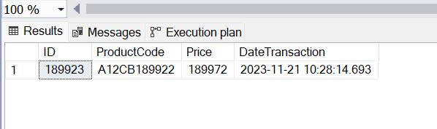

Stastistics:

SQL Server parse and compile time:

CPU time = 0 ms, elapsed time = 0 ms.

SQL Server Execution Times:

CPU time = 0 ms, elapsed time = 0 ms.

SQL Server parse and compile time:

CPU time = 0 ms, elapsed time = 1 ms.

SQL Server Execution Times:

CPU time = 0 ms, elapsed time = 0 ms.

SQL Server Execution Times:

CPU time = 0 ms, elapsed time = 0 ms.

SQL Server parse and compile time:

CPU time = 0 ms, elapsed time = 0 ms.

(1 row affected)

Table 'Sales'. Scan count 1, logical reads 1129, physical reads 0, page server reads 0, read-ahead reads 1125, page server read-ahead reads 0, lob logical reads 0, lob physical reads 0, lob page server reads 0, lob read-ahead reads 0, lob page server read-ahead reads 0.

(1 row affected)

SQL Server Execution Times:

CPU time = 15 ms, elapsed time = 35 ms.

SQL Server parse and compile time:

CPU time = 0 ms, elapsed time = 0 ms.

SQL Server Execution Times:

CPU time = 0 ms, elapsed time = 0 ms.

Completion time: 2023-11-21T10:34:15.0553763+05:30

--CASE2 🡪creating cluster index on ID column

CREATE CLUSTERED INDEX CL_ID ON SALES(ID);

SET STATISTICS IO ON

SET STATISTICS TIME ON

SELECT * FROM Sales WHERE ID=189923

Output: 1 row returned



Operations: Clustered index seek

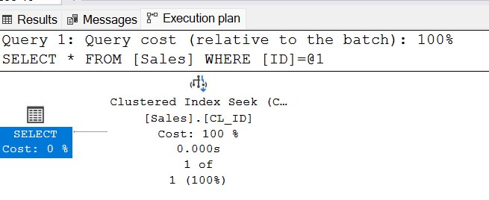

Statistics:

SQL Server parse and compile time:

CPU time = 0 ms, elapsed time = 0 ms.

SQL Server Execution Times:

CPU time = 0 ms, elapsed time = 0 ms.

SQL Server parse and compile time:

CPU time = 0 ms, elapsed time = 1 ms.

SQL Server Execution Times:

CPU time = 0 ms, elapsed time = 0 ms.

SQL Server Execution Times:

CPU time = 0 ms, elapsed time = 0 ms.

SQL Server parse and compile time:

CPU time = 0 ms, elapsed time = 0 ms.

(1 row affected)

Table 'Sales'. Scan count 1, logical reads 3, physical reads 0, page server reads 0, read-ahead reads 0, page server read-ahead reads 0, lob logical reads 0, lob physical reads 0, lob page server reads 0, lob read-ahead reads 0, lob page server read-ahead reads 0.

(1 row affected)

SQL Server Execution Times:

CPU time = 0 ms, elapsed time = 2 ms.

SQL Server parse and compile time:

CPU time = 0 ms, elapsed time = 0 ms.

SQL Server Execution Times:

CPU time = 0 ms, elapsed time = 0 ms.

Completion time: 2023-11-21T10:40:45.3855998+05:30

Case 3 🡪clustered index is on ID column, but the predicate is product code

SET STATISTICS IO ON

SET STATISTICS TIME ON

SELECT * FROM Sales WHERE ProductCode like 'A12CB908%' order by Price

Output: 111 records

Operations – Clustered index scan

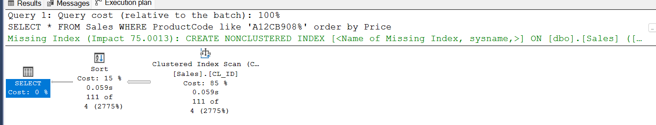

Statistics:

SQL Server parse and compile time:

CPU time = 0 ms, elapsed time = 0 ms.

SQL Server Execution Times:

CPU time = 0 ms, elapsed time = 0 ms.

SQL Server parse and compile time:

CPU time = 248 ms, elapsed time = 248 ms.

SQL Server Execution Times:

CPU time = 0 ms, elapsed time = 0 ms.

SQL Server Execution Times:

CPU time = 0 ms, elapsed time = 0 ms.

(111 rows affected)

Table 'Worktable'. Scan count 0, logical reads 0, physical reads 0, page server reads 0, read-ahead reads 0, page server read-ahead reads 0, lob logical reads 0, lob physical reads 0, lob page server reads 0, lob read-ahead reads 0, lob page server read-ahead reads 0.

Table 'Sales'. Scan count 1, logical reads 1136, physical reads 1, page server reads 0, read-ahead reads 196, page server read-ahead reads 0, lob logical reads 0, lob physical reads 0, lob page server reads 0, lob read-ahead reads 0, lob page server read-ahead reads 0.

(1 row affected)

SQL Server Execution Times:

CPU time = 16 ms, elapsed time = 152 ms.

SQL Server parse and compile time:

CPU time = 0 ms, elapsed time = 0 ms.

SQL Server Execution Times:

CPU time = 0 ms, elapsed time = 0 ms.

Completion time: 2023-11-21T10:46:34.3919676+05:30

Case 3 🡪clustered index is on ID column, Non Clustered index on product code

USE [Devbasics]

GO

CREATE NONCLUSTERED INDEX nci_prodct_code

ON [dbo].[Sales] ([ProductCode])

GO

SET STATISTICS IO ON

SET STATISTICS TIME ON

SELECT * FROM Sales WHERE ProductCode like 'A12CB908%' order by Price

Out put –111 records

Operations: Non clustred index seek, key lookup

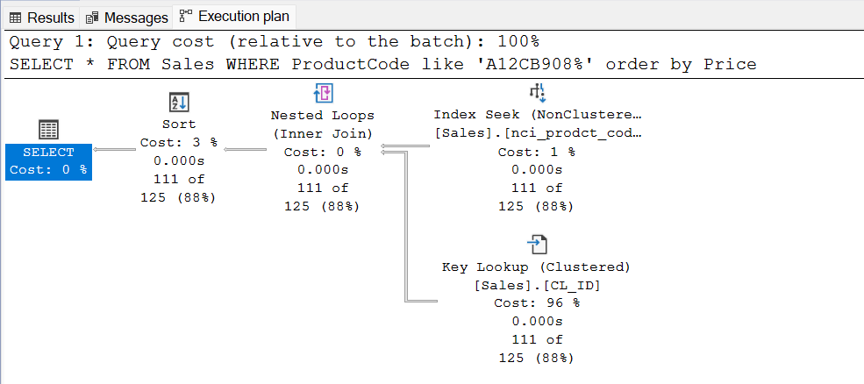

Statistics:

QL Server parse and compile time:

CPU time = 0 ms, elapsed time = 0 ms.

SQL Server Execution Times:

CPU time = 0 ms, elapsed time = 0 ms.

SQL Server parse and compile time:

CPU time = 4 ms, elapsed time = 4 ms.

SQL Server Execution Times:

CPU time = 0 ms, elapsed time = 0 ms.

SQL Server Execution Times:

CPU time = 0 ms, elapsed time = 0 ms.

(111 rows affected)

Table 'Worktable'. Scan count 0, logical reads 0, physical reads 0, page server reads 0, read-ahead reads 0, page server read-ahead reads 0, lob logical reads 0, lob physical reads 0, lob page server reads 0, lob read-ahead reads 0, lob page server read-ahead reads 0.

Table 'Sales'. Scan count 1, logical reads 351, physical reads 0, page server reads 0, read-ahead reads 0, page server read-ahead reads 0, lob logical reads 0, lob physical reads 0, lob page server reads 0, lob read-ahead reads 0, lob page server read-ahead reads 0.

(1 row affected)

SQL Server Execution Times:

CPU time = 0 ms, elapsed time = 90 ms.

SQL Server parse and compile time:

CPU time = 0 ms, elapsed time = 0 ms.

SQL Server Execution Times:

CPU time = 0 ms, elapsed time = 0 ms.

Completion time: 2023-11-21T10:51:06.7144960+05:30

How to eliminate these Key lookup:

USE [Devbasics]

GO

--covering index

CREATE NONCLUSTERED INDEX nci_prodct_code

ON [dbo].[Sales] ([ProductCode])

INCLUDE ([Price],[DateTransaction])

GO

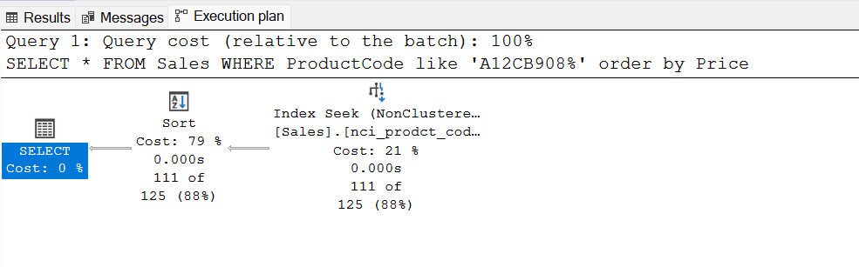

SQL Server parse and compile time:

CPU time = 0 ms, elapsed time = 0 ms.

SQL Server Execution Times:

CPU time = 0 ms, elapsed time = 0 ms.

SQL Server parse and compile time:

CPU time = 0 ms, elapsed time = 1 ms.

SQL Server Execution Times:

CPU time = 0 ms, elapsed time = 0 ms.

SQL Server Execution Times:

CPU time = 0 ms, elapsed time = 0 ms.

(111 rows affected)

Table 'Worktable'. Scan count 0, logical reads 0, physical reads 0, page server reads 0, read-ahead reads 0, page server read-ahead reads 0, lob logical reads 0, lob physical reads 0, lob page server reads 0, lob read-ahead reads 0, lob page server read-ahead reads 0.

Table 'Sales'. Scan count 1, logical reads 3, physical reads 0, page server reads 0, read-ahead reads 0, page server read-ahead reads 0, lob logical reads 0, lob physical reads 0, lob page server reads 0, lob read-ahead reads 0, lob page server read-ahead reads 0.

(1 row affected)

SQL Server Execution Times:

CPU time = 0 ms, elapsed time = 89 ms.

SQL Server parse and compile time:

CPU time = 0 ms, elapsed time = 0 ms.

SQL Server Execution Times:

CPU time = 0 ms, elapsed time = 0 ms.

Completion time: 2023-11-21T10:55:52.2835560+05:30

Case 3 🡪No clustered index, Non Clustered index on product code

USE [Devbasics]

GO

--covering index

CREATE NONCLUSTERED INDEX nci_prodct_code

ON [dbo].[Sales] ([ProductCode])

GO

Operation:

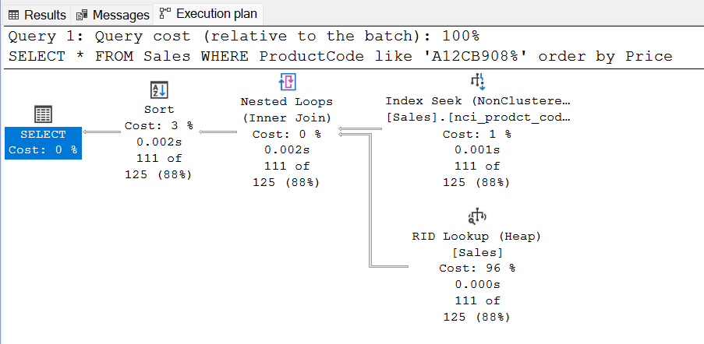

Out put –111 records

Statistics:

SQL Server parse and compile time:

CPU time = 0 ms, elapsed time = 0 ms.

SQL Server Execution Times:

CPU time = 0 ms, elapsed time = 0 ms.

SQL Server parse and compile time:

CPU time = 0 ms, elapsed time = 4 ms.

SQL Server Execution Times:

CPU time = 0 ms, elapsed time = 0 ms.

SQL Server Execution Times:

CPU time = 0 ms, elapsed time = 0 ms.

(111 rows affected)

Table 'Worktable'. Scan count 0, logical reads 0, physical reads 0, page server reads 0, read-ahead reads 0, page server read-ahead reads 0, lob logical reads 0, lob physical reads 0, lob page server reads 0, lob read-ahead reads 0, lob page server read-ahead reads 0.

Table 'Sales'. Scan count 1, logical reads 114, physical reads 2, page server reads 0, read-ahead reads 23, page server read-ahead reads 0, lob logical reads 0, lob physical reads 0, lob page server reads 0, lob read-ahead reads 0, lob page server read-ahead reads 0.

(1 row affected)

SQL Server Execution Times:

CPU time = 0 ms, elapsed time = 98 ms.

SQL Server parse and compile time:

CPU time = 0 ms, elapsed time = 0 ms.

SQL Server Execution Times:

CPU time = 0 ms, elapsed time = 0 ms.

Completion time: 2023-11-21T10:58:46.7021824+05:30

USE [Devbasics]

GO

--covering index

CREATE NONCLUSTERED INDEX nci_prodct_code

ON [dbo].[Sales] ([ProductCode])

INCLUDE ([Price],[DateTransaction])

GO

Profiler: is inbuilt monitoring tool which we can use to capture query performance metrics. Here we can create a trace to which we can capture all the events and also query metrics like statement start, statement end, execution plan, durations, cpu ..etc

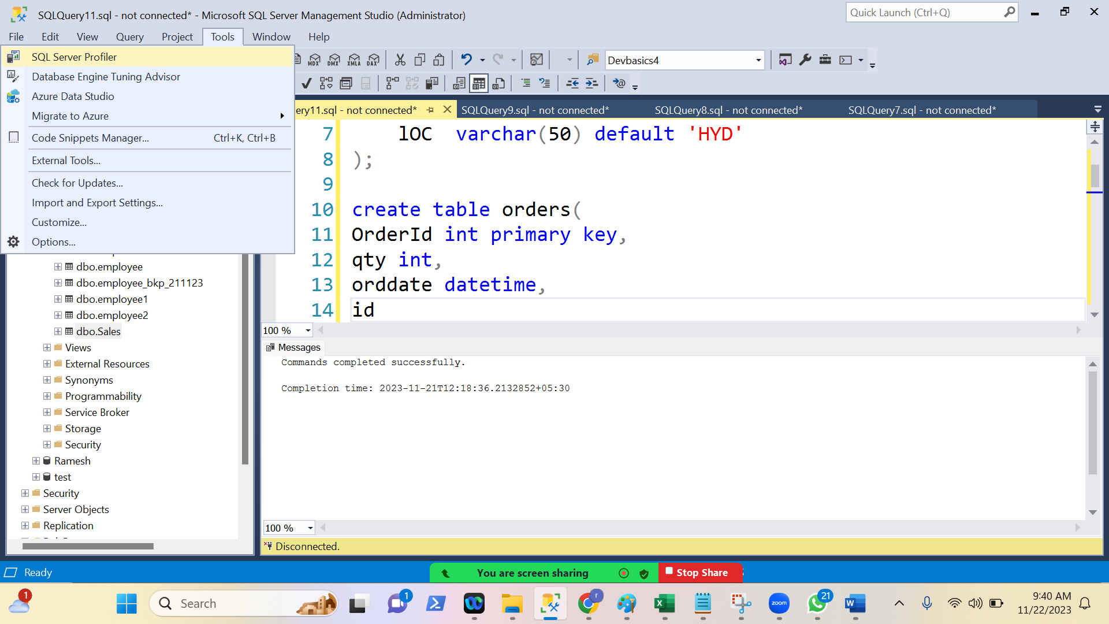

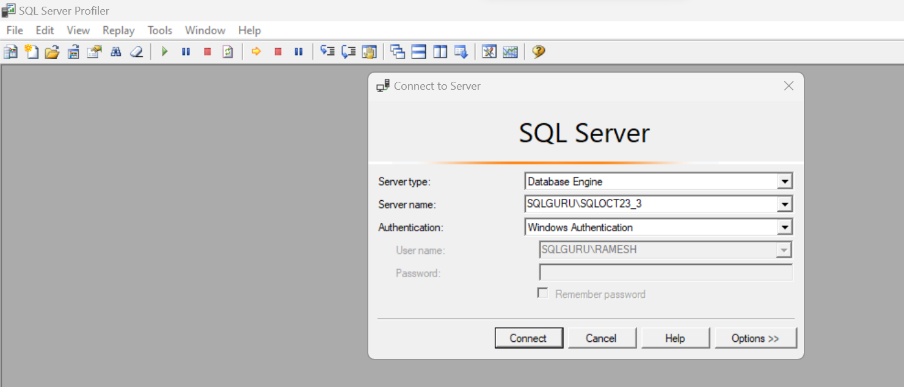

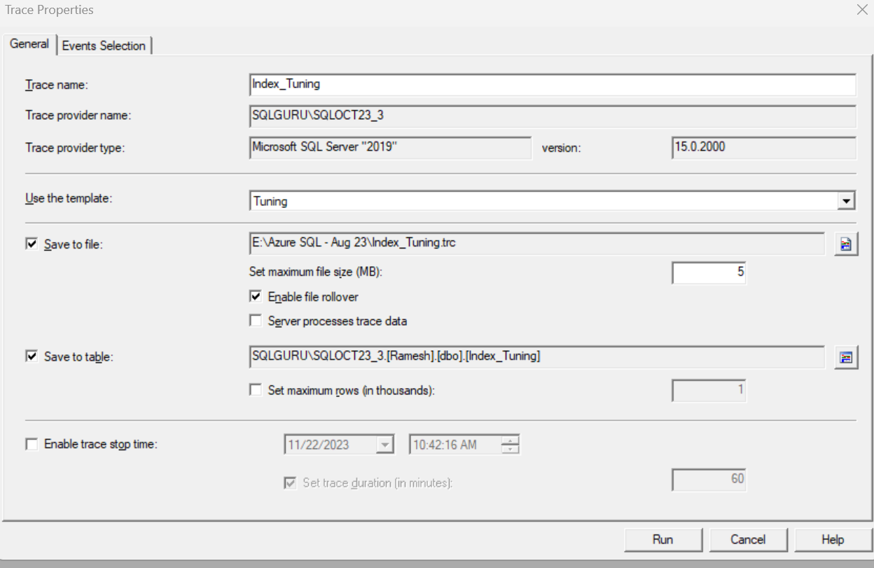

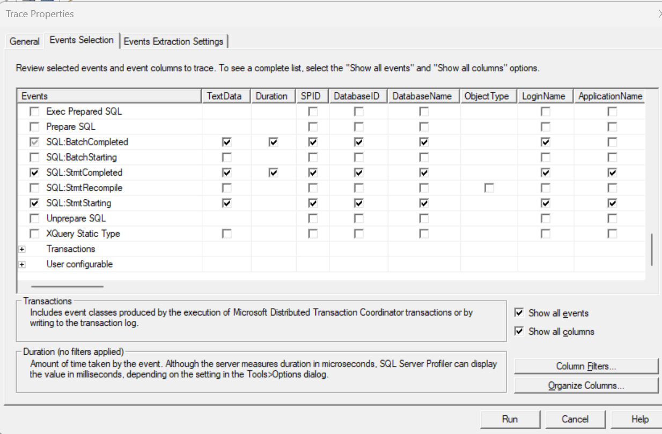

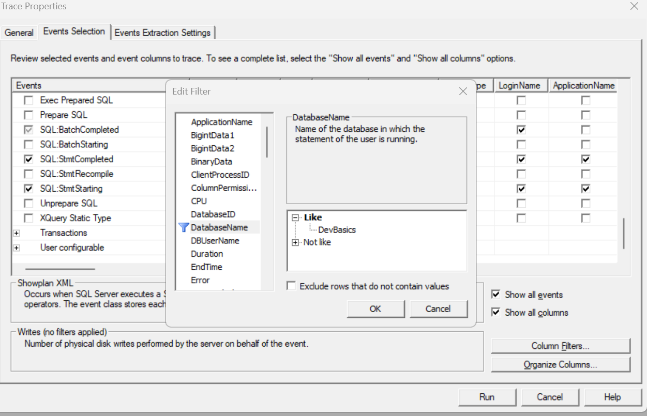

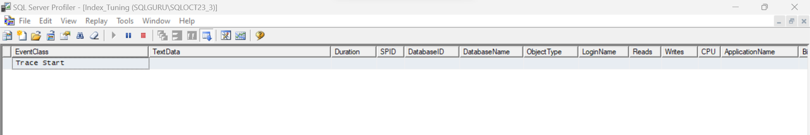

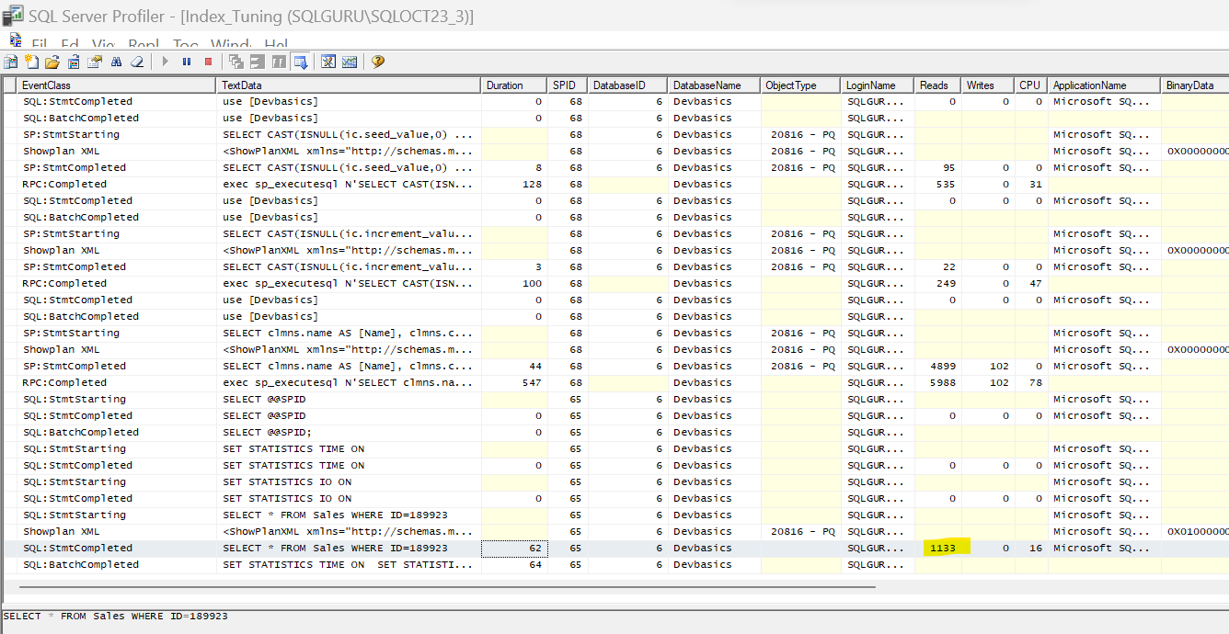

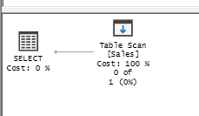

DTA (Database Tuning Advisor):

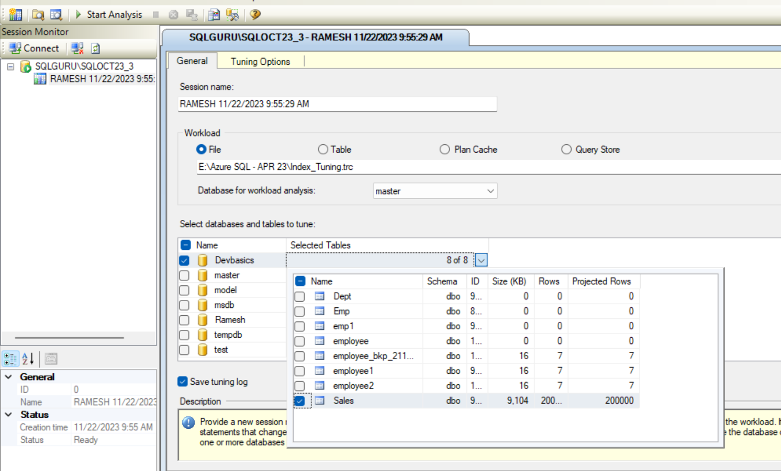

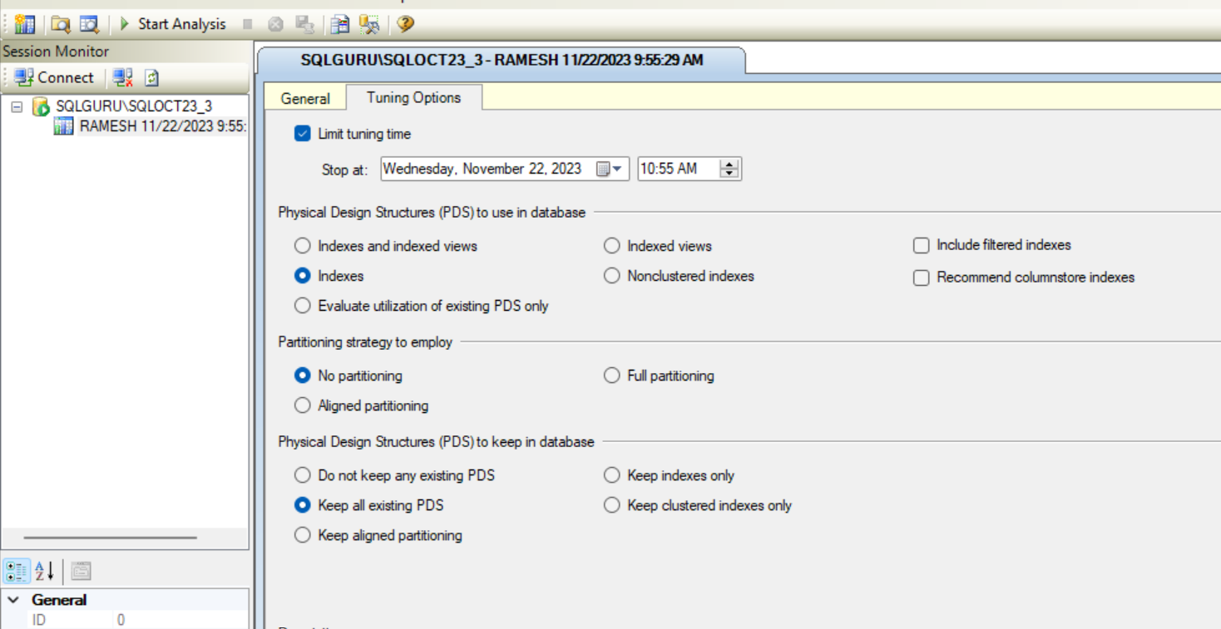

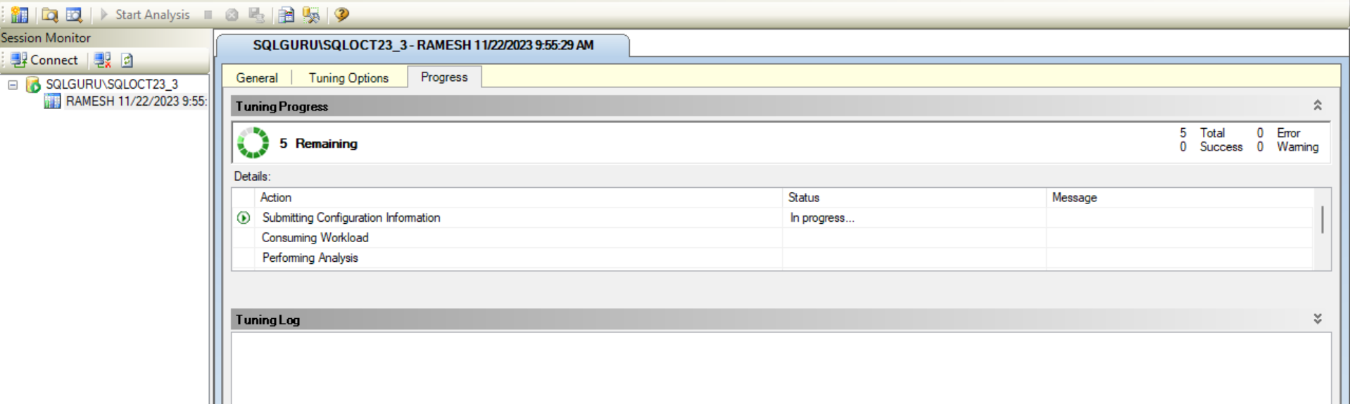

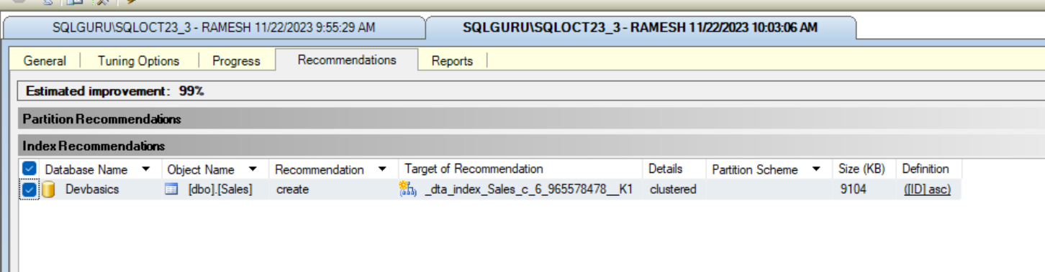

CREATE CLUSTERED INDEX [_dta_index_Sales_c_6_965578478__K1] ON [dbo].[Sales]

(

[ID] ASC

)WITH (SORT_IN_TEMPDB = OFF, DROP_EXISTING = OFF, ONLINE = OFF) ON [PRIMARY]

Fragmentation:

SQL Server Internal Fragmentation

SQL Server Internal Fragmentation is caused by pages that have too much free space. Let's pretend at the beginning of the day we have a table with 40 pages that are 100% full, but by the end of the day we have a table with 50 pages that are only 80% full because of various delete and insert statements throughout the day. This causes an issue because now when we need to read from this table we have to scan 50 pages instead of 40 which should may result in a decrease in performance

## SQL Server External Fragmentation

External Fragmentation is caused by pages that are out of order. Let's pretend at the beginning of the day we have a perfectly ordered table. During the day we issue hundreds of update statements possibly leaving some empty space on one page and trying to fit space into other pages. This means our storage has to jump around to obtain the data needed instead of reading in one direction.

How to identify the fragmentation:

Option#1: dbcc showcontig

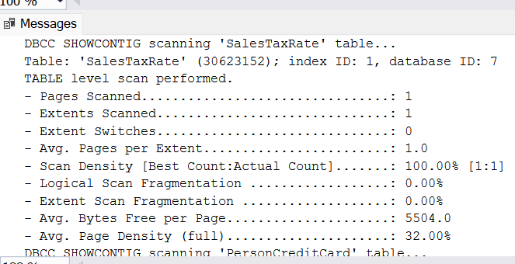

Option #2:

SELECT OBJECT_NAME(ips.OBJECT_ID) as table_name

,i.NAME

,ips.index_id

,index_type_desc

,avg_fragmentation_in_percent

,avg_page_space_used_in_percent

,page_count

FROM sys.dm_db_index_physical_stats(DB_ID(), NULL, NULL, NULL, 'SAMPLED') ips

INNER JOIN sys.indexes i ON (ips.object_id = i.object_id)

AND (ips.index_id = i.index_id)

ORDER BY avg_fragmentation_in_percent DESC

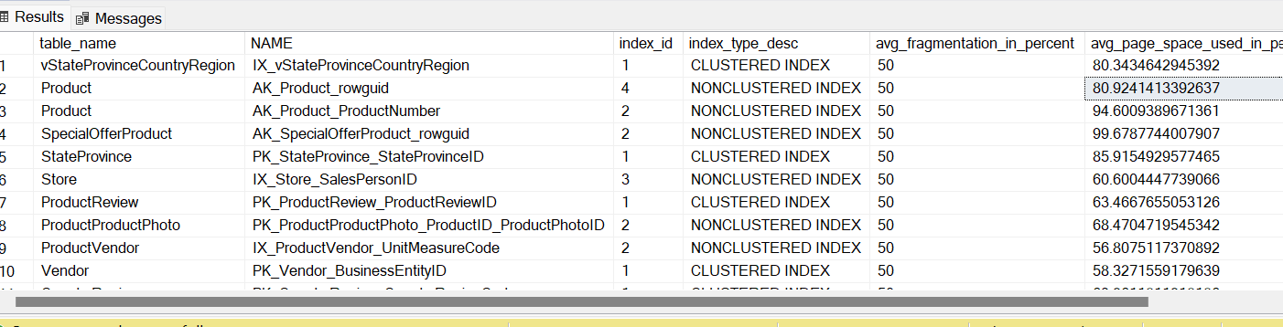

How to remove the Fragmentation:

Index Rebuild 🡪 if the fragmentation is >30 %, we need run index rebuild. It will drop index and it will recreate same index

Index Re-Org 🡪 if the fragmentation is between 10-30%, then we need reorg the index. It will not drop the index, it will rearrange the pages to match with physical order.

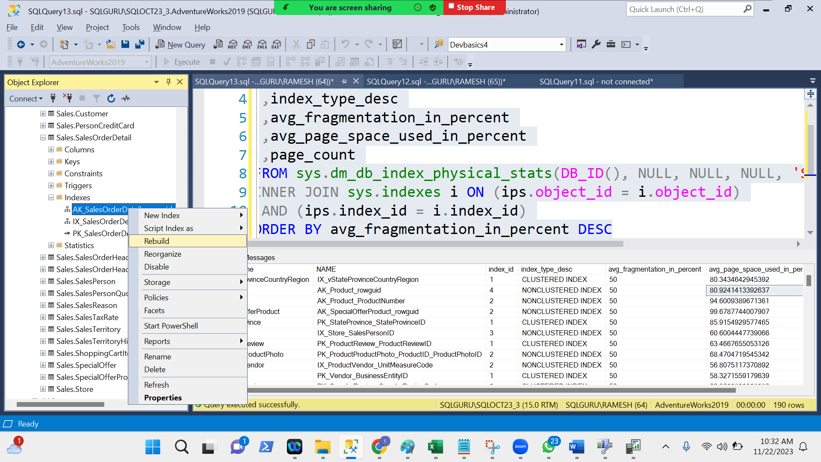

T-SQL:

alter index [AK_SalesOrderDetail_rowguid]

on [Sales].[SalesOrderDetail] rebuild

alter index [AK_SalesOrderDetail_rowguid]

on [Sales].[SalesOrderDetail] reorganize

Maintenance Plans: To automate index maintenance for entire database level

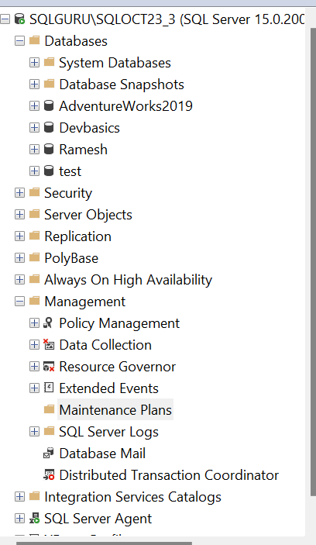

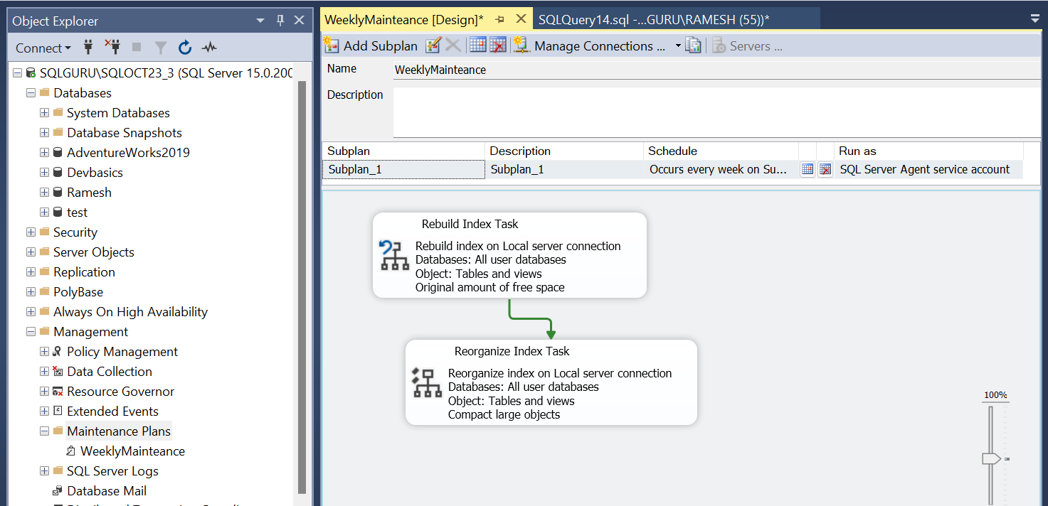

Fill factor:

It defines the amount of free space need to be maintained at index page level. So that it will minimize the page splits and controls the fragmentation

Default value is : 0

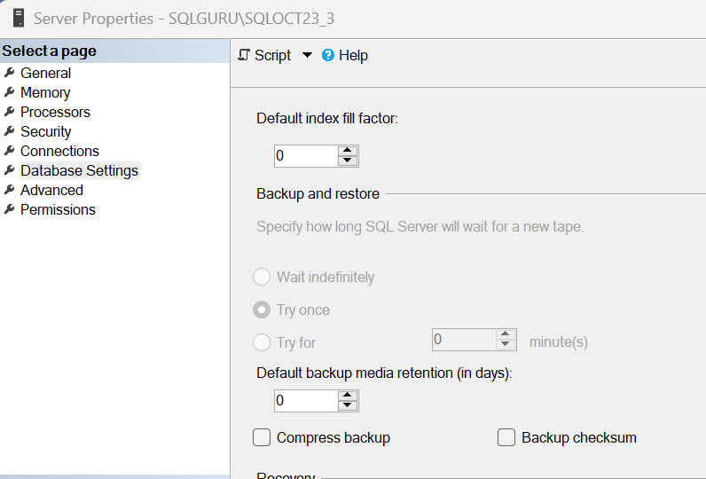

If fill factor is 10%, it will fill 90%% and keeps 10% empty

Locks, Blocks and Deadlocks